**Prepare Appium Instance for Window 10**

To Start Automation with Appium, we have to follow couple of steps. First we have to make your system ready then we can start our journey with appium.

1. [Download & Install JDK](https://www.oracle.com/java/technologies/javase/jdk11-archive-downloads.html)
2. [Download & Install IntelliJ IDEA Community Version](https://www.jetbrains.com/idea/download/)
3. [Download & Install android studio Android SDK thourgh Android Studio](https://developer.android.com/studio)
4. [Download & Install LTS Node Js](https://nodejs.org/en/download/)
5. [Download & Install Vysor](https://www.vysor.io/download/)
6. [Download & Install Appium Desktop Apps](https://github.com/appium/appium-desktop/releases/)
7. Set environment variable(path) - Set JAVA_HOME & ANDROID_HOME
8. Check if node.js, npm & Android SDK are installed - node --version, npm --version, adb --version
9. Install appium with node.js - npm install -g appium
10. Check if appium is installed - appium -v
11. Plugin Device (turn on developer mode & USB debugging)
    * Find build number under settings and tap 7 times on build number.
    * Enter your pattern, PIN or password to enable the Developer options menu.
    * The "Developer options" menu will now appear in your Settings menu.
    * Turn On the "USB Debugging" option from "Developer Options"
12. Indentify appPackage & appActivityName Open the app in your device. and use the command - adb shell "dumpsys activity activities | grep mResumedActivity"
13. **Create TestNG XML** plugin install from Marketplace - File >> Settings >> plugin >> Marketplace >> search 'Create TestNG XML' & install

**Create Java(Gradle) Project in IntelliJ IDEA for Appium**

1. Create Java(Gradle) Project in IntelliJ IDEA
2. Add Gradle Dependencies
   * [Selenium](https://mvnrepository.com/artifact/org.seleniumhq.selenium/selenium-java)
   * [Appium CLient](https://mvnrepository.com/artifact/io.appium/java-client)
   * [TestNG](https://mvnrepository.com/artifact/org.testng/testng)
3. [Desired Capabilities](https://appium.io/docs/en/writing-running-appium/caps/)

**Open existing Java(Gradle) Project using IntelliJ IDEA**

1. Open existing Java(Gradle) Project using IntelliJ IDEA
2. Identify Elements
3. Start Writing Automation Code
4. Run Test Cases

**Appium Inspector to Identify Elements**

1. [Appium Inspector download & install](https://github.com/appium/appium-inspector/releases)
2. **Configure Appium Desktop client & Appium Inspector**

* Appium Desktop
  + Go to Appium Server GUI -> Advanced
    - Server address: localhost
    - Port: 4723
    - Allow CORP: yes
* Appium Inspector
  + Go to or Open Appium Inspector
    - Remote host: localhost
    - Port: 4723
    - Path: /wd/hub
    - Allow Unauthorized Certificates
* Select your capabilities [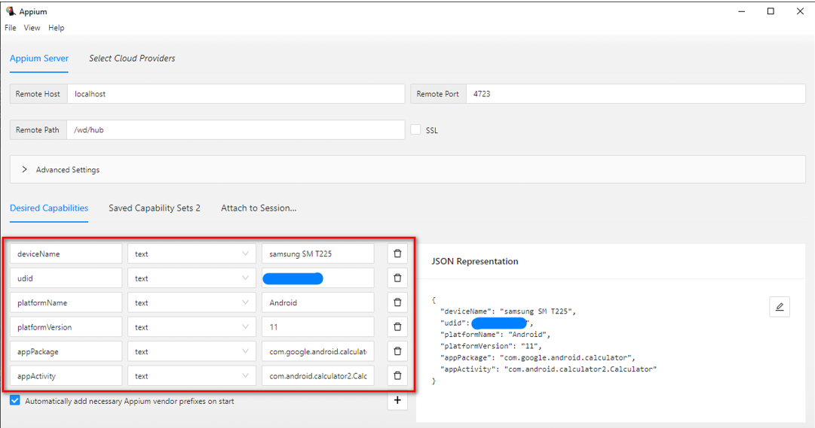](https://github.com/hiromia006/mobileAutomation/blob/main/images/img.png)
* Start Appium Server GUI First [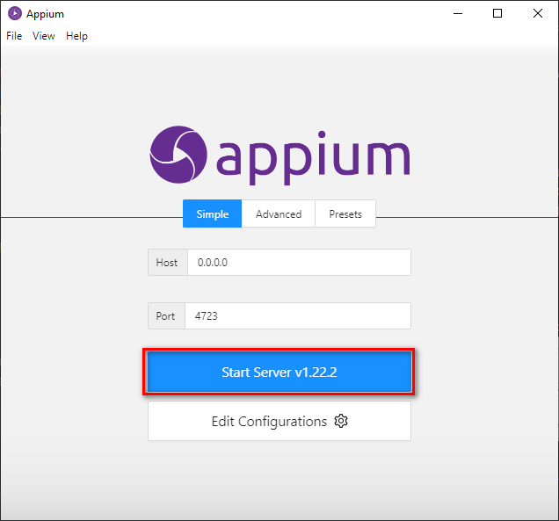](https://github.com/hiromia006/mobileAutomation/blob/main/images/img_1.png)
* Appium Inspector server [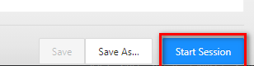](https://github.com/hiromia006/mobileAutomation/blob/main/images/img_2.png)
* Appium Inspector will open [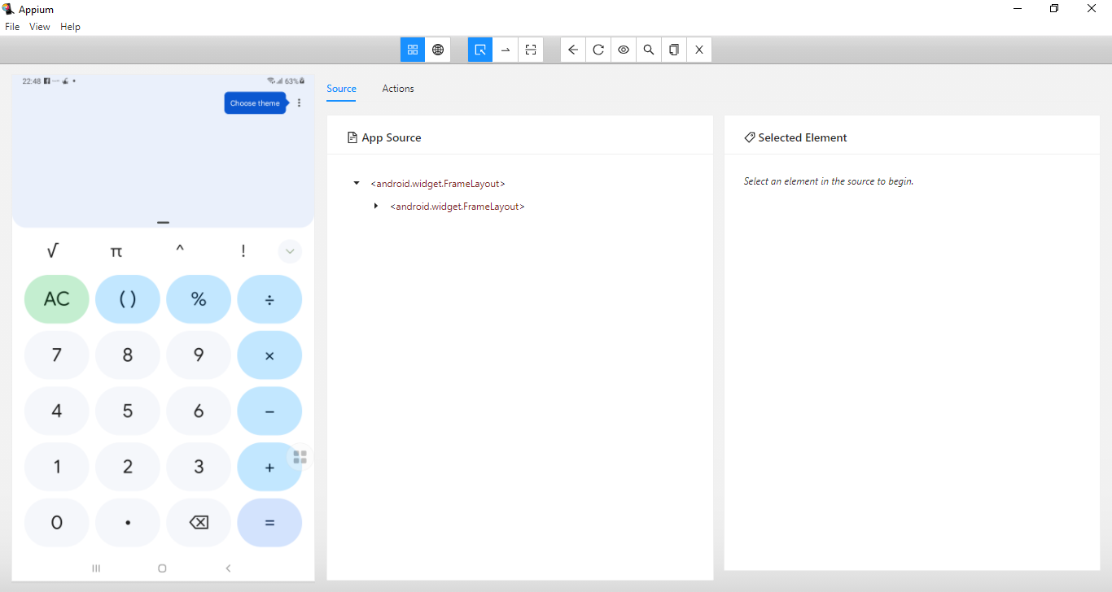](https://github.com/hiromia006/mobileAutomation/blob/main/images/img_3.png)

**Run Test Case**

* **Run Test Case** - Go to desired Java Class where has Test Case, Right click of mouse on Test Case >> click on Run
* **Run XML File** - After create TestNG file, Right click of mouse on TestNG xml >> click on Run

**Related Resources**

* [Troubleshoot Activities Startup](https://appium.io/docs/en/writing-running-appium/android/activity-startup/)
* [Appium API Documentation](https://appium.io/docs/en/about-appium/api/)
* [Selenium WebDriver](https://www.selenium.dev/documentation/webdriver/)

**Create automated scripts to test EMI Calculator mobile app**

[Download & install EMI Calculator mobile app your device](https://github.com/hiromia006/mobileAutomation/blob/main/src/test/resources/emi-calculator.apk)

**Key functionalities, that have to be covered:**

1. Open EMI calculator
2. Navigate to the EMI Calculator screen
3. Enter <*loan*> in the amount field
4. Enter <*interest*> percent rate in the interest field
5. Enter <*period*> in the period field in years
6. Enter <*pFee*> percent for the processing fee
7. And tap on the calculate button
8. Then Verify that the detail results are correct <*mEMI*>, <*tInterest*>, <*tpFee*> and <*tPayment*>

**Examples:**

| **loan** | **interest** | **period** | **pFee** | **mEMI** | **tInterest** | **tpFee** | **tPayment** |
| --- | --- | --- | --- | --- | --- | --- | --- |
| 100000 | 9.0 | 2 | 2.0 | 4568 | 9643 | 2000 | 109643 |
| 325000 | 9.5 | 5 | 1.5 | 6826 | 84536 | 4875 | 409536 |
| 450000 | 11.0 | 7 | 1.8 | 7705 | 197228 | 8100 | 647228 |

**Additional functionalities, that may be covered:**

1. Please use Example table data to create excel/csv file as external test data provider and your automation script have the abitlity to read and write data from excel/csv