|  |  |
| --- | --- |
| Date | 10 TH may 2023 |
| Team ID | **NM2023TMID01603** |
| Project Name | **A Comprehensive Analysis of Financial Performance: Insights from a Leading Banks** |
| Team Leader | **KAVIYA R** |
| Team Member | **NANDHINI S** |
| **TAMIL ELAKKIYA M** |

**A Comprehensive Analysis of Financial Performance: Insights from a Leading Banks**

**A COMPREHENSIVE ANALYSIS OF FINANCIAL PERFORMANCE : INSIGHTS FROM A LEADING BANKS**

**1. INTRODUCTION**

***1.1 Overview***

The banking industry world-wide is being transformed. The global forces for change include technological innovation; the deregulation of A Comprehensive Analysis of Financial Performance: Insights from a Leading Banks at the international level of eight countries with 120 rank of banks.

***1.2 Purpose***

The financial analysis aims to analyze whether an entity is stable, liquid, solvent, or profitable enough to warrant a monetary investment. It is used to evaluate economic trends, set financial policies, build long-term plans for business activity, and identify projects or companies for investment.

**2. Define Problem And Understanding**

A business problem can be defined as any hurdle, situation, or variation that leads to a difference between the desired objectives and accomplished results.

Business requirements, also known as stakeholder requirements specifications (StRS), describe the characteristics of a proposed system from the viewpoint of the system's end user like a CONOPS

**3. Data Collection & Extraction from Database:**

The banking industry is changing globally. The ranking of banks has been calculated through global banking data analysis of China, USA, Russia, Japan etc. Through this 120 ranks are divided based on assets.

**4. Storing Data in DB:**

The data in a database is grouped into a series of database records. Each database record is composed of smaller groups of data called segments. A segment is the smallest piece of data IMS can store.

**5. Data Preparation:**

Given data analysis of bank with rank

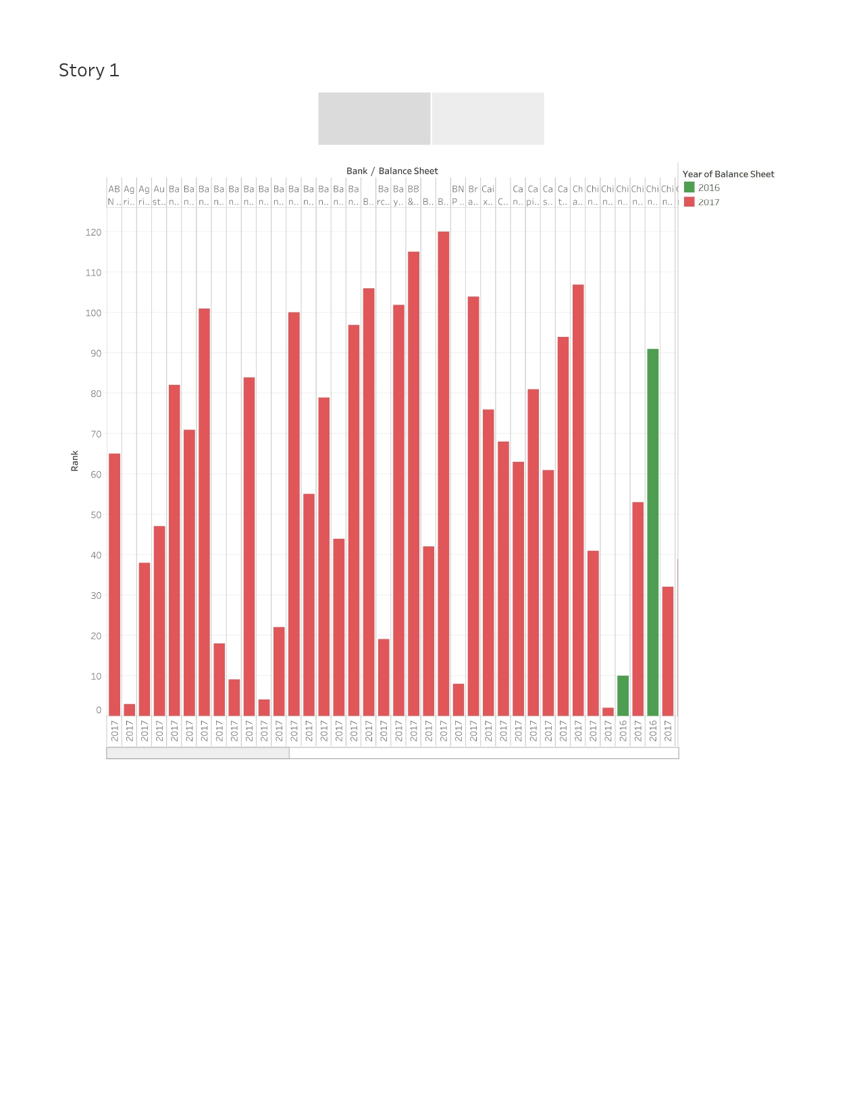

Collection of data from country with rank

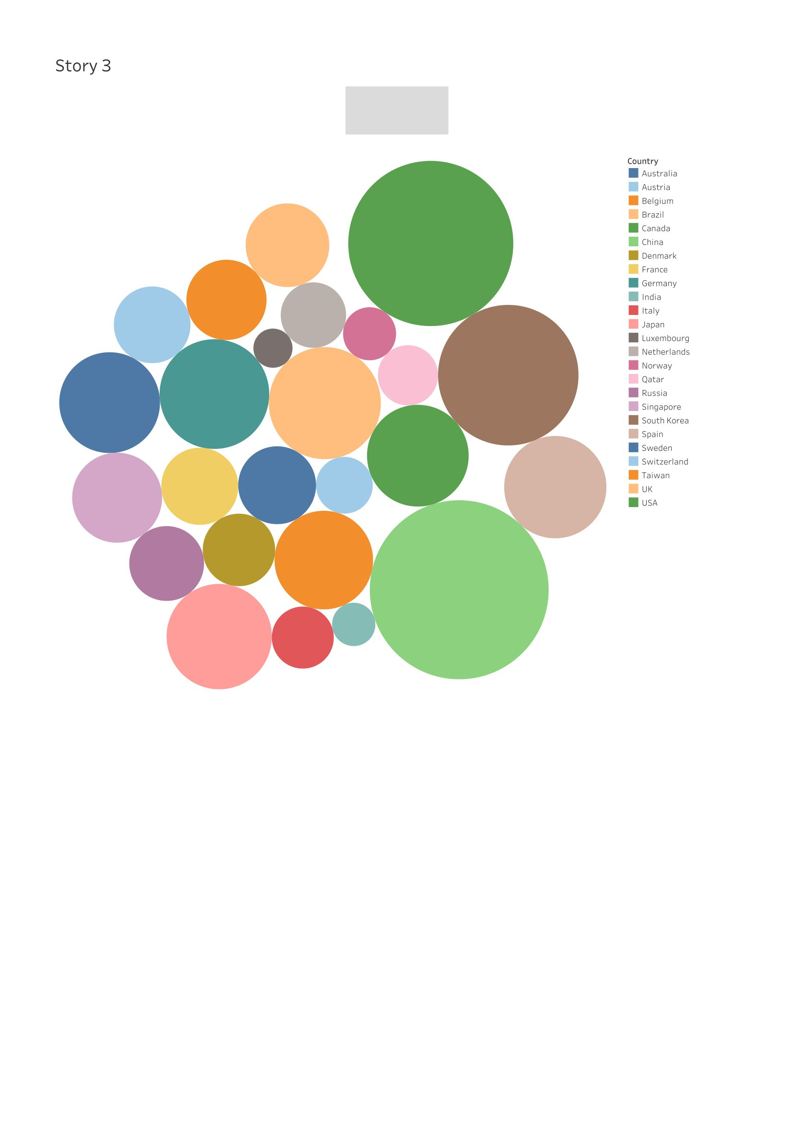

Data analysis of balance sheet with total assets



Data analysis of country and rank with total assets

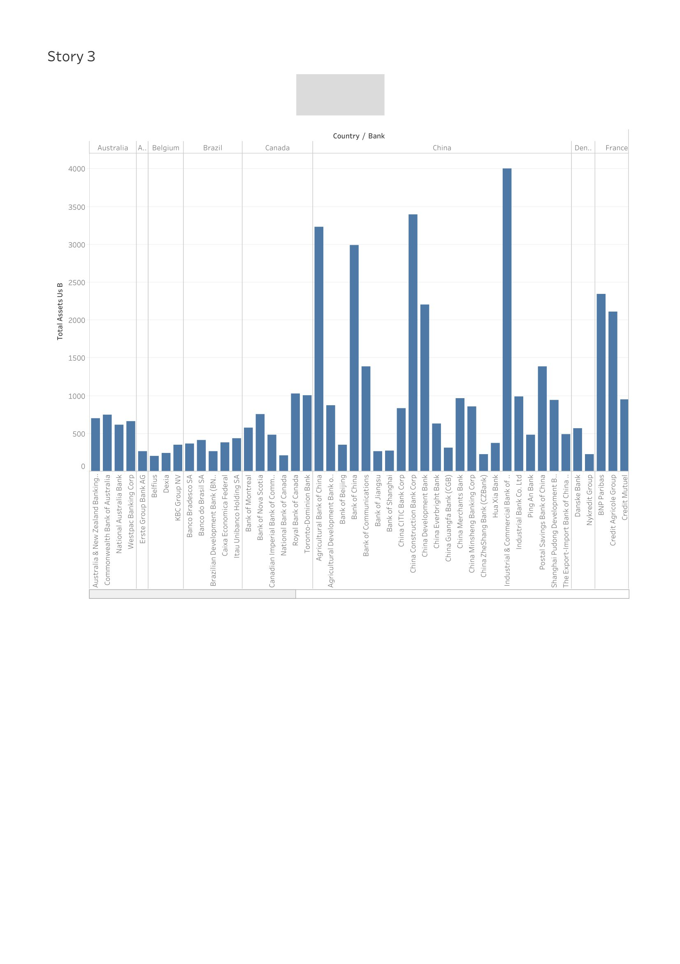

Collection of data from country and balance sheet with total assets

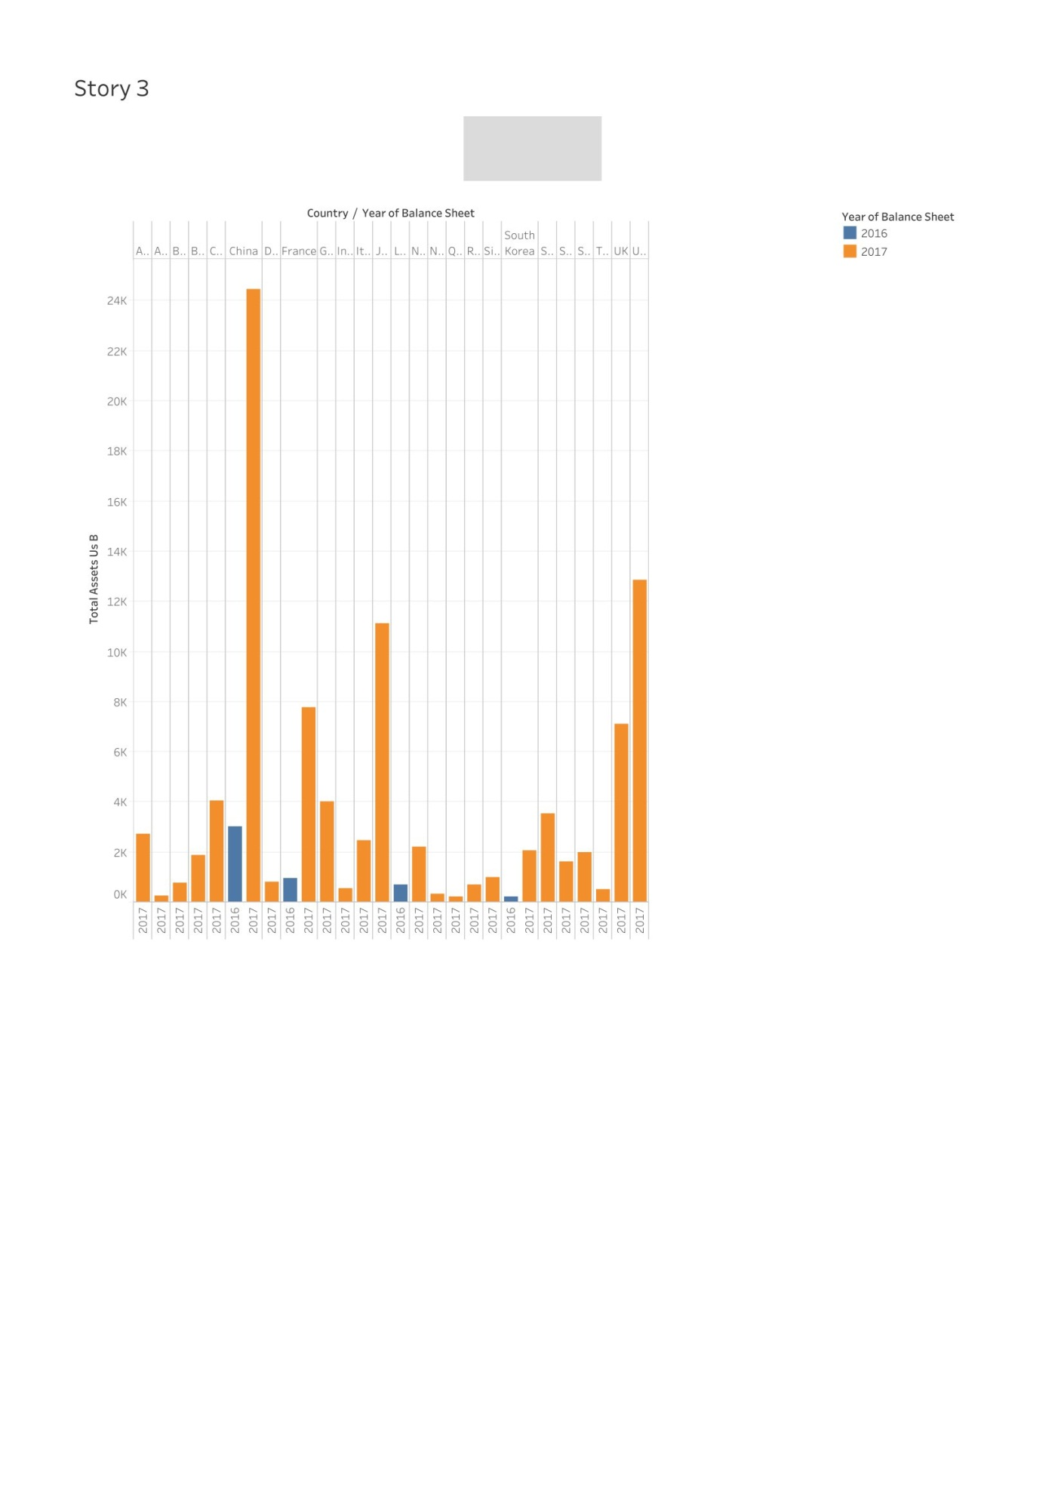

Collection of data from country with rank

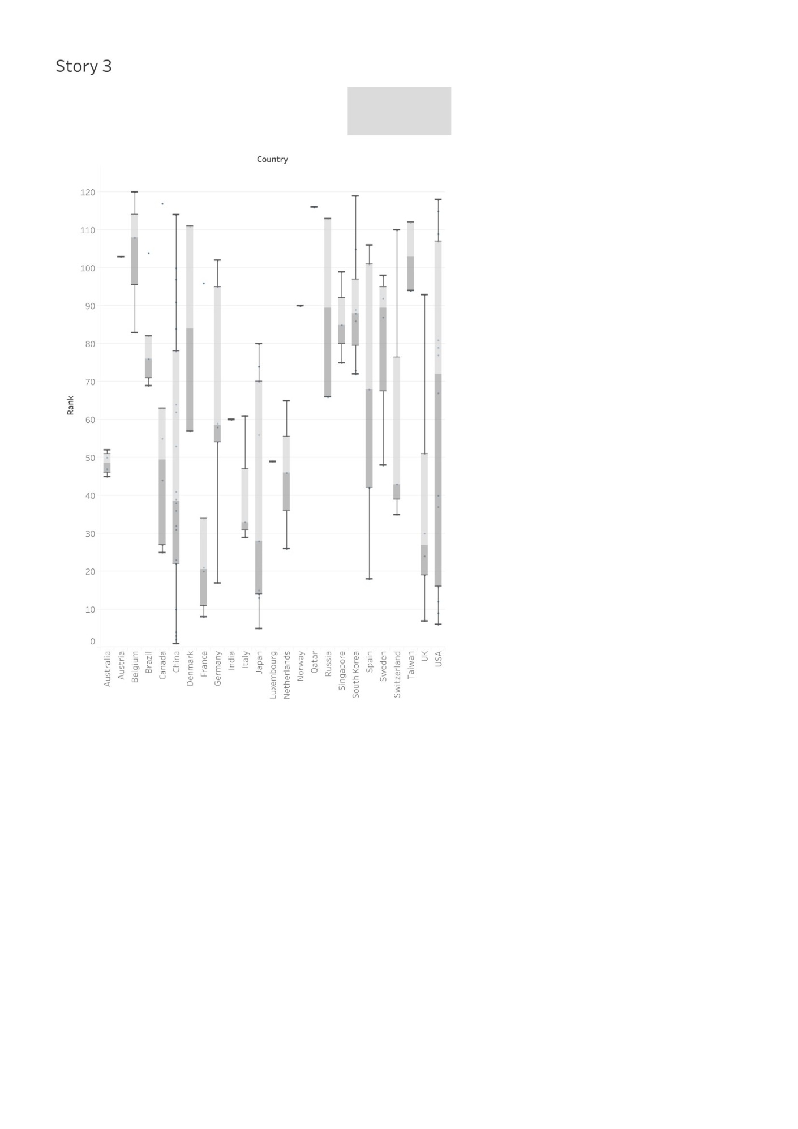

Data analysis of rank and total assets with country and bank

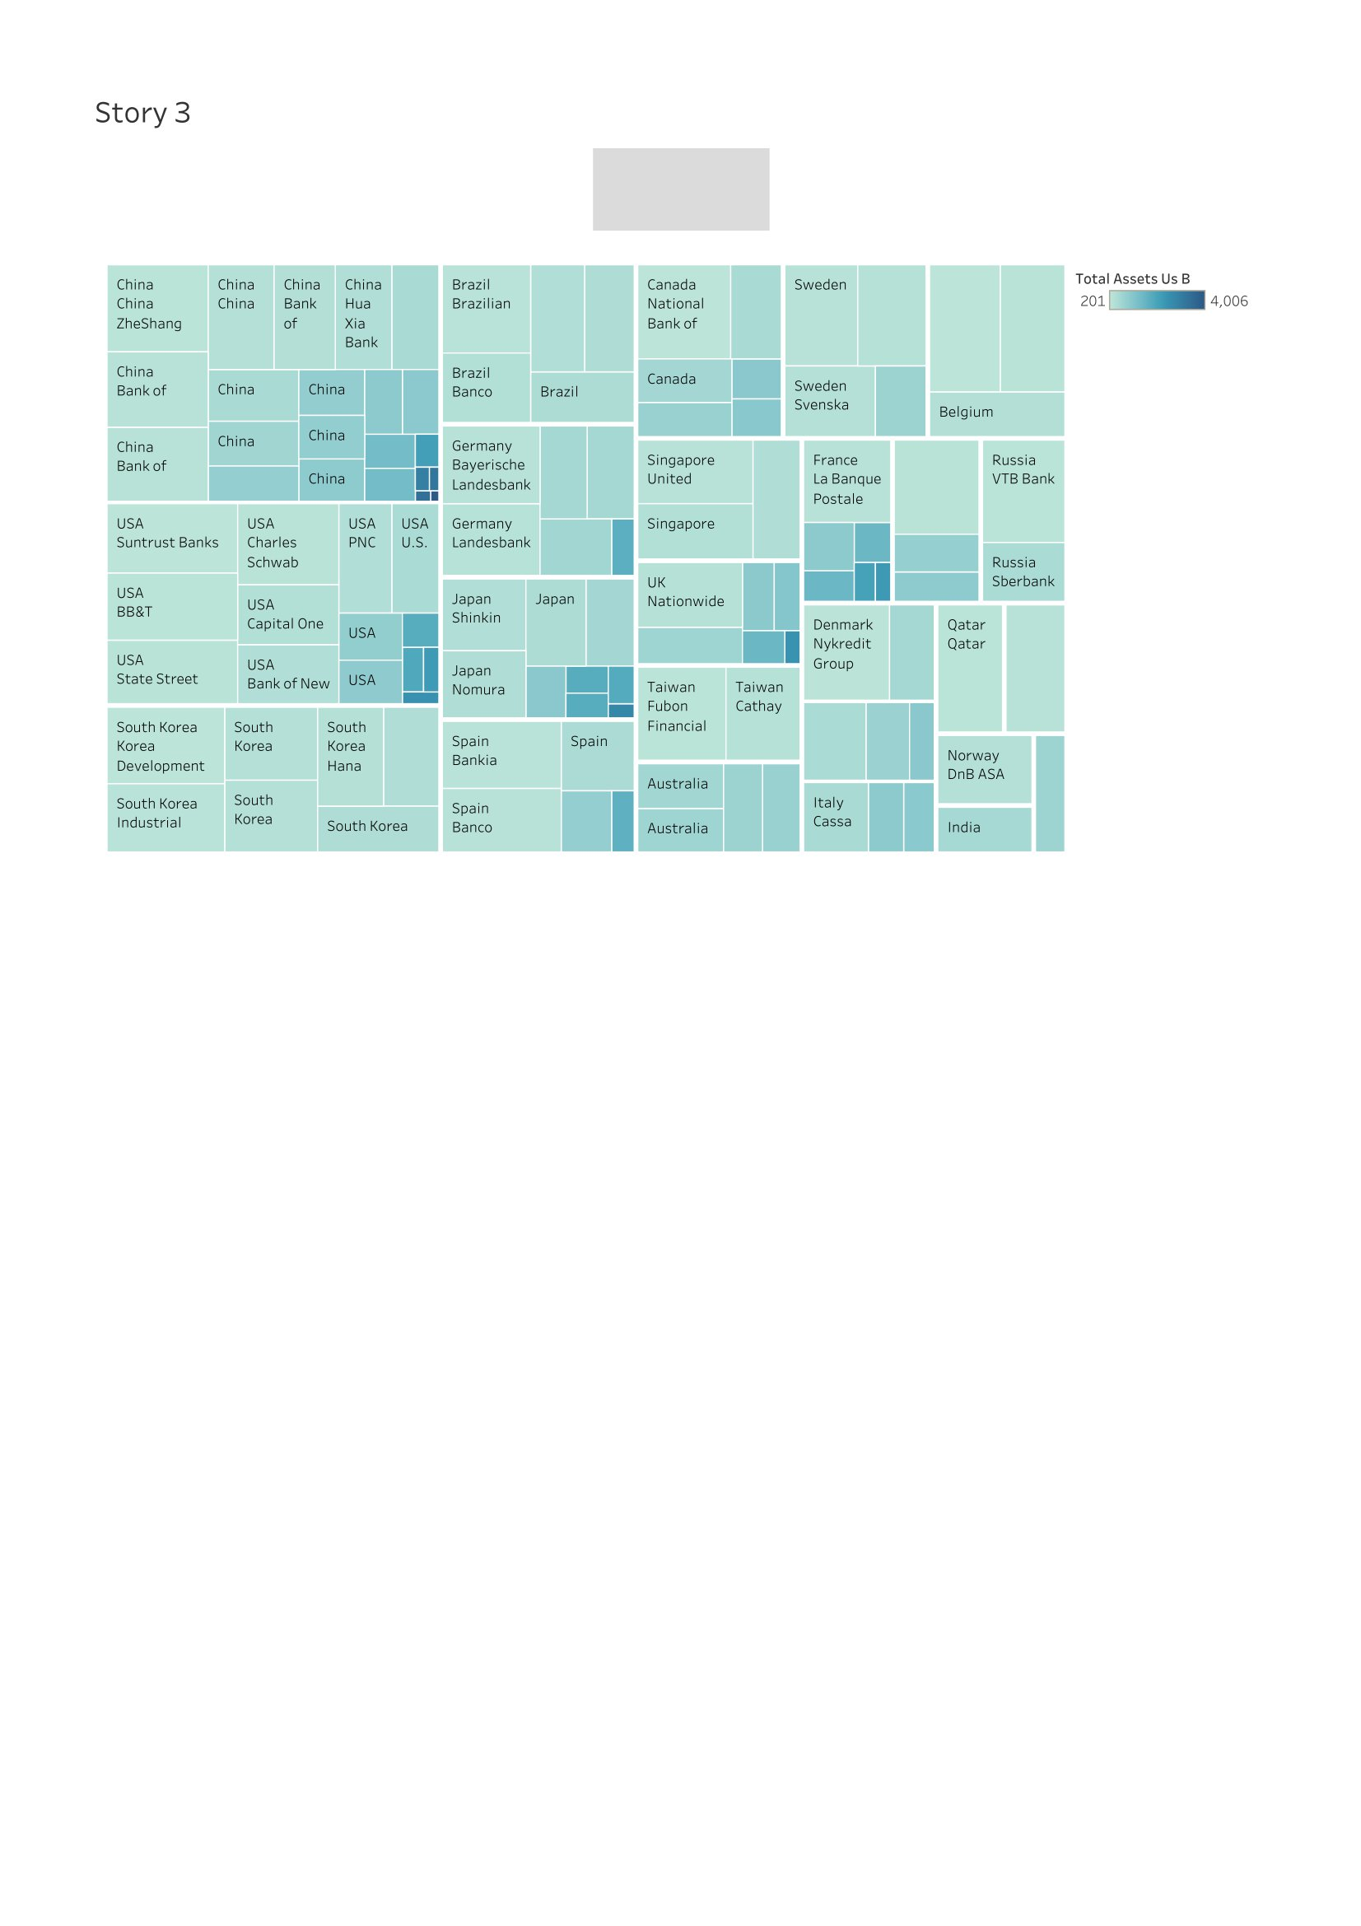

Collection of data from country with rank

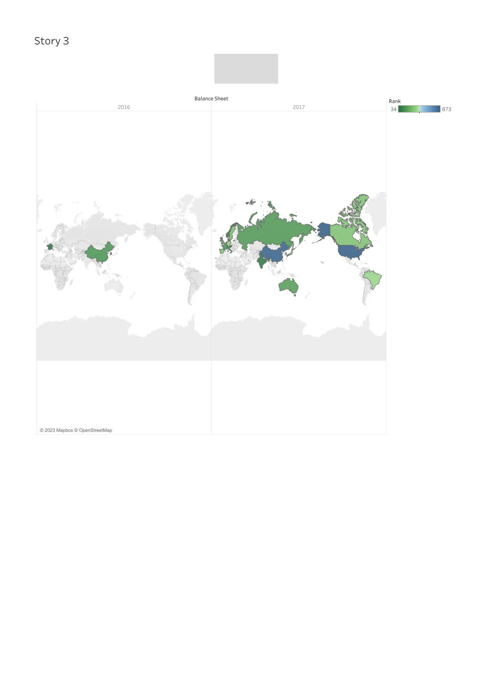

**CONCLUSION**

Comparing all the countries in the global bank ranking, each country has its own ranking, with China at the top and Luxembourg at the bottom.