Custom Bow Design Form

Here you will draw out the design for your bow idea. We do not expect you to be an amazing artist, so no pressure! This will just be used as a guide to help us start the process of designing your bows and to mainly make sure we are on the same page from the start. Please include the following information to make sure we can translate your design into your custom bow. Please incorporate as much detail as possible, even down to the rhinestones!

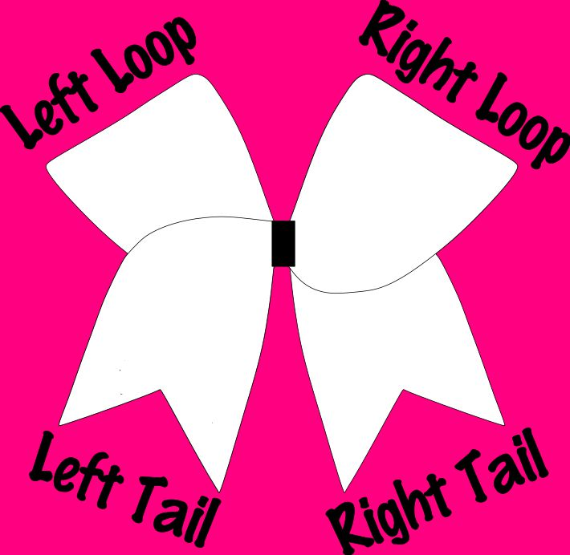

Custom Bow Design Form

Team Name: ________________________________________________

Team Color: _________________________________________________

Does your team have a theme/mascot: _____________________________

Ribbon Color (please see the customization samples page): _______________

Options for the base (circle one): Fabric Glitter Ribbon

Base color of the bow (please see the customization samples page): _________

__________________________________________________________

Rhinestones? YES or NO

STANDARD RHINESTONES or PREMIUM RHINESTONES

Rhinestone Colors & Sizes (please see the customization samples page):

__________________________________________________________

What kind of middle (circle one): Glitter Rhinestones Pop-Out Middle

If Pop-Out Middle, please sketch:

|  |
| --- |
|  |

Please describe your custom bow design:

____________________________________________________________________________________________________________________________________________________________________________________________________________________________________________________________________________________________________________________________________________________________

***Please scan and email both forms to BOWfinityCheerBows@gmail.com***