Table of Contents
Planning 3
Project Execution Plan (Week-by-Week) 3
Roles and Responsibilities 5
Resourcing the Country Team 6
Governance and Review Cadence 7
Infrastructure and Requirements 8
Hardware Specifications and Requirements 8
Software and Platform Requirements 12
Pilot Design 14
Designing the Participant Mix 14
Training 15
Functional Training and Real-Life Scenarios 15
Platform Readiness 16
Platform Readiness --- Functional Capabilities to Verify 16
Sandbox Hardening Before the Pilot 17
Field Operations 18
Online and Offline Registration 18
Registration Center --- Operations and Logistics 19
The Registration Workflow, Step by Step 21
Best Practices for Biometric Capture 23
Authentication and Credentials 25
Authentication with eSignet (OTP and Biometrics) 25
Issuing and Using INJI Wallet 25
Go-Live 26
User Acceptance Testing 26
Pre Go-Live Readiness 26
Go-Live Strategy --- Internal Then External 27
Closure 29
Pilot Closure and Hand-Off 29
References 30
Critical Success Factors and Risks** 30
Appendix A 31
Appendix B 32
Appendix C 33

Planning

Project Execution Plan (Week-by-Week)
The plan below compresses the pilot into approximately 14 weeks. Pre-week 0 activities --- particularly biometric device procurement and infrastructure approvals --- should begin as soon as the pilot is approved.
Window | Theme | Activities
Week 0 | Kick-off, MOSIP introduction and *migration prep | MOSIP introduction; high-level demo of MOSIP, INJI and eSignet; acquire source data and database structure for any legacy migration in scope.
Week 1 | Infrastructure readiness | Begin procurement and shipping of biometric devices; readiness check of on-prem or cloud hardware (compute, storage, networking); *continue acquiring legacy source data.
Weeks 2--3 | ID schema, master data, customisation | Define country ID schema and master data; identify customisation needs; obtain SMS / email gateway details; start customisation; deploy MOSIP onto the country environment; *start data quality analysis for any legacy migration.
Week 4 | Customisation, configuration and platform readiness | Publish data quality analysis; complete customisation; finalise email and SMS configuration.
Weeks 5--6 | Integration and *migration utility | Build the legacy migration utility; integrate biometric components into the country environment; deploy ABIS, SDKs and the manual adjudication system; configure SMS in the platform.
Weeks 7--8 | Pilot system readiness | User acceptance testing; functional training for the country technical staff; biometric functional training.
Weeks 9--10 | Field readiness | Operator and supervisor training; migration training; field pilot preparation; calibration of registration Centers for go-live.
Weeks 11--14 | Pilot go-live | Field execution: legacy migration, new registrations up to 3,000 residents, authentication exercises, INJI Wallet usage, helpdesk operation; pilot closure and report preparation.
This is just an indicative execution plan. The actual execution plan with dates to be prepared based understanding and agreement between the country and MOSIP team.
*For brown-field pilots only; a brown-field pilot re-uses issued National ID from a legacy system by migrating the ID data into MOSIP.

Critical dependencies
- On-prem or cloud infrastructure and the necessary access for installation must be ready before the start of Week 1 or 2.
- Biometric device procurement and shipping typically takes 6 to 8 weeks. The country team supports the customs clearance process.
- The country lead finalises the ID schema and provides the master data inputs.
- SMS and email gateway access is configured ahead of customisation completion in Week 4.
ℹ️ Note
If you only do one thing in week 0 Place the biometric device order and lock the infrastructure environment. Everything downstream depends on these two long-lead items.
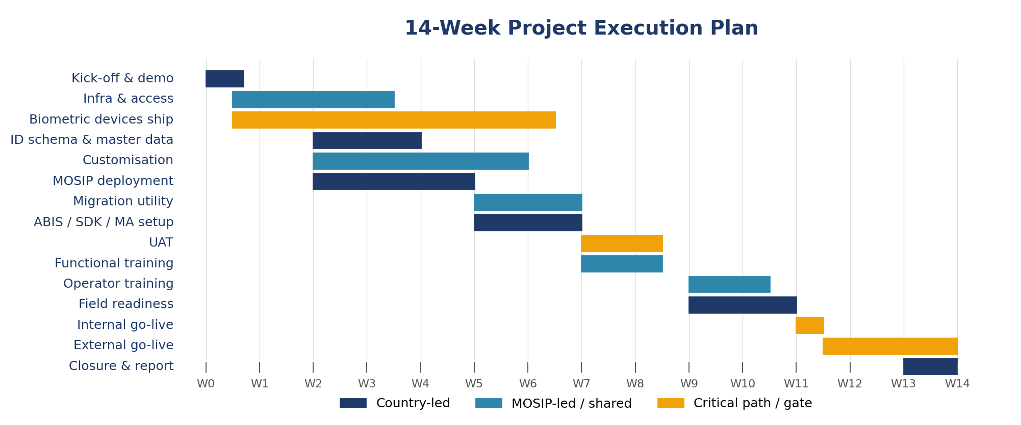
Figure 3 --- Indicative 14-week schedule. Country-led streams (navy), MOSIP-led / shared streams (teal) and critical-path / gate items (orange).

Roles and Responsibilities
Responsibilities are split between the country program and the MOSIP team. The matrix below covers technical resources, setup, rollout, management and procurement.
Category | Activity | Responsibility
Technical resources | Country technical team | Country & field staff
Technical resources | MOSIP pilot deployment team | MOSIP
Technical resources | Government resource for ID schema and master data preparation | Country
Technical resources | Functional training; operator and supervisor training | MOSIP + Country
Technical resources | Field staff for registration | Country
Pilot setup | GitHub private account, Docker account creation and access | Country
Pilot setup | ID schema, master data | Country + MOSIP
Pilot setup | MOSIP deployment in the country environment | MOSIP with Country support
Pilot setup | Customisation | MOSIP
Rollout | Resident pre-registration | Country
Rollout | Resident registration at Centers, ID issuance | Country
Rollout | ID authentication using relying-party portal and INJI | Country
Rollout | Feedback, metrics collection, report generation | Country
Rollout | Pilot closure sign-off | Country + MOSIP
Management | Initial pilot plan | MOSIP
Management | Pilot plan finalisation | Country
Management | Pilot project management | Country + MOSIP
Management | Governance structure | Country + MOSIP
Procurement | On-prem / cloud environment | Country
Procurement | ABIS, biometric SDKs, manual adjudication system | MOSIP
Procurement | SMS / email gateway | Country
Procurement | SSL certificates | Country or MOSIP
Procurement | Biometric devices for registration and authentication (fingerprint slap scanner, dual iris scanner, fingerprint authentication device) | MOSIP
Procurement | Face camera for registration | Country
Procurement | PCs / laptops, printers and scanners | Country

Resourcing the Country Team
The country team is the Center of gravity of the pilot. They run the deployment, register residents, and inherit the system at sign-off --- so resourcing them well is the single biggest predictor of success.
Role | Count | Responsibilities
Project Manager | 1 | Owns the country program. Reports to the steering committee, manages dependencies, and signs off the pilot.
Senior Technical Lead | 1 or more | Functional and technical owner of MOSIP within the country team. First point of contact for field issues. Becomes the in-house MOSIP expert for future scale.
Junior Technical Engineers | 3 or more | Hands-on engineers handling deployment support, configuration, integrations and incident response.
Field Operators | 5 or more | Run the registration kits at the Centers. Identified, trained and certified by the country team.
Field Supervisors | 1 per registration Center | Supervise operators, manage exceptions and run the day-to-day helpdesk.
Adjudicators | 1 or more | Handle manual adjudication for biometric duplicates and quality exceptions.
Communications focal point | 1 | Coordinates resident outreach, appointment scheduling and notification content for SMS and email.
ℹ️ Note
Identify operators and supervisors early Operators and supervisors must be identified by the country team well before the training window. Onboarding is hands-on and assumes participants are available for a continuous training block, not part-time.

Governance and Review Cadence
A lightweight, predictable governance structure keeps decisions moving without burying the technical team in meetings.
Forum | Membership | Cadence
Pilot Governance Committee | Country representatives, MOSIP, key stakeholders. Set up during kick-off. | Pilot kick-off and at major milestones.
Weekly technical review | Country and MOSIP technical Leads | Weekly or as discussed in the kick-off meeting, throughout the pilot
Steering committee | Executive members from the country and MOSIP. | Bi-weekly or at gate decisions.
Pilot readiness review | Members of the Steering Committee, Tech leads from the country and MOSIP | After User Acceptance Testing
Closure meeting | All stakeholders | After registrations are completed; final sign-off.
ℹ️ Note
Always close with lessons learned Block the last 30 minutes of each weekly review for 'what surprised us this week'. The compiled list becomes the lessons-learned annex of the closure report. It also helps in mid-course corrections during the pilot.

Infrastructure and Requirements

Hardware Specifications and Requirements
MOSIP supplies the full hardware specification for the pilot so that the country team can provision exactly what is needed. The list below is the minimum footprint to run the pilot end to end.

Server and infrastructure footprint
The MOSIP pilot can be deployed on a public cloud or on the country's on-prem environment. Either way, the following virtual machine footprint is recommended.
Virtual Machine | vCPU | RAM (GB) | SSD (GB) | Operating System
svr-mosip-01 | 16 | 64 | 128 | Ubuntu 20.04 LTS
svr-mosip-02 | 16 | 64 | 128 | Ubuntu 20.04 LTS
svr-mosip-03 | 16 | 64 | 128 | Ubuntu 20.04 LTS
svr-mosip-04 | 16 | 64 | 128 | Ubuntu 20.04 LTS
svr-mosip-05 | 16 | 64 | 128 | Ubuntu 20.04 LTS
svr-mosip-06 | 16 | 64 | 128 | Ubuntu 20.04 LTS
svr-mosip-07 | 16 | 64 | 128 | Ubuntu 20.04 LTS
srv-iam-01 | 8 | 16 | 64 | Ubuntu 20.04 LTS
srv-abis-01 | 20 | 64 | 256 | As recommended by ABIS vendor
srv-nginx-01 | 4 | 16 | 64 | Ubuntu 20.04 LTS
srv-nginx-02 | 4 | 16 | 64 | Ubuntu 20.04 LTS
srv-postgres | 16 | 32 | 256 | Ubuntu 20.04 LTS
srv-minio | 16 | 32 | 256 | Ubuntu 20.04 LTS
srv-bastion | 4 | 16 | 64 | Ubuntu 20.04 LTS

Aggregate footprint
- Total RAM: ~600 GB
- Total SSD storage: ~2 TB
- vCPU sizing on physical servers can be calculated as (threads × cores) × processors per host. As a reference, an Intel Xeon E-2288G with 8 cores / 16 threads on one socket exposes 128 vCPUs.
ℹ️ Note
Cloud or on-prem? If the country plans to run the future production system on-prem, exercise the on-prem footprint here so that operations, networking and security teams rehearse the real run-book. If the production target is cloud, run the pilot on the same cloud provider.

Registration kit -- laptop specification
Specification | Recommended value
Processor | Multi-core, latest generation (e.g., Intel 12th-gen Core i7, 1.7 GHz up to 4.7 GHz, 12 MB L3 cache)
RAM | 16 GB minimum
Operating System | Windows 10 or 11, 64-bit
Storage | 512 GB SSD
Display | 14 inches or larger, full HD
Networking | Ethernet RJ45 and Wi-Fi (IEEE 802.11 b/g/n)
Ports | 2 × USB 3.0 (1.5 A each), 1 × USB 2.0 (≥1 A), HDMI for external monitor; include a powered USB hub with 4 × USB 3.0 ports
Security chip | TPM 2.0 or higher
Antivirus | Enterprise-grade antivirus pre-installed and patched
Citizen-facing monitor: 18 to 22 inch external display per kit.

Biometric devices and authentication devices
Device | Source | Quantity
Fingerprint slap scanner (Registration) | Provided by MOSIP biometric partner ecosystem. Shipped to the country. | 1 per registration kit
Dual iris scanner (Registration) | Provided by MOSIP biometric partner ecosystem. | 1 per registration kit
Face camera (Registration) | Country-provided. Must meet MOSIP photo capture guidance. | 1 per registration kit
Single fingerprint device (Authentication) | Provided by MOSIP biometric partner ecosystem. | Approximately 5-10 across the pilot
ℹ️ Note
Plan for shipping lead time Procurement and international shipping of biometric devices typically takes 6 to 8 weeks. Start this on day one. The country team should pre-clear the customs process to avoid delays.

Document scanners, printers and photo booths

Printer with scanner (per registration station)
Specification | Value
Type | Color
Print resolution | 600 dpi
Scan resolution | 300 dpi
Paper size | A4
Connectivity | USB 2.0+ or wireless
OS support | Windows 10/11
Driver support | TWAIN / WIA compatible
Quantity | Approximately 4 units across the pilot (scale with number of Centers)
These are regular printers available off the shelf such as HP, Epson, Canon etc.

Photo booth (per registration station)
Specification | Value
Backdrop | 3 ft (W) × 4 ft (H), white, with stand and wall mount
Lighting | 2 × 30 W clear white lights (or LED equivalent), with stands and operator-controlled long cabling
Quantity | Approximately 4 stations across the pilot

Mobile phones for INJI Wallet
Residents and operators need a small fleet of phones to exercise INJI Wallet on both ecosystems. Country team typically provisions:
- Approximately 10 Android phones (Android 12 and above).
- Approximately 10 iPhones (iPhone 12 or above)

Helpdesk, administration and adjudication terminals
Terminal | Purpose / configuration | Source
Manual adjudication terminal | 1 Windows laptop or desktop (minimal configuration) to handle exceptions and deduplication adjudications. | Country-provided
Mock health portal terminal | A few Windows laptops or desktops (minimal configuration) for the mock relying-party portal used to demonstrate authentication. | Country-provided
Helpdesk / supervisor terminal | 1 Windows laptop or desktop per registration Center to handle citizen queries. | Country-provided
Administration console terminal | 1 Windows desktop or laptop with privileged access for the country admin to manage configuration, users and master data. | Country-provided

Software and Platform Requirements
MOSIP supplies the platform and integrates the third-party components. The country team is responsible for the operating environment, gateways and identity-related accounts.
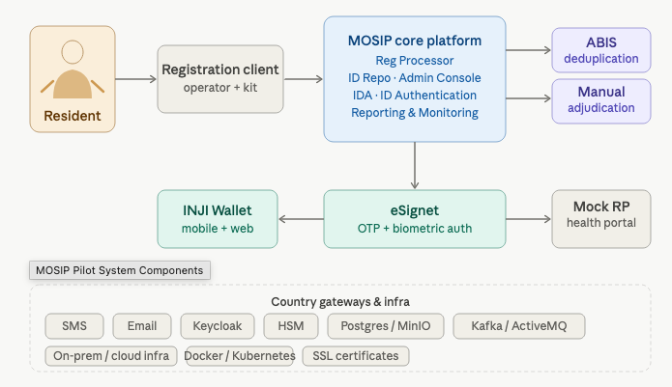
Figure 2 --- Pilot system components and how the resident, registration client, MOSIP core, ABIS, eSignet, INJI Wallet and the mock relying party portal connect.
Component | Purpose | Owner
Operating system and VMs | A secure on-prem or cloud sandbox onto which MOSIP will be deployed. | Country
Databases and object store | Provisioned and managed as part of the MOSIP deployment. | MOSIP
Hardware Security Module (HSM) | Stores cryptographic keys used for encryption and decryption. A software HSM is used for the pilot. | MOSIP
Biometric SDKs and ABIS | Used for biometric quality check, authentication and deduplication. Provided through the MOSIP biometric partner ecosystem. | MOSIP
SMS and email gateway | Required to send notifications to residents' phones and email addresses. | Country
Mock relying-party portal (health) | Bundled with eSignet; used to demonstrate authentication and service delivery. | MOSIP
INJI Wallet (mobile and web) | Bundled in the pilot deployment for residents to download and present credentials. | MOSIP
GitHub and Docker accounts | Private accounts that the country team uses to access source code, container images and configuration repositories. | Country
SSL certificates | Provisioned for the MOSIP pilot environment. | MOSIP

Pilot Design

Designing the Participant Mix
The point of the pilot is to feel what MOSIP behaves like for real residents, not for an idealised, average user. Aim for a participant pool that mirrors the country's population mix, with deliberate inclusion of harder edge cases.

Recommended demographic distribution
The following distribution is recommended as a starting point. The country team owns the final mix and can adjust to reflect the local population profile and the coverage they want to validate during the pilot.
Group | Why include them | Suggested share
Adult males | Reference registration path; surfaces the most common workflow. | ≈ 50% of adult registrations
Adult females | Validates the same reference path with diverse face capture conditions. | ≈ 25% of adult registrations
Elderly residents (60+) | Lower fingerprint quality is common; iris and face fall-back paths are exercised; OTP-based authentication is deliberately tested. | ≈ 25% of adult registrations
Children below 5 years | Biometric thresholds differ; guardian linkages and consent flows are tested. | ≈ 5% of total population
Adults with biometric exceptions | Residents who cannot present fingerprints, iris or both. Exception biometric flow, missing-biometric reason capture and supervisor approval are exercised. | ≈ 5% of total population
Minors (6--17 years) | Fingerprint and iris capture works but operators must handle consent and guardian linkage flows. | Country to decide
Persons with disabilities | Includes residents in wheelchairs, with limited mobility, or low vision. Validates Center accessibility and operator scripts. | Country to decide
ℹ️ Note
Consent and ethics Residents participating in the pilot must give informed consent. Make sure the consent form makes clear that this is a pilot, what data is collected, how long it is retained and whether the credential will continue to work after pilot closure.

Training

Functional Training and Real-Life Scenarios
Training is the heart of the pilot. The country team is functionally trained through hands-on sessions, and they go through real-life examples during the pilot and how to deal with them.

Training streams
Stream | Topics | Audience
Technical training | Architecture, deployment, configuration, monitoring and incident response. | Country technical team
Functional training | Pre-registration, registration packet flow, ID processing, ID issuance, Lost ID issuance, ID update, eSignet, INJI Wallet, admin console. | Program managers and tech leads
Operator and supervisor training | End-to-end registration on the kit, exception handling, daily run-sheet, device hygiene. | Field operators and supervisors
Adjudicator training | Manual adjudication console, decision rationale, escalation paths. | Adjudicators
Helpdesk training | Stuck packets, lost credentials, biometric exceptions, complaint logging. | Backoffice and Helpdesk staff

Real-life scenarios to walk through
- A senior citizen with worn fingerprints --- fall back to iris, then to OTP authentication.
- An infant accompanied by a guardian --- biometrics deferred, guardian linkage captured, consent recorded.
- A resident with no fingers --- exception biometric flow, missing-biometric reasons captured, supervisor approval.
- A resident in a wheelchair --- accessibility set-up at the Center, photo booth at seated height, operator script.
- A resident living in a low/no-connectivity area --- offline registration, packet sync the next morning, status check.
- A duplicate detection at ABIS --- manual adjudicator reviews the case and decides whether to confirm or reject the duplicate.
- A lost or damaged ID --- physical re-issuance at the registration center and re-download into a new INJI Wallet device.
- An impersonation attempt at the relying-party portal --- biometric authentication fails and the helpdesk logs the incident.
ℹ️ Note
Make training stick Pair every classroom session with a live registration of a real participant (operator, supervisor or technical team member volunteering). Theory alone never produces confident operators.

Platform Readiness

Platform Readiness --- Functional Capabilities to Verify
Before the country team puts a real resident in front of the registration kit, the platform must be exercised end to end on every functional capability the pilot will use. Ownership of this verification is shared between the country team and the MOSIP team. The objective is not to test exhaustively --- that is UAT --- but to be certain that every flow the pilot will hit has been seen working at least once.

Pre-registration and registration flows
- Operator onboarding and login.
- Pre-registration of residents (online appointment booking and demographic capture).
- New adult registration, end to end.
- New child registration, including guardian linkage.
- Update flows for adults and children --- both demographic data update and biometric update.
- Biometric correction for an in-flight registration.

ID processing and issuance
- Demographic and biometric deduplication via ABIS.
- Biometric manual adjudication for ABIS-flagged matches.
- Biometric exception handling and capture.
- Unique Identification Number (or UIN) generation.
- ID card printing as PDF, ready for the dedicated print station.
- ID card delivery to the resident's email.
- Lost ID re-issuance flow.

Authentication and notifications
- Biometric authentication via fingerprint through eSignet.
- OTP authentication through eSignet.
- Notifications to residents over email.
- Notifications to residents over SMS.
- Notifications to residents over WhatsApp (where supported in country).

Reporting and administration
- Registration dashboard --- daily volumes, success rates, exception rates.
- Pre-registration dashboard --- appointments booked vs. consumed.
- Consolidated dashboard for the steering committee.
- Authentication dashboard --- OTP and biometric success and failure trends.
- Admin console with packet upload status and queue health.
ℹ️ Note
Sign off as you go Treat each capability above as a small gate. The country technical lead and the MOSIP deployment lead jointly tick it off the readiness register. No capability is allowed to be 'probably working' on go-live day.
| Pre-registration inside registration center | | | | It may be pertinent, but not mandatory, to have a pre-registration | | kiosk where a resident perform per-registration by providing the | | demographic details, upload documents and get registration ID issued | | prior to actual registration. This can reduce the time to register a | | resident by capturing only biometrics and verifying the documents | | uploaded. |

Sandbox Hardening Before the Pilot
The pilot environment is built up incrementally during demos, training and UAT. By the time real residents arrive, that same environment is full of test packets, stale messages, demo accounts and broad access. Before go-live the MOSIP team with country support performs a structured hardening pass so that the pilot runs on a clean, narrowly-scoped platform.

Cleaning the runtime
- Clear the Kafka cache so no test events are reprocessed during the pilot.
- Clear residual packets from the landing zone inside the platform pods.
- Clear ActiveMQ queues to avoid replaying dummy notifications.

Tightening access
- Audit Wireguard (or equivalent VPN) access --- every client machine should be deliberately authorized, not inherited from a demo phase.
- Remove Wireguard access from people who no longer need it.
- Audit Keycloak users; remove demo accounts and any user no longer participating in the pilot.
- Reduce admin role membership in Keycloak to one or two named individuals; everyone else is moved to a least-privilege role.
- Capture and file the revocation list --- it becomes part of the pilot audit trail.
ℹ️ Note
Treat hardening as a gate Hardening is a prerequisite for the internal go-live. If it has not been completed and signed off, the pilot does not start.

Field Operations

Online and Offline Registration
MOSIP supports registration in both connected (online) and disconnected (offline) modes. The pilot exercises both so the country team understands the trade-offs before national rollout.

Online registration
- The Registration Client communicates with the central MOSIP environment in real time over the country network or VPN.
- Residents may pre-register online (basic demographics and an appointment slot) and complete biometric capture at the Center.
- Used at Centers that have reliable, high-speed internet for the duration of the registration window.

Offline registration
- The Registration Client captures demographics and biometrics locally; packets are synced to the central system once connectivity returns.
- Used at Centers with intermittent or no internet, or as a fall-back when the online path is degraded.
- Operators must understand sync windows, packet status and the helpdesk steps for stuck packets.
ℹ️ Note
Exercise both modes deliberately Schedule at least one full day of offline registration at one Center, even if connectivity is good. The point is to build muscle memory for the offline run-book before scale-up exposes the country to it for real.

Registration Center --- Operations and Logistics
A registration Center is more than a room with laptops. It is a small operations environment that has to receive residents, route them through a queue, capture their data accurately, manage exceptions and end the visit with a printed credential. The components below should be in place at every Center, scaled to the expected daily throughput.
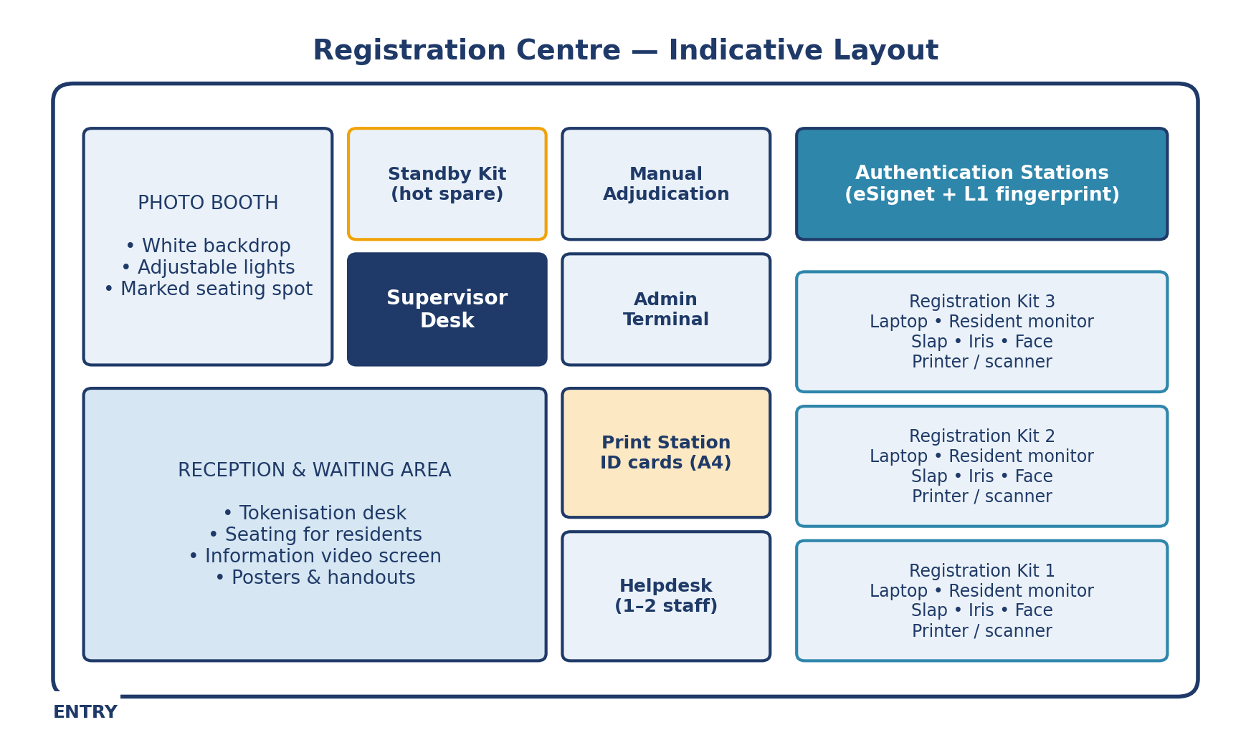
Figure 6 --- Indicative top-down layout of a registration Center. Adjust to the building you actually have, but keep the flow: entry → reception → registration → print → exit.

What a registration Center comprises
- One or more registration stations --- typically three registration kits --- with one extra laptop available as a hot standby.
- Biometric devices and printer/scanner attached to each registration workstation.
- A trained registration operator, and a registration supervisor, present at all times.
- A dedicated print station for ID cards, with its own color printer (not shared with the registration stations).
- Sufficient seating in a waiting area for residents and their accompanying family members.
- A tokenisation mechanism for batching walk-in residents into registration slots.
- Handouts that explain the flow of activities so residents know what to expect.
- Posters at the entrance about what may and may not be carried into the Center.
- Pre-printed consent forms for residents to fill in and sign.
- Power backup sized to keep all kits running through any expected outage window.
- Security measures appropriate to the location, agreed with the country authority.
- A large screen in the reception area playing a short video that explains the registration process while residents wait.
- A helpdesk with one or two dedicated staff members to answer queries.
- Staff identification through a uniform or badge, so residents always know who to ask.

Registration staff per Center
Role | Coverage
Registration operator | One trained operator per registration workstation.
Standby registration operator | At least one extra operator on shift to absorb absences and breaks.
Supervisor | One trained supervisor present whenever the Center is open.
Standby supervisor | One additional supervisor available, particularly for the first weeks of go-live.
Helpdesk officer | One or two officers --- first line for resident queries; escalates to the supervisor.
Print-station operator | One operator dedicated to ID card printing and handover.

Documentation
A printed copy of the Registration Client Operations handbook is distributed to every operator and supervisor.

Per-kit configuration
Each registration kit must be prepared and locked down before the Center opens. The supervisor walks the kit checklist with the operator at the start of each day.

Workstation
- Laptop matches the specification in Section 5.2.
- Latest Windows updates applied; Windows Update is then disabled until pilot closure to avoid mid-day reboots.
- Antivirus or Windows Defender installed and current; verified not to conflict with the Registration Client.
- Unrelated applications removed so the kit boots clean.
- External monitor for the resident is connected and tested.

Biometric devices
- Fingerprint slap scanner connected and recognized by the kit.
- Iris scanner connected and recognized.
- Face camera connected, framed correctly with the photo booth.
- If devices are connected through a USB hub, the hub is a powered hub.
- Each device is registered with its vendor and the registration is not scheduled to expire during the pilot window.

SBI software
- SBI L0 (registration) software installed and running on each registration workstation; device drivers installed.
- Devices verified to work end to end from the Registration Client.
- SBI L1 (authentication) software installed and running on the workstations dedicated to authentication, with the corresponding drivers in place.

Printer and scanner
- Each workstation has its own printer/scanner, never shared.
- Print and scan are tested with sample output before opening to residents.
- A4 paper stocked, with backup paper readily available.
- Toner or ink stock checked; a spare cartridge is on site.

Photo booth
- White background --- a stand with white cloth, or a clean white standee.
- Adjustable focus light, angled to remove shadows from the face.
- The seating position is marked and aligned with the camera so the framing is consistent across operators.
- Standby laptop is fully provisioned and ready to take over from any kit that fails during the day.

Operator tooling
- Each operator is given a notepad to record the Registration ID (RID), resident name and phone number --- a manual back-pocket reference if a resident has to be called back.

Print station for ID cards
- A dedicated desk away from the registration queue.
- A laptop or desktop with adequate configuration for PDF rendering.
- A color printer connected to the workstation, exclusively for ID card printing on A4 sheets.
ℹ️ Note
One printer per kit Plan one printer/scanner per registration workstation, plus one separate, exclusive printer for ID cards.

The Registration Workflow, Step by Step
Operators do not invent the flow on the spot, they follow a consistent script. The steps below are the country-agnostic recipe for one resident moving through one registration station, from greeting to acknowledgment.

Greeting and consent
- Receive the resident at the kit; explain the process briefly in their preferred language.
- Confirm that the consent form has been filled in and signed (per country policy).
- Verify the proof of identity documents and confirm that the demographic data on the evidence matches what will be entered.

Demographic and document capture
- Capture demographics into the agreed schema; read each entry back to the resident for confirmation.
- Scan the supporting documents; check on screen that the scanned image is legible before saving.

Biometric capture
- Capture fingerprints, iris and face following the best-practice guidelines in Section 19.
- Watch the on-screen biometrics and quality scores; repeat captures whose score is below the configured threshold.
- Where a biometric exception applies, mark the missing-biometric and call the supervisor for a second pair of eyes.
- Ask the resident whether they are satisfied with the captures before moving on.

Preview, submit and acknowledge
- Walk the resident through the preview page; ask them to look for any errors in spelling, dates or contact information.
- Submit the registration packet. In offline mode, queue the packet for sync and note the packet ID on the manual log.
- Print the acknowledgment slip and hand it to the resident.
- Explain what is on the acknowledgment slip and the importance of keeping it; ask the resident to note down the registration ID.
- If the resident has a smartphone, suggest taking a photo of the slip as a back-up.

Closing the visit
- Make a manual entry in the operator notebook --- RID, name, phone --- for fall-back reference.
- Tell the resident what happens next and when to return to collect the physical ID card.
- Explain the notifications they will receive over SMS, email or WhatsApp.
- If the resident later receives a failed-registration notification, ask them to come back to the Center immediately.
- Inform the supervisor that the registration is complete; invite the next person in the queue.

Supervisor responsibilities during the day
- Review every registration packet before approval.
- Run random spot-checks at registration desks to confirm operators are following the script.
- Compare successful registrations against total registrations attempted at end of day.
- Collect operator feedback on the difficulties they faced and address them before the next day.
- Upload registration data at regular intervals --- typically twice a day --- so back-end processing has time to keep up.
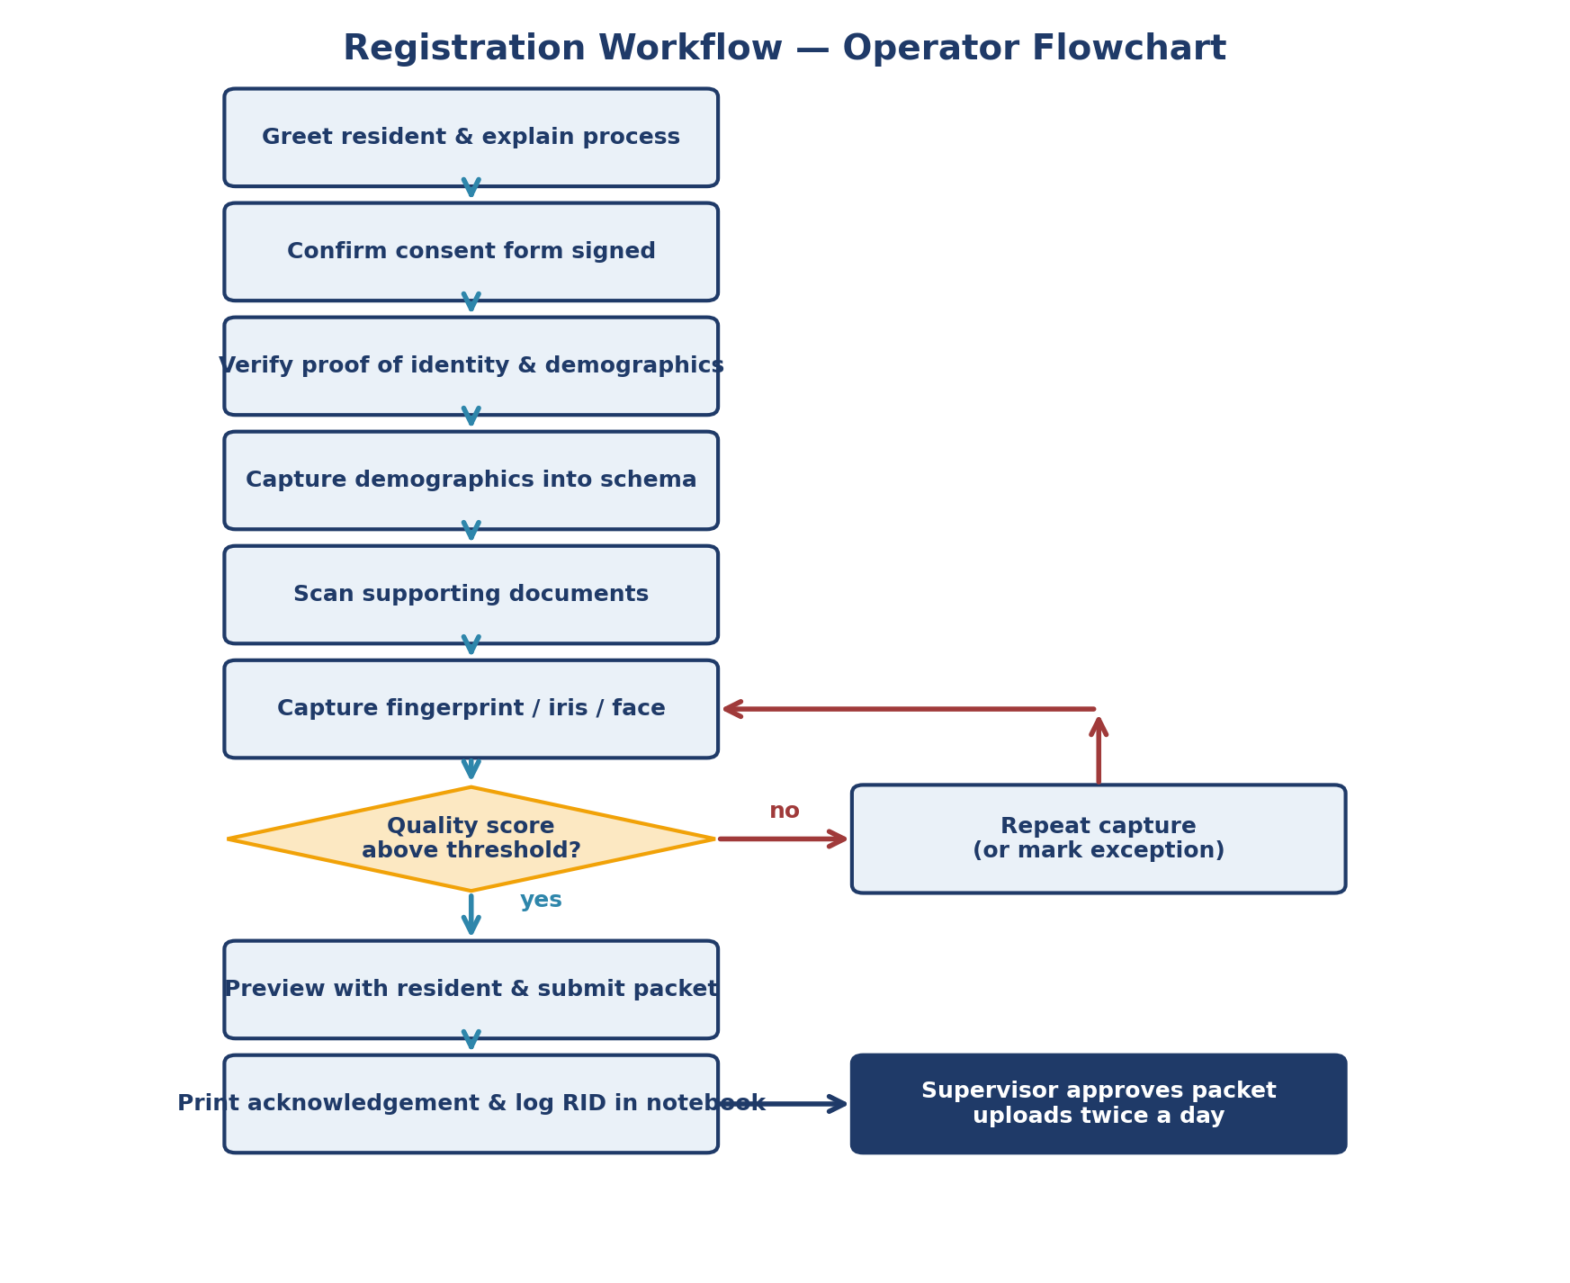
Figure 7 --- The operator workflow as a flowchart. Captures that miss the quality threshold loop back; everything else flows through to supervisor approval.
ℹ️ Note
One thing every operator should remember If anything feels off during a capture --- quality score, fingerprint placement, face framing --- stop and redo it. A few extra seconds at the kit saves an hour in adjudication later.

Best Practices for Biometric Capture
Biometric quality is the single largest determinant of authentication success later in the resident's life with the credential. The minute spent doing it well at the registration kit pays off across every future authentication, every issuance and every adjudication. The practices below should be drilled into every operator during training and reinforced by supervisors on the floor.

General hygiene
- Clean the biometric device before every capture.
- Show the resident how to position their fingers, hands or eyes; do not assume they know.
- Help the resident press gently --- not hard --- against the slap scanner.
- Do not assume the first capture is good. Take multiple attempts and keep the best.
- Watch the on-screen biometric score for every capture. Aim above 40 and redo anything below threshold.
- Watch the on-screen biometrics that shows up at the time of capture and after the capture is complete to assess the quality of biometrics captures
- Watch out for smudged fingerprints, light fingerprints, half closed or 3/4th open eyes etc

Fingerprint capture
- Ask the resident to press the fingers gently and evenly on the scanner.
- Re-calibrate the slap scanner per vendor guidance --- typically every ~10 captures --- and clean the surface before each calibration.
- If a finger is damaged, note the exception clearly and capture the remaining fingers.

Iris capture
- Confirm the iris scanner is held the right way up --- operators sometimes hand a binocular device to the resident upside down and it may not be caught as an issue on the registration client.
- Ask the resident to open their eyes wide and not to blink during capture.

Face capture
- Look straight into the camera, not at the screen.
- Do not smile.
- Do not cover the face with a mask.
- Do not slant or tilt the head.
- Do not blink during capture.
- Do not wear a cap or any head covering not required for religious or medical reasons.
- No one should stand directly behind the resident while the photo is taken.
- Lighting on the face should be even, with no harsh shadows.
- The result should be ICAO-compliant photo quality --- train operators against ICAO references during training.

Capturing exceptions
- When recording a biometric exception, show the resident which biometric type is being marked as an exception, in their language.
- When capturing an exception photo (for a missing biometric), make sure the physical reason is visibly captured in the image.
- Get a supervisor to co-sign exception captures so the audit trail is clean.
ℹ️ Note
Quality over throughput It is always better to spend an extra two minutes at the kit than to send a low-quality packet downstream. Low-quality biometrics translate directly into ABIS false positives, manual adjudication backlogs and authentication failures after issuance.
ℹ️ Note
Display aample good and bad biometrics posters MOSIP team can generate synthetic biometrics (good, bad ugly) that can be printed and displayed in the registration center at a prominent place.

Authentication and Credentials

Authentication with eSignet (OTP and Biometrics)
eSignet is the authentication front door for residents. The pilot uses a mock relying-party (RP) portal --- typically a sample health portal bundled with eSignet to demonstrate authentication flows end to end.

OTP authentication
- Resident enters their ID at the mock RP portal.
- eSignet sends a one-time password to the resident's registered mobile or email.
- Resident enters the OTP and is authenticated.
- Resident gives consent by allowed a set of attributes (claims) to the RP.
- RP receives an authentication assertion and grants access to the demo service.

Biometric authentication
- Resident enters their ID at the mock RP portal.
- Operator captures a single fingerprint (or iris) on the authentication device.
- eSignet matches the live capture against the stored biometric template.
- Resident gives consent by allowed a set of attributes (claims) to the RP.
- RP receives an authentication assertion and grants access to the demo service.
ℹ️ Note
Real-life scenarios to rehearse Run at least one OTP-only flow (resident has no fingerprint), one | | biometric flow, one fingerprint failure that falls back to OTP, and | | one deliberate impersonation attempt that should fail. These are the | | cases the country team will see at scale. |

Issuing and Using INJI Wallet
INJI Wallet is the resident-side companion to MOSIP. It allows the resident to download a verifiable credential of their ID and present it back to relying parties without having to repeat the registration process. The pilot exercises both INJI Wallet (mobile) and INJI Web.

Method
- Resident installs INJI Wallet on Android or iPhone (or opens INJI Web).
- Resident authenticates to the country MOSIP environment using their ID and an OTP via eSignet.
- MOSIP issues a verifiable credential into the wallet.
- Resident presents the credential to the mock health portal; the portal verifies the credential cryptographically and grants the demo service.

Edge cases worth rehearsing
- Resident loses the phone and re-issues the credential on a new device.
- Resident has no smartphone --- INJI Web is used from a shared kiosk.
- Credential is revoked centrally and the wallet refuses presentation at the Relying Party.

Go-Live

User Acceptance Testing
User Acceptance Testing is the country team's formal sign-off that the platform is ready for the field. It is led by the country team, supported by MOSIP, and runs in the dedicated UAT window before training and go-live.

Exit criteria
- Every planned test scenario has been executed.
- All tests have either passed or have a documented, accepted fix/workaround.
- No major issues remain open. Issues categorized as major must be resolved before exit; minor issues can be carried forward with explicit acknowledgment.
- The country team has given a successful demo back to the MOSIP team showing they can run the platform, not just operate it.

Test scenarios to cover
- All flows listed in Section 15 (Platform Readiness).
- Real-life scenarios from Section 14 --- senior citizen with worn fingerprints, infant with guardian, resident with no fingers, resident in a wheelchair, low-connectivity Center, ABIS duplicate, lost ID, impersonation attempt.
- End-to-end happy path: pre-register → register → ABIS → UIN → ID print → notification → eSignet auth → INJI Wallet credential download.
ℹ️ Note
Demo back, don't just watch The country team gives the demo at UAT exit. If they cannot drive the platform without MOSIP at the wheel, UAT is not done.

Pre Go-Live Readiness
In the one to two weeks before residents start arriving, the program runs a structured readiness sweep. The objective is to make sure that every moving part --- platform, Center, communications, logistics, safety is in place and visible to the country leadership.

Platform and end-to-end sanity
- End-to-end sanity test successful from a fresh kit through to credential in INJI Wallet.
- Platform readiness checklist (Section 15) fully ticked.
- Sandbox hardening (Section 16) completed and signed off.

Communications and public relations
- Notifications sent to residents about appointment slots, what to bring and what to expect.
- Notifications sent to internal support teams with on-call rosters.
- Notifications sent to vendors (biometric devices, ABIS, SDK, gateways) so they have heightened support during go-live.
- MOSIP team notified and on-call across the go-live window.
- Public-facing notifications: where the Centers are, who is eligible, opening hours.
- Media engagement plan agreed with the country authority.

Center logistics and safety
- Posters, handouts and consent forms re-stocked at every Center.
- Hygiene materials available --- sanitiser, masks, gloves --- appropriate to country health guidance.
- Emergency medical supplies on site at every Center.
- Medical responder coverage arranged within reach of every Center --- ambulance or designated medical staff identified before opening.
- Centers fumigated or cleaned to country health standards.
- Fire safety equipment present at every Center and tested.
- Temporary food and refreshment arrangements (eateries or vending) considered for high-volume days.
- All logistics --- power, network, transport, security --- re-checked the day before opening.
ℹ️ Note
Run a dry day The day before external go-live, run a half-day dry run with internal staff playing residents. It surfaces queue, signage and logistics issues that a platform UAT cannot.

Go-Live Strategy --- Internal Then External
Going live is staged. The pilot starts with a small, internal go-live to confirm the platform is stable in real conditions. Only when that is signed off does the Center open to the public --- and even then, the first days deliberately ramp volume so issues surface while the audience is small.

Internal go-live
- Country registers a small number of internal staff members.
- Biometric thresholds are calibrated based on the captures observed.
- Daily review at end of day: what worked, what surprised, what needs to change. It may be a good idea to pass on these information to MOSIP team on a daily basis or have a daily sync up call with the MOSIP team.
- A formal decision is taken on whether to proceed to external go-live, based on the platform's observed stability. Jointly decide with the MOSIP team.

External go-live --- phased ramp
Day | Audience and approach
Day 1 | A small number of internal staff registrations, in a public setting, to surface any issues that only occur with the Center fully opened.
Day 2 | Another small batch of registrations to confirm that the issues seen on Day 1 do not recur.
Day 3 | Senior staff, country bureaucrats and visible community figures --- the audience is still controlled, but the credential begins to circulate beyond the project team.
Day 4 onwards | Open to residents in line with the appointment plan. Volume ramps to plan; daily reports go to the steering committee.

Daily reporting during go-live
- Volumes by Center --- registered, in flight, failed.
- Biometric exception rate by Center and by operator.
- ABIS deduplication outcomes and adjudication queue depth.
- Authentication success rate at the mock relying party portal.
- Incident log --- what happened, what was done, what is still open.
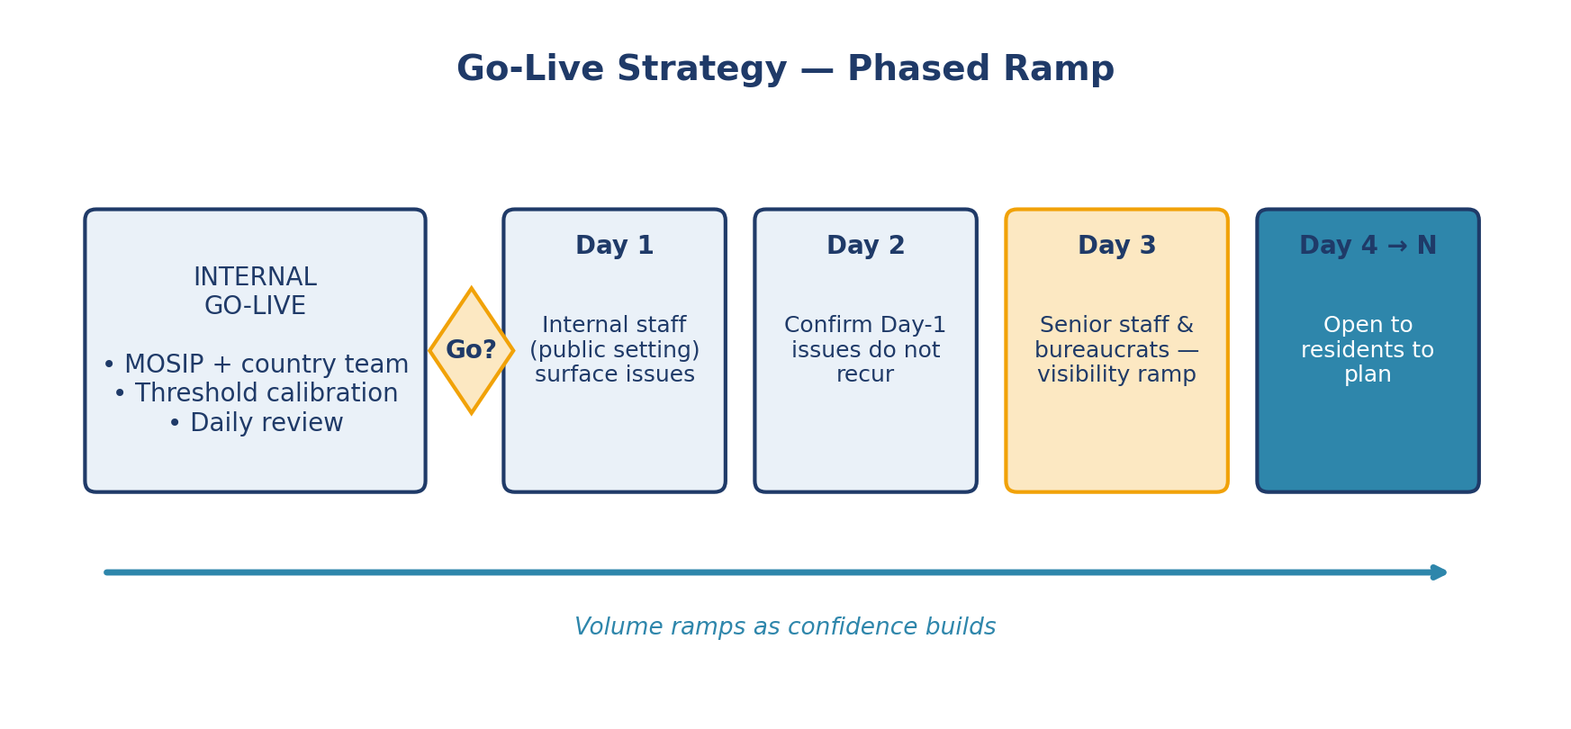
Figure 8 --- The phased go-live: internal first, then a deliberate Day 1 → Day N ramp into the public.
ℹ️ Note
Don't skip Day 1 It is tempting to compress the phased ramp on a 3 to 4 month pilot. Don't. The phased ramp exists to find the issue you missed in UAT, while the audience is still small enough to fix things gracefully.

Closure

Pilot Closure and Hand-Off
Closure is not just turning the lights off. It is the moment the country team formally takes ownership of MOSIP and decides what to keep, what to redo and what to scale. The closure activities below are a structured way to make sure no lesson learned in the pilot is lost in the transition.

Formal closure
- Inform the country authorities, in writing, that the pilot has been completed.
- Generate the formal pilot reports from the reporting console --- registration, authentication, exceptions, dashboards.

Capturing field experience
- Interview every registration field operator and supervisor; record their experience in their own words.
- Interview the country technical leads and program managers.
- Hold a closure meeting with the MOSIP team to discuss outcomes, surprises and recommendations.
- Send a formal pilot closure report to the MOSIP team.

Closure deliverables
- Registration metrics: total registered, breakdown by demographic group, on-line vs off-line split, biometric exception rates, average registration time per kit.
- Authentication metrics: OTP and biometric success rates, helpdesk incident counts.
- Lessons-learned register, captured weekly across the pilot.
- Configuration baselines: ID schema, master data, customisation diff, infrastructure footprint as actually deployed.
- Recommendations for scale: sizing, integrations, capacity, governance.
- Final sign-off from the Pilot Governance Committee.
ℹ️ Note
Cost note The pilot platform is provided at no cost (open source). The country invests in infrastructure, country-side hardware, gateways, personnel and travel. Production costing for a national rollout is a separate exercise and is not represented by the pilot footprint.

References

Critical Success Factors and Risks**

Success factors
- Country infrastructure (on-prem or cloud) is available at the earliest possible time, with the access and security approvals MOSIP needs to deploy.
- Country project team --- program, technical, field is identified, trained and available full time during the registration window.
- Non-biometric components of the registration kit (laptop, photo booth, printer/scanner, monitor, helpdesk and admin terminals) are procured and tested before training begins.
- Biometric devices arrive on time and pass acceptance testing at first delivery.
- ID schema and master data are signed off at the beginning of the pilot, anything later cascades into the registration window.
- Participant pool reflects the population mix, including children, minors, senior citizens and persons with disabilities.
- Functional training is paired with real registrations; no operator goes to the field untested. Some countries have even conducted examinations and grading to operators.

Top risks and mitigations
Risk | Impact | Mitigation
Biometric devices delayed at customs | Compresses or cuts the field window. | Country pre-clears customs; MOSIP ships in two waves so a partial shipment can start training.
On-prem environment not ready | Deployment slips, downstream training and customisation cascade. | Have a public cloud fallback environment pre-approved as a contingency (depends on country's sovereign principles).
Operator attrition during the pilot | Loss of trained operators forces re-training mid-flight. | Train at least 1.5× the operators required and rotate them through Centers.
ID schema changes late into the pilot preparation | Triggers re-customisation and re-test of the registration UI. | Freeze the schema by end of Week 3; treat post-freeze changes as scope changes needing committee approval.
Connectivity outage at a Center | Online registration grinds to a halt. | Offline mode is enabled, exercised during training, and used as the default fall-back.
Low resident turnout | Cannot reach 3,000 registrations in the window. | Communications focal point runs structured outreach via campaigns and partner channels; Centers open extended hours in the last week and may be use weekends.

Appendix A
Registration Center Setup Checklist
Print this page and do an audit with a supervisor before the first registration. Tick everything before opening to residents.
Area | Checks
Power and connectivity | Power outlets sufficient for laptop, monitor, printer/scanner, lights and devices. Surge protection in place. Wired or stable Wi-Fi tested at the kit. Offline-mode fallback verified end to end.
Registration kit | Laptop (specs per Section 5.2) up to date, antivirus current. Citizen-facing monitor connected. Fingerprint slap scanner, dual iris scanner and face camera tested with sample captures.
Documents and printers | Printer/scanner installed. A4 paper, ink/toner stocked. Document scanner tested with a sample identity document.
Photo booth | Backdrop and lights set up; framing tested with a person of average height. Lighting uniform; no shadow on the face. A chair placed at a distance from the camera to get a good photograph.
Helpdesk and admin | Supervisor terminal logged in with helpdesk role. Admin terminal accessible only by the country admin. Incident log template available.
Resident experience | Signage and queueing arranged with accessibility in mind. Seating available, including for senior citizens and residents with disabilities. Drinking water and rest areas signposted.
Compliance | Consent forms printed in the language(s) used by participants. Data-handling poster displayed. Incident contact details visible at every kit. Good, average and poor quality biometrics printed and pasted in various locations in the center with copies circulated to supervisor and operators.

Appendix B
Day-of-Pilot Operator Run Sheet
A condensed run sheet for an operator on a registration day. Localize it for your Center.
Phase | What the operator does
Start of day | Power on the kit. Verify the operator login and date/time. Run a self-test capture on the fingerprint, iris and face devices. Print a calibration page from the printer.
Pre-registration check | Look up the resident's pre-registration appointment. Confirm identity documents match. Confirm consent.
Demographic capture | Capture demographics in the country language, in the agreed schema. Re-read each entry to the resident before saving.
Biometric capture | Capture fingerprints (slap), iris (dual) and face. Repeat captures whose quality score is below threshold. For exceptions, mark the missing-biometrics and call the supervisor.
Document scan | Scan the supporting document at 300 dpi. Confirm legibility before saving.
Submit packet | Submit the packet. In offline mode, queue it for sync and note the packet ID on the manual log.
Authentication exercise | If the resident is part of the authentication sample, walk them through eSignet OTP or biometric flow at the mock RP portal. Demonstrate INJI Wallet credential download if requested.
End of day | Sync any offline packets. Power down devices. Lock kit. Hand the daily metrics sheet to the supervisor.

Appendix C
Experiencing Security and Privacy during the Pilot
The MOSIP pilot is deliberately designed so that security and privacy are not theoretical. Every step of the pilot --- from configuring network rules on Day 1 to watching the consent screen during authentication --- is an opportunity for the country team to build the operational instincts needed to govern a national identity system responsibly at scale.

What the Team Experiences
Layer | What you experience / observe | Security / privacy principle at work
Biometric capture | Biometric data leaves the device encrypted. The operator never sees raw fingerprint or iris data on screen --- only a quality score. | Data-at-capture encryption via SBI device; hardware-bound keys in TPM on the registration laptop.
Registration packet | Every packet uploaded from the Registration Client is encrypted before it travels over the network. Even if intercepted, it is unreadable. | AES-256 encryption; hybrid key wrapping with RSA. Packet is signed with the machine's TPM key, binding it to the physical hardware.
MOSIP core platform | Observe in the Admin Console that each resident's UIN is never stored in plain text. Identity and biometric data are stored in separate encrypted stores. | Zero-Knowledge encryption on biometric templates; UIN hashing and encryption; AES keys per data category stored in HSM / SoftHSM.
Deduplication (ABIS) | Watch biometric deduplication run without any human operator seeing the templates being compared. Results return as match / no-match only. | Biometric templates are shared with ABIS in encrypted form. ABIS returns a score --- never the raw template back to MOSIP.
eSignet authentication | Authenticate using OTP and fingerprint. Observe that the relying party (mock health portal) receives only a pseudonymous token --- not the resident's real ID number. | Partner Specific User Token (PSUT) --- each service gets a different identifier for the same resident. Cross-service profiling is cryptographically prevented.
INJI Wallet | Download a credential to a phone. The credential is a signed Verifiable Credential that can be verified offline --- no call back to MOSIP needed. | W3C Verifiable Credential with cryptographic proof. Credential is bound to the wallet's hardware key (Android Keystore / iOS Secure Enclave).
Consent | See the consent screen appear before any data is shared with a relying party. The resident explicitly approves what is shared. | Consent is recorded as an artifact with a unique ID. No data leaves MOSIP without a valid consent record.

Key privacy behaviors observed during Registration
During the pilot, specifically observe and discuss the following with your team:
- The operator never sees the resident's biometric data in raw form --- only a quality indicator (green / amber / red). This is enforced by the SBI device driver, not just policy.
- The citizen-facing screen shows the resident their own data before submission, giving them the opportunity to correct errors --- a built-in data accuracy and consent mechanism.
- Acknowledgement slips printed for residents contain only the Application ID, not the resident's full biometric or demographic record.
- The deduplication process (ABIS) never returns the matching resident's data to an operator --- only a match / no-match flag routes to manual adjudication.
- eSignet consent screen lists exactly which data fields a relying party is requesting. The resident can see and refuse before any data is shared.
- The INJI Wallet credential shows the resident's data but the verifier's QR scan returns only a cryptographic validity result --- the verifier cannot harvest and store the resident's data from the scan.

Questions to guide your team's security discussion
For the Technical Team | For the Policy Team
What happens to a registration packet if the network drops mid-upload? Is it lost, or stored securely and retried? | Which government authority will be the data controller for resident biometrics at national scale?
Who in MOSIP has the ability to decrypt a stored biometric? What prevents misuse? | What data retention policy will apply to packets and logs once ID is generated?
How would we detect if a rogue operator was registering fictitious residents? | Under what legal authority can a third-party service request a resident's eSignet authentication?
What is the process for rotating the signing keys after the pilot? | How will residents exercise their right to correction or deletion under the country's data protection law?
How do we ensure the SoftHSM seed material is protected, and what replaces it in production? | What audit trail must be maintained for each resident's data access events?

