<https://www.automationtestinghub.com/download-install-node-js-npm/>

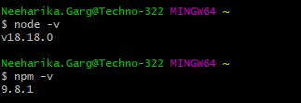

=================================================================

npm install -g appium@next



===========================================================================

Appium

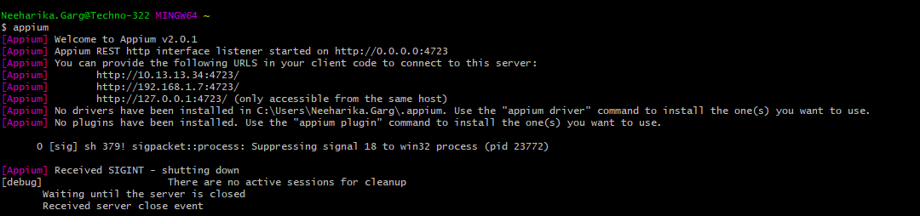

======================================================

appium driver install uiautomator2

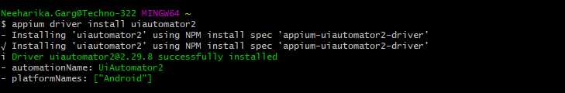

Appium

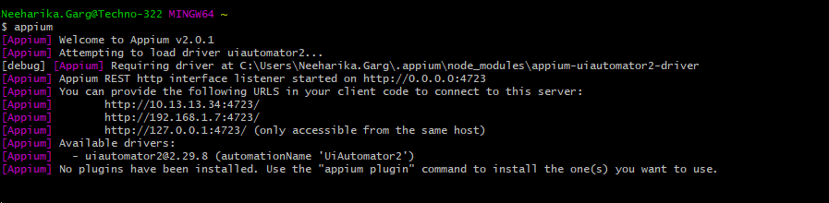

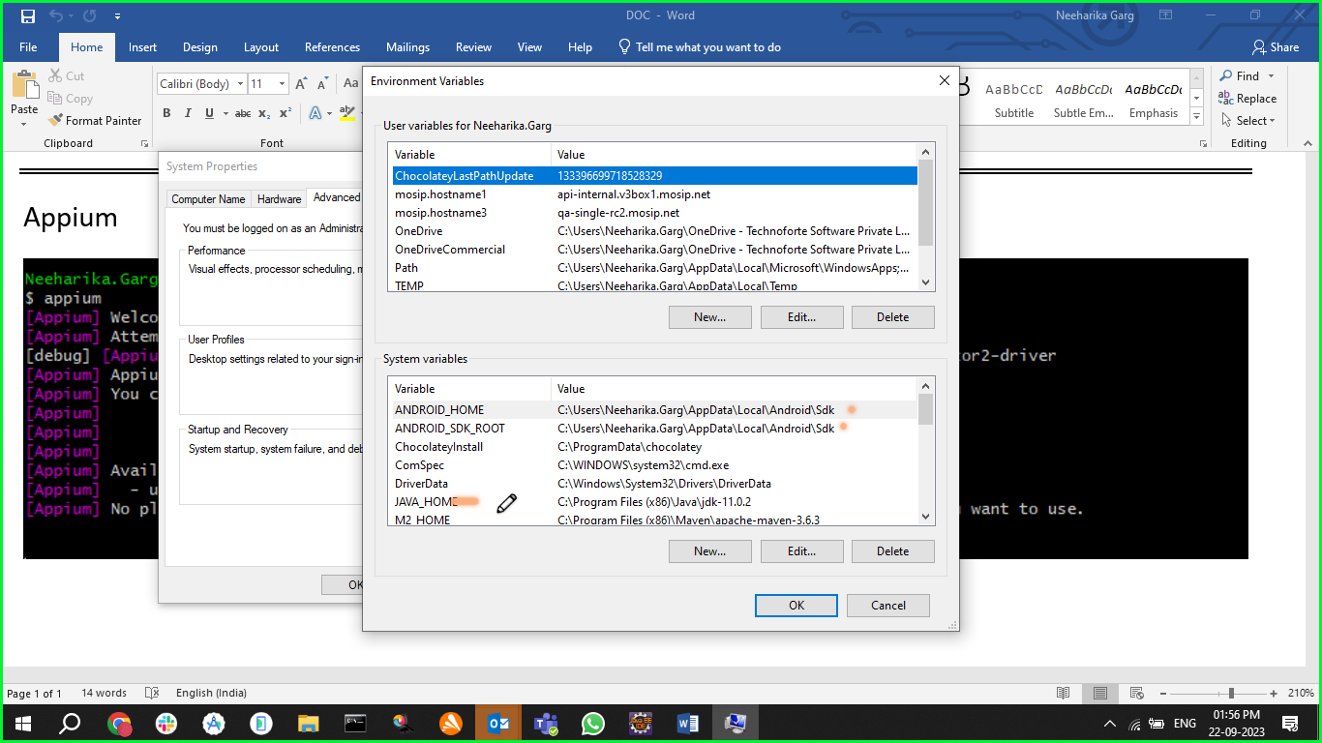

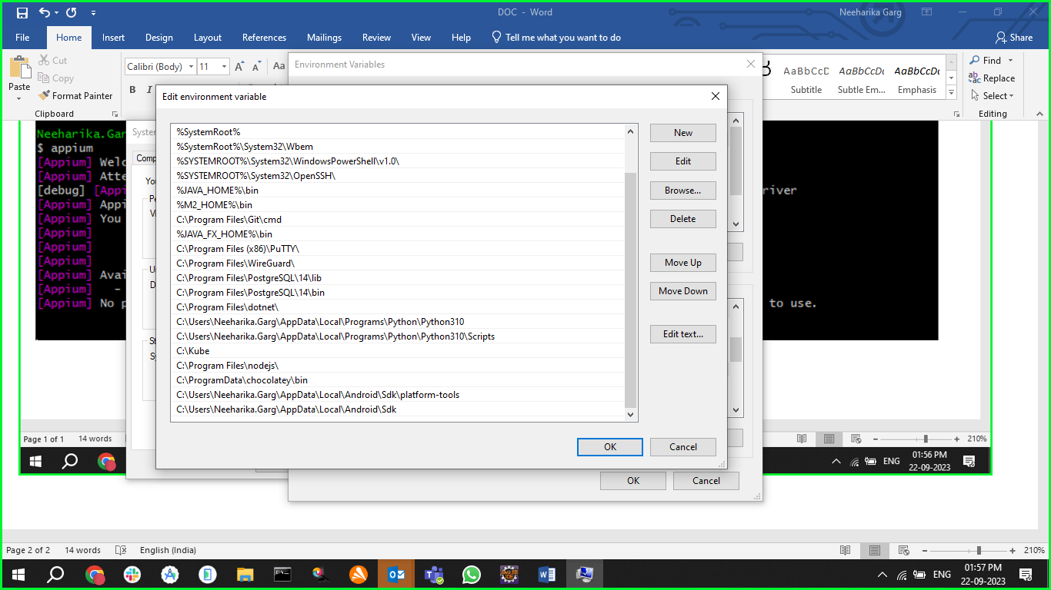

Adb devices

Need to take the devices..

Download Android Studio   
Link: <https://developer.android.com/studio>  
Install android Studio with default settings.

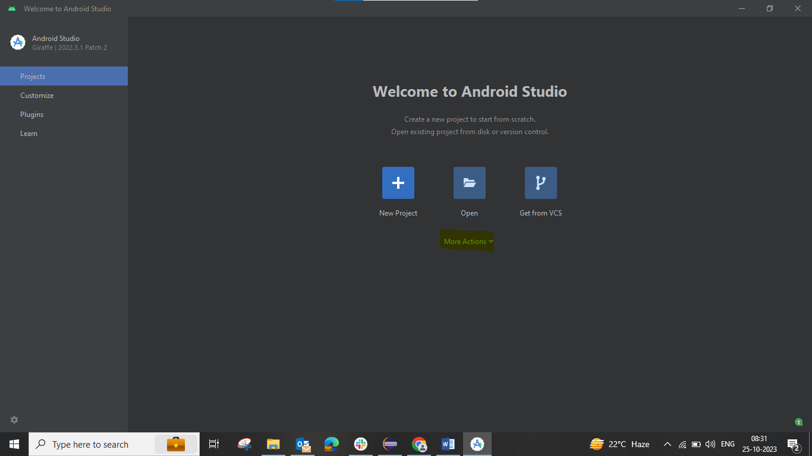  
  
Here click on more options & select Virtual device Manager  
 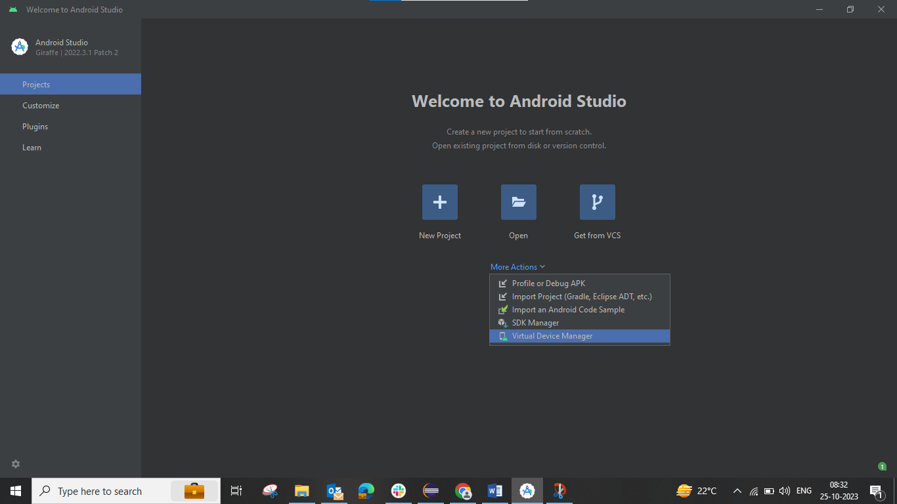  
  
  
  
  
then click on play button Device will be shown on screen  
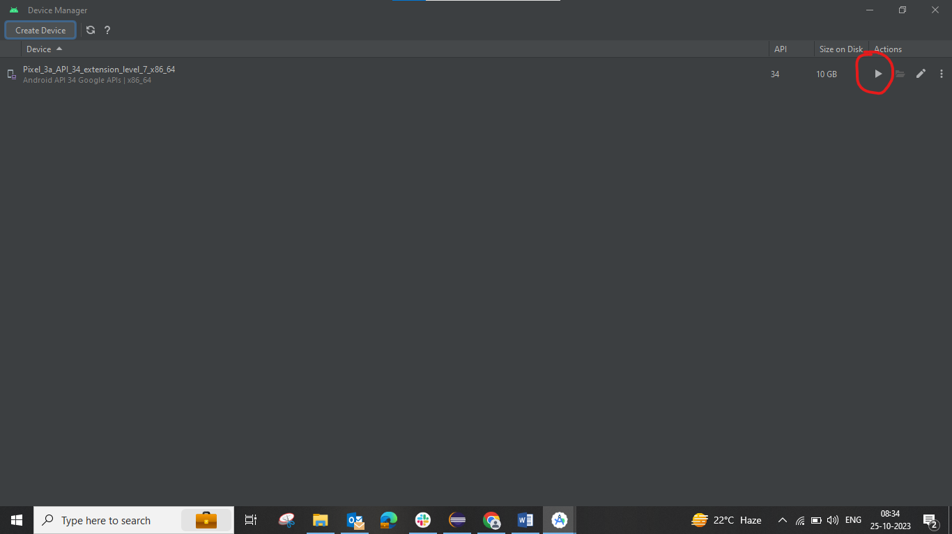  
  
  
  
\*\*Download Appium inspector   
Link: <https://github.com/appium/appium-inspector/releases>  
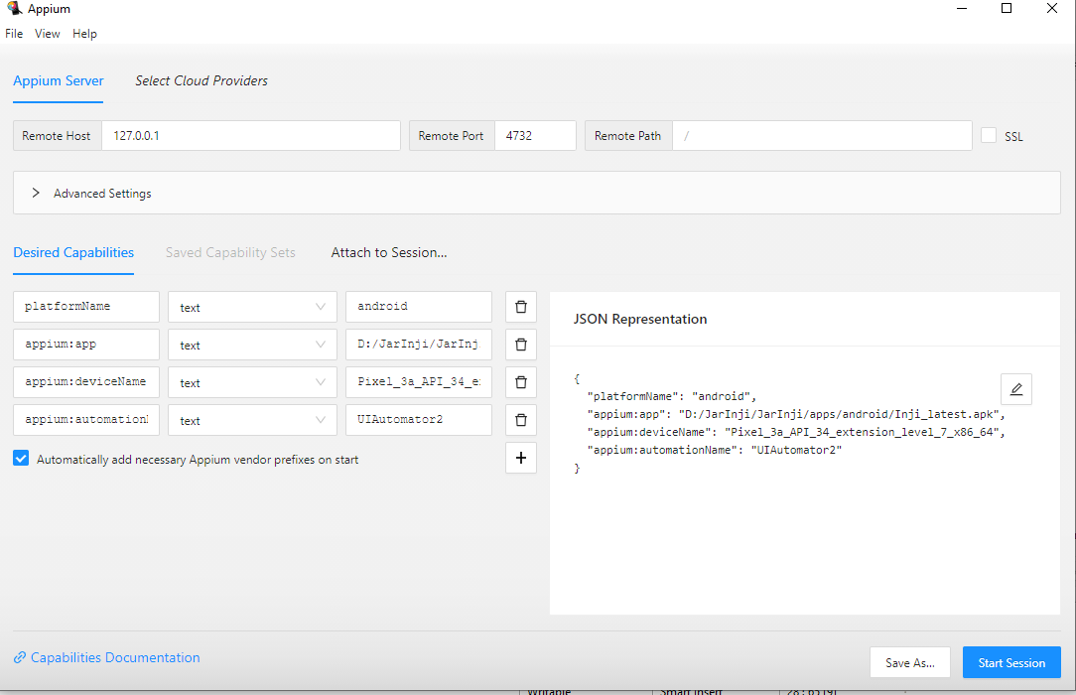  
  
Once downloaded fill credentials

(Note:- make sure Appium server, android studio is running)