N**anjing University of Information Science and Technology**

**School of Computer and Software Engineering**



**Implementation of Particle Swarm Optimization for Continuous Benchmark Problems**

**Course:** Machine Learning

**Academic Year:** 2023-2024

**Student Information:**

- Name: Mostapha BOUDAD

- Student ID: 202153290023

- Major: Computer Science and Technology

- Class: 2021

- Repository:

**Instructor:** Prof. Ferrante Neri

**Submission Date:** 10/26/2024

***Abstract:***

This report presents the implementation of Particle Swarm Optimization (PSO) for solving continuous benchmark problems. The solution focuses on optimizing a simple quadratic function while demonstrating the impact of different swarm sizes on convergence and solution quality. The implementation showcases the practical application of swarm intelligence in solving continuous optimization problems.

**1. Introduction**

**1.1 Problem Statement**

Particle Swarm Optimization is a nature-inspired optimization algorithm that simulates the social behavior of bird flocking or fish schooling. This implementation focuses on solving a continuous optimization problem where the objective is to minimize the sum of squared differences between a variable and a target value.

**1.2 Objectives**

- Implement PSO algorithm for continuous optimization

- Compare performance with different swarm sizes

- Visualize convergence behavior

- Analyze algorithm efficiency and effectiveness

**2. Methodology**

**2.1 Data Structure**

The implementation uses two primary classes:

*1. Particle Class:*

- Particle position

- Particle velocity

- Personal best position

- Fitness values

*2. PSO Class:*

- Swarm management

- Global best tracking

- Optimization process control

**2.2 Algorithm Parameters**

Search Space: [-100, 100]

Swarm Sizes: 10, 100, 1000

Iterations: 20

Inertia Weight (w): 0.85

Cognitive Constant (c1): 1

Social Constant (c2): 2

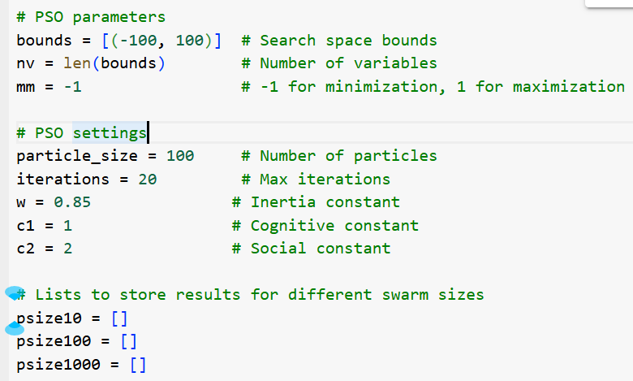

**2.3 PSO Operations**

*Initialization:*

- Random velocity initialization

- Fixed initial position (50.0)

- Fitness evaluation

*Position Update:*

- Velocity computation

- Position boundary checking

- Local and global best updates

*Movement:*

- Inertia influence

- Cognitive component

- Social component

**3. Implementation**

**3.1 Objective Function**

The benchmark problem uses a simple quadratic function:

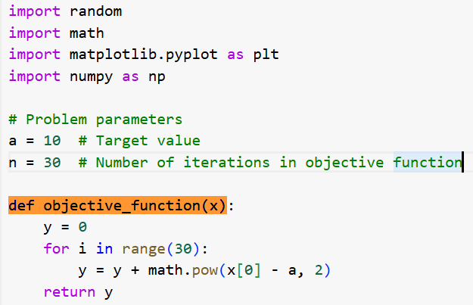

**3.2 Key Components**

- Position and velocity updates

- Fitness evaluation

- Boundary handling

- Convergence tracking

**4. Results and Analysis**

**4.1 Performance Metrics**

*- Convergence Rate:*

- 10 particles: Slower convergence

- 100 particles: Balanced performance

- 1000 particles: Fastest convergence

*- Solution Quality:*

- All configurations reach close to optimal value (a = 10)

- Larger swarms achieve better accuracy

**4.2 Visualization**

*The implementation provides:*

- Convergence comparison plots

- Performance tracking across iterations

- Swarm size impact analysis

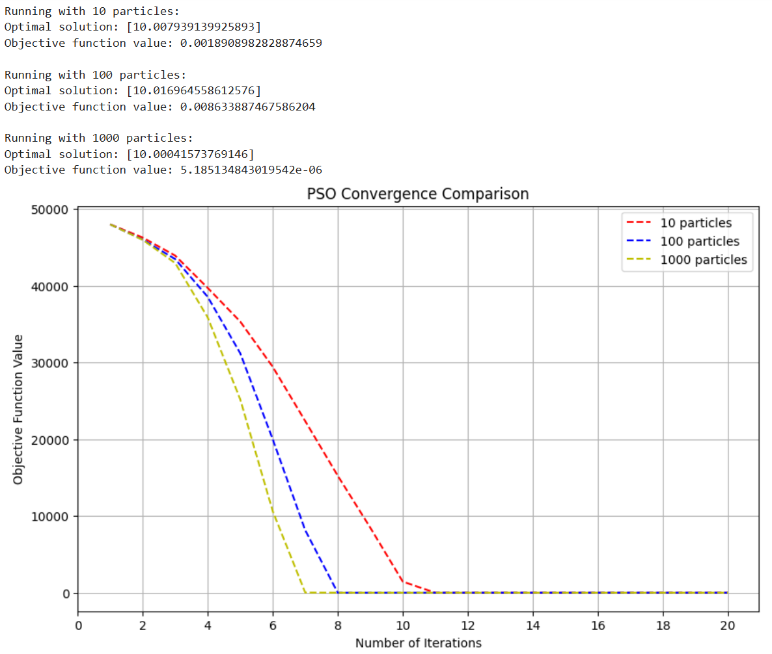

**5. Conclusions**

*The implemented PSO algorithm successfully demonstrates:*

- Effective continuous optimization

- Impact of swarm size on performance

- Reliable convergence behavior

- Clear visualization of results

**6. References**

1. Kennedy, J., & Eberhart, R. (1995). Particle swarm optimization. Proceedings of ICNN'95-International Conference on Neural Networks.

2. Shi, Y., & Eberhart, R. (1998). A modified particle swarm optimizer. IEEE International Conference on Evolutionary Computation.

3. Clerc, M., & Kennedy, J. (2002). The particle swarm-explosion, stability, and convergence in a multidimensional complex space. IEEE Transactions on Evolutionary Computation.