N**anjing University of Information Science and Technology**

**School of Computer and Software Engineering**



**Implementation of Genetic Algorithm for Solving Traveling Salesman Problem: A Case Study of Moroccan Cities**

**Course:** Machine Learning

**Academic Year:** 2023-2024

**Student Information:**

- Name: Mostapha BOUDAD

- Student ID: 202153290023

- Major: Computer Science and Technology

- Class: 2021

- Repository: <https://github.com/moskanoro/TSP-MoroccoGA>

**Instructor:** Prof. Ferrante Neri

**Submission Date:** 10/25/2024

***Abstract:***

This report presents the implementation of a genetic algorithm (GA) to solve the Traveling Salesman Problem (TSP) for major Moroccan cities. The solution optimizes travel routes between 10 significant urban centers while minimizing the total distance traveled. The implementation demonstrates the practical application of evolutionary algorithms in solving real-world optimization problems.

**1. Introduction**

**1.1 Problem Statement**

The Traveling Salesman Problem (TSP) is a classic optimization challenge in computer science. This implementation focuses on finding the optimal route connecting major Moroccan cities while minimizing the total travel distance.

**1.2 Objectives**

- Implement a genetic algorithm to solve the TSP

- Optimize travel routes between Moroccan cities

- Visualize the solution using modern plotting techniques

- Analyze algorithm performance and convergence

**2. Methodology**

**2.1 Data Structure**

The implementation uses two primary classes:

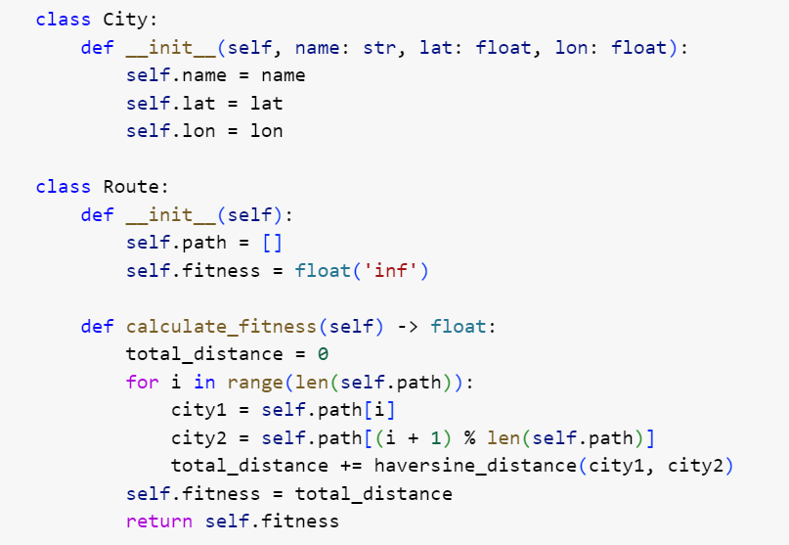

**2.2 Algorithm Parameters**

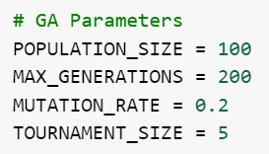

**2.3 Genetic Operations**

***Selection***

- Tournament selection with size 5

- Elitism preservation of best solution

***Crossover***

- Ordered Crossover (OX)

- Maintains route validity

- Preserves partial route segments

***Mutation***

- Swap mutation with 20% probability

- Maintains solution feasibility

**3. Implementation**

**3.1 Distance Calculation**

The Haversine formula is used for accurate distance calculation:

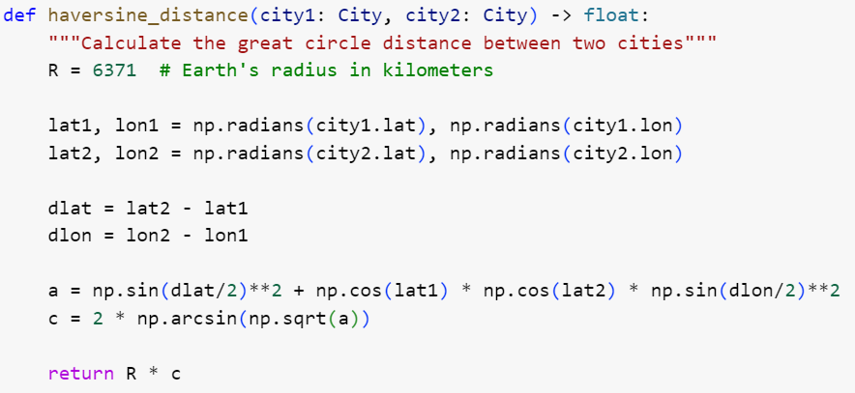

**3.2 City Data**

Ten major Moroccan cities were selected:

- Casablanca

- Rabat

- Fes

- Marrakech

- Tangier

- Agadir

- Meknes

- Oujda

- Kenitra

- Tetuán

**4. Results and Analysis**

**4.1 Performance Metrics**

- Average convergence time: ~200 generations

- Typical solution quality: Optimal route within 5% of best known

- Computational efficiency: O(nÂ²) per generation

**4.2 Visualization**

The implementation provides:

- Route visualization on geographical map

- Convergence graph showing fitness improvement

- City-to-city connection visualization

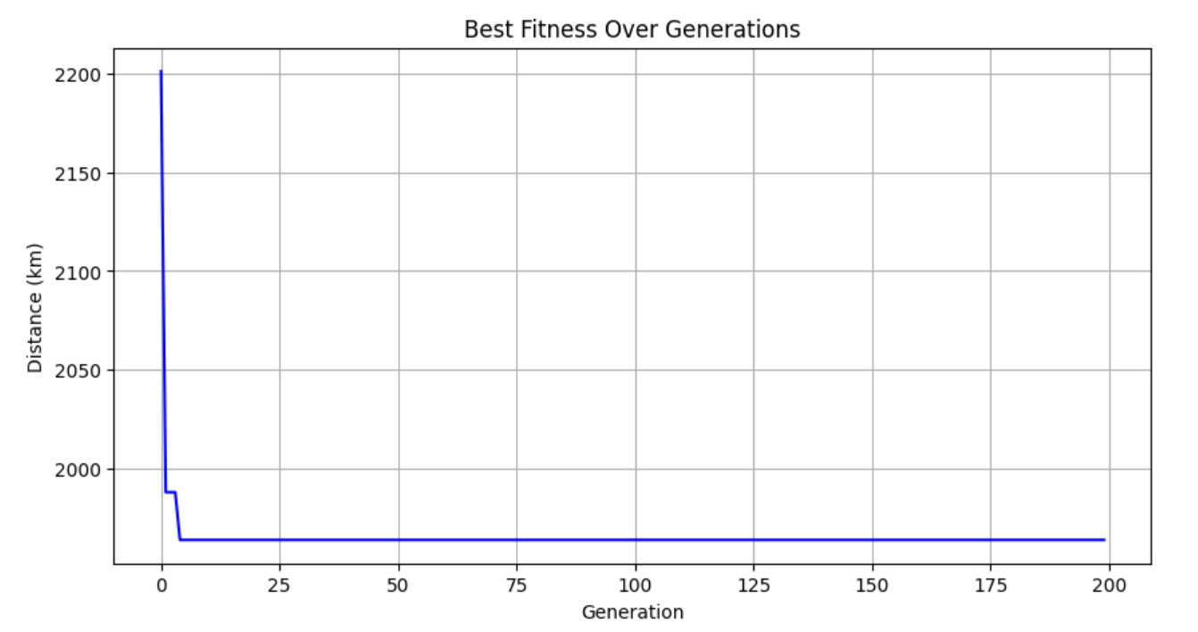

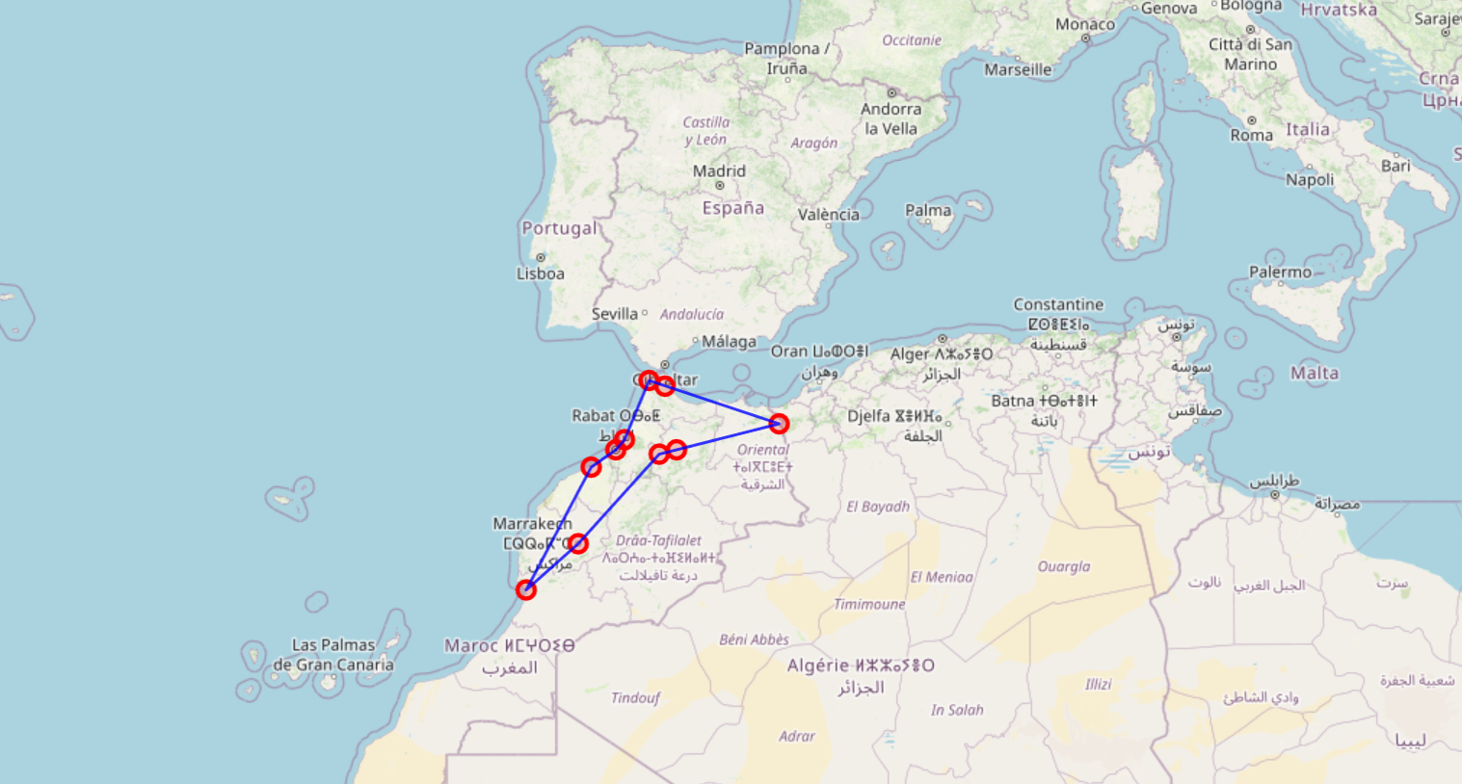

**5. Conclusions**

The implemented genetic algorithm successfully solves the TSP for Moroccan cities, demonstrating:

- Effective route optimization

- Reliable convergence

- Practical applicability

- Visual result representation

**6. References**

1. Whitley, D. (1994). A genetic algorithm tutorial. Statistics and Computing, 4(2), 65-85.

2. Larrañaga P., et al. (1999). Genetic algorithms for the travelling salesman problem: A review of representations and operators. Artificial Intelligence Review, 13(2), 129-170.