

**American International University- Bangladesh**

**CSC 2209: Object Oriented Programming 1 (JAVA)**

**CO1 Evaluation**

**Project Summary Report**

**Summer 18-19**

**Group No: 8**

**Project Title: Super Shop Management System**

|  |  |
| --- | --- |
| Student Name | Student Id |
| Saiful Islam Sohel | **17-35895-3** |
| Chinmoy Mondol | **17-35926-3** |
| Hassan Shahriar Ayon | **17-35967-3** |

**Introduction:**

A super shop management system allows the employees to manage the super shop efficiently and flawlessly. In this current digital era a system which is easy to use and understand for managing the super shop is a must. This system provides an efficient way of managing the super shop information. It also allows the customer to purchase and pay for the items purchased.

**User Category:**

There are two types of Users here. They are:

* Admin
* Cashier

**Feature List:**

In this project the “Admin” has the following features:

* add, remove and edit employees
* add, and edit stock
* See sale info

In this project the “Cashier” has the following features:

* Sell items from the stock
* Create bill
* See sale info

**GUI Description:**

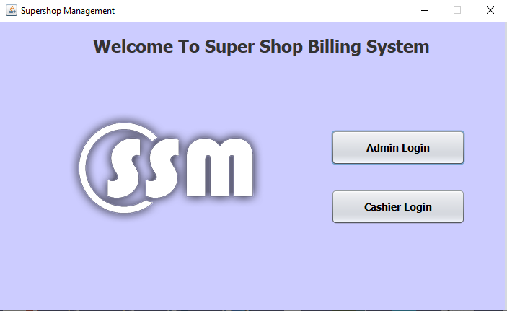

This is the default screen presented to the user for logging in to the software.

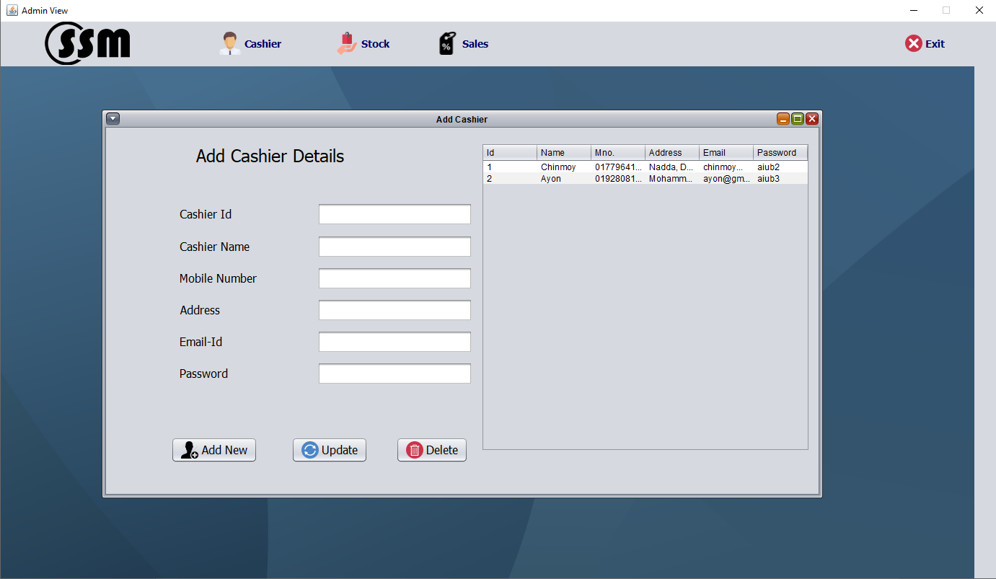 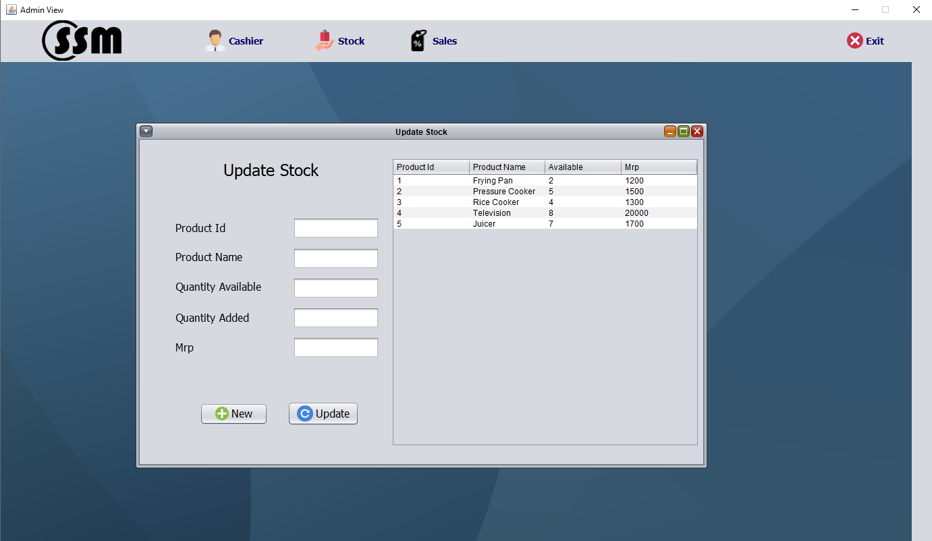

These are the admin panels used to edit Cashier details and Stock listings.

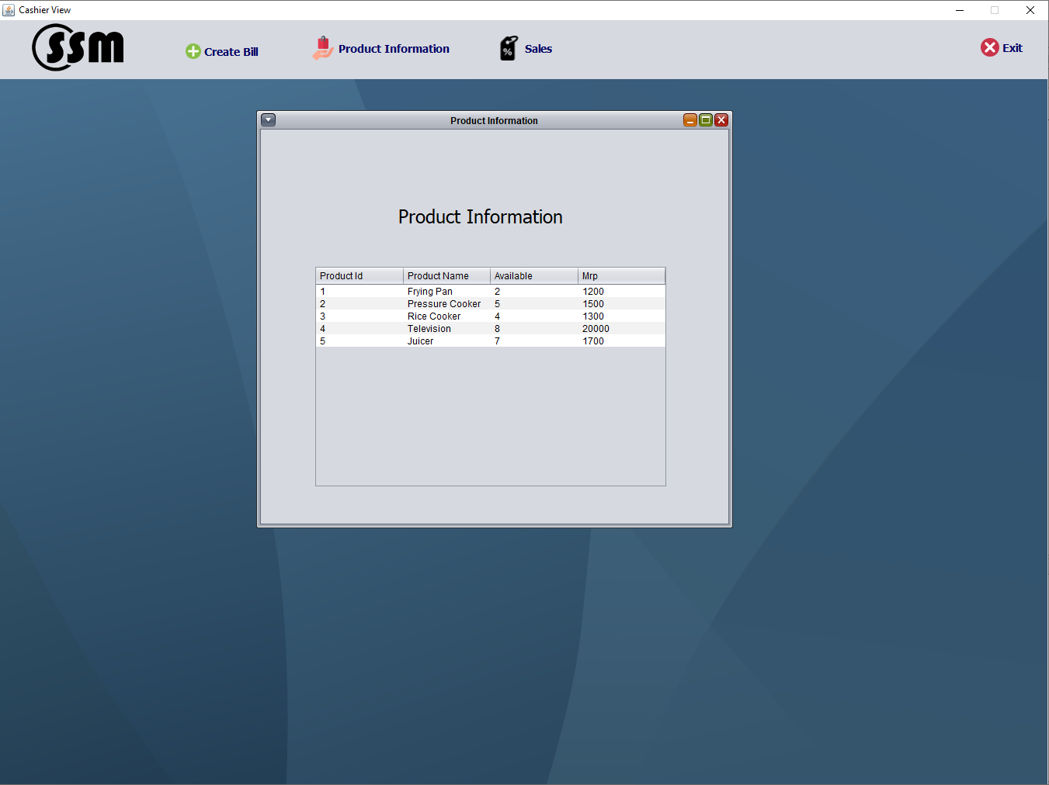 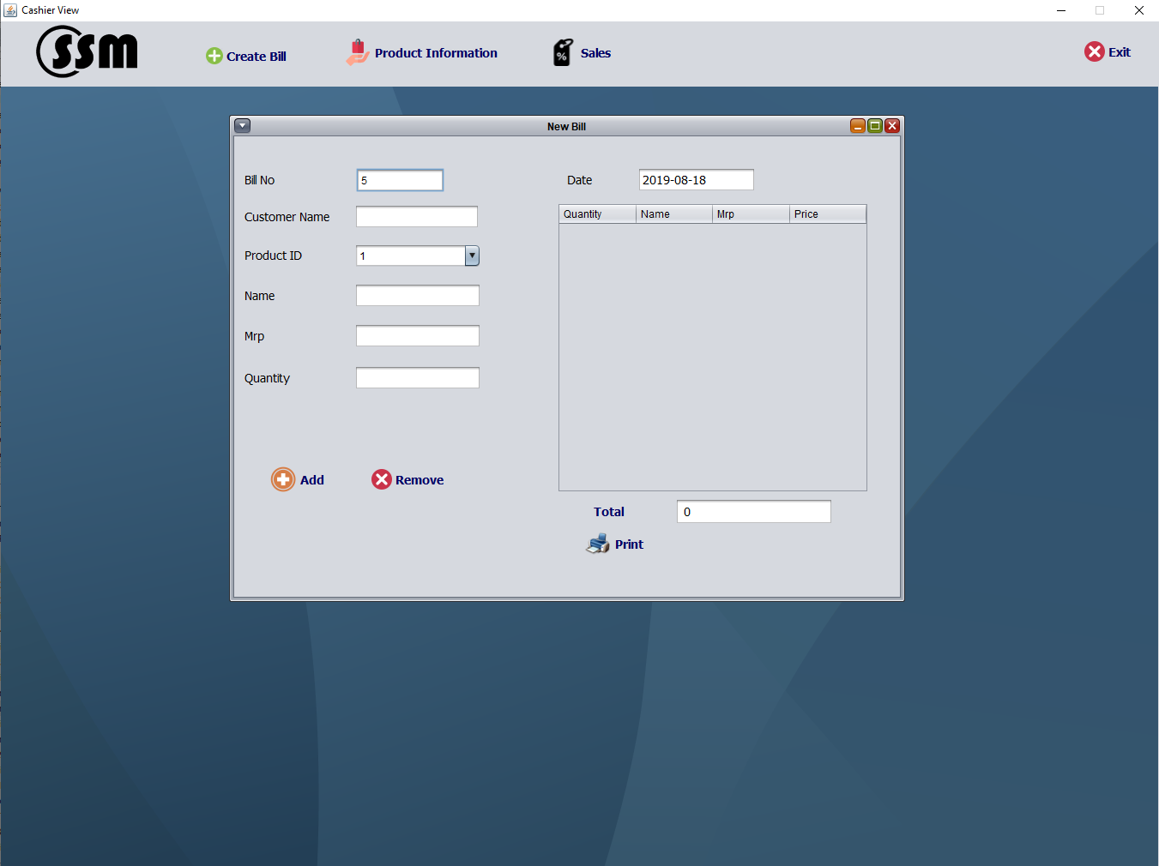

These are the cashier panels used to view stock and product information and create bills.

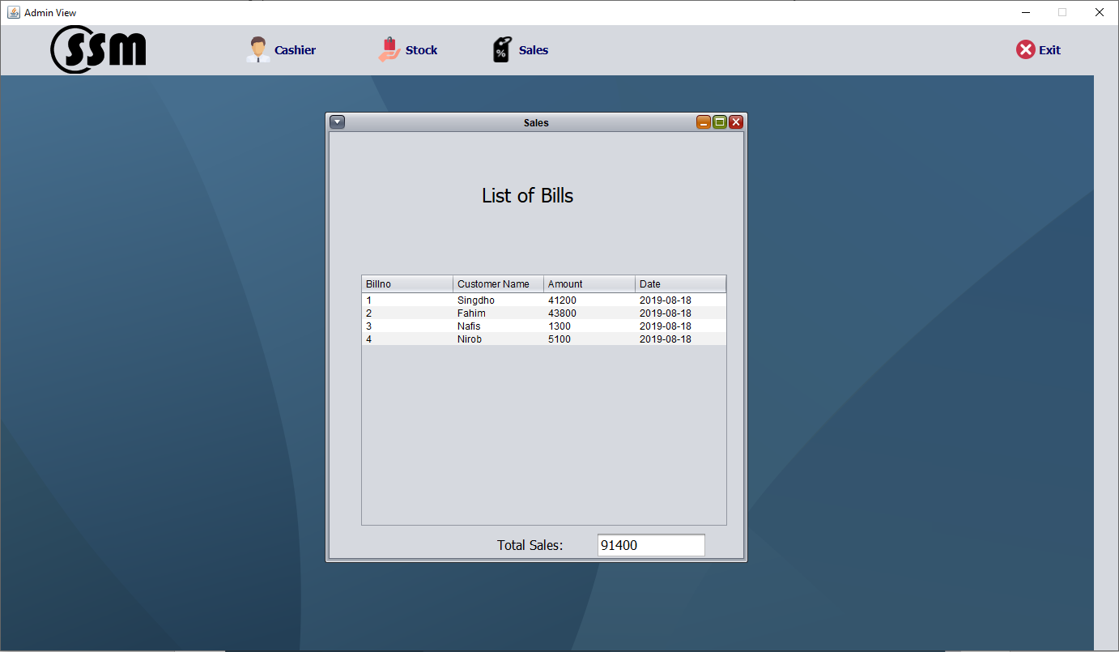

Both type of users have this panel to view the sales information.

**Database Table Description:**

**Tables:**

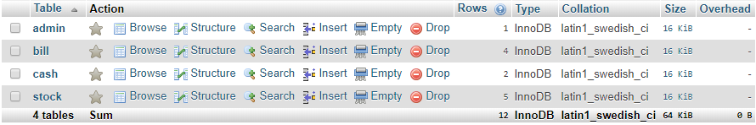

**Admin table structure:**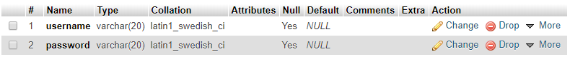

**Cashier table structure:**

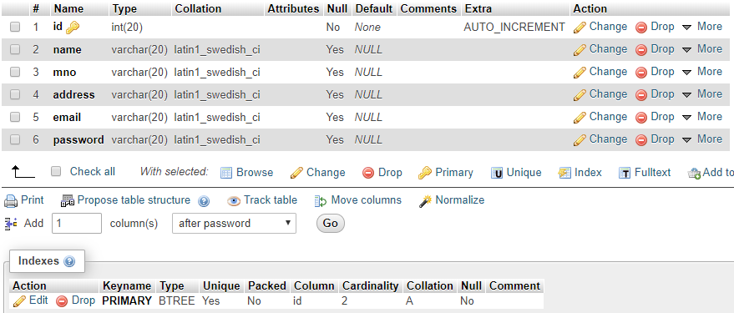

**Stock table structure:**

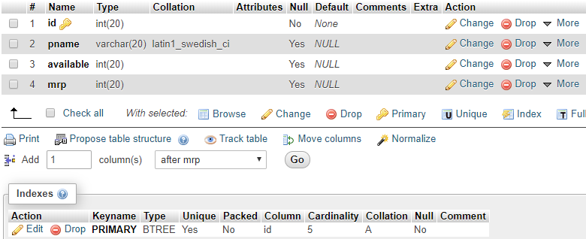

**Bill table structure:**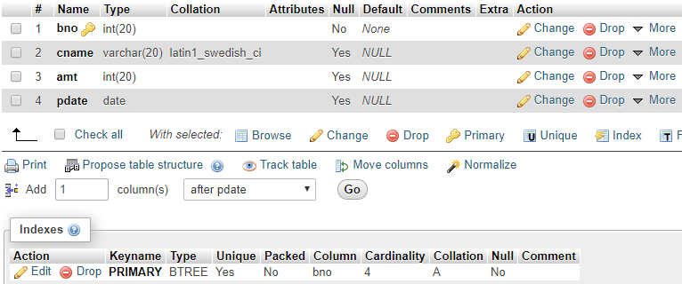

**Class Diagram:**

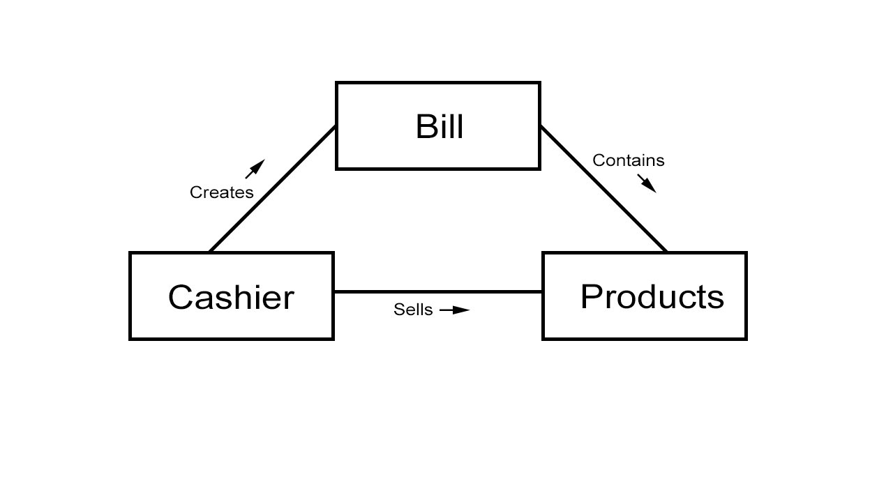

**Tools Used:**

To develop this project we have used the following:

* NetBeans IDE
* XAMPP

**OOP and Java Concepts Used:**

* Abstraction and Interfaces.
* Encapsulation
* Swing and AWT libraries for implementing the GUI
* ArrayList
* Exception Handling

**Impact of this Project:**

A super shop management system will cut down the cost for managing employees and the stock drastically. It will reduce the human error when manually operating a super shop and also reduce time consumption.

The employees can manage some aspects of the super shop even when they are away from the workplace. It also enables people in developing countries and rural areas to enjoy and access products, services, information and other people which otherwise would not be so easily available to them.

**Limitations and Possible Future Improvements:**

In the project, there is no instance of customer interaction. If more than the available quantity of a product is sold, it will carry out the action by making the available quantity into a negative amount. When billing, the window must be closed and reopened for a new bill.

In the future, the customer side may be implemented. A catalogue of items may be shown to the customer through a separate interface through customer login. Implementation of customers with special privileges may be done. A method for switching users easily may also be implemented.