DOI: to be assigned by the journal

RESEARCH ARTICLE
Dependency-Aware Commit Gating: Check Costs, Over-Stopping and Extracted-Graph Failures in Simulation
Sepide Ebrahimian Maqsoud¹, Moslem Mohseni Khah^{2*}, Navid Sadeghi³
¹ Department of Electrical Engineering, Hamedan University of Technology, Hamedan, Iran
² Department of Computer Engineering, Islamic Azad University, Hamedan Branch, Hamedan, Iran
³ Department of Electrical Engineering – Control, Shahid Beheshti University, Tehran, Iran
*Corresponding author: Moslem Mohseni Khah • Email: moslem.mohsenikhah@iau.ir
Received: 26.10.2026 • Accepted: — • Published: —

ABSTRACT
An irreversible action can be locally valid even when a dependent later step cannot be completed. We compare precommit check scopes in a parametric simulation of plans with hidden predicate truth, declared dependencies and immutable effects. Each of 3,000 base plans has a feasible variant and variants with local, downstream or independent predicate failure. The primary outcome requires both feasible completion and withholding commitment on the paired downstream failure. With complete dependency knowledge, the gate attains 0.912 paired accuracy and 0.026 downstream structural harm, compared with 0.970 harm for a local check. The large safety contrast is partly imposed by the variant construction. The gate uses 1.88 checks per plan versus 2.42 for exhaustive checking and withholds fewer first commitments on independent failures. Missing edges sharply degrade protection. On a fresh stream, explicit-reference parsing recovers all edges in a known grammar, while a shared-predicate heuristic has recall 0.254 and harm 0.766. Independent failures are defined relative to the first irreversible step and do not imply harmlessness for the entire plan. These results expose cost, over-stopping and dependency-representation limits rather than a new safety guarantee. A separate model-execution protocol was implemented, but no real model was available; mock tests supply no behavioral validation.
Keywords: irreversible actions; commit gating; dependency extraction; read-only checks; abstention; simulation study

© 2026 The Author(s). This article is licensed under a Creative Commons Attribution-NonCommercial 4.0 International License (CC BY-NC 4.0): https://creativecommons.org/licenses/by-nc/4.0/

1. Introduction
An agent can cancel an existing booking before discovering that a replacement cannot be obtained. Checking the cancellation alone does not establish the feasibility of the remaining work. AgentAbstain identifies related post-hoc abstention and already formalizes execution graphs, critical actions and commit-level evaluation (Liu et al., 2026). We examine a narrower question: which unresolved predicates should a controller inspect before releasing an irreversible step, and how much does that scope cost?
Preconditions, planning graphs and execution mediation are established ideas. STRIPS reasons about applicable operators, Graphplan analyzes graph constraints, and shielding places a formal monitor between a learned controller and its environment (Fikes & Nilsson, 1971; Blum & Furst, 1997; Alshiekh et al., 2018). SafeCommit certifies an action against plausible worlds using a domain safety map that can include downstream feasibility (Akewar & Ranjan, 2026). We do not propose dependency-aware checking as a new principle or use a local-check baseline as a surrogate for these systems.
Our contribution is a controlled comparison of local, dependency-scoped and exhaustive checks with outcomes for harmful commitments, feasible completion and withheld first actions. A fresh experiment measures graph extraction from public step contracts, making representation quality observable rather than representing it only as an assumed edge-retention probability. All results concern a small synthetic generator and a structural harm proxy.
- RQ1: How does dependency-scoped checking affect paired feasible completion and withheld commitment relative to local checks and other policies?
- RQ2: What check cost and first-commit over-stopping accompany this behavior relative to exhaustive checking?
- RQ3: How do missing or spurious dependencies, executable extraction and noisy observations change the result?

2. Literature Review

2.1. Abstention and effect accounting
AgentAbstain evaluates should-act and should-abstain task pairs, including triggers discoverable during tool interaction. Operational verdicts combine a deterministic critical-action check and a separate verbal judge; informational tasks use the verbal signal. Its formal appendix already defines data-dependency graphs and critical commit nodes (Liu et al., 2026). Our paired design borrows this logic but omits semantic response judging and realistic applications. A silent stopped simulation is not evidence of calibrated verbal abstention. AgentAbstain tasks were not run.
ToolEmu uses language models to emulate tool executions and evaluate safety and helpfulness, with human validation of trajectory realism and evaluator reliability (Ruan et al., 2024). It covers richer underspecified tasks at the cost of emulation and judging errors. We instead know symbolic truth and effects exactly but lose semantic breadth. Our ordinary and verbal policies are simulator probabilities, not measured prompt effects or reproductions of ToolEmu agents.

2.2. Planning, mediation and certification
Classical planning establishes that action applicability and future goal feasibility are distinct concerns. STRIPS searches operator sequences over world models, while Graphplan exploits planning-graph constraints to find partial-order plans (Fikes & Nilsson, 1971; Blum & Furst, 1997). We execute a fixed sequence with declared dependencies rather than solving a new planning problem. Shielding monitors proposals against a formal specification (Alshiekh et al., 2018); our predicate gate is a restricted external monitor under assumed graph semantics.
SafeCommit retains calibrated plausible worlds, permits an action safe in every retained world, and otherwise probes or falls back. Its guarantee depends on world coverage and a correct safety map; repeated commitments require further risk accounting (Akewar & Ranjan, 2026). That map is not inherently local and could encode our downstream conditions. We neither reproduce its calibration nor establish a performance gap against it. Sagas addresses a different recovery layer through compensating transactions (Garcia-Molina & Salem, 1987); compensation is absent from our immutable effect model.

2.3. Positioning and dependency representation
We assess imposed and measured graph errors separately: random edge retention is a parameter, explicit-reference parsing is executable but assumes a known grammar, and shared-predicate overlap is a simple proxy for data dependence. No novel abstention framework, graph formalism, planner or security certificate is claimed. The empirical questions are costs, stopping behavior and representation failure within these assumptions.

3. Materials and Methods

3.1. Paired plans and selection boundary
The main stream contains 3,000 base plans at seed 7, each with act, LOCAL, DOWN and INDEP variants. Plans have four to six steps, one or two preconditions per step and a predicate pool two larger than the step count. Every later step is irreversible with probability 0.35, with at least one irreversible step forced. Forward edges have probability 0.45 and predicates are initially unresolved with probability 0.50.
Rejection sampling admits only plans with both a later descendant and an independent later step relative to the first irreversible step, plus eligible failure predicates. The admitted population is conditioned on the contrast being possible. The act variant has all predicates true. LOCAL makes a predicate of the first irreversible step false; it may also occur earlier. DOWN selects a false predicate used exclusively by descendants, and INDEP one used only by later non-descendants. The failing predicate is forced unresolved, so the visible unresolved mask can differ across variants. This is a construction assumption, not naturally sampled failure incidence.

3.2. Observations, execution and harm
A read-only check has unit cost and symmetric error probability 0.03. Its observation is cached, so repeated access is not independent verification. Resolved values are known; unresolved truth is hidden. Execution follows the fixed step order and halts on a false required predicate. An irreversible step whose own predicate fails nevertheless executes with probability 0.50. Earlier effects persist; no repair, alternative plan or rollback is attempted.
Structural harm means that an irreversible step executed while a false predicate exists at itself or a graph descendant. This proxy does not evaluate severity, actual recovery or every reason a plan might halt. Edges are declared relations; execution does not dynamically establish or invalidate predicate truth. An INDEP failure is independent of the first irreversible step but may affect a later irreversible step. Preserving the first commitment is not full-task success or proof that the entire trajectory is harmless.

3.3. Policies and check scopes
The ordinary policy checks each current unresolved predicate with probability 0.25. Verbal caution raises this probability to 0.60 and adds a 0.05 chance of initial blanket abstention. These are assumed behavior changes. Local check inspects the current irreversible step; check-all inspects every unresolved predicate; the dependency gate inspects the current step and all descendants before each irreversible action. Observed false values cause stopping. All executing policies retain incidental checks at the stated ordinary or verbal rate.
Blanket abstention stops if any used predicate is unresolved. Gate variants retain each true edge with probability 0.8 or 0.5, or add each non-edge with probability 0.3. These are independent inclusion probabilities, not exact fractions per graph. Worlds are paired across policies. Fixed policy-name noise streams avoid order dependence but do not couple every stochastic decision.

3.4. Primary outcome and uncertainty
The primary base-plan outcome requires both complete act execution and no irreversible effect on its paired DOWN variant. Always stopping cannot satisfy the feasible half. Seven contrasts cover gate against local check, check-all, blanket abstention and verbal caution, plus the three imperfect-graph variants against the complete gate. All seven sign-flip tests receive Holm correction (Holm, 1979). Bootstrap intervals use 1000 base-plan resamples and tests use 2000 permutations, with statistical seed 71 (Efron, 1979). Nominal rate intervals use the Wilson method (Wilson, 1927). A standardized paired effect divides the mean difference by its standard deviation. This family was fixed for the revision, not preregistered.
Secondary metrics include structural harm, checks, feasible completion and absence of any irreversible effect on INDEP. The latter equals withholding the first irreversible step in this fixed model and is called first-commit over-stopping, not whole-task refusal. Original component contrasts retain a combined 42-test Holm correction; intervals are pointwise. Main seed 7 differs from sweeps at 11, long plans at 13 and new extraction at 23. The inherited draft had already inspected the main design, so separated seeds do not constitute untouched confirmation.

3.5. Executable dependency extraction
A fresh stream evaluates 1,500 base plans using the given gate, local check, check-all and two extracted gates. Public contracts list steps, preconditions, reversibility and explicit producer-result references, without truth or variant labels. A fixed parser recovers those references. Because gold dependencies are published in a known grammar, this tests extraction plumbing, not semantic inference. A second heuristic ignores producer references and links ordered steps sharing any precondition. Neither extractor receives hidden truth or the gold graph as an argument.
We measure micro edge precision/recall and first-commit descendant-scope precision/recall, then execute the inferred graph. Gold edges are used only for scoring. Parsing and graph construction are not charged as checks. Results and paired nominal intervals are exploratory, without another confirmatory family. Six one-factor sweeps and a long-plan condition with six, eight or ten steps retain the inherited generator.

3.6. Separate model protocol and ethics
The protocol uses 200 variant episodes from 50 base plans, comparing ordinary prompt, verbal caution, per-action check and code-enforced gates with given or model-extracted dependencies. Extraction sees public contracts only. Code owns noisy read caching, sequential execution and immutable effects; unsupported proposals cannot mutate the workspace. Up to 40 turns use temperature zero, prompt-hash caching and a persistent USD 5 cap. Six primary paired contrasts would compare both gates against the three alternatives, Holm corrected, with separate secondary rate/cost intervals. The small paired cohort would limit inference even if executed.
No credentials or ready local model were discovered; official runtime acquisition had timed out. No real-model cohort was run. A labelled mock tests the protocol and fails closed on invalid actions, without providing behavioral evidence. The study uses synthetic local tasks only, with no human participants, personal data or external operational effects.

4. Results

4.1. Paired outcome and structural harm
Table 1. Paired accuracy, completion, structural harm and check cost
Policy | Paired accuracy | Act completion | DOWN harm | INDEP first withheld | Mean checks
Ordinary | 0.012 | 0.977 | 0.988 | 0.012 | 0.76
Verbal caution | 0.069 | 0.898 | 0.926 | 0.069 | 1.57
Local check | 0.029 | 0.952 | 0.970 | 0.028 | 1.50
Blanket abstention | 0.026 | 0.026 | 0.000 | 1.000 | 0.00
Check all | 0.888 | 0.916 | 0.029 | 0.976 | 2.42
Dependency gate | 0.912 | 0.937 | 0.026 | 0.054 | 1.88
Gate, retention 0.8 | 0.745 | 0.941 | 0.210 | 0.050 | 1.81
Gate, retention 0.5 | 0.475 | 0.943 | 0.501 | 0.043 | 1.71
Gate, spurious rate 0.3 | 0.908 | 0.932 | 0.025 | 0.440 | 1.97
Note. Paired accuracy requires correct act and DOWN behavior for the same base plan. First-commit withholding does not measure whole-task feasibility. Main intervals and local-failure outcomes are supplied.
For RQ1, gate paired accuracy is 0.912 [0.901, 0.922], versus 0.029 for local checks and 0.888 for check-all (Table 1). DOWN harm is 0.026 [0.021, 0.033], versus 0.970 locally. The large contrast follows the exclusive downstream failure: a local check cannot directly inspect it. This is a mechanism demonstration, not an expected real-agent effect size.
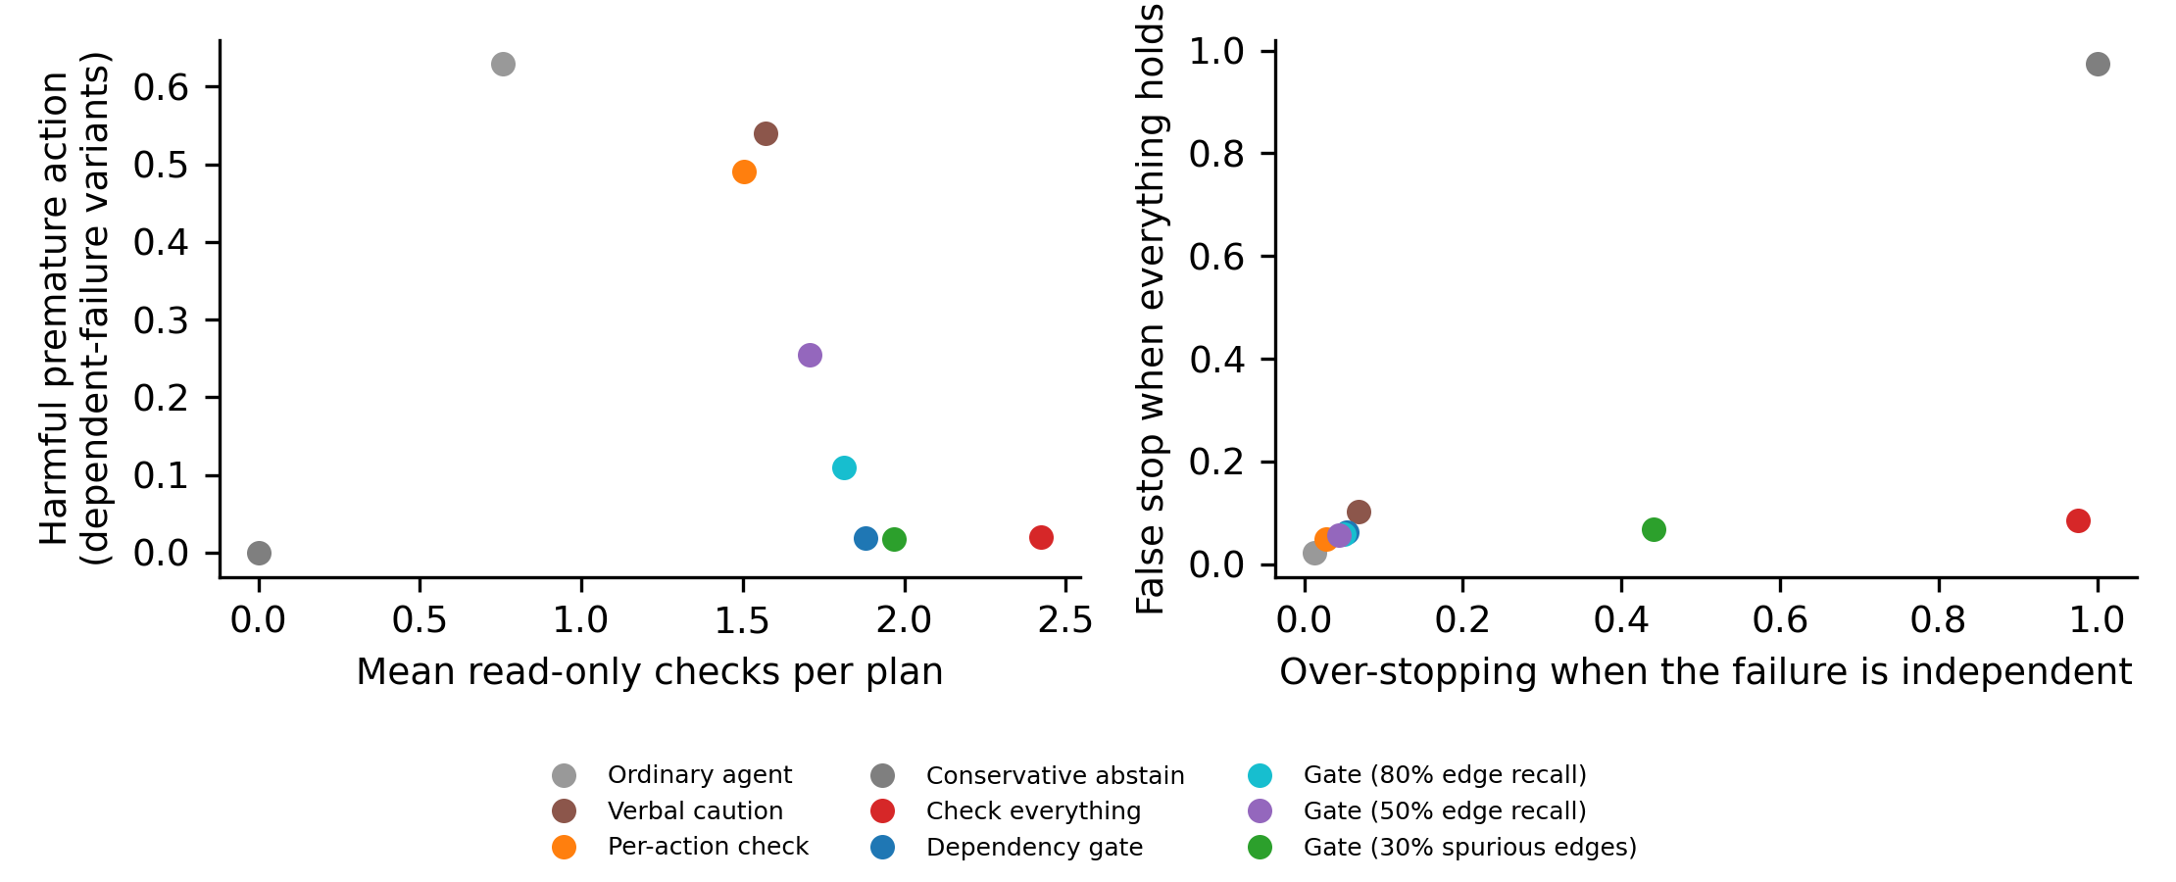
Figure 1. Structural harm against read-only check cost, and INDEP first-commit withholding against false stopping on act. Low harm alone can reward inaction.

4.2. Primary contrasts and costs
Table 2. Seven primary paired-accuracy contrasts
Contrast | Difference [nominal interval] | Paired effect | Holm p
Dependency gate minus Local check | +0.883 [+0.871, +0.895] | 2.725 | 0.0035
Dependency gate minus Check all | +0.024 [+0.010, +0.039] | 0.057 | 0.0060
Dependency gate minus Blanket abstention | +0.886 [+0.874, +0.897] | 2.756 | 0.0035
Dependency gate minus Verbal caution | +0.843 [+0.830, +0.857] | 2.221 | 0.0035
Gate, retention 0.8 minus Dependency gate | −0.167 [−0.182, −0.154] | −0.432 | 0.0035
Gate, retention 0.5 minus Dependency gate | −0.437 [−0.456, −0.418] | −0.858 | 0.0035
Gate, spurious rate 0.3 minus Dependency gate | −0.004 [−0.018, +0.010] | −0.010 | 0.6162

For RQ2, the gate uses 1.88 checks across variants versus 2.42 for check-all, or 22.5% fewer. Act cost is 2.12 versus 2.69; its paired difference is −0.571 [−0.602, −0.539]. These are unit check counts, not token or latency savings. Similar harm estimates or overlapping intervals do not establish equivalence.
INDEP first commitment is withheld in 0.054 of gate episodes versus 0.976 for check-all. Yet gate INDEP harm is 0.006 because another irreversible step can be implicated. Every perturbed variant has a false required predicate, so preserving a first commitment cannot mean complete task success. LOCAL harm is 0.010 for the gate and 0.012 for local checks, where scopes differ less.

4.3. Missing edges and extraction
For RQ3, edge retention 0.8 and 0.5 raises DOWN harm to 0.210 and 0.501. Primary paired-outcome losses appear in Table 2. Spurious edges produce first-commit withholding 0.440, versus 0.054 for the complete graph. Irrelevant reachability can therefore impose substantial stopping while primary accuracy changes little.
Table 3. Fresh-stream extraction quality and downstream structural harm
Extractor | Edge precision | Edge recall | Scope recall | DOWN harm [interval] | Checks
Explicit-reference parser | 1.000 | 1.000 | 1.000 | 0.027 [0.020, 0.036] | 2.09
Shared-predicate heuristic | 0.454 | 0.254 | 0.275 | 0.766 [0.744, 0.787] | 1.91
Note. Scope recall concerns descendants of the first irreversible step. Explicit references encode true edges in a fixed grammar. Shared-predicate overlap is a proxy, not established data dependence.
The parser has edge recall 1.000; the shared-predicate heuristic has recall 0.254 and precision 0.454 (Table 3). Its descendant recall is 0.275 and DOWN harm 0.766. Dependency knowledge is thus a measurable bottleneck here. Perfect parsing establishes decoding of supplied links, not extraction from unrestricted plans. Separate noise streams also prevent exact equality of given and parsed outcome rates.
With check noise 0.20, gate DOWN harm is 0.155; at zero noise it is 0.000. Long-plan checks average 2.54 versus 3.20 for check-all. These exploratory conditions do not establish robustness to arbitrary planning errors.
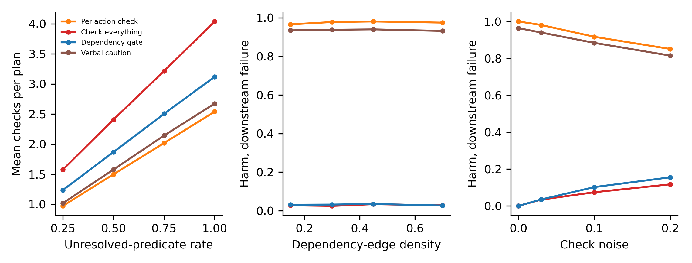
Figure 2. Exploratory sensitivity to unresolved predicates, edge density and observation noise. Every condition remains restricted to plans eligible for all paired variants.

4.4. Model execution status
No real-model result exists. Labelled mock episodes are excluded from the scientific estimates. They test action parsing, cached calls, dependency parsing and effect preservation, but cannot establish whether real agents infer dependencies, follow verbal caution or preserve the policy ranking. No empirical model interval or model version is asserted.

5. Discussion
DOWN deliberately separates the current action from its only failing downstream predicate. Local mandatory checks cannot see that predicate, while a complete graph gate can. The large harm gap partly follows the definitions. More informative observations are checks, feasible false stops, INDEP first-commit withholding and graph-error degradation. They still depend on the conditioned generator and unit costs.
Independent does not mean globally harmless. It describes the first irreversible step; the remaining plan can contain further irreversible actions or halt for unrelated reasons. Preserving the first effect while later failing may be undesirable under a user-level objective. Our structural proxy does not price incomplete work. Changing the graph or harm semantics could change the preferred policy; no universal safety-utility optimum follows.
The extraction experiment distinguishes representation from acquisition. Explicit links can be parsed when a planner publishes an auditable contract; shared predicate names alone do not establish dependence. Yet the gold graph itself is declared rather than verified causality. Practical use would require auditing whether the links capture commitment-relevant consequences as well as extraction fidelity. Parser success cannot substitute for that semantic audit.
AgentAbstain already evaluates critical effects over graphs, SafeCommit permits broad safety maps, and shielding requires a correct abstraction (Liu et al., 2026; Akewar & Ranjan, 2026; Alshiekh et al., 2018). Dependency scope can help implement one map but cannot calibrate uncertainty or establish hazard completeness. The unexecuted model protocol leaves graph inference and actual agent behavior untested.

6. Conclusion
RQ1 finds paired accuracy 0.912, with a partly constructed advantage over local checks. RQ2 finds 22.5% fewer unit checks than check-all and less first-commit withholding, without implying whole-task safety. RQ3 shows degradation from missing dependencies, weak shared-predicate extraction and observation noise. The evidence supports a conditional scope/cost comparison, not a new planning principle, certified safety layer or validated real-agent intervention.

6.1. Recommendations
Publish producer references and side-effect contracts, measure edge precision and descendant recall, and audit graph semantics against actual consequences. Report useful-action pairs alongside harm and stopping. Price incomplete work and graph construction before selecting a policy. Future work should compare given and extracted gates with real models and realistic tools, retaining exact effects and separating calibration from check scope.

6.2. Limitations
The generator conditions on eligible plans, uses one small grammar and selects exclusive failures by construction. Variant masks can differ. Graphs do not arise from changing effects, truth is static, observations have independent symmetric errors and repeats share a cached answer. Behavior parameters, silent execution and unit costs are assumptions. Binary harm omits severity, recovery and failed independent work after commitment.
The main design had already been explored; the primary family and extraction study are revision analyses without preregistration. A correct parser sees gold references encoded by the generator, and the overlap heuristic is not a modern semantic extractor. Scope recall concerns only the first irreversible step. The model protocol has 50 paired bases and was not run with a real model because credentials and a ready runtime were unavailable after the documented attempt. Transfer to language, changing dependencies, concurrent tools and production remains unresolved.

Declarations
Ethics Committee Approval: Not applicable: synthetic tasks and simulated data; no human participants or personal data were involved.
Author Contributions: The authors take collective responsibility for this manuscript.
Conflict of Interest: The authors declare no conflict of interest.
Funding: This research received no external funding.
Data and Code Availability: Code, data and generated results: https://github.com/moslem-mohseni/dependency-aware-commit-gating. Supplementary material: supplementary_p5.zip; also available from the corresponding author.

References
Akewar, M., & Ranjan, R. (2026). SafeCommit: Certifying when memory-grounded agents may safely act. arXiv. https://arxiv.org/abs/2608.04289v1
Alshiekh, M., Bloem, R., Ehlers, R., Könighofer, B., Niekum, S., & Topcu, U. (2018). Safe reinforcement learning via shielding. Proceedings of the AAAI Conference on Artificial Intelligence, 32(1). https://doi.org/10.1609/aaai.v32i1.11797
Blum, A. L., & Furst, M. L. (1997). Fast planning through planning graph analysis. Artificial Intelligence, 90(1–2), 281–300. https://doi.org/10.1016/S0004-3702(96)00047-1
Efron, B. (1979). Bootstrap methods: Another look at the jackknife. The Annals of Statistics, 7(1), 1–26. https://doi.org/10.1214/aos/1176344552
Fikes, R. E., & Nilsson, N. J. (1971). STRIPS: A new approach to the application of theorem proving to problem solving. Artificial Intelligence, 2(3–4), 189–208. https://doi.org/10.1016/0004-3702(71)90010-5
Garcia-Molina, H., & Salem, K. (1987). Sagas. ACM SIGMOD Record, 16(3), 249–259. https://doi.org/10.1145/38714.38742
Holm, S. (1979). A simple sequentially rejective multiple test procedure. Scandinavian Journal of Statistics, 6(2), 65–70. https://www.jstor.org/stable/4615733
Liu, X., Zhang, Y. E., Kasprova, V., Rabbani, P., Zahraei, P. S., Zhang, T., Ebrahimpour-Boroojeny, A., & Chandrasekaran, V. (2026). AgentAbstain: Do LLM agents know when not to act? arXiv. https://arxiv.org/abs/2607.10059v1
Ruan, Y., Dong, H., Wang, A., Pitis, S., Zhou, Y., Ba, J., Dubois, Y., Maddison, C. J., & Hashimoto, T. (2024). Identifying the risks of LM agents with an LM-emulated sandbox. arXiv. https://arxiv.org/abs/2309.15817v2
Wilson, E. B. (1927). Probable inference, the law of succession, and statistical inference. Journal of the American Statistical Association, 22(158), 209–212. https://doi.org/10.1080/01621459.1927.10502953

Footnote example: explanatory footnotes appear at the bottom of the page in 8 pt type. Footnotes are not used for citations; references are cited in the text in APA 7 style.

