**Mosoftware Systems 2.1 – Finance Module**

**Finance Admin**

This module can be accesed with those with finance admin system rights

It has Six areas: Capital, School Fees, Suppliers, Assets, Books and Category

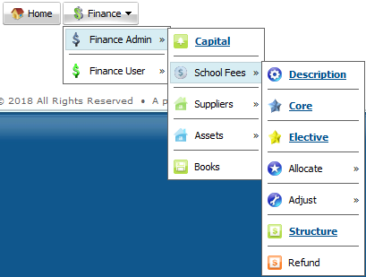

1. **Capital**

Represents the ininitial investment used to begin the school

Enter the capital amount and click submit

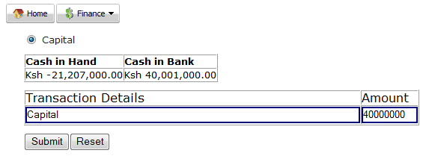

**Note**

This amount is transferred directly to the bank and reflects as cash in bank

1. **School Fees**

Enables management of school fees at higher level and has seven sub areas: Description, Core, Elective, Allocate, Adjust, Structure and Refund

1. **Description**

Enables entry or edit of school fee vote heads / descriptions. The vote heads may be core (compulsory to all students and paid each term) or elective (variable fee vote based on factors around the student).

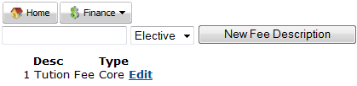

Enter the fee description and select if it’s either core or elective.

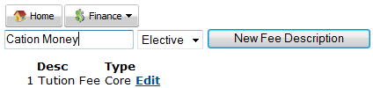

Click new fee description to save your entry.

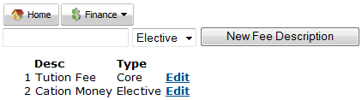

Below is a sample list of fee descriptions / vote heads.

**Note** It is advisable to only have tuition fee as the only core description and the rest as elective

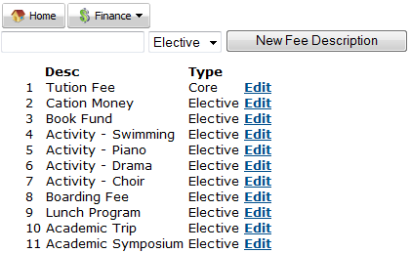

1. **Core**

Enables to set the core fee for a specified year. Confirm the desired year and click on new core fee.



Enter the correct amount of fee payable for each class and term and click on new global fee.

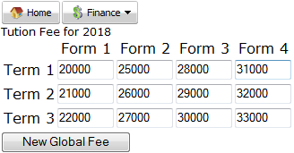

The core fee will appear as below

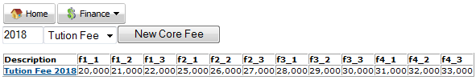

1. **Elective**

Enables setting of elective fee for the desired year. The elective fee can be paid in four ways: One Off, Annual, Per Term and Randomly.



Confirm the desired year, select the elective fee type, select the payment type and enter the amount payable.



Click on new elective fee to save your desired input.

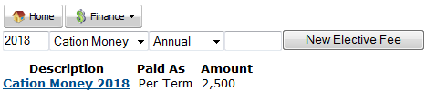

Click on the elective fee name (hyperlink) if you desire to edit the saved entry.

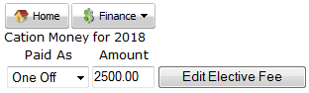

Click on edit elective fee to save your entry.

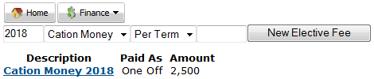

Below is a sample list of how elective fee details will appear.

**Note** Random fee types can be paid several times in a term

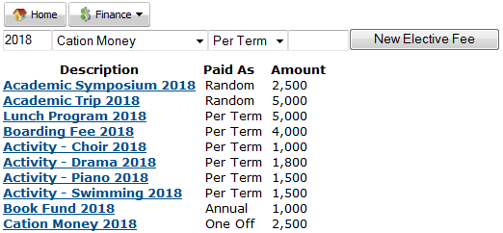

1. **Allocate**

Enables assigning of fee items to the students. It can either be done on single basis (one student at a time) or in bulk (all students in a given class per term)

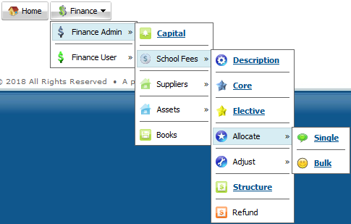

1. Allocate Single

Enables assigning of fee item to one student at a time. Confirm the year and click on submit to get a list of students.

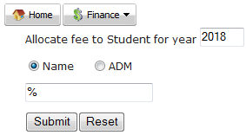

Click on the desired student from the list

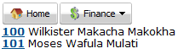

Select the desired elective fee, year and term and click allocate fee

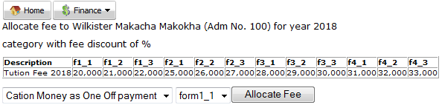

Confirm the amount payable based on the student category discount and click on allocate new fee.

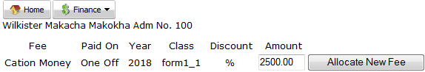

The fee item will appear on the student fee page. You can either edit (by clicking on the allocated amount) or delete the fee item

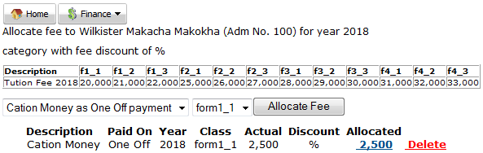

Below is a list of fee items on a sample student fee page.

**Note** The fee amount payable (core and elective) is auto computed by the system wherever any change is made.

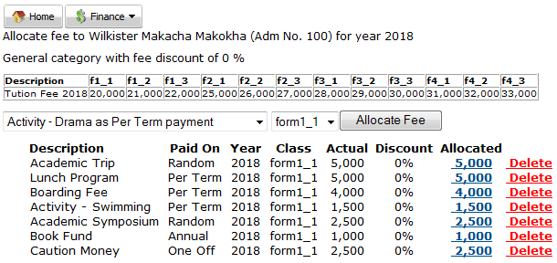

1. Allocate bulk

Enables assigning of fee items to all the students in a given class and term. Confirm the desired year, class and term are selected and click on submit.

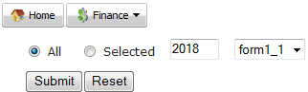

Select the desired elective fee and click on allocate fee

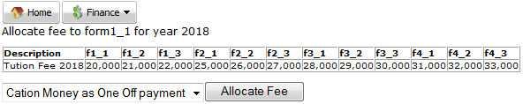

Below message will appear.

Note The system will intelligently allocate the fee based on the payment types, assign correct discount and skip students who already have the desired vote in their page.

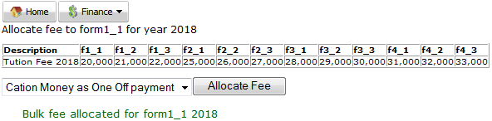

1. **Adjust**

Enables making changes to either debit or credit balances at the beginning of each term for either single (one student at a time) or bulk (multiple students, term and year). This is common when using ERIS for the first time and there is need to correctly capture historical information of the students.

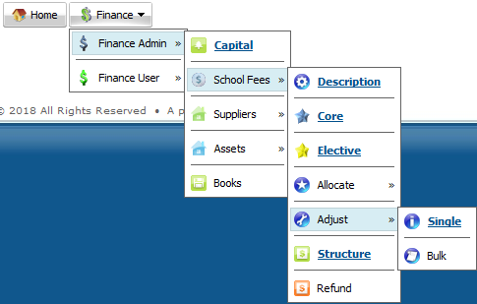

1. Adjust single

Enables making changes to either the debit balance (fee balance) or credit balance (fee overpayments) at the beginning of a given term and year for a given student. Conform the correct term and year are selected and click on submit

Select the desired student from the list and click on them

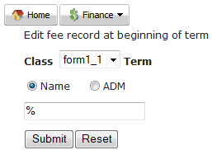

Enter the correct debit (fee balance) or credit (fee overpayment) balance at the beginning of the selected term and year and click on submit.

**Note** This will appear just before the term fee on the fee statement.

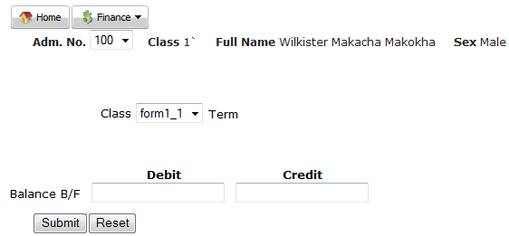

1. Adjust bulk

Enables making changes to either the debit balance (fee balance) or credit balance (fee overpayments) at the beginning of multiple term and year from a given csv file (**not excel file**). Click on browse, Navigate up to where the inventory csv file is click on it and click open

Click Submit to upload the csv file

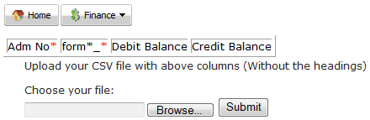

**Note** Below is a sample csv file indicating how the columns should appear ready for uploading. Multiple different term and years can appear in one csv file. In addition, a student can only have either debit or credit balance and not both

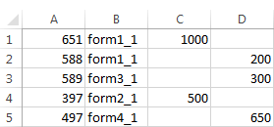

Suppliers

1. **Structure**

Enables obtaining list of fee payable and existing invoice for a given term and year

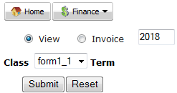

Below is sample fee structure

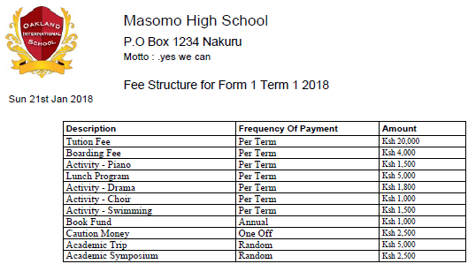

Below is sample invoice

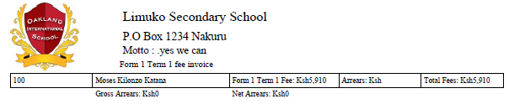

1. **Refund**

Enables refund / reversal of fee that has been earlier paid by the student. Select the desired term and year then click Submit.

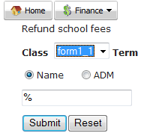

Select the desired student from the list



Click on the radio button that corresponds to the desired fee to reverse then click submit

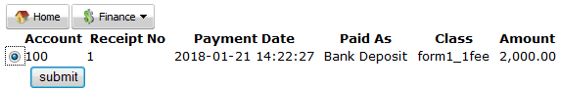



**Note:**

The module reverses the whole amount of fee that was paid out by the student

This process is recorded in the books of accounts and hence the reversed money may be given back to the parent

After reversal, the transaction disappears from the student fee statement

1. **Suppliers**

Enables entry or edit of persons or organisations approved to transact business with the school. Has three sub areas: New, Edit and List.

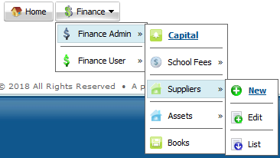

1. **New**

Enables entry of supplier details into the system. Enter all the details as per below sample and click on new supplier details.

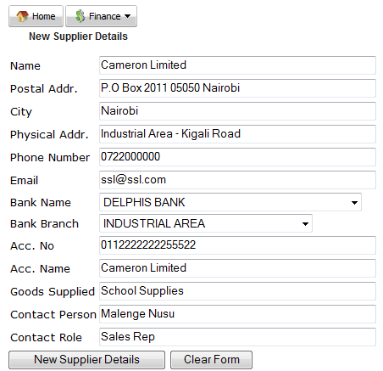

1. **Edit**

Enables making changes on exiting supplier details in the system. Click on desired supplier name.

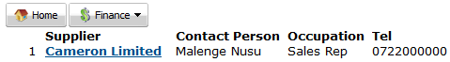

Make the desired changes and click on edit supplier details.

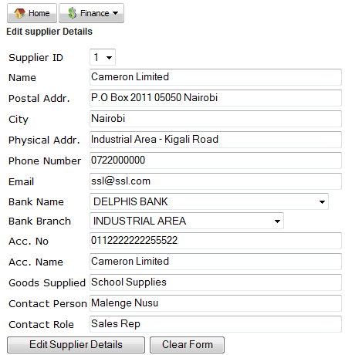

1. **List**

Enables viewing of report on supplier details already saved in the system.

1. **Assets**

Enables management of school assets. Has two sub areas: Depreciate (reduce in value) and Dispose (sell at either gain or loss)

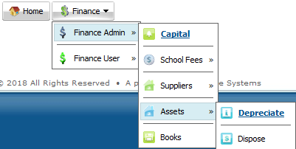

1. **Depreciate**

Enables depreciation of Fixed Assets

Click on the radio button that corresponds to the asset that you desire to depreciate, then click submit

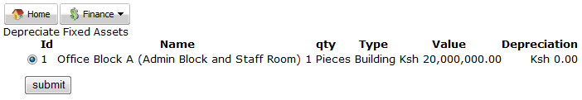

Enter the desired amount that correspond to the amount being depreciated then click depreciate

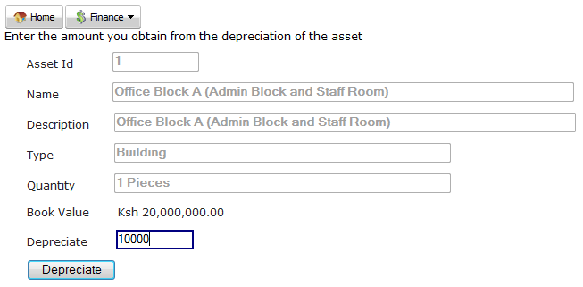

1. **Dispose**

Enables disposal of Fixed Assets

Click on the radio button that corresponds to the asset that you desire to dispose, then click submit

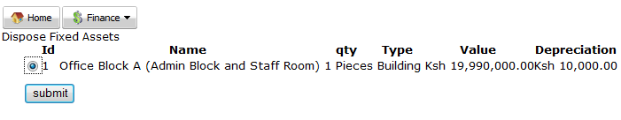

Enter the desired amount that correspond to the amount obtained after disposal of the asset then click submit

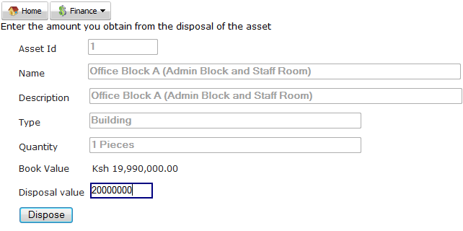

1. **Books**

These are three books of finance that represent records of the school financial transaction. These books are auto closed / auto opened on each new calendar year.

Click on the radio button that correspond to the desired book, enter the desired financial year then click submit

Books

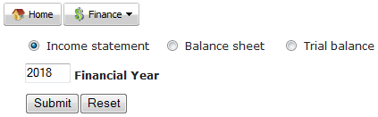

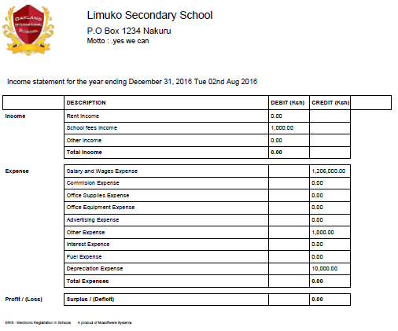Below are sample books

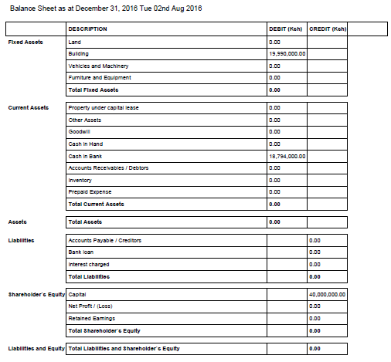

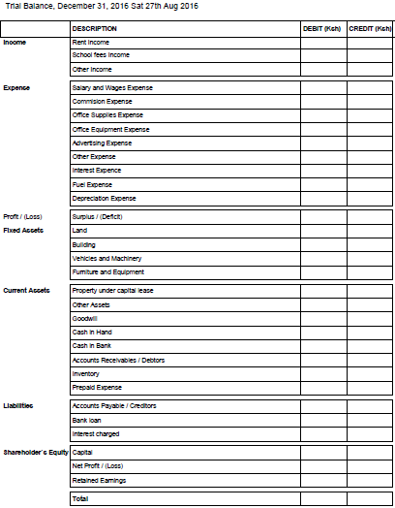

1. **Category**

Enables clustering of students into fee categories, where each category may enjoy a given discount on fee payable.

Enter the desired category name, desired discount (0 {zero} for no discount) and click on new category

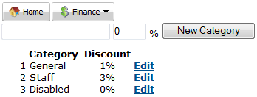

Click on edit category, make desired changes then click on edit category to save your changes.

