**Mosoftware Systems 2.1 – Finance Module**

**Finance user**

This module can be accessed by those with Finance User, Finance Admin and Admin rights only

It has five areas: School Fees, Invoices, Loan, Float and Transactions

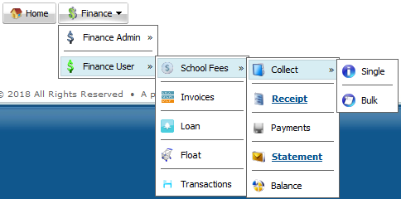

1. **School Fees**

This enables management of school fees at a lower level. School fees is the major income earner for the school and therefore the need to manage it using a system like ERIS.

This has five sub areas: Collect, Receipt, Payments, Statement and Balance.

1. **Collect**

Enables fees to be received from students and posted in their respective accounts. Fee can be received ether Single (from one student in given year and term) or bulk (multiple students in desired term and year)

1. Single

Enables fee to be received from a given student for a given year and term. Select the desired term and year, click submit, and select the desired student from the list

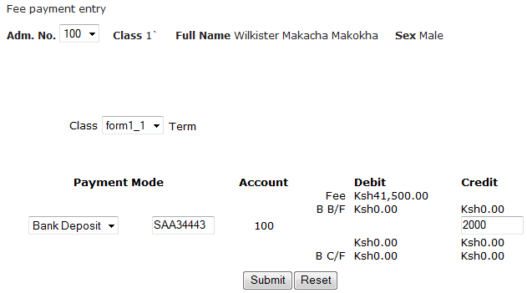

Enter the fee payment details and click submit. Note that payment is posted in the student account (adm no)

The system supports different payment modes.

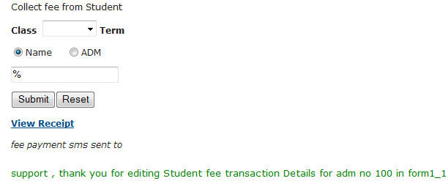

You can download the receipt after payment or latter from receipt sub area

1. Bulk

Enables receiving fee from multiple students, term and year from a csv file (**Not Excel**)

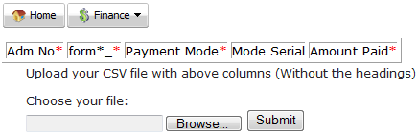

Below is a sample csv file (**Not Excel**) indicating correct columns to upload

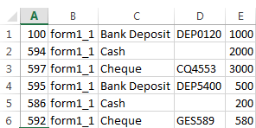

1. **Receipt**

Enables download of proof of school fees payment for a given student. These are auto generated by the system

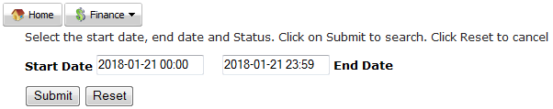

Select and click the desire payment from the list displayed

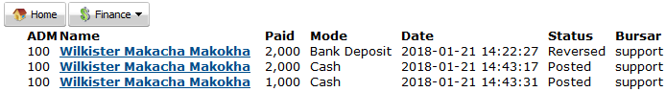

Below is a sample receipt

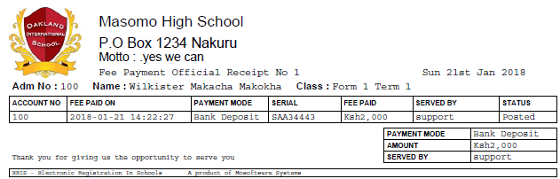

1. **Payments**

Enables download of verifiable document of money received in the school

Below is a sample payments document

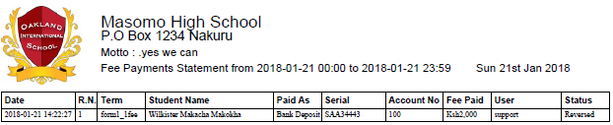

1. **Statement**

Enables download of personalised document indicating debit and credit details posted on the student fee account.

Select the desired term and year, click submit, and select the desired student from the list.

Below is a sample statement document

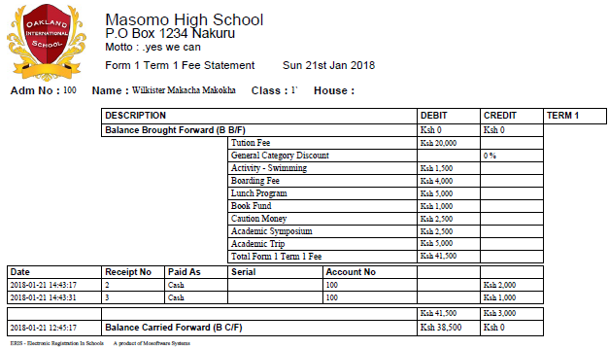

1. **Balance**

Enables viewing of students with fee debit balance based on a defined term, year and amount.

Select the desired term and year, enter the desire balance amount then click submit

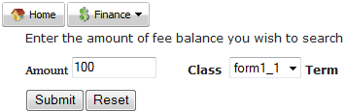

Below is a sample fee debit balance statement

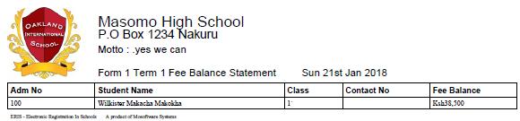

1. **Invoices**

Enables view and payment of invoices from suppliers.

Select the desired supplier and click submit

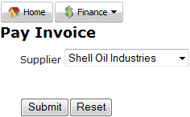

Click on the desired invoice from the list provided

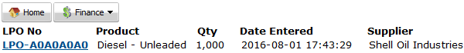

Confirm all the details are correct, enter invoice number, select mode of payment, select payment then click submit

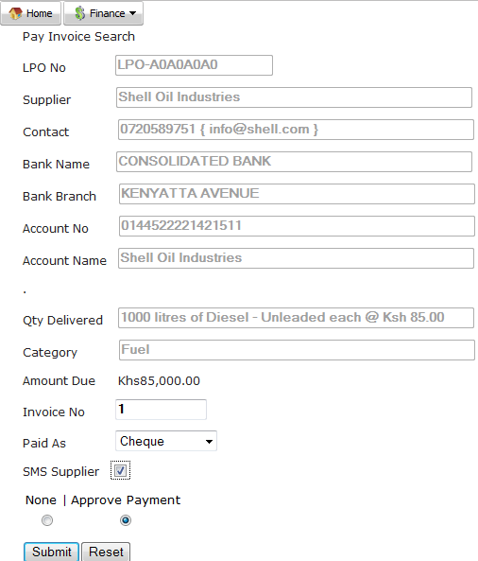

Follow up and honour the payment.

**Note**

Supplier bank details come in handy when making payments

Details of the LPO are received from the Inventory module

1. **Loan**

Enables recording of details from loan acquired from the bank.

Click on get bank loan, enter the transaction details, principal and interest amount received and click submit

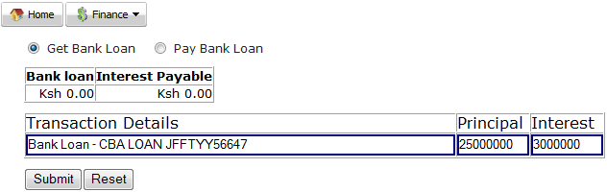

To pay for a loan, click on pay bank loan, enter the transaction details, principal and interest amount to be paid and click submit

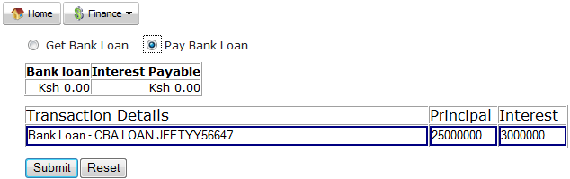

1. **Float**

Enables movement of money from and to the bank.

To withdraw from bank (move money from bank to hand), click on withdraw from bank, enter the transaction details, amount to transfer and click submit

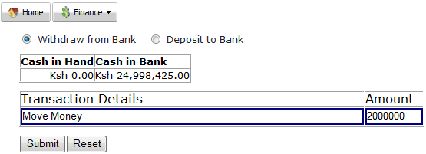

To deposit to bank (move money from hand to bank), click on deposit to bank, enter the transaction details, amount to transfer and click submit

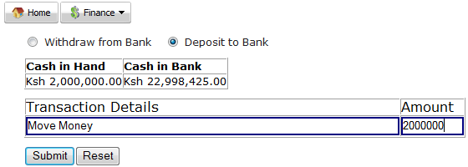

1. **Transactions**

Enables download of document that indicates how finances within the school have been managed.

Select the desired start and end date, desired transaction (blank yields all transactions) and click submit

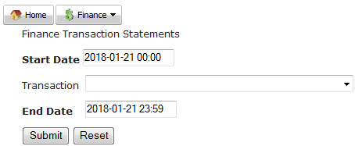

Below is a sample transactions document

