**Mosoftware Systems**

**Inventory Module – ERIS 2.1**

**Inventory Admin**

It is only accesed by those with inventory admin system access and admin system access.

Enables management of products owned by the school at a higher level.

It has three areas: Products, Units and Procure

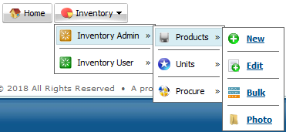

1. **Products**

Enables entry and edit of products owned by the school

It has four sub areas: New, Edit, Bulk and Photo

1. **New**

Enables entry of details of one product at a time into the system.

Enter the product details and click on new product details to save the entry

**Note** The supplier details need to have populated in the finace module before making a new product entry

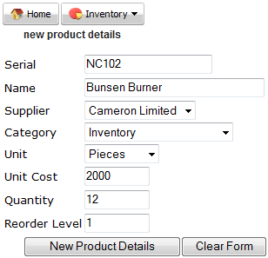

1. **Edit**

Enables making changes to exiting products in the system.

Click on the desired product name.



Make the desired changes and click on edit product details to save your entry.

To upload a photo, click on the upload photo link.

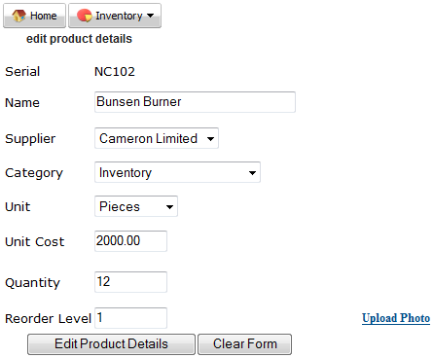

Click browse and navigate to where you have stored the product photo, select it then click upload photo

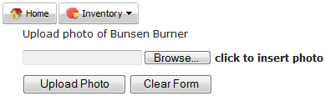

Once uploaded, click on edit product details to save the changes made.

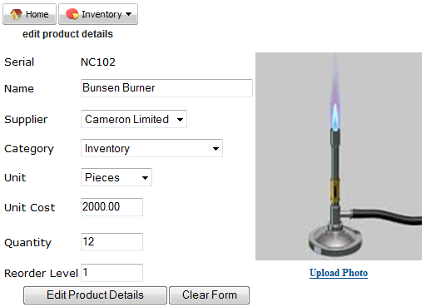

1. **Bulk**

Enables entry of multiple product details by uploading a csv file (**Not Excel**)

Click on browse, navigate to where the file is, select it and click on submit

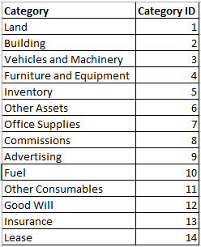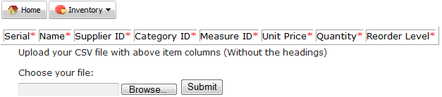

Below is a sample csv file (**Not Excel**) indicating correct column details

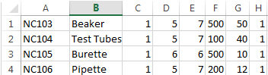

**Note**

Use supplier id rather instead of the supplier name (refer details from the finance module)

Use category id rather instead of the category name (use the table provided for reference).

Use measure id rather instead of the measure name (refer details from the units area, edit sub area)

1. **Photo**

Enables entry of product photos in bulk from a csv file (**Not Excel**)

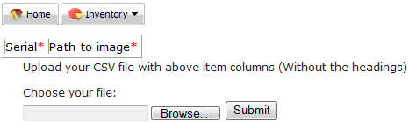

1. **Units**

Enables entry or edit of product units of measurement. Has two sub areas: New and Edit.

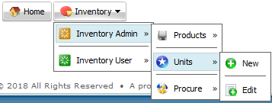

1. **New**

Enables entry on product unit of measurement. Enter the unit abbreviation and full name then click submit

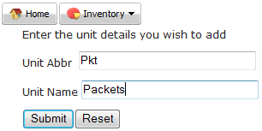

1. **Edit**

Enables making changes to existing units of measurements for the products. Click submit after making changes

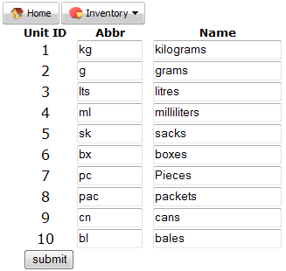

1. **Procure**

Enables process of acquiring school products by replenishing deleted ones.

The process is initiated when a product quantity reaches the re-order level

Has five sub areas: Request Quotation, Update Quotation, Order, Receive Delivery and Report

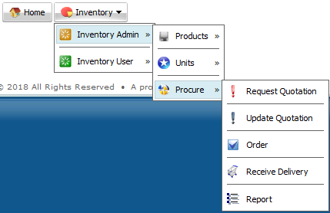

1. **Request Quotation**

It populates product whose quantity are at or below the re-order level. Below are the steps to request quotation:

1. Select the most suitable supplier (based on school preference) from the supplier list
2. Enter the quantity of the product that you desire to be given quotes on
3. Change Status from **Pending** to **Approve**
4. Select to put a tick if you desire the supplier to be sent a text message / sms requesting for the quote

Click submit

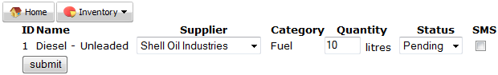

**Note:** Once the quote request is sent, it is passed on to the next level (update quotation) and disappears from the queue

1. **Update Quotation**

This is the second stage after requesting for a quote. It assumes that the supplier responds with their quotation

Select the suitable supplier and click submit

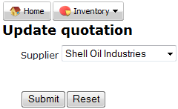

All quotation requests awaiting to be updated under the supplier will be visible

Click on hyperlink of desired product so as to update the quote as received from the supplier.

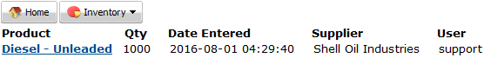

Update the unit price, discount and VAT amount, Select Approve or Cancel, Click submit

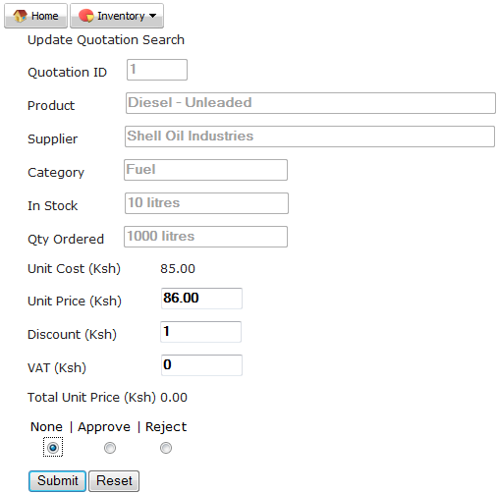

**Note:** Select **Approve** to accept the quote or **Reject** to cancel the quote and take it back to the previous step

1. **Order**

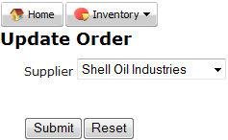This is the third step where an order to the supplier is generated once their quote has been updated and approved / accepted

Select the suitable supplier and click submit

All orders awaiting to be updated under the supplier will be visible

Click on hyperlink of desired product so as to update the orders.

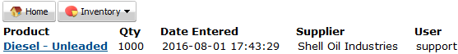

Update the desired quantity to be ordered, select whether to sms the supplier

Select whether to Approve or Cancel the order, Click submit

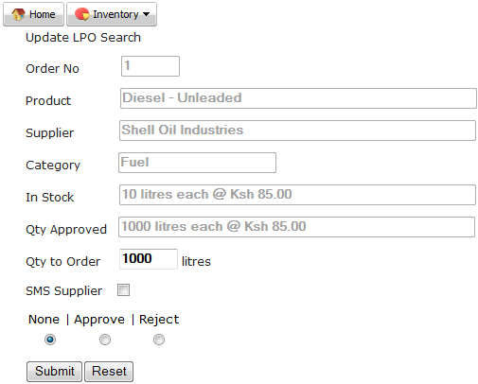

**Note:** Select **Approve** to accept the order or **Reject** to cancel the order and take it back to the previous step

1. **Receive Delivery**

This is the fourth and final step in the procurement process where once an order is approved / accepted, an LPO (Local Purchase Order) No is generated and the supplier uses this as a reference to supply the product

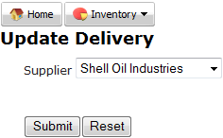

All LPO of products awaiting to be delivered under the supplier will be visible,

Click on hyperlink of desired product so as to update the delivery.

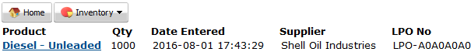

Enter the quantity of product delivered, invoice number, select approve and click Submit

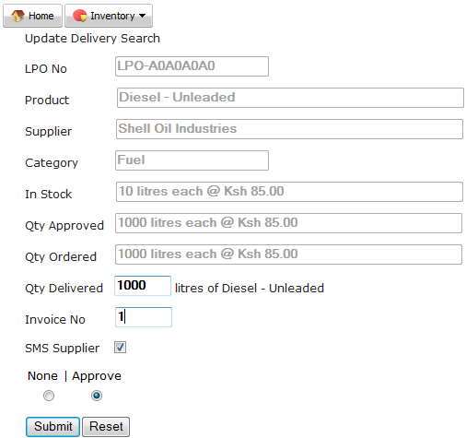

**Note:** once product has been received, the supplier payment process is then transferred to the Finance Module and the delivered product quantity is added into the corresponding; existing inventory product quantity

1. **Report**

This is a professional report where a start and end date ranges may be set to view reports below

1. Approved or rejected quotes
2. Approved or rejected orders
3. Paid or unpaid deliveries
4. Active or expired annuities (Insurance policies)

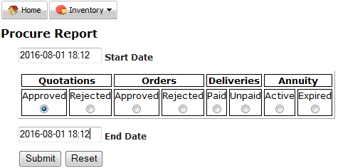

Below are sample reports

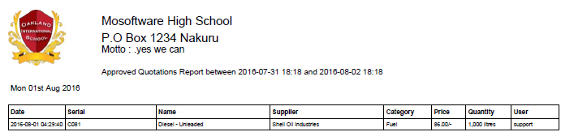

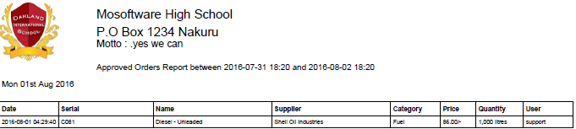

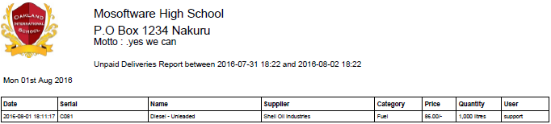

**Inventory User**

Can be accessed only by those with inventory user, Inventory admin and admin system access.

Enables management of school products at a lower level.

It has three areas: Issue, Return and Report

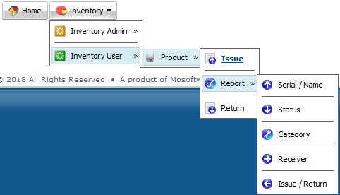

1. **Issue**

Enables dispensing of product to ether an enrolled student or employed member of staff

Select desired student or staff details and click submit.

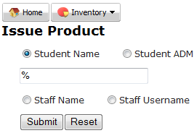

Select the desired name from the list.



Enter either product name or serial and click submt

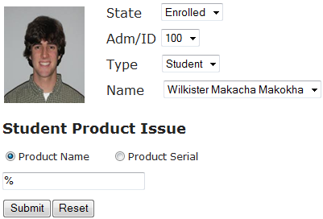

Select desired product name from the list



Confirm the desired product to be dispensed, enter the quantity being dispensed and click issue product

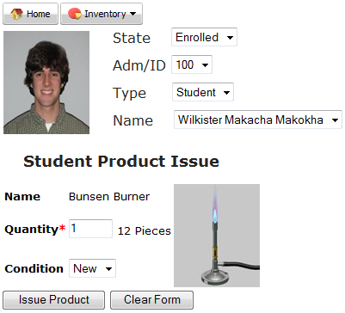

**Note** The product is auto deducted from the store and placed on the student / staff account

1. **Return**

Enables receiving of returned product from either staff or student

Select the desired student / staff from the list

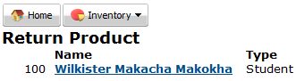

Change status from issued to returned and click on submit

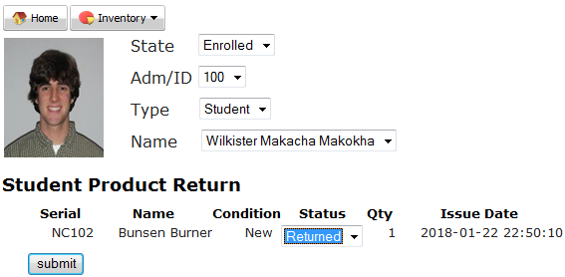

**Note** The product is auto removed from the student / staff account and added back to the store

1. **Report**

Enables download of information on lower management of products owned by the school.

It has five sub areas: Serial/Name, Status, Category, Receiver and Issue/Return

1. **Serial/Name**

Enables search of existing products by their serial number or name

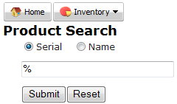

Select the desired product from the list



Below is a sample display of existing product

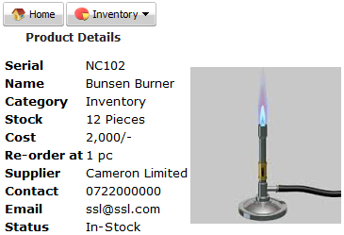

1. Status

Enables searching of existing products based on their availability or lack of availability.

Below is a sample status document result

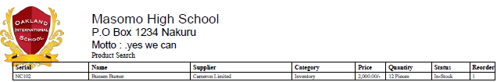

1. Category

Enables searching of existing products based on existing fourteen product category names.

Below is a sample category document result

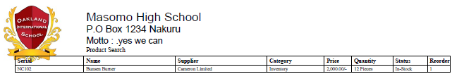

1. Receiver

Enables searching by details of the individual who has been issued with a product in the past.

Below is a sample receiver document result

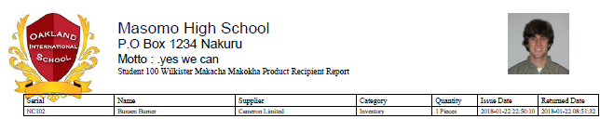

1. Issue/Return

Enables searching based on start and end dates, details of who has been issued with or returned a given product.

Select the desired date range, either issued or returned and click on sumit

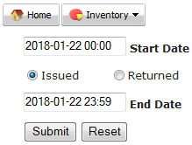

Below is a sample issued / returned document result

