**Mosoftware System**

**Managing Transport Module**

Enables management of transport system within the school

**Define Bus drivers**

The first step is to define a driver among the school employees. To do so go to admin >

Manage User > New User and populate the required details. Select staff type as Driver. Once done submit request.

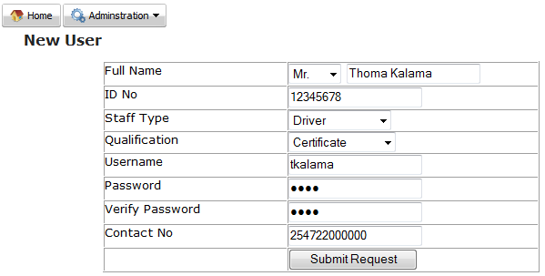

**Define Bus supplier**

Next we need to define the school bus supplier

Go to Finance > Finance Admin > Suppliers > New and populate all required details and click new supplier details

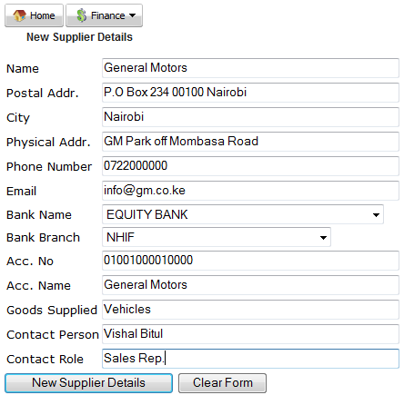

**Enter new bus details**

Go to Inventory > Inventory Admin > Products > New and populate with all the required details

**Note** remember to select vehicle and Machinery under category

Once done click on new product details

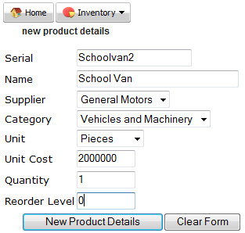

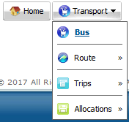Transport Module has four sections

1. **Bus**
2. **Route**
3. **Trips**
4. **Allocations**
5. **Bus**

Enables management of school vans / Bus that is used to ferry students to and from school

Click on the hyperlink that corresponds to the desired bus

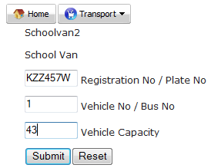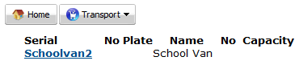

Enter required details then click on submit

**Note** do not leave a space for the registration no / plate no

1. **Route**

Routes are geographical areas around the school where students may be clustered into for ease of being picked or dropped.

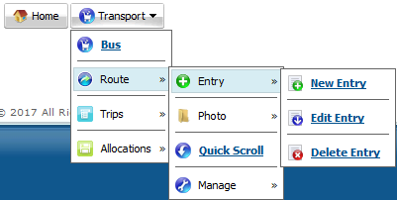This has four areas

1. **Entry**
2. **New Entry**

Enables entry of new route into the module

Enter all the details and click submit

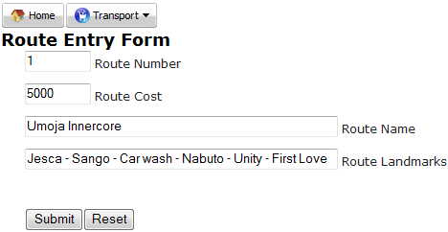

1. **Edit Entry**

Enables making of bulk changes on routes. Once opened, make the desired changes then click submit

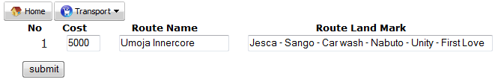

1. **Delete Entry**

Enter the route number to delete and click submit

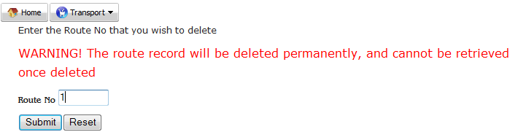

1. 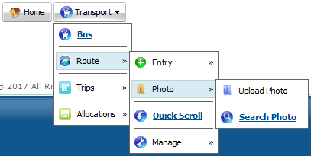**Photo**

Has upload photo and search photo

Route photos can be got from google earth

1. **Upload Photo**

Select the desired route, Click Browse and

navigate to where the image is stored, open

and click Upload Photo

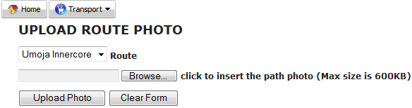

1. **Search Photo**

Select the desired route and click on submit

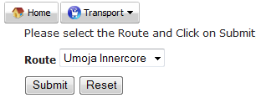

Below is a sample map photo

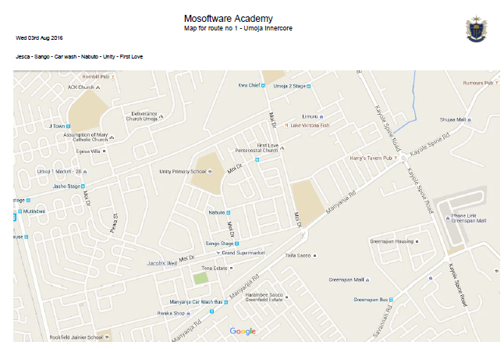

1. **Quick Scroll**

Enables a quick view of the routes within the system

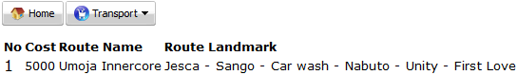

1. **Manage**

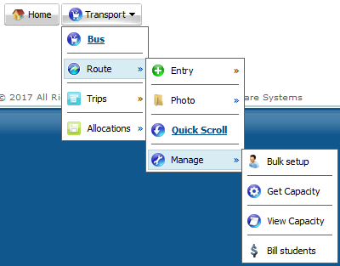This is the admin console for the route within the

school transport module

1. **Bulk Setup**

Enables bulk setting up of routes for the student

using route number by uploading a csv file

Click Browse and navigate to where the csv file

is stored, open it then click Submit

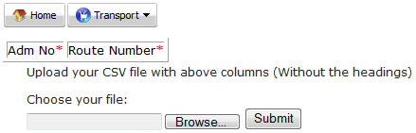

1. **Get Capacity**

Click on compute route capacity to determine how many students are contained in each route



Below is a sample route capacity. This helps in planning on which bus to allocate on a given route

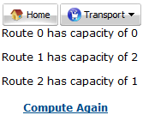

1. **View Capacity**

Enables viewing of students in the desired route

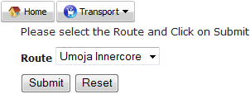

Below is a sample route capacity view

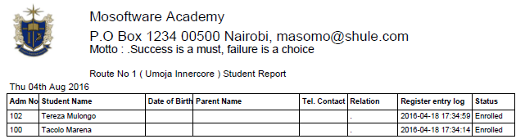

1. **Bill Students**

Enables charging of the route cost to the student fee for the desired term. Select the desired term then click submit

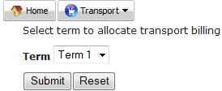

Below is the billing confirmation

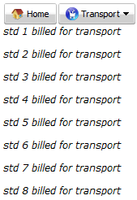

1. 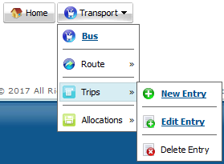**Trips**

Trips are components of a route

1. **New Entry**

Enables entry of new trip into the transport module,

enter all the details and click submit

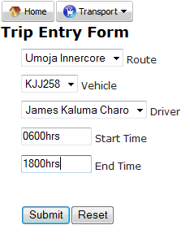

1. **Edit Entry**

Enables making of bulk changes on trips. Once opened, make the desired changes then click submit

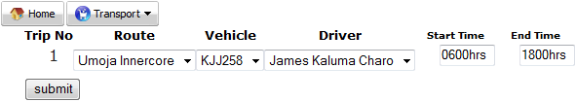

1. **Delete Entry**

Enter the driver number to delete and click submit

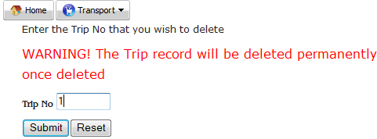

1. **Allocation**

Enables allocation of student to the various trips within their respective routes. Also known as boarding students into the available vans / buses. Allocation is done per class where students of the same class and same route are allocated into the same vehicle until it is full. This encourages bonding and cohesion.

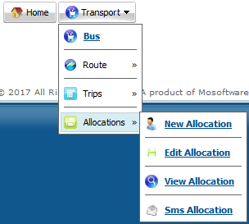It has four sections

1. **New Allocation**

Enables boarding of students into a bus in a given trip,

Select route, class and stream and click submit

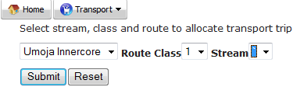

Allocate the desired trip then click submit

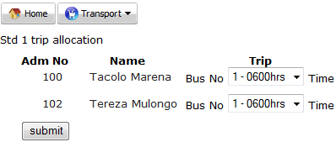

Below is the sample message received after the process of allocation.

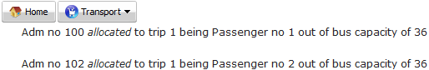

**Note**

The system will automatically stop the allocation once the bus is full.

1. **Edit Allocation**

Enables making changes on a given allocation (students boarded in a bus on a trip)

Select the desired bus no and time then click submit

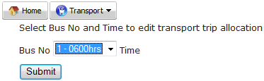

Change the trip on the respective student and click submit

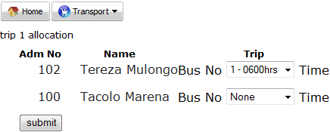

**Note**

Once a student has been removed from a bus, the vacancy may be filled in by a student from the same route

1. **View Allocation**

Enables viewing of students in a bus for a given trip

Select the desired bus no and click submit

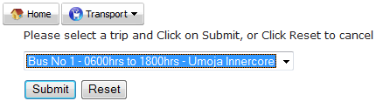

Below is a sample allocation

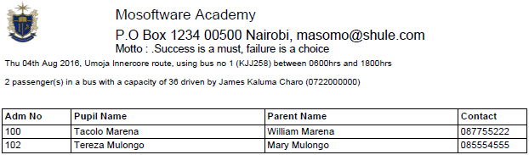

**Note**

This list may be used as a checklist when picking or dropping student in the school as it has student details

The document also contains the bus number, registration number, trip time, name and contact of the driver

1. **Sms Allocation**

Enables communication to the parents/guardians on the allocation details of their respective students

Below are two sample text sent to the parents/guardians contact

Hi, Tereza Mulongo of Umoja Innercore route will be picked by James Kaluma Charo - 080808206 with bus no 1 - KJJ258 at 0600hrs and back at 1800hrs

Hi, Mary Akoth of Dohnholm route will be picked by Luke Maloti - 0857455565 with bus no 2 - KJJ259 at 0600hrs and back at 1800hrs

**Note**

Depending on the school policy, these sms may be sent either when there is changes in the routes, vehicles, drivers or trips

The sms is only sent to parents/guardians whose contacts are captured in the system