**Report: Analysis of Frailty Indicators in Female Participants**

**1. Introduction: The Ingest Stage**

* **1.1. Objective:** To analyze the relationship between physical attributes (height, weight, age, grip strength) and the presence of frailty in a sample of 10 female participants.
* **1.2. Data Source:** The analysis is based on a provided dataset containing measurements for 10 individuals. The raw data was saved to https://raw.githubusercontent.com/mosomo82/COMP_SCI_5530/refs/heads/main/Assignment/Assignment_1/Q1_Frailty_Study/raw_data/raw_data.csv and loaded into a pandas DataFrame for processing.
* **1.3. Workflow Overview:** This report follows a three-stage data processing workflow:
  + **Ingest:** Loading the raw data from the CSV file.
  + **Process:** Cleaning, standardizing, and transforming the data by applying unit conversions, feature engineering, and encoding.
  + **Analyze:** Performing exploratory data analysis (EDA) to derive insights and quantify relationships within the data.

**2. Data Processing Methodology**

This section details the sequential steps taken to transform the raw data into a structured and analyzable format. Preliminary data cleaning process performed such as checking missing, format the columns and save the dataset as a clean data for processing,

* **2.1. Unit Standardization:**
  + **Height Conversion:** The Height column, originally in inches, was converted to meters and stored in a new Height_m column using the formula: Height_m = Height_in * 0.0254.
  + **Weight Conversion:** The Weight column, originally in pounds, was converted to kilograms and stored in a new Weight_kg column using the formula: Weight_kg = Weight_lb * 0.45359237.
* **2.2. Feature Engineering:**
  + **Body Mass Index (BMI):** A BMI feature was calculated from the standardized height and weight using the formula BMI = Weight_kg / (Height_m ** 2). The result was rounded to two decimal places.
  + **Age Group Categorization:** The continuous Age variable was categorized into a new AgeGroup column with the following bins: "<30", "30–45", "46–60", and ">60".
* **2.3. Categorical to Numeric Encoding:**
  + **Binary Encoding of Frailty:** The Frailty column (Y/N) was converted into a numeric binary format. 'Y' was mapped to 1 and 'N' was mapped to 0, stored as an int8 in the Frailty_binary column.
  + **One-Hot Encoding of AgeGroup:** The AgeGroup categorical variable was transformed into four new binary columns (AgeGroup_<30, AgeGroup_30–45, AgeGroup_46–60, AgeGroup_>60) to allow for quantitative analysis.

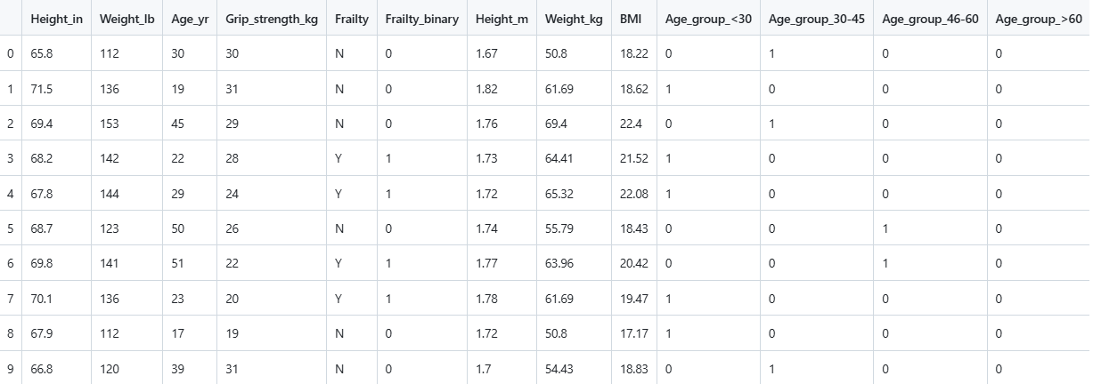

**3. Analysis and Findings**

This section presents the results derived from the processed data.

* **3.1. Summary of Descriptive Statistics:**
  + A summary table was generated to outline the central tendency and dispersion of the key numeric variables.



* **3.2. Correlation Between Grip Strength and Frailty:**
  + To quantify the relationship between physical strength and frailty, the Pearson correlation coefficient was computed between the Grip strength and Frailty_binary columns.
  + Correlation between Grip Strength and Frailty: -0.48.The finding of -0.48 provides statistical evidence to support the initial hypothesis. Female participants with lower grip strength are classified as frail. Conversely, those with higher grip strength are classified as not frail.

**4. Conclusion**

* **4.1. Summary of Results:** This analysis successfully processed raw health data through a three-stage workflow. Key findings include the statistical summary of participant attributes and a quantified negative correlation between grip strength and the presence of frailty, which aligns with the initial hypothesis.
* **4.2. Future Work:** The processed dataset is now suitable for more advanced analysis, such as developing a predictive machine learning model to classify frailty based on the engineered features.

**5. Appendix: Python Implementation**

https://raw.githubusercontent.com/mosomo82/COMP_SCI_5530/refs/heads/main/Assignment/Assignment_1/Q1_Frailty_Study/src/Assignment1_Frailty.ipynb