Executive Report: Used Car Dataset Analysis
This report details the data cleaning, transformation, and analysis performed on the used car dataset (train.csv). The primary goal was to process messy, real-world data into a clean, machine-learning-ready format and then perform a final analysis to compare car brands.
The analysis concluded that among popular, first-owner vehicles, Mercedes-Benz, BMW, and Audi are the most expensive brands on average, while Toyota and Mahindra vehicles show the highest average kilometers driven per year.

Data Cleaning and Validation
The initial dataset contained 5,847 rows and 14 columns. Several key columns (Mileage, Engine, Power, New_Price) were incorrectly stored as text (character) data, embedding units and non-numeric values. Here is the summary of raw data
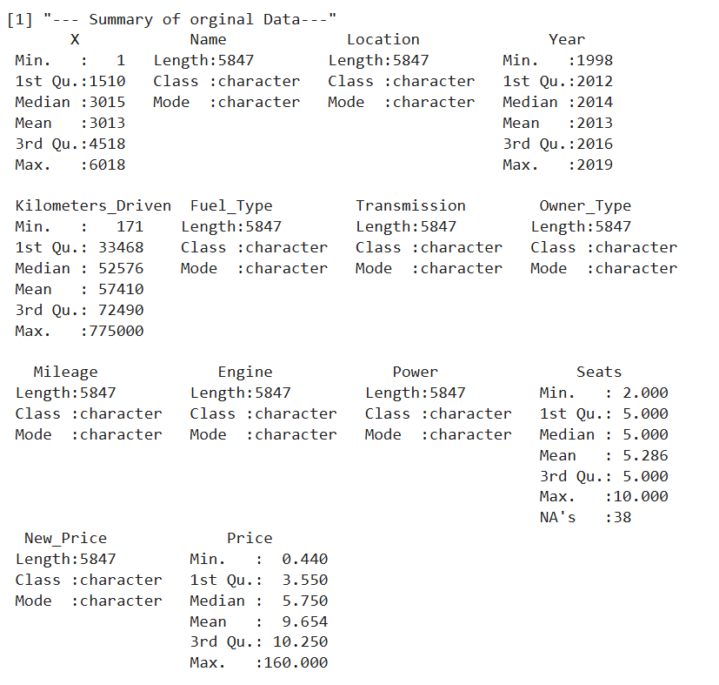
Key cleaning actions taken:
- Unit Standardization: Text-based units were removed, and values were converted to a numeric format.
  - Mileage: Standardized to "kmpl". Values in "km/kg" were converted to an approximate "kmpl" equivalent (multiplied by 1.6).
  - Engine: "CC" text was removed.
  - Power: "bhp" text was removed.
  - New_Price: "Lakh" and "Cr" (Crore) values were standardized to "Lakh" (e.g., "1.5 Cr" became "150 Lakh").
- Outlier Correction: An extreme outlier in Kilometers_Driven (6,500,000 km) was identified and corrected to 650,000 km, assuming a data entry error.
- Missing Value Identification: After converting columns to numeric, the true number of missing values (NAs) was identified:
  - New_Price: 5,049 NAs (over 86% of the data)
  - Seats: 38 NAs
  - Engine: 36 NAs
  - Power: 36 NAs
  - Mileage: 2 NAs
The sample of problematic rows for Mileage, Engine and Power in the dataset
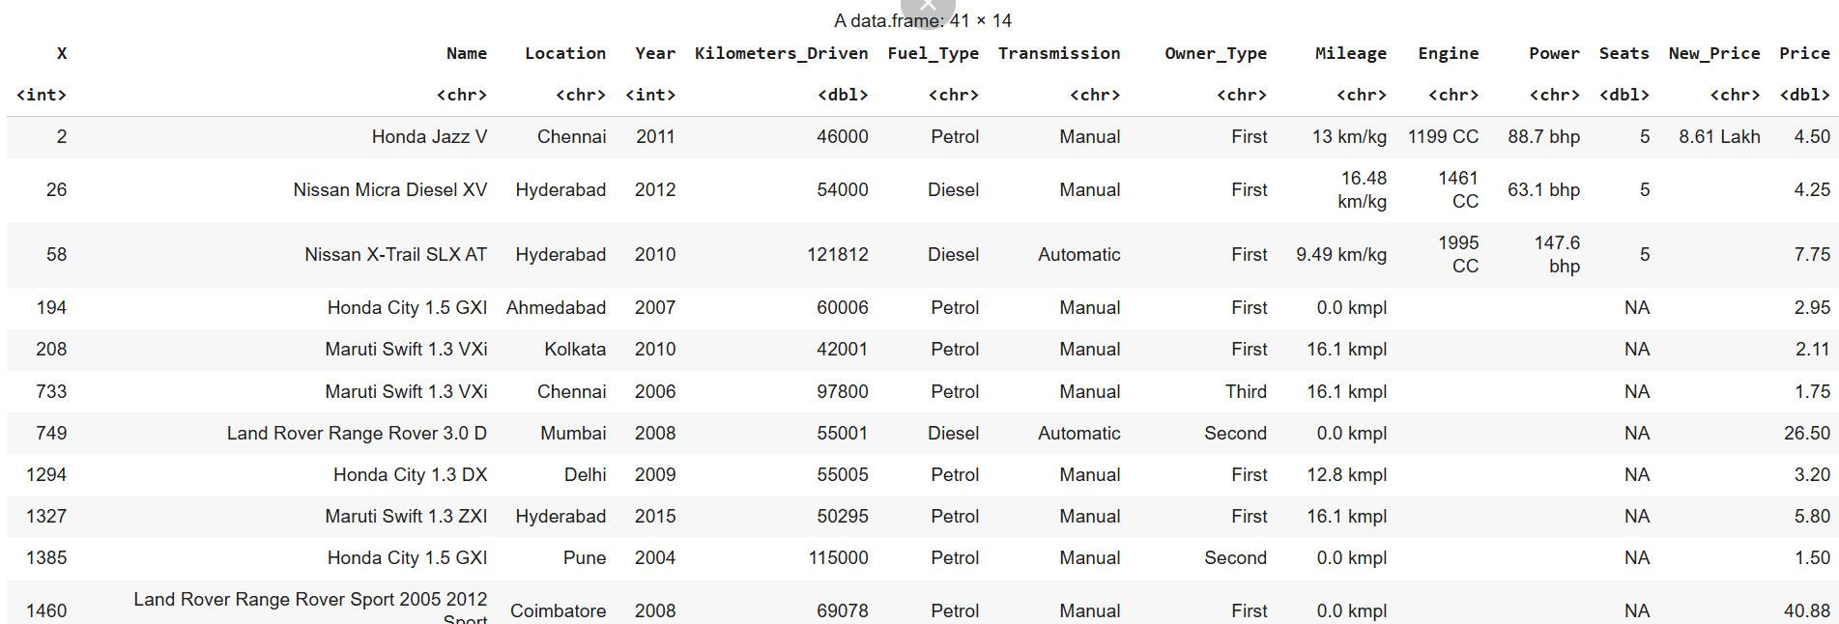
Data Transformation and Imputation
To create a complete, clean dataset, missing values were imputed using robust methods, and new features were engineered. Dropping rows should be avoided because the NAs are spread across different rows. Also, we are not dropping the columns (like ‘New_Price’) because knowing the ‘New_Price’ is not used for the analysis, and it is set for the price of selling based on the price of purchasing cars.
Imputation Methodology
- Mileage, Engine, & Power: NAs were filled using the median value of each column. The median was chosen over the mean to prevent distortion from a few high-performance or luxury cars.
- Seats: NAs were filled using the mode (most frequent value), which was 5. This is the most logical choice for discrete, categorical data. Using the mean is not appropriate (you cannot have 4.8 s/eats).
- New_Price: Due to the extreme number of missing values (86%+), a sophisticated, multi-step imputation was used:
  - Grouped Median: First, NAs were filled using the median New_Price for that specific car model (e.g., all "Honda Jazz V" entries).
  - Global Median: If a car model had no New_Price data at all, the global median New_Price from the entire dataset was used as a fallback.
  - Validation: A final check ensured that no imputed New_Price was lower than the car's used Price.
Feature Engineering
New columns were created to add more value to the dataset:
- Car_Age: Calculated using the Year column (2025 - Year).
- Brand: Extracted from the Name column (e.g., "Hyundai Creta..." became "Hyundai").
- Kilometers_Per_Year: A normalized metric of car usage, calculated by dividing Kilometers_Driven by (Car_Age + 1).
- Is_First_Owner: A binary (0/1) column created from the Owner_Type column, which is ideal for modeling.
One-Hot Encoding
Categorical columns (Fuel_Type, Transmission, Brand, Location) were one-hot encoded (converted into dummy variables). This transformed the dataset into a wide format (64 columns), making it fully numeric and suitable for machine learning models.
The final, fully processed dataset was saved as clean_used_cars.csv. Here is the sample of clean_used_cars
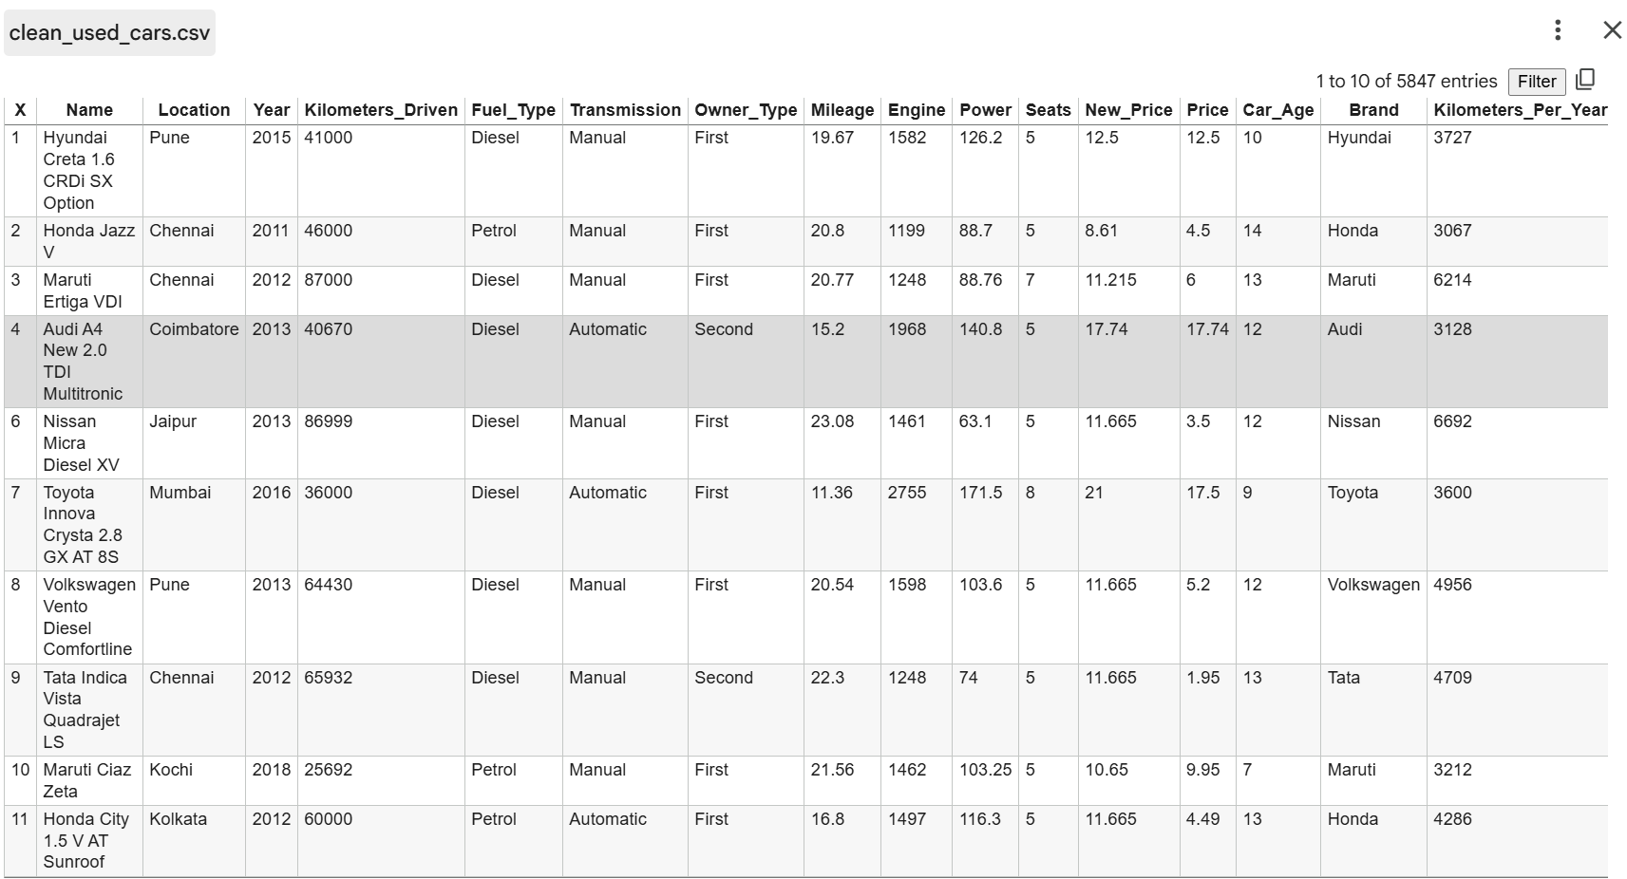

Final Analysis and Key Findings
The final step was to analyze the cleaned data. The analysis focused on first-owner cars only to provide a clear comparison of brands based on their price, power, and usage.
The code grouped all first-owner cars by ‘Brand’ calculated the average price, power, and annual kilometers, and then sorted the results to highlight popular brands (defined as >50 listings).
This analysis was saved as analysis_goal.csv.
Key Findings:
- Most Expensive (Popular Brands):
  - Mercedes-Benz: 29.06 Lakh
  - BMW: 27.56 Lakh
  - Audi: 26.21 Lakh
- Most Affordable (Popular Brands):
  - Chevrolet: 3.19 Lakh
  - Tata: 4.14 Lakh
  - Nissan: 4.81 Lakh
- Highest Average Power (Popular Brands):
  - BMW: 211.24 BHP
  - Mercedes-Benz: 192.66 BHP
  - Audi: 191.74 BHP
- Highest Average Annual Usage (Popular Brands):
  - Toyota: 6,117 km/year
  - Mahindra: 5,404 km/year
  - Skoda: 5,109 km/year
- Least Driven (Popular Brands):
  - Hyundai: 3,973 km/year
  - Honda: 4,078 km/year
  - Maruti: 4,212 km/year
The analysis of the sample:
