Table of Contents
Benchmarking and Performance 1
Pain point, Sentiment and Satisfaction Levels Analysis 2
Summary of Each Customer’s Journey and Risk Factors 20
Customer Journey Assessment 20
Risk Factor Analysis 20

Benchmarking and Performance
To validate our data, our methodology is to generate behavioral narratives for a random sample of 150 customers (75 churned and 75 non-churned) via API calls
The performance of this data generation process was subject to significant bottlenecks and variables.
Primary bottleneck: API Service Availability
The dominant factor affecting processing speed was the external API. It includes network latency, server-side processing demands, fluctuating server load, and account limitation.
We observed a distinct performance based on the time of day:
- Off-Peak Execution (Night): the script generated all 150 narratives in 32 minutes with almost zero API retry calls.
- Peak Execution (Morning): The same task took 45 minutes to complete, experiencing several retry calls due to server-side issues and higher traffic.
Secondary constraints
Beyond the server-side load, performance was also impacted by account limitations, prompt design, and hardware constraint.
API Account limits: The “Free Tier” service plan has a strict daily limit (250 requests) and a low request-per-minute (RPM) quota. To operate within these constraints, our code was implemented to be serial design (processing one request at a time), which prevented faster parallel processing or batch processing for bugging, testing and redesigning the prompt.
Prompt Design: The complexity of the prompt (e.g, few-shot vs. chain-of-thought – COT) was a factor. More complex COT prompts required more remote processing time, affecting the overall speed of each API call.
Hardware Constraints: Colab hardware availability also contributed to the total processing time. For example, running the serial script for 150 COT narratives took approximately 90 minutes on a CPU-based machine.
In summary, our current data validation process encounters two core problems: unpredictable performance due to server load and hard-enforced limits. These constraints make the validation process slow and unreliable, preventing us from scaling this analysis or running on demand.

Pain point, Sentiment and Satisfaction Levels Analysis
We will apply three models to get different results on three different datasets
- Zero-shot classification using model "valhalla/distilbart-mnli-12-3"
Goal: fast and light implementation but we use descriptive phrase instead of single, abstract words so NLI model can yield better results
- Relationship charts Dataset 1
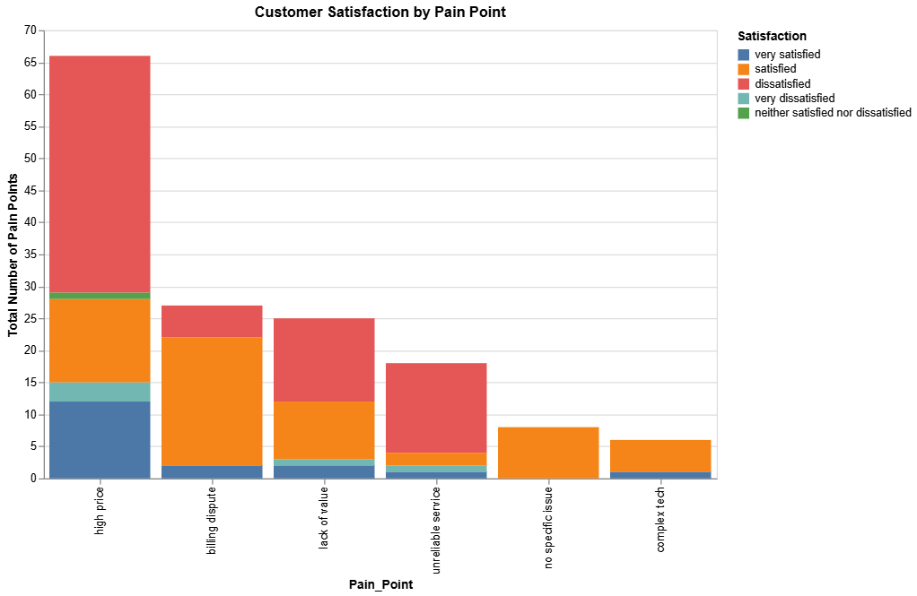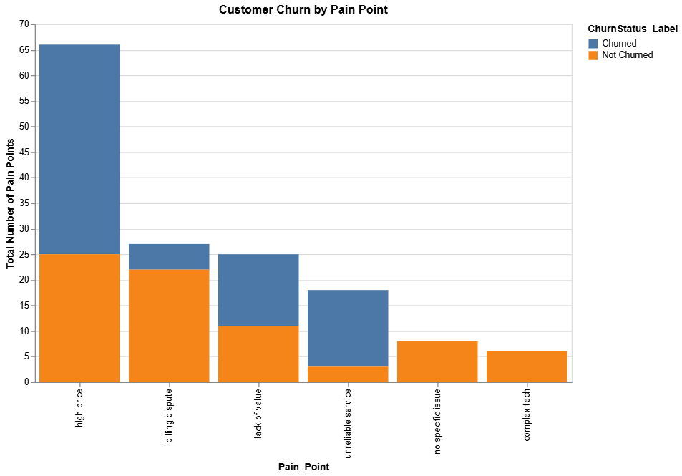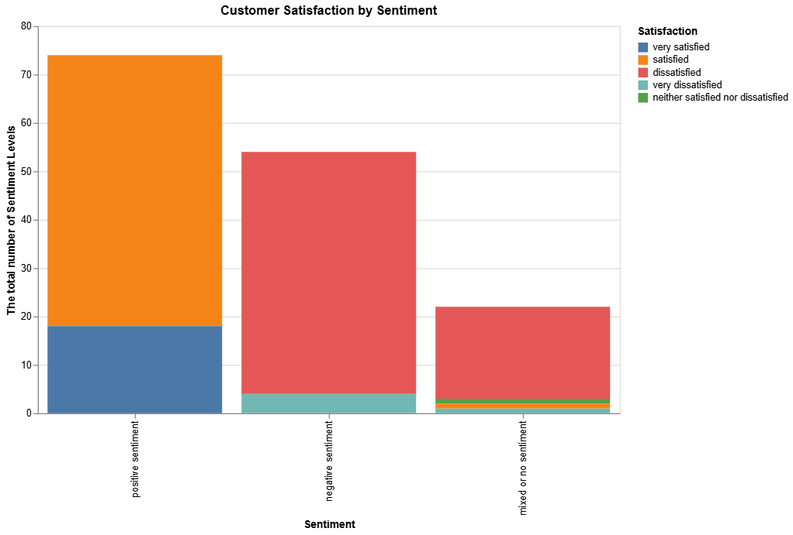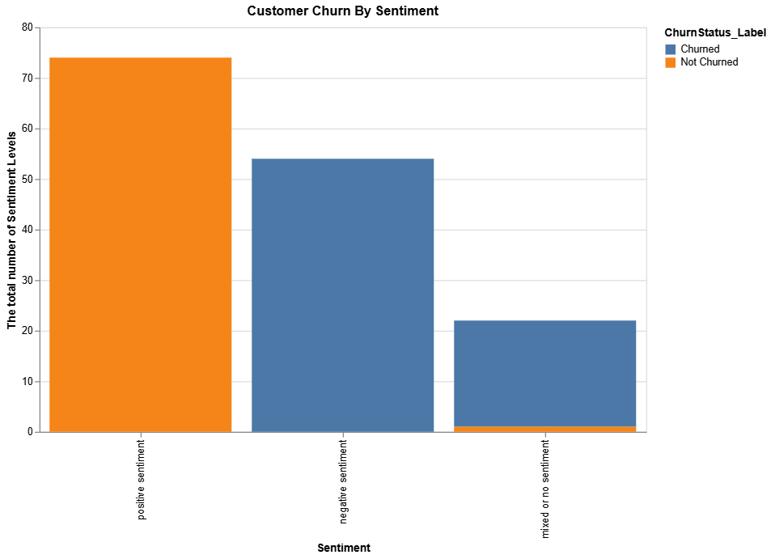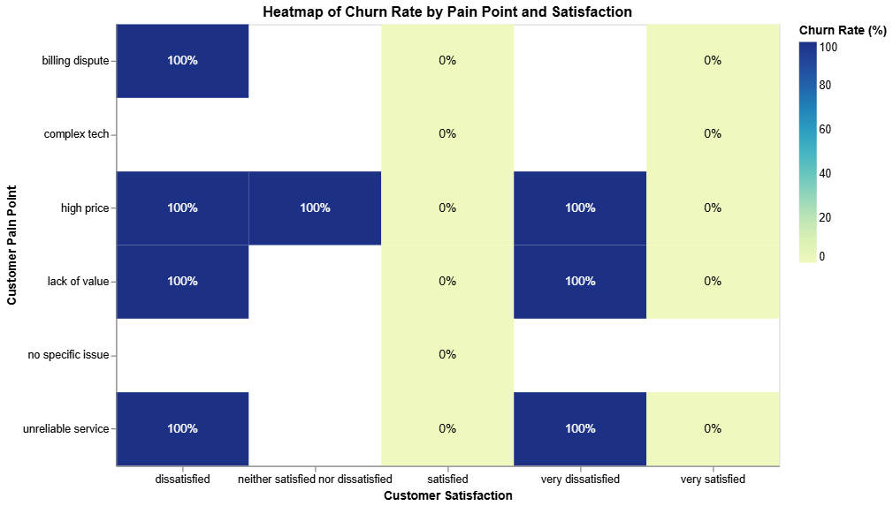
- Relationship charts on Dataset 2
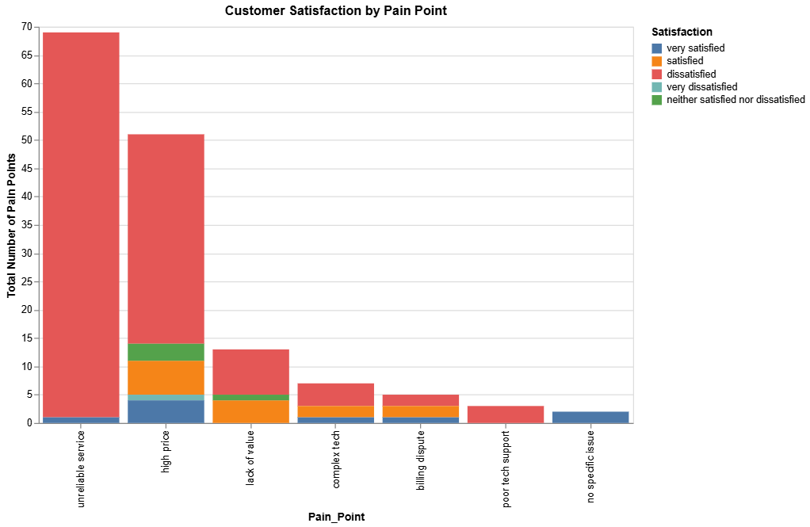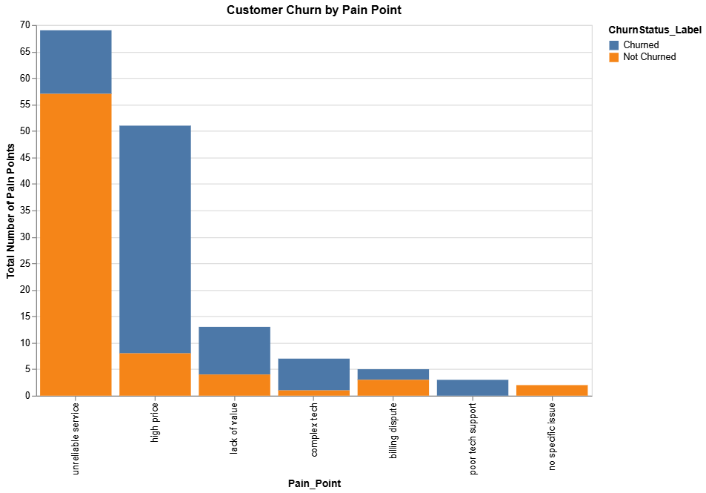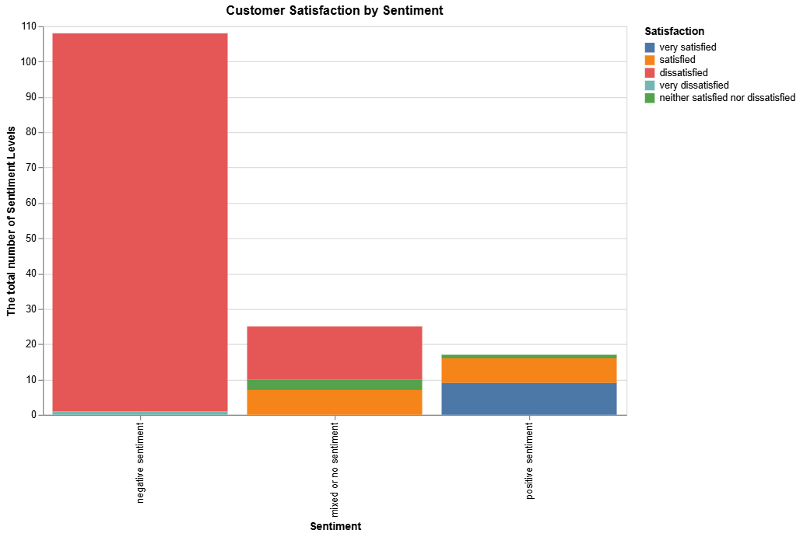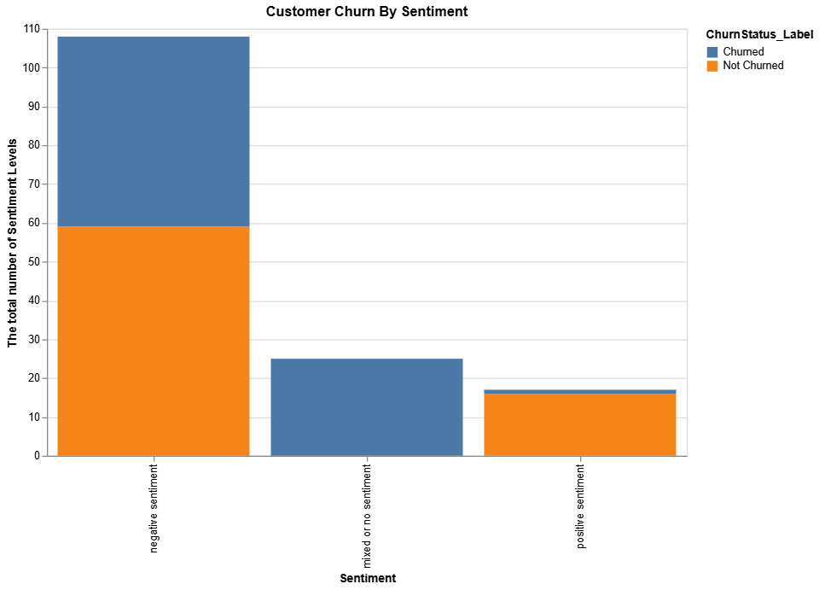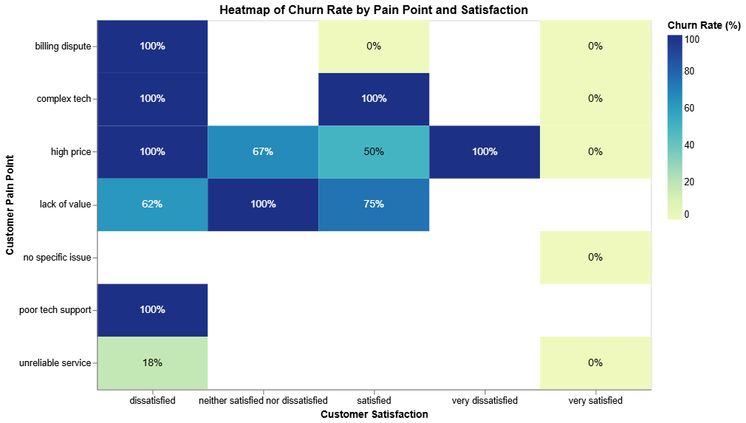
- An hybrid approach using sentiment pipeline and zero-class classification models: "cardiffnlp/twitter-roberta-base-sentiment-latest” and "valhalla/distilbart-mnli-12-3"
Goal: yield better results when the model can truly understand “neutral” for sentiment and a flexible model for pain points
  - Relationship charts Dataset 1
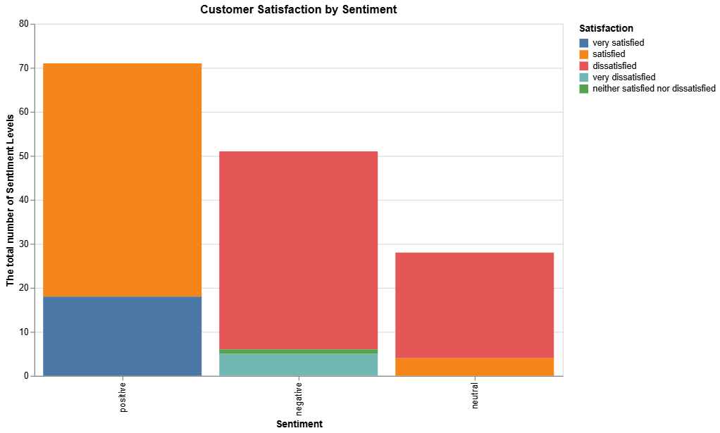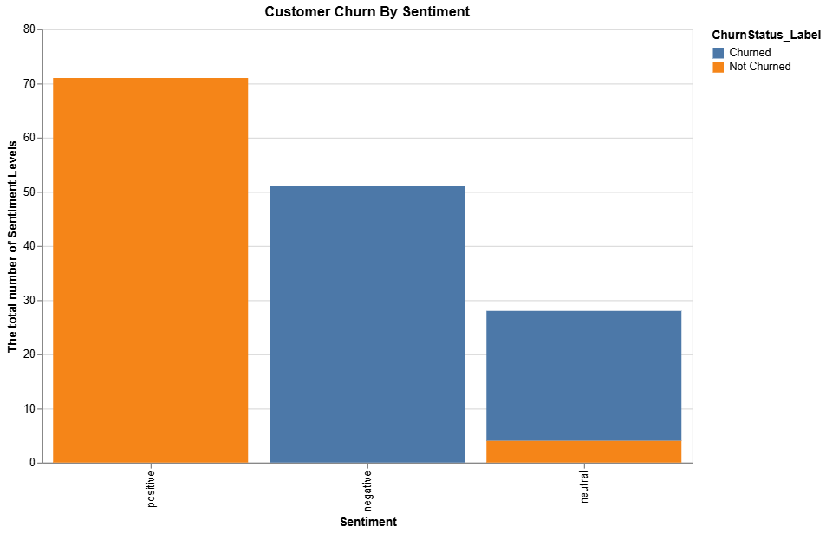
    - Relationship charts for dataset 2
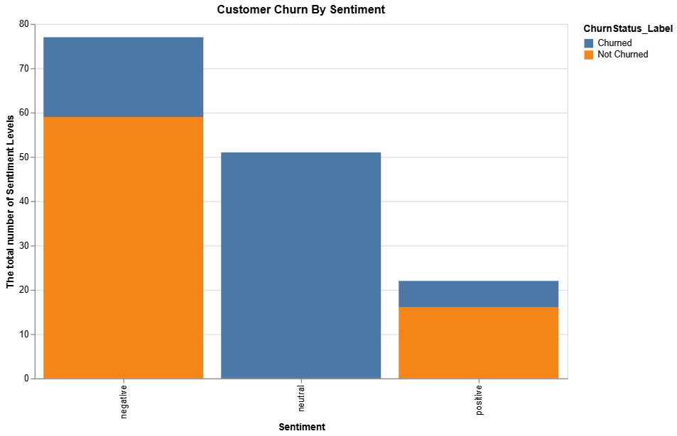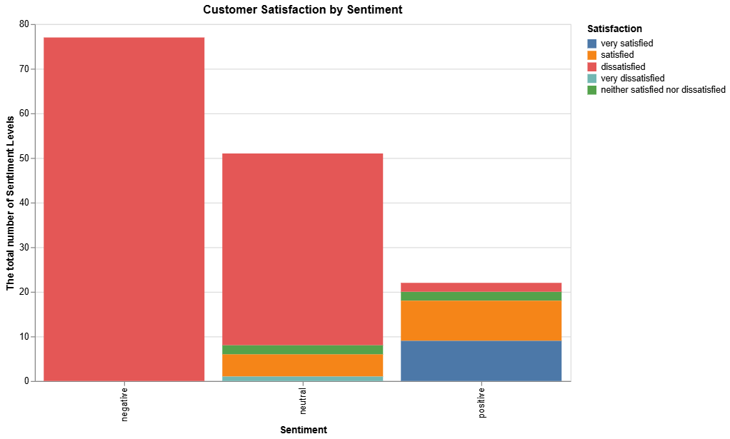

Summary of Each Customer’s Journey and Risk Factors

Customer Journey Assessment
- Customer tenure: the average customer has been with the company for 32 months.
- Contract type: The majority customers are monthly
- Internet service: Fiber optic is the most popular internet service (3,096 customers), followed by DSL (2,416 customers). 1,520 customers has no internet service
- Payment Method: Customers prefer manual payment methods over automatic ones.
  - Manual Payments: 3,969 customers
  - Automatic Payments: 3,063 customers
  - Most Popular Method: Electronic check (2,365 customers) is the most common single payment method.
- Monthly Charges: The average monthly charge is $64.80.

Risk Factor Analysis
This analysis shows which factors are most strongly correlated with customers leaving (churning). The overall churn rate for this dataset is 26.58%.
- Contract Type is a Major Factor: customers on month-to-month contracts are significantly more likely to churn out.
  - Month-to-month: 42.71% churn rate
  - One-year: 11.28% churn rate
  - Two-year: 2.85% churn rate
- New Customers are at High Risk: the first year is critical period. Nearly half of all new customers churn out
  - Customers less than 12 months (New): 47.68% churn rate
  - Customers > 12 months (Established): 17.13% churn rate
- Service Type Matters: while fiber optic is popular, it is associated with a much higher churn rate compared to other types of internet service
  - Fiber optic: 41.89% churn rate
  - DSL: 19.00% churn rate
  - No Internet: 7.43% churn rate
- Key Support Services Reduce Churn: customers without basic support add-on like Tech Support or Online Security have a churn rate almost as high as month-to-month customers
  - No Tech Support and No Online Security: 48.96% churn rate (among internet users)
  - Yes Tech Support and Yes Online Security: 9% churn rate (among internet users)
- Payment Method Impacts Retention: customers who pay manually churn at more than double the rate of those on automatic payments
  - Manual Payment: 34.74% churn rate
  - Automatic Payment: 16.00% churn rate

