Report: Statistical Analysis of PIMA Diabetes Dataset
This report details the findings from a statistical analysis of Diabetes dataset, as outlined in the assignment. The primary objectives were:
- To prepare and clean the dataset by addressing biologically impossible values.
- To analyze the effects of sampling variability by comparing statistics from a small, single sample (n=25) to the full population for Glucose
- To analyze the effects of finding the 98th percentile from sampling variability by comparing statistics from a small, single sample (n=25) to the full population for BMI
- To demonstrate the effectiveness of bootstrapping by comparing the average statistics from 500 bootstrap samples (n=150) to the population parameters for BloodPressure.
Data Preparation: Imputation of Missing Values
The initial analysis of the diabetes.csv data (the "population") revealed that the columns Glucose, BloodPressure, SkinThickness, Insulin, and BMI contained zero ('0') values. These values are clinically impossible for living patients and were therefore treated as missing data.
To create a clean dataset for analysis, the following imputation was performed:
- All '0' values in the specified columns were replaced with NaN (NA).
- The median of each column (calculated after excluding NAs) was used to fill in these missing NaN values.
This cleaned dataset (768 observations) was used as the "population" for all subsequent sampling and analysis.
Findings
a) Glucose: Small Sample (n=25) vs. Population
A single random sample of 25 observations was drawn from the population (using set.seed(101)). The sample's mean and highest glucose values were compared to the population's.

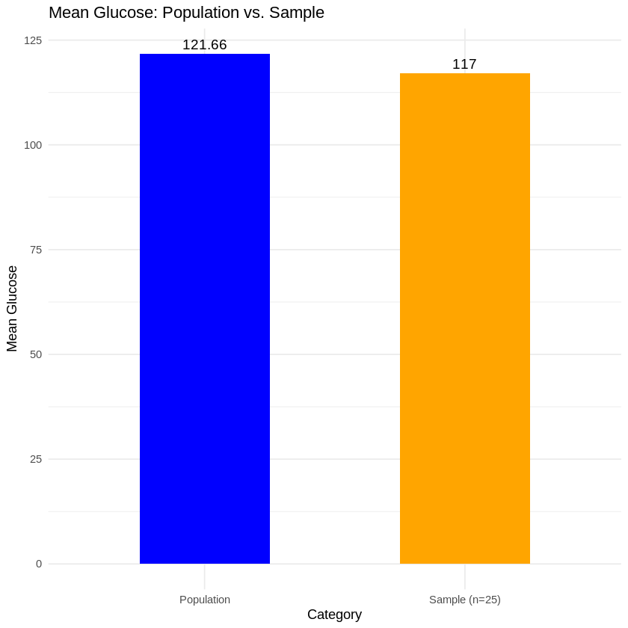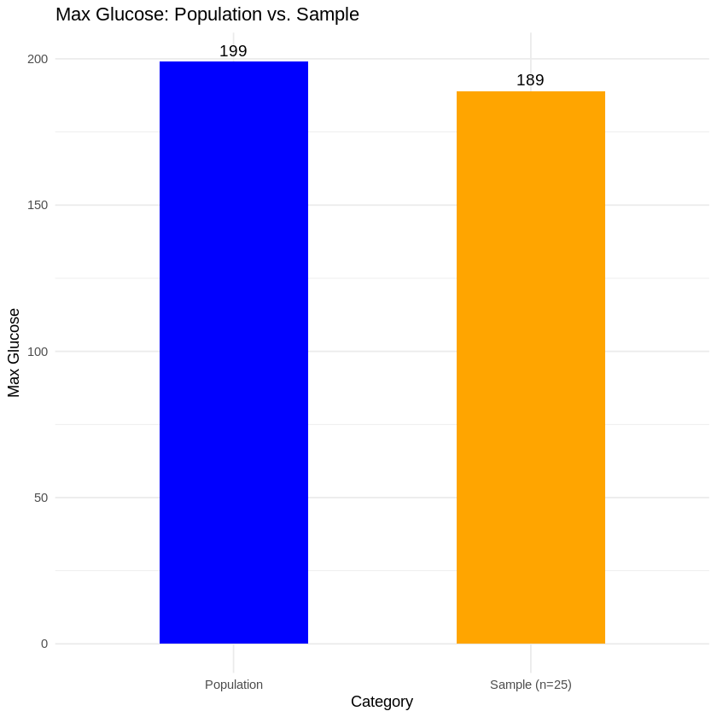

Findings:
- As confirmed by the bar charts, the single small sample produced statistics that were noticeably different from the true population parameters. The sample mean was 4.0 % lower than the population mean, and the sample's highest value was 10.0% lower.
- This discrepancy highlights the unreliability and high variance of using small, single samples to estimate population statistics.
- An additional bootstrap analysis (500 trials of n=25) in the notebook showed an average bootstrap mean of 121.58, which is extremely close to the population mean of 122.0. This demonstrates the power of repeated sampling (Central Limit Theorem) even when the sample size is small.
b) BMI 98th Percentile: Small Sample (n=25) vs. Population
Using the same random sample (n=25), the 98th percentile for BMI was calculated and compared to the population's 98th percentile.
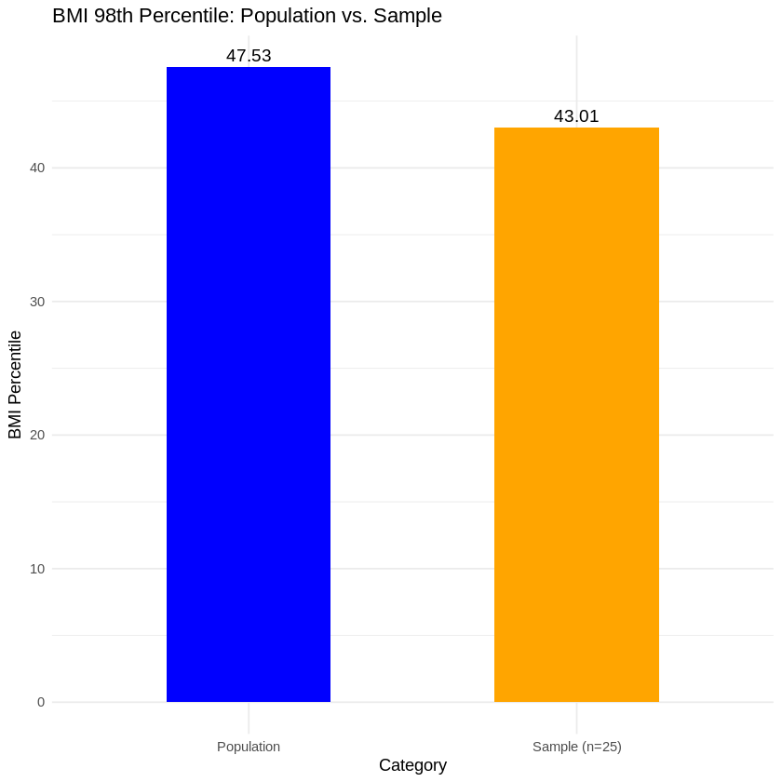
Findings:
- The sample's 98th percentile (43.01) was lower (by (4.5%) than the population's 98th percentile (47.53).
- This finding that statistics based on the tails of a distribution (like percentiles) are particularly sensitive to sampling variability. A small sample is unlikely to capture the true distribution of extreme values, making it a poor estimator for percentiles.
c) Blood Pressure: Bootstrap (n=150) vs. Population
A bootstrap analysis was performed by drawing 500 random samples, each with 150 observations (with replacement). The average mean, standard deviation, and percentiles from these 500 samples were then compared to the true population statistics for BloodPressure.
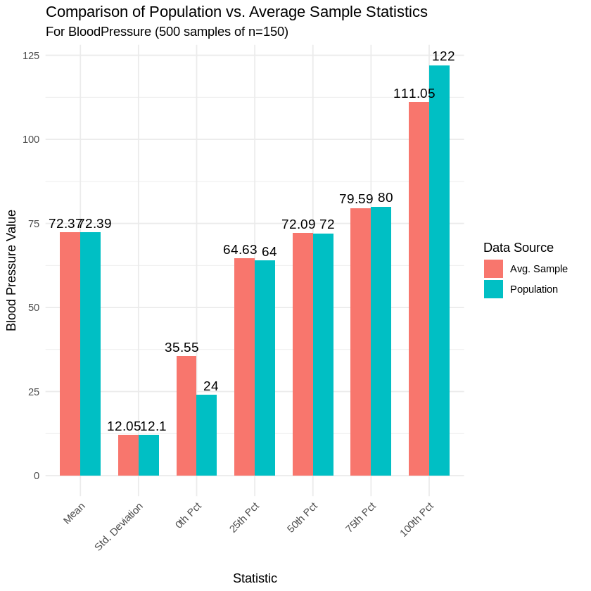
Findings:
- As shown in the chart above, the bootstrap analysis was highly effective.
- The average values for measures of central tendency (Mean, p25, p50, p75) and dispersion (Std. Deviation) from the 150-observation samples were nearly identical to the true population statistics.
- The estimates for the extremes (Min/p0 and Max/p100) were less accurate. This is expected, as a sample (even of 150) is less likely to consistently capture the absolute lowest or highest outliers present in the full population.
- This analysis clearly demonstrates that bootstrapping with a larger sample size (n=150) is a robust and reliable method for accurately estimating a population's key parameters.
4. Overall Conclusion
This assignment successfully demonstrated the core principles of statistical sampling. The analysis clearly shows that:
- A single, small sample (n=25) is prone to high variance and can produce misleading statistics, especially for non-mean-based measures like percentiles (Parts A & B).
- A larger, bootstrapped sample (n=150) provides a stable, accurate, and powerful method for estimating the true parameters of a population, particularly for measures of central tendency and dispersion (Part C).

