**clothing ecommerce website**

**Website functionality documentation**



**Team 4**

# Developers:

* Hitha hareendran
* Manuel osoriow
* Maryam Janalizadeh

# Tools Used

A variety of tools have been used in this project and are listed below:

* Adobe XD: to build the wireframe and make the primary design of the website. It was chosen because it’s very popular, responsive, and can be used in the clouds. Therefore, all developers were able to access it and share their ideas.
* VisualStudio : to write the HTML / CSS and javascript of the website. The is the best tool in the industry to write websites.
* Github: to share the code among developers and keep multiple versions of this project in case unexpected problems happen.
* Bootstrap: to building custom frameworks, work with HTML, CSS, JavaScript and design websites faster and easier. ... It also gives us support for JavaScript plugins.
* PhotoShop: to range from the full-featured editing of large batches of photos to **creating** intricate digital paintings and drawings that mimic those done by hand.
* ASP.net MVC Pattern: to decouple user-interface (view), data (model), and application logic (controller). It helps to achieve separation of concerns.
* NuGet package: to mangae .NET. The NuGet client tools provide the ability to produce and consume packages.
* Entity Framework: to work with data using objects of domain specific classes without focusing on the underlying database tables and columns where this data is stored.

# Website description

## Ecommerce webshop

## Main WebShop

## Ecommerce WebShop

### Brief description:

This page is intended for use only in the Clothing ecommerce. The customer is supposed to Login, Register as a new customer, become a member, order a Product and fill a billing information, see a summary of his product and price in the same page, payment processing, add and edit product by admin, add and edit and delete customer details information ,rating and reviews , authentication , authorization.

### 

### Main page:

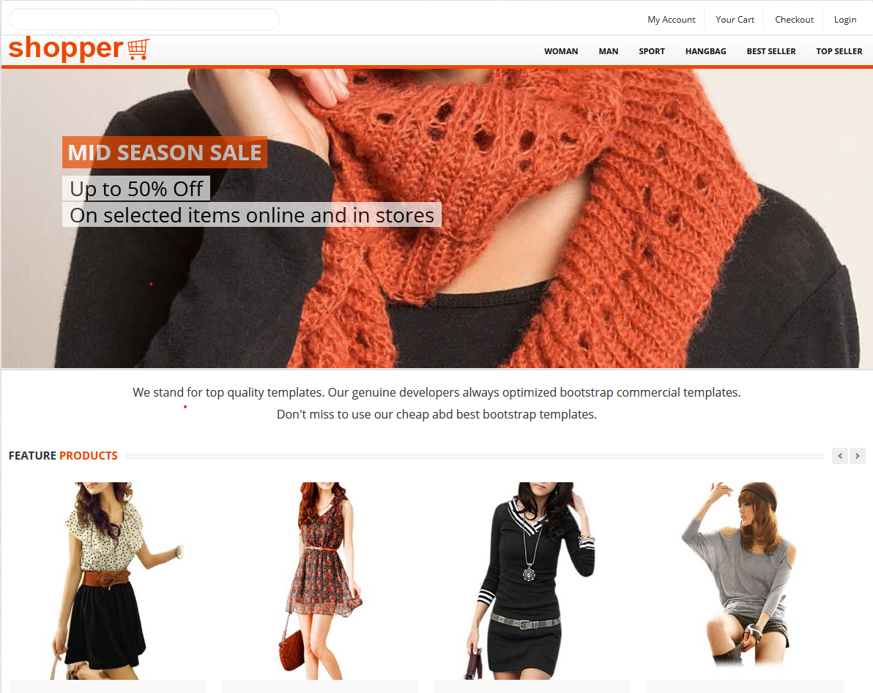

The landing page is the first page when visitors come to your site they will land on the [home page](https://www.bigcommerce.com/blog/product-page-examples/) or a [product page](https://www.bigcommerce.com/blog/product-page-examples/) ,WishList,MyOrder,CheckOut,My Basket . It is a standalone web page, created specifically for marketing purposes.

Design: It also has a very simplistic design because this is the welcoming page and needs to be simple and attractive.

### Home page:

### Main page:

The menu is elegantly designed with beautiful pictures to attract customers. The following functionalities appear in the main page:

# Admin :

### ‘Customer Management’ : The ability to edit ,details and delete and disable customers by Admin .

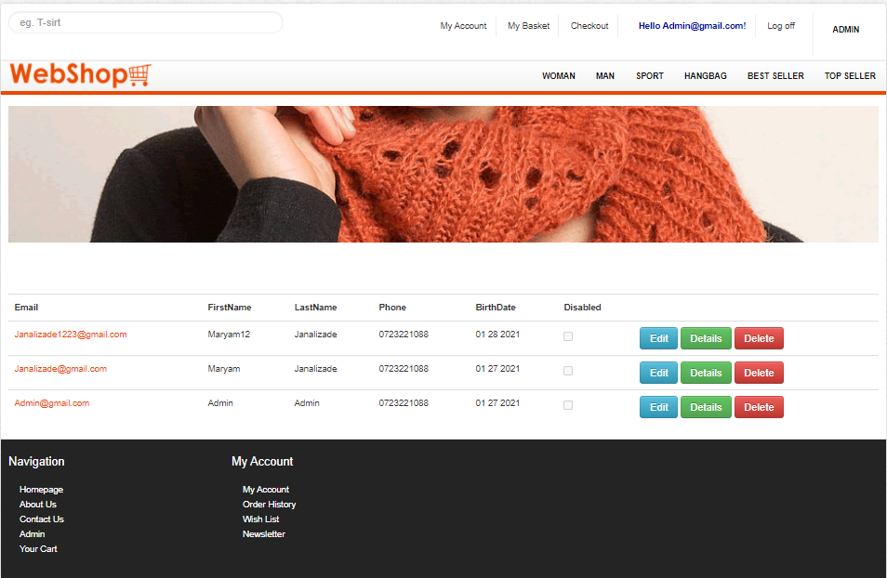

### Product Management

It is a web **page** on an eCommerce **website** that provides opportunity to Creat , Edit,Delete and change details products by Admin.

# Login

to get to know customers and better serve them. It works based on the membershipType and access level (SuperAdmin Or Customer)

‘Technology’ **Asp.net Identity**  is released as NuGet package and also included by default in Visual Studio .

Login task is:

1. Validate the submitted email address and password.
2. Compare the submitted values with those in the database.
3. Create errors if the values are incorrect.
4. Use facebook Service to log in.

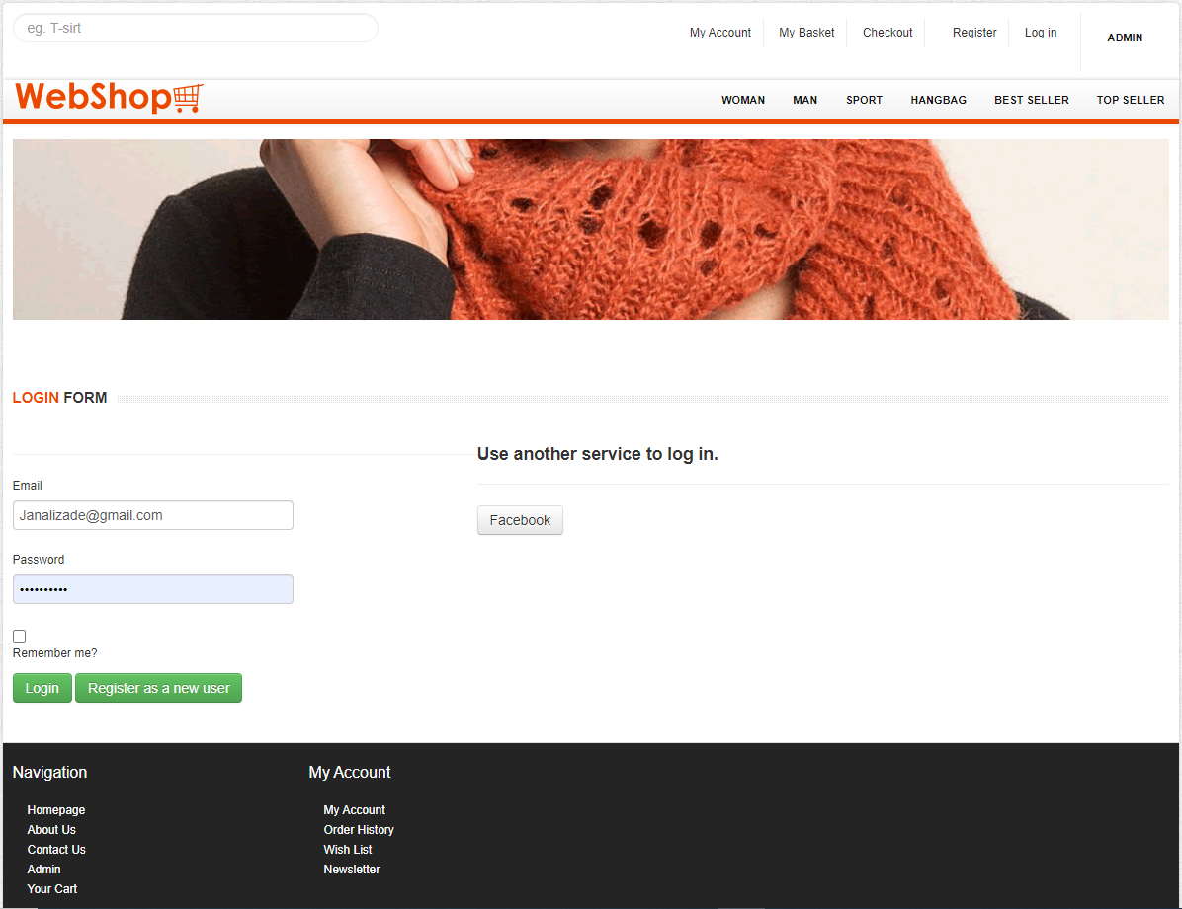

# Register

Visitors are often prompted with a sign-upform as soon as they enter to eCommerce website.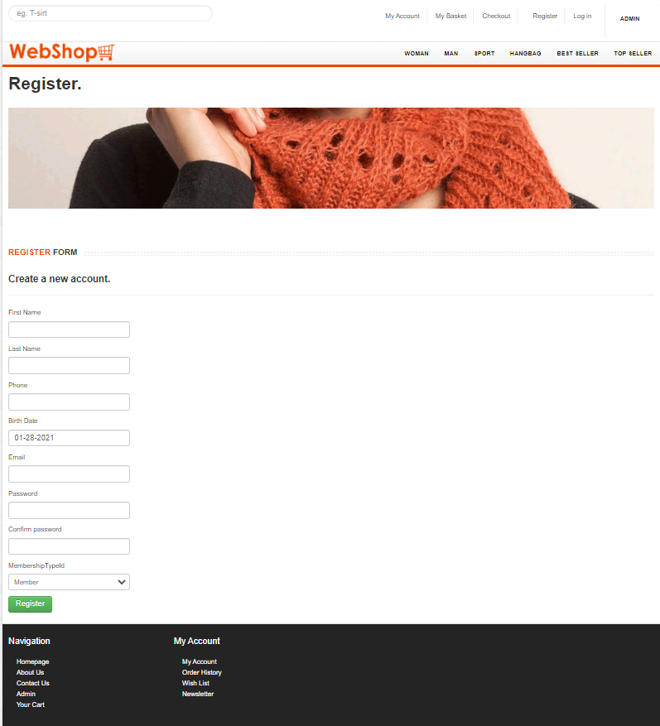

# Product Details Page

It is a web **page** on an eCommerce **website** that provides information on a specific **product**. This information includes size, color, price, shipping information, reviews, and other relevant information

customers want to know before purchasing. 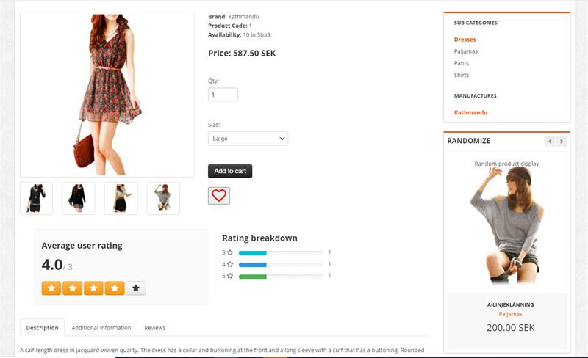

# Wish List

It is an eCommerce feature that allows shoppers to create personalized ... a product is out-of-stock; a customer has spent some time on a product page

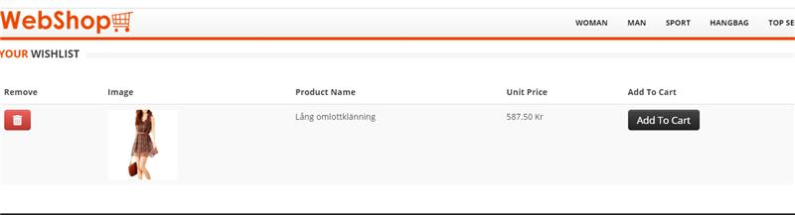

# Basket Page:

The opportunity to review their cart, modify its contents, assess the total price and choose delivery options.

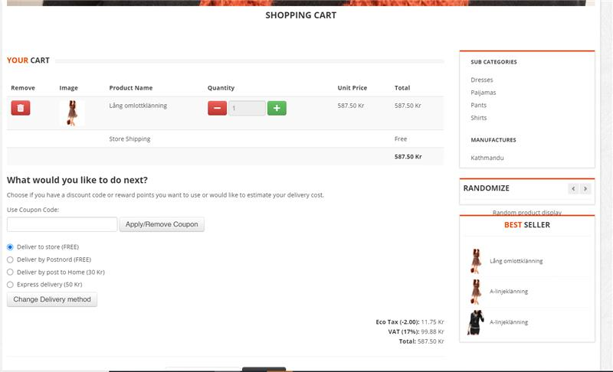

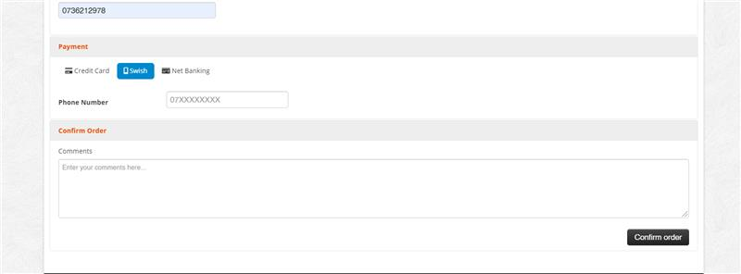

# CheckOut Page

It shown to a customer during the step-by-step checkout process. Think of a checkout pages as the online version of a physical checkout counter in a grocery store.

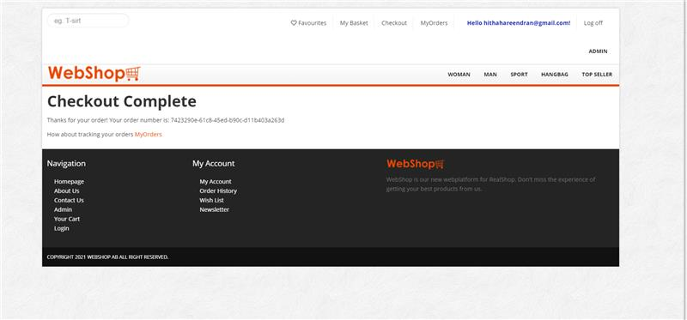

# Order Page

The Opportunity to review the list of orders by customer.

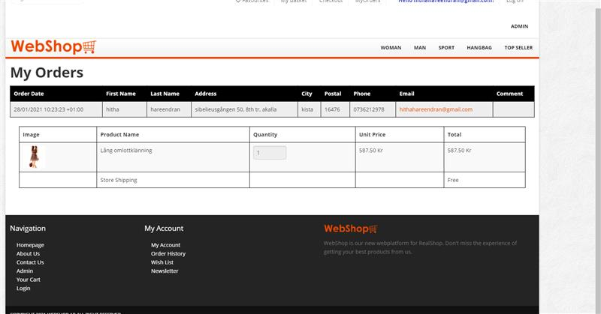

# Reviews Part

User reviews are proven sales drivers, and something the majority of customers will want to see before deciding to make a purchase.

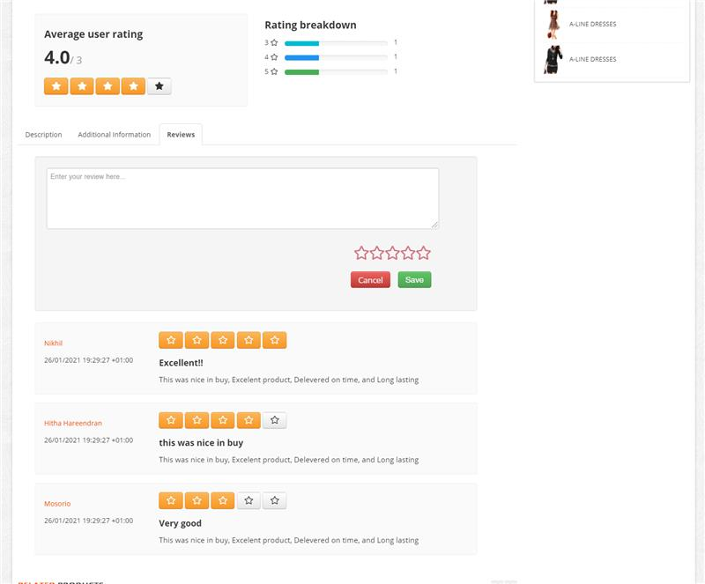

# Contact Us

The User can send a message to contact the Admin, with the ability of sending ‘noreply’ email to the customer.

# 

# Product List

Customer can see the list of product in the main page .

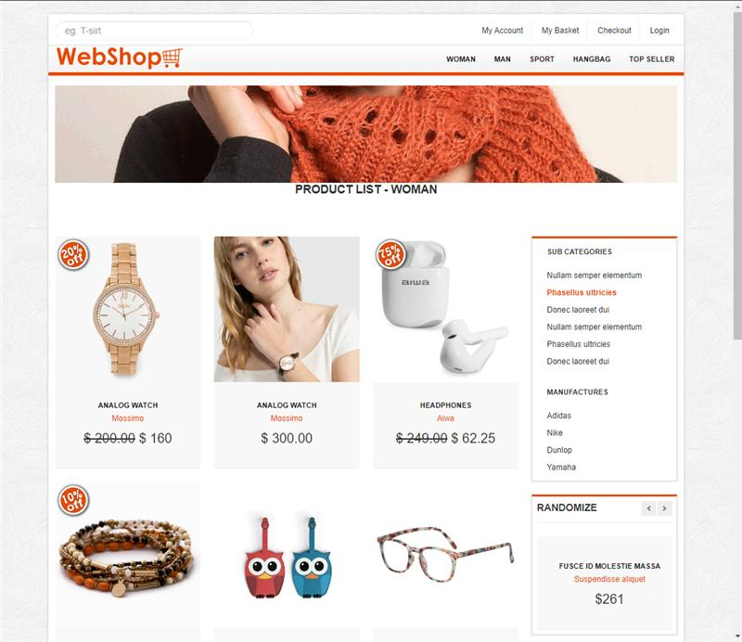

# Product Page:The ability to edit ,details and delete products by Admin.

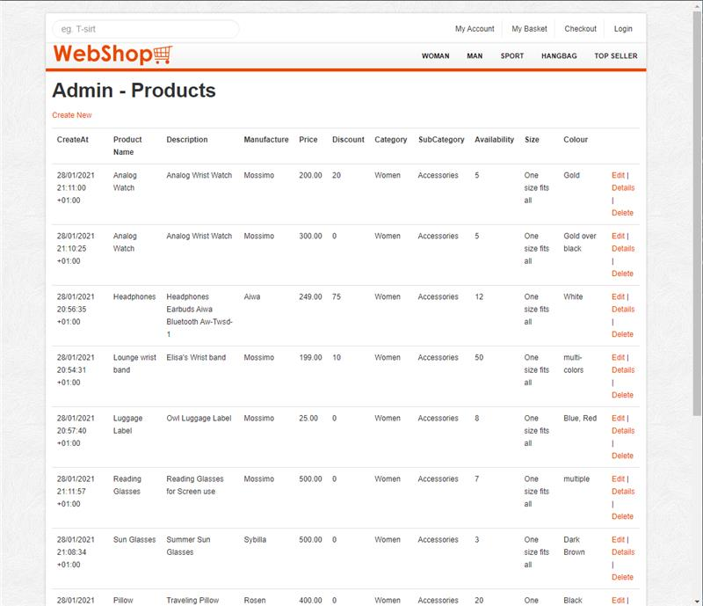



# Challenges encountered

Several challenges have been encountered throughout the project, listed below:

* Technical challenges in exchanging files through Github. As the developers have little and limited experience with Github, it was difficult to merge files among different branches and work synchronously.
* Operational challenges due to social restrictions. As the developers were working remotely and not on site, it was challenging to discuss and collaborate more openly.
* Programming structure challenges. As the project grew bigger, it was challenging to follow up on the code, keep it coherent and keep the structure simple.