**Simplified model (did not use carrying capacity by hexagon)**

$$Yi​∼Bernoulli(pi​)$$

where pi is the probability of *Anopheles* *stephensi* presence.

**Predictor covariates**

* X1​ = Built volume
* X2​ = tcb (Tasselled Cap Brightness)
* X3​ = tcw (Tasselled Cap Wetness)
* X4 = estimated climatic relative abundance for *An. stephensi*

The predictors are combined linearly

$$ηi​=β0​+β1​X1i​+β2​X2i​+β3​X3i​+β4​X4i​​$$

where:

* ηi​ is the log-odds
* β0​ is the intercept
* β1,β2,...,β4​ are the regression coefficients for each predictor

To get the probability of presence pi​, the logistic (sigmoid) function ensured pi is between 0 and 1.

$$1 / (1 + e^(-ηi​ ))$$

**Priors**

Assumption of normal priors. Where N(0,1) is a standard normal distribution

$$βj​∼N(0,1),for j=0,1,2,3,4$$

**Predicted probabilities**

$$P​new=1/(1+e^{-\left(β0+β1X1+…β4X4\right)})$$

**Prediction into new locations**

$$Ynew​∼Bernoulli(P​new​)$$

**Output for Kenya, Ethiopia, Sudan, Eritrea**

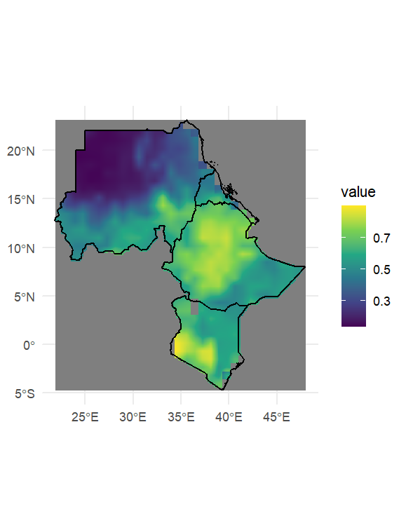

Next steps:

* Work on the Kenya only model
* Re-try the model incorporating carrying capacity in hexagons