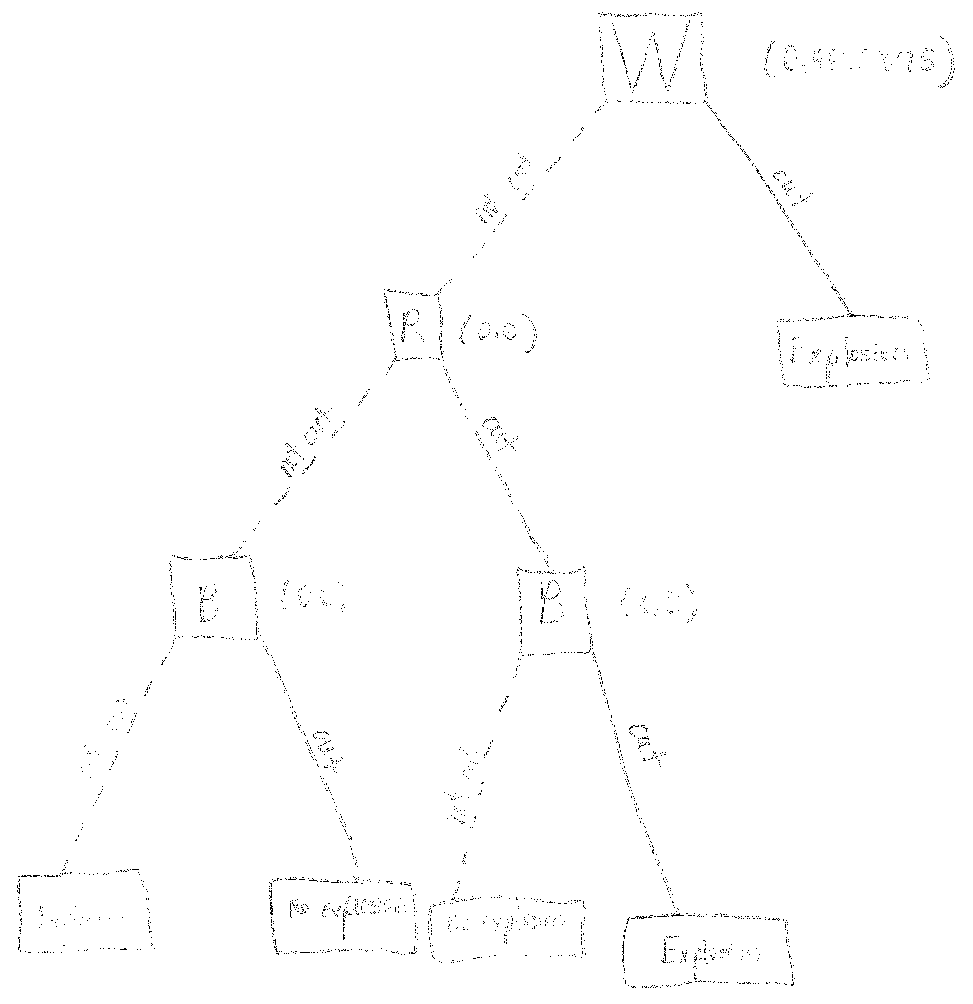

* 1. Decisions:
     1. First round
        1. White = -(3/7)((1)lg(1) + (0)lg(0))

-(4/7)((1/2)lg(1/2) + (1/2)lg(1/2))

= 0.4635875

* + - 1. Red = 0.857 (given)
      2. Blue = -(3/7)((2/3)lg(2/3) + (1/3)lg(1/3))

-(4/7)((3/4)lg(3/4) + (1/4)lg(1/4))

= 0.857142857

* + - 1. Green = 0.801 (given)
    1. Second round (white chosen in first)
       1. Red = -(1/2)((1/2)lg(1/2) + (1/2)lg(1/2))

-(1/2)((1/2)lg(1/2) + (1/2)lg(1/2))

= 0

* + - 1. Blue = Red = 0
      2. Green = -(1/4)((0)lg(0) + (1)lg(1))

-(3/4)((2/3)lg(2/3) + (1/3)lg(1/3))

= 0.688721876

* + 1. Third round (red chosen in second)
       1. Blue (red not cut) = -(1/2)((0)lg(0) + (1)lg(1))

-(1/2)((1)lg(1) + (0)lg(0))

= 0

* + - 1. Green (red not cut) = Blue (red not cut) = 0
      2. Blue (red cut) = -(1/2)((1)lg(1) + (0)lg(0))

-(1/2)((0)lg(0) + (1)lg(1))

= 0

* + - 1. Green (red cut) = -(1/2)((0)lg(0) + (1)lg(1))

-(1/2)((1/2)lg(1/2) + (1/2)lg(1/2))

= 0.5

* 1. Accuracy on test data = 33%
  2. No. By the rules of Bayesian nets, nodes are unaffected by ancestors if the value of their parents are known. Since D is provided with the values of A and C, which are its parents, the value of B is unnecessary in determining the value.
  3. P(A, -B, -C, -D, E) = P(A ^ -B ^ -C ^ -D ^ E)

= P(A) ^ P(-B) ^ P(C | A ^ -B) ^ P(D | -C ^ A) ^ P(E | -C)

= 0.7 \* 0.5 \* 0.0 \* 0.3 \* 0.5

= 0

* 1. With no conditional independencies, the full distribution requires 2^5 – 1 = 31 different numbers. This is because the binary distribution can be represented by 2^n numbers, but the last number can be deduced from the values of the other numbers. This is far greater than the number required in the example (12), because conditional independencies are what allow probabilistic reasoning to reduce the number of variable assignments.
  2. Let:

A = the amount of money Mayfest has

B = the probability that a band I enjoy has recently won a major award

S = the probability that I share musical tastes with a member of Mayfest

Y = the number of years since 1963

I = the probability I will like an act at Dillo Day

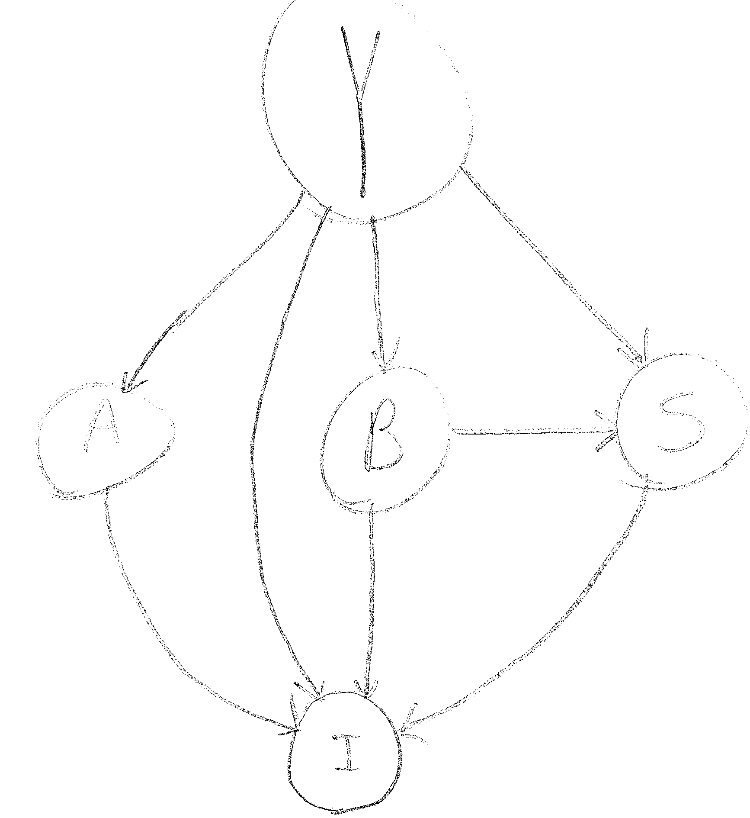

* 1. Obviously, the answer I’m looking for (whether or not I will like an act) is dependent on all the other factors; it’s the reason for the model. More interestingly, S is conditionally independent given Y and B, since the probability that I share tastes with a Mayfest member decreases as the current age moves away from my preferred music (classic rock), and a Mayfest member is more likely to like a band I enjoy if that band has recently won a major award. In addition, B is conditionally independent given Y, because the probability of bands I enjoy winning a major award will decrease as those bands become older (and I assume that my music tastes are mostly constant).