

Project Report on 4x4 LED Wall Matrix using Arduino Nano

**Course Title:** Operating Systems Design

**Course Code:** CSE323

**Section:** 05

**Semester:** Spring 2023

**Submitted to:**

Dr. Saeed Mahmud Ullah (SMU1)

Adjunct Faculty

Department of Electrical & Computer Engineering

North South University

**Submitted by:**

**Name:** Mosroor Mofiz Arman

**ID:** 1921079642, **Group:** 07

**Date of Submission:** 13-06-2023

**Table of Contents**

OBJECTIVES ..........................................................................................................................3 APPARATUS...........................................................................................................................4 SOFTWARE.............................................................................................................................4

WORKING DIAGRAM...........................................................................................................5

WORKING DATA...................................................................................................................5

CODE........................................................................................................................................8 DISCUSSION..........................................................................................................................29

**OBJECTIVES**

* Design and construct a 4x4 wall matrix LED light using Arduino Nano.
* Connect the LED matrix to the Arduino Nano, ensuring proper current limiting and electrical connections.
* Create a sturdy and compact physical setup for the LED matrix suitable for wall mounting.
* Develop Arduino code to control the LED matrix and enable the display of static patterns, scrolling messages, and animated effects.
* Implement functions for dynamically changing the displayed content to allow user interaction and customization.
* Optimize the code for efficient resource utilization of the Arduino Nano, ensuring smooth and flicker-free animations.
* Document the hardware setup, circuit connections, and wiring diagrams to facilitate replication and understanding.
* Demonstrate the capabilities of Arduino Nano in driving a 4x4 LED matrix.

**APPARATUS**

* Arduino Nano
* 16 LED Light
* Resistors (for current limiting)
* Digital Multimeter (for measuring the resistance of the resistors)
* Jumper wires
* Breadboard
* USB cable (for programming the Arduino Nano)
* Soldering Iron

**SOFTWARE**

* Arduino IDE

**WORKING DIAGRAM**

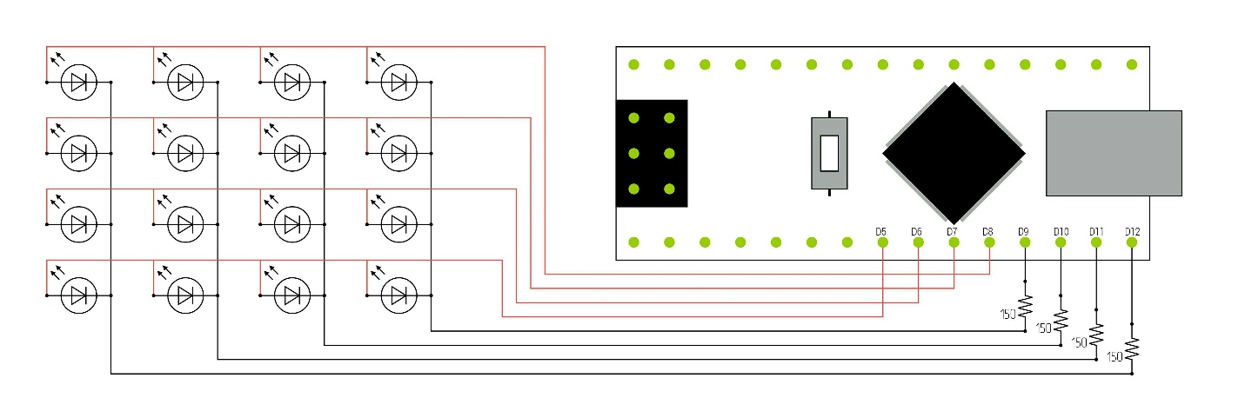

*Figure 1: Circuit Diagram*

**WORKING DATA**

The LED matrix is connected to the Arduino Nano as follows:

Arduino Nano Digital Pins:

* Pin D5 to Column 1 of the LED Matrix
* Pin D6 to Column 2 of the LED Matrix
* Pin D7 to Column 3 of the LED Matrix
* Pin D8 to Column 4 of the LED Matrix
* Pin D9 to Row 1 of the LED Matrix
* Pin D10 to Row 2 of the LED Matrix
* Pin D11 to Row 3 of the LED Matrix
* Pin D12 to Row 4 of the LED Matrix

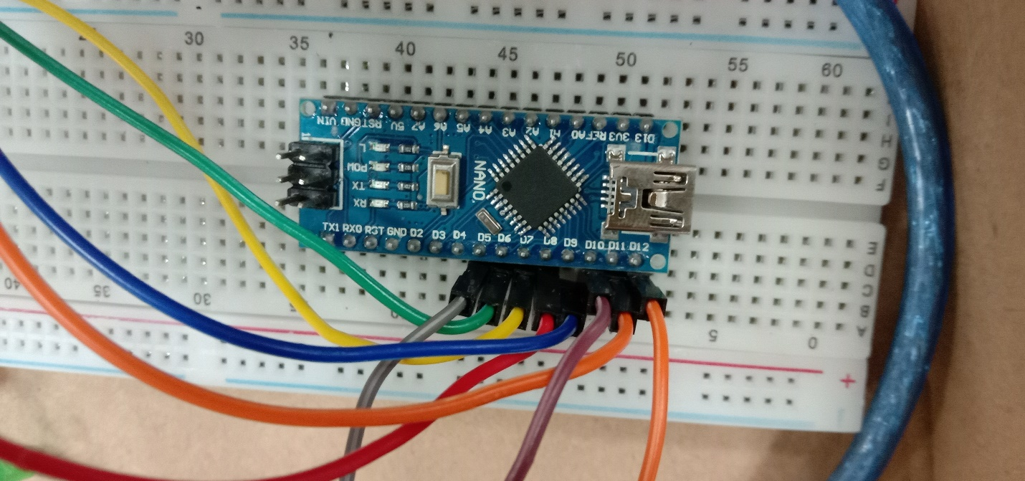

*Figure 2: Arduino Nano*

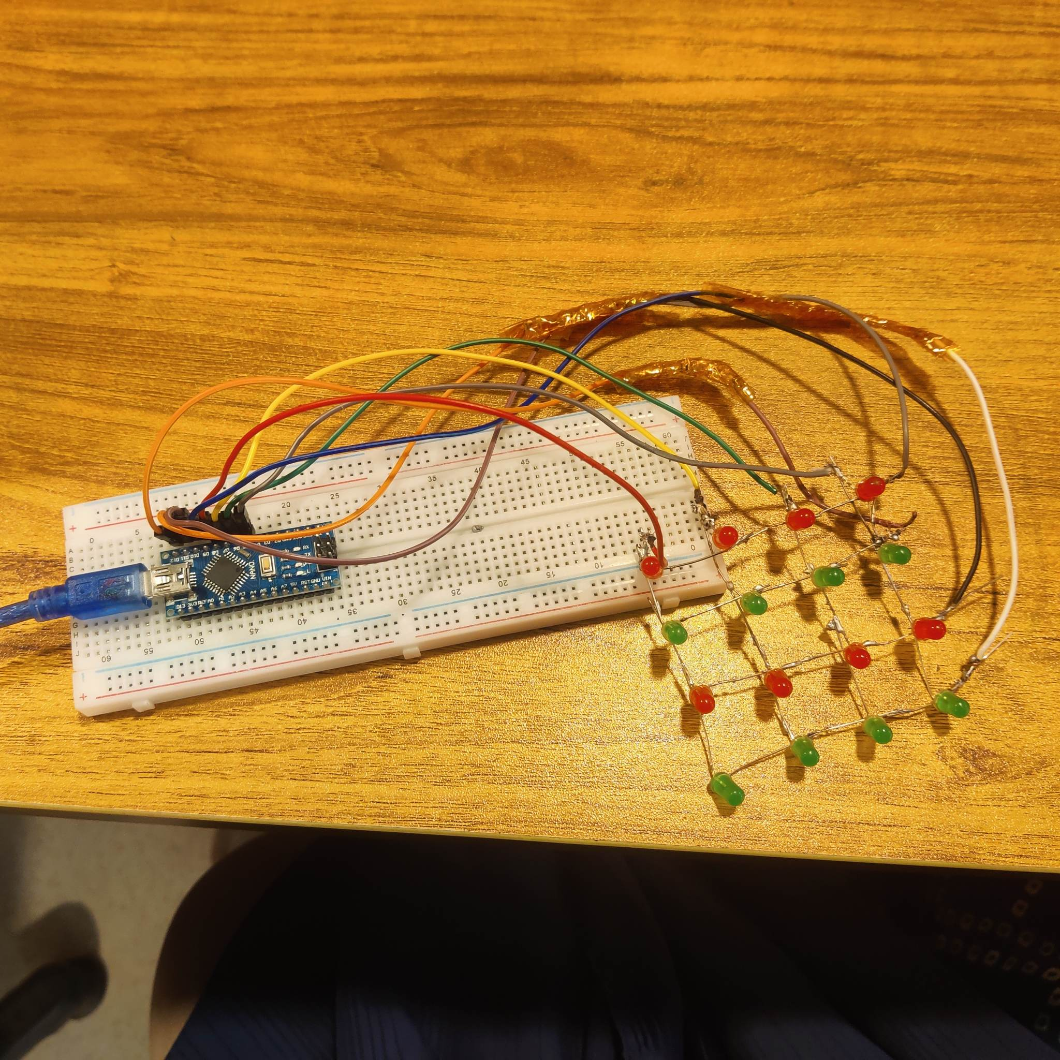

*Figure 3: Compilation -OFF*

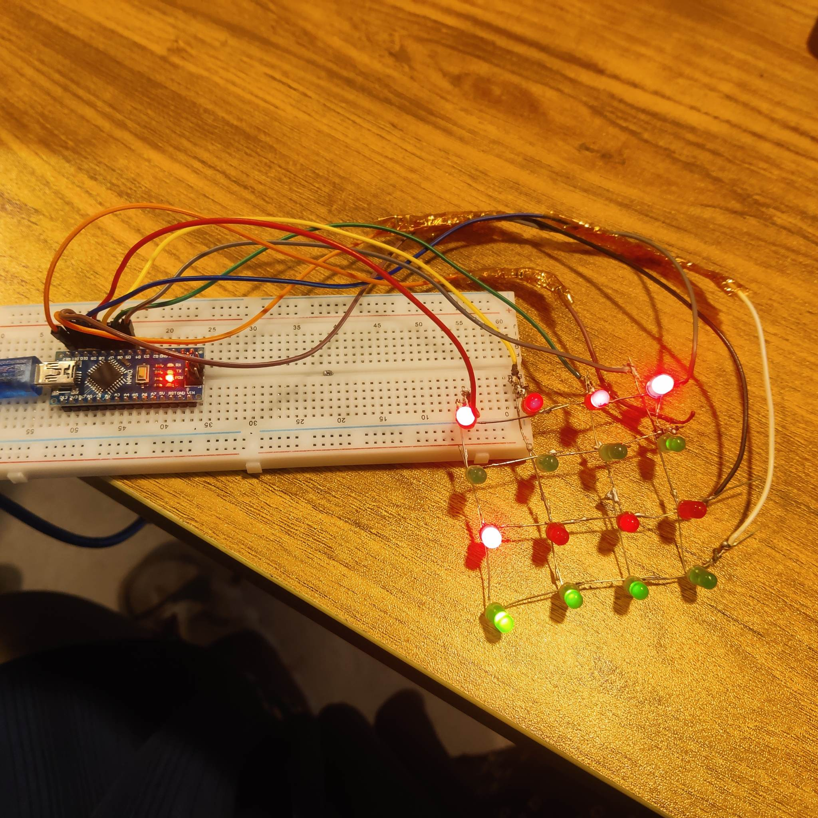

*Figure 4: Compilation -ON*

**CODE**

*/\**

*: Project: 4x4 LED Wall Matrix*

*\*/*

*#define fpin 5*

*#define gpin 6*

*#define hpin 7*

*#define ipin 8*

*#define jpin 9*

*#define kpin 10*

*#define lpin 11*

*#define mpin 12*

*void setup() {*

*pinMode(fpin, OUTPUT);*

*pinMode(gpin, OUTPUT);*

*pinMode(hpin, OUTPUT);*

*pinMode(ipin, OUTPUT);*

*pinMode(jpin, OUTPUT);*

*pinMode(kpin, OUTPUT);*

*pinMode(lpin, OUTPUT);*

*pinMode(mpin, OUTPUT);*

*}*

*void loop() {*

*analogWrite (fpin, 0);*

*analogWrite (gpin, 0);*

*analogWrite (hpin, 0);*

*analogWrite (ipin, 0);*

*analogWrite (jpin, 0);*

*analogWrite (kpin, 0);*

*analogWrite (lpin, 0);*

*analogWrite (mpin, 0);*

*delay(250);*

*analogWrite (fpin, 0);*

*analogWrite (gpin, 0);*

*analogWrite (hpin, 0);*

*analogWrite (ipin, 255);*

*analogWrite (jpin, 0);*

*analogWrite (kpin, 255);*

*analogWrite (lpin, 255);*

*analogWrite (mpin, 255);*

*delay(240);*

*analogWrite (fpin, 0);*

*analogWrite (gpin, 0);*

*analogWrite (hpin, 0);*

*analogWrite (ipin, 255);*

*analogWrite (jpin, 255);*

*analogWrite (kpin, 0);*

*analogWrite (lpin, 255);*

*analogWrite (mpin, 255);*

*delay(240);*

*analogWrite (fpin, 0);*

*analogWrite (gpin, 0);*

*analogWrite (hpin, 0);*

*analogWrite (ipin, 255);*

*analogWrite (jpin, 255);*

*analogWrite (kpin, 255);*

*analogWrite (lpin, 0);*

*analogWrite (mpin, 255);*

*delay(230);*

*analogWrite (fpin, 0);*

*analogWrite (gpin, 0);*

*analogWrite (hpin, 0);*

*analogWrite (ipin, 255);*

*analogWrite (jpin, 255);*

*analogWrite (kpin, 255);*

*analogWrite (lpin, 255);*

*analogWrite (mpin, 0);*

*delay(210);*

*analogWrite (fpin, 0);*

*analogWrite (gpin, 0);*

*analogWrite (hpin, 255);*

*analogWrite (ipin, 0);*

*analogWrite (jpin, 255);*

*analogWrite (kpin, 255);*

*analogWrite (lpin, 255);*

*analogWrite (mpin, 0);*

*delay(190);*

*analogWrite (fpin, 0);*

*analogWrite (gpin, 255);*

*analogWrite (hpin, 0);*

*analogWrite (ipin, 0);*

*analogWrite (jpin, 255);*

*analogWrite (kpin, 255);*

*analogWrite (lpin, 255);*

*analogWrite (mpin, 0);*

*delay(170);*

*analogWrite (fpin, 0);*

*analogWrite (gpin, 255);*

*analogWrite (hpin, 0);*

*analogWrite (ipin, 0);*

*analogWrite (jpin, 255);*

*analogWrite (kpin, 255);*

*analogWrite (lpin, 0);*

*analogWrite (mpin, 255);*

*delay(150);*

*analogWrite (fpin, 0);*

*analogWrite (gpin, 255);*

*analogWrite (hpin, 0);*

*analogWrite (ipin, 0);*

*analogWrite (jpin, 255);*

*analogWrite (kpin, 0);*

*analogWrite (lpin, 0);*

*analogWrite (mpin, 255);*

*delay(8);*

*analogWrite (fpin, 0);*

*analogWrite (gpin, 255);*

*analogWrite (hpin, 255);*

*analogWrite (ipin, 0);*

*analogWrite (jpin, 255);*

*analogWrite (kpin, 255);*

*analogWrite (lpin, 0);*

*analogWrite (mpin, 255);*

*delay(8);*

*analogWrite (fpin, 0);*

*analogWrite (gpin, 255);*

*analogWrite (hpin, 0);*

*analogWrite (ipin, 0);*

*analogWrite (jpin, 255);*

*analogWrite (kpin, 0);*

*analogWrite (lpin, 0);*

*analogWrite (mpin, 255);*

*delay(8);*

*analogWrite (fpin, 0);*

*analogWrite (gpin, 255);*

*analogWrite (hpin, 255);*

*analogWrite (ipin, 0);*

*analogWrite (jpin, 255);*

*analogWrite (kpin, 255);*

*analogWrite (lpin, 0);*

*analogWrite (mpin, 255);*

*delay(8);*

*analogWrite (fpin, 0);*

*analogWrite (gpin, 255);*

*analogWrite (hpin, 0);*

*analogWrite (ipin, 0);*

*analogWrite (jpin, 255);*

*analogWrite (kpin, 0);*

*analogWrite (lpin, 0);*

*analogWrite (mpin, 255);*

*delay(8);*

*analogWrite (fpin, 0);*

*analogWrite (gpin, 255);*

*analogWrite (hpin, 255);*

*analogWrite (ipin, 0);*

*analogWrite (jpin, 255);*

*analogWrite (kpin, 255);*

*analogWrite (lpin, 0);*

*analogWrite (mpin, 255);*

*delay(8);*

*analogWrite (fpin, 0);*

*analogWrite (gpin, 255);*

*analogWrite (hpin, 0);*

*analogWrite (ipin, 0);*

*analogWrite (jpin, 255);*

*analogWrite (kpin, 0);*

*analogWrite (lpin, 0);*

*analogWrite (mpin, 255);*

*delay(8);*

*analogWrite (fpin, 0);*

*analogWrite (gpin, 255);*

*analogWrite (hpin, 255);*

*analogWrite (ipin, 0);*

*analogWrite (jpin, 255);*

*analogWrite (kpin, 255);*

*analogWrite (lpin, 0);*

*analogWrite (mpin, 255);*

*delay(8);*

*analogWrite (fpin, 0);*

*analogWrite (gpin, 255);*

*analogWrite (hpin, 0);*

*analogWrite (ipin, 0);*

*analogWrite (jpin, 255);*

*analogWrite (kpin, 0);*

*analogWrite (lpin, 0);*

*analogWrite (mpin, 255);*

*delay(8);*

*analogWrite (fpin, 0);*

*analogWrite (gpin, 255);*

*analogWrite (hpin, 255);*

*analogWrite (ipin, 0);*

*analogWrite (jpin, 255);*

*analogWrite (kpin, 255);*

*analogWrite (lpin, 0);*

*analogWrite (mpin, 255);*

*delay(8);*

*analogWrite (fpin, 0);*

*analogWrite (gpin, 255);*

*analogWrite (hpin, 0);*

*analogWrite (ipin, 0);*

*analogWrite (jpin, 255);*

*analogWrite (kpin, 0);*

*analogWrite (lpin, 0);*

*analogWrite (mpin, 255);*

*delay(8);*

*analogWrite (fpin, 0);*

*analogWrite (gpin, 255);*

*analogWrite (hpin, 255);*

*analogWrite (ipin, 0);*

*analogWrite (jpin, 255);*

*analogWrite (kpin, 255);*

*analogWrite (lpin, 0);*

*analogWrite (mpin, 255);*

*delay(8);*

*analogWrite (fpin, 0);*

*analogWrite (gpin, 255);*

*analogWrite (hpin, 0);*

*analogWrite (ipin, 0);*

*analogWrite (jpin, 255);*

*analogWrite (kpin, 0);*

*analogWrite (lpin, 0);*

*analogWrite (mpin, 255);*

*delay(8);*

*analogWrite (fpin, 0);*

*analogWrite (gpin, 255);*

*analogWrite (hpin, 255);*

*analogWrite (ipin, 0);*

*analogWrite (jpin, 255);*

*analogWrite (kpin, 255);*

*analogWrite (lpin, 0);*

*analogWrite (mpin, 255);*

*delay(8);*

*analogWrite (fpin, 0);*

*analogWrite (gpin, 255);*

*analogWrite (hpin, 0);*

*analogWrite (ipin, 0);*

*analogWrite (jpin, 255);*

*analogWrite (kpin, 0);*

*analogWrite (lpin, 0);*

*analogWrite (mpin, 255);*

*delay(8);*

*analogWrite (fpin, 0);*

*analogWrite (gpin, 255);*

*analogWrite (hpin, 255);*

*analogWrite (ipin, 0);*

*analogWrite (jpin, 255);*

*analogWrite (kpin, 255);*

*analogWrite (lpin, 0);*

*analogWrite (mpin, 255);*

*delay(8);*

*analogWrite (fpin, 0);*

*analogWrite (gpin, 255);*

*analogWrite (hpin, 0);*

*analogWrite (ipin, 0);*

*analogWrite (jpin, 255);*

*analogWrite (kpin, 0);*

*analogWrite (lpin, 0);*

*analogWrite (mpin, 255);*

*delay(8);*

*analogWrite (fpin, 0);*

*analogWrite (gpin, 255);*

*analogWrite (hpin, 255);*

*analogWrite (ipin, 0);*

*analogWrite (jpin, 255);*

*analogWrite (kpin, 255);*

*analogWrite (lpin, 0);*

*analogWrite (mpin, 255);*

*delay(8);*

*analogWrite (fpin, 0);*

*analogWrite (gpin, 255);*

*analogWrite (hpin, 0);*

*analogWrite (ipin, 0);*

*analogWrite (jpin, 255);*

*analogWrite (kpin, 0);*

*analogWrite (lpin, 0);*

*analogWrite (mpin, 255);*

*delay(8);*

*analogWrite (fpin, 0);*

*analogWrite (gpin, 255);*

*analogWrite (hpin, 255);*

*analogWrite (ipin, 0);*

*analogWrite (jpin, 255);*

*analogWrite (kpin, 255);*

*analogWrite (lpin, 0);*

*analogWrite (mpin, 255);*

*delay(8);*

*analogWrite (fpin, 0);*

*analogWrite (gpin, 255);*

*analogWrite (hpin, 0);*

*analogWrite (ipin, 0);*

*analogWrite (jpin, 255);*

*analogWrite (kpin, 0);*

*analogWrite (lpin, 0);*

*analogWrite (mpin, 255);*

*delay(8);*

*analogWrite (fpin, 0);*

*analogWrite (gpin, 255);*

*analogWrite (hpin, 255);*

*analogWrite (ipin, 0);*

*analogWrite (jpin, 255);*

*analogWrite (kpin, 255);*

*analogWrite (lpin, 0);*

*analogWrite (mpin, 255);*

*delay(8);*

*analogWrite (fpin, 0);*

*analogWrite (gpin, 255);*

*analogWrite (hpin, 0);*

*analogWrite (ipin, 0);*

*analogWrite (jpin, 255);*

*analogWrite (kpin, 0);*

*analogWrite (lpin, 0);*

*analogWrite (mpin, 255);*

*delay(8);*

*analogWrite (fpin, 0);*

*analogWrite (gpin, 255);*

*analogWrite (hpin, 255);*

*analogWrite (ipin, 0);*

*analogWrite (jpin, 255);*

*analogWrite (kpin, 255);*

*analogWrite (lpin, 0);*

*analogWrite (mpin, 255);*

*delay(8);*

*analogWrite (fpin, 0);*

*analogWrite (gpin, 255);*

*analogWrite (hpin, 0);*

*analogWrite (ipin, 0);*

*analogWrite (jpin, 255);*

*analogWrite (kpin, 0);*

*analogWrite (lpin, 0);*

*analogWrite (mpin, 255);*

*delay(8);*

*analogWrite (fpin, 0);*

*analogWrite (gpin, 255);*

*analogWrite (hpin, 255);*

*analogWrite (ipin, 0);*

*analogWrite (jpin, 255);*

*analogWrite (kpin, 255);*

*analogWrite (lpin, 0);*

*analogWrite (mpin, 255);*

*delay(8);*

*analogWrite (fpin, 0);*

*analogWrite (gpin, 255);*

*analogWrite (hpin, 0);*

*analogWrite (ipin, 0);*

*analogWrite (jpin, 255);*

*analogWrite (kpin, 0);*

*analogWrite (lpin, 0);*

*analogWrite (mpin, 255);*

*delay(8);*

*analogWrite (fpin, 0);*

*analogWrite (gpin, 255);*

*analogWrite (hpin, 255);*

*analogWrite (ipin, 0);*

*analogWrite (jpin, 255);*

*analogWrite (kpin, 255);*

*analogWrite (lpin, 0);*

*analogWrite (mpin, 255);*

*delay(8);*

*analogWrite (fpin, 0);*

*analogWrite (gpin, 255);*

*analogWrite (hpin, 0);*

*analogWrite (ipin, 0);*

*analogWrite (jpin, 255);*

*analogWrite (kpin, 0);*

*analogWrite (lpin, 0);*

*analogWrite (mpin, 255);*

*delay(8);*

*analogWrite (fpin, 0);*

*analogWrite (gpin, 255);*

*analogWrite (hpin, 255);*

*analogWrite (ipin, 0);*

*analogWrite (jpin, 255);*

*analogWrite (kpin, 255);*

*analogWrite (lpin, 0);*

*analogWrite (mpin, 255);*

*delay(8);*

*analogWrite (fpin, 0);*

*analogWrite (gpin, 255);*

*analogWrite (hpin, 255);*

*analogWrite (ipin, 0);*

*analogWrite (jpin, 255);*

*analogWrite (kpin, 0);*

*analogWrite (lpin, 0);*

*analogWrite (mpin, 255);*

*delay(230);*

*analogWrite (fpin, 255);*

*analogWrite (gpin, 255);*

*analogWrite (hpin, 255);*

*analogWrite (ipin, 255);*

*analogWrite (jpin, 0);*

*analogWrite (kpin, 255);*

*analogWrite (lpin, 255);*

*analogWrite (mpin, 0);*

*delay(8);*

*analogWrite (fpin, 255);*

*analogWrite (gpin, 0);*

*analogWrite (hpin, 0);*

*analogWrite (ipin, 255);*

*analogWrite (jpin, 0);*

*analogWrite (kpin, 0);*

*analogWrite (lpin, 0);*

*analogWrite (mpin, 0);*

*delay(8);*

*analogWrite (fpin, 255);*

*analogWrite (gpin, 255);*

*analogWrite (hpin, 255);*

*analogWrite (ipin, 255);*

*analogWrite (jpin, 0);*

*analogWrite (kpin, 255);*

*analogWrite (lpin, 255);*

*analogWrite (mpin, 0);*

*delay(8);*

*analogWrite (fpin, 255);*

*analogWrite (gpin, 0);*

*analogWrite (hpin, 0);*

*analogWrite (ipin, 255);*

*analogWrite (jpin, 0);*

*analogWrite (kpin, 0);*

*analogWrite (lpin, 0);*

*analogWrite (mpin, 0);*

*delay(8);*

*analogWrite (fpin, 255);*

*analogWrite (gpin, 255);*

*analogWrite (hpin, 255);*

*analogWrite (ipin, 255);*

*analogWrite (jpin, 0);*

*analogWrite (kpin, 255);*

*analogWrite (lpin, 255);*

*analogWrite (mpin, 0);*

*delay(8);*

*analogWrite (fpin, 255);*

*analogWrite (gpin, 0);*

*analogWrite (hpin, 0);*

*analogWrite (ipin, 255);*

*analogWrite (jpin, 0);*

*analogWrite (kpin, 0);*

*analogWrite (lpin, 0);*

*analogWrite (mpin, 0);*

*delay(8);*

*analogWrite (fpin, 255);*

*analogWrite (gpin, 255);*

*analogWrite (hpin, 255);*

*analogWrite (ipin, 255);*

*analogWrite (jpin, 0);*

*analogWrite (kpin, 255);*

*analogWrite (lpin, 255);*

*analogWrite (mpin, 0);*

*delay(8);*

*analogWrite (fpin, 255);*

*analogWrite (gpin, 0);*

*analogWrite (hpin, 0);*

*analogWrite (ipin, 255);*

*analogWrite (jpin, 0);*

*analogWrite (kpin, 0);*

*analogWrite (lpin, 0);*

*analogWrite (mpin, 0);*

*delay(8);*

*analogWrite (fpin, 255);*

*analogWrite (gpin, 255);*

*analogWrite (hpin, 255);*

*analogWrite (ipin, 255);*

*analogWrite (jpin, 0);*

*analogWrite (kpin, 255);*

*analogWrite (lpin, 255);*

*analogWrite (mpin, 0);*

*delay(8);*

*analogWrite (fpin, 255);*

*analogWrite (gpin, 0);*

*analogWrite (hpin, 0);*

*analogWrite (ipin, 255);*

*analogWrite (jpin, 0);*

*analogWrite (kpin, 0);*

*analogWrite (lpin, 0);*

*analogWrite (mpin, 0);*

*delay(8);*

*analogWrite (fpin, 255);*

*analogWrite (gpin, 255);*

*analogWrite (hpin, 255);*

*analogWrite (ipin, 255);*

*analogWrite (jpin, 0);*

*analogWrite (kpin, 255);*

*analogWrite (lpin, 255);*

*analogWrite (mpin, 0);*

*delay(8);*

*analogWrite (fpin, 255);*

*analogWrite (gpin, 0);*

*analogWrite (hpin, 0);*

*analogWrite (ipin, 255);*

*analogWrite (jpin, 0);*

*analogWrite (kpin, 0);*

*analogWrite (lpin, 0);*

*analogWrite (mpin, 0);*

*delay(8);*

*analogWrite (fpin, 255);*

*analogWrite (gpin, 255);*

*analogWrite (hpin, 255);*

*analogWrite (ipin, 255);*

*analogWrite (jpin, 0);*

*analogWrite (kpin, 255);*

*analogWrite (lpin, 255);*

*analogWrite (mpin, 0);*

*delay(8);*

*analogWrite (fpin, 255);*

*analogWrite (gpin, 0);*

*analogWrite (hpin, 0);*

*analogWrite (ipin, 255);*

*analogWrite (jpin, 0);*

*analogWrite (kpin, 0);*

*analogWrite (lpin, 0);*

*analogWrite (mpin, 0);*

*delay(8);*

*analogWrite (fpin, 255);*

*analogWrite (gpin, 255);*

*analogWrite (hpin, 255);*

*analogWrite (ipin, 255);*

*analogWrite (jpin, 0);*

*analogWrite (kpin, 255);*

*analogWrite (lpin, 255);*

*analogWrite (mpin, 0);*

*delay(8);*

*analogWrite (fpin, 255);*

*analogWrite (gpin, 0);*

*analogWrite (hpin, 0);*

*analogWrite (ipin, 255);*

*analogWrite (jpin, 0);*

*analogWrite (kpin, 0);*

*analogWrite (lpin, 0);*

*analogWrite (mpin, 0);*

*delay(8);*

*analogWrite (fpin, 255);*

*analogWrite (gpin, 255);*

*analogWrite (hpin, 255);*

*analogWrite (ipin, 255);*

*analogWrite (jpin, 0);*

*analogWrite (kpin, 255);*

*analogWrite (lpin, 255);*

*analogWrite (mpin, 0);*

*delay(8);*

*analogWrite (fpin, 255);*

*analogWrite (gpin, 0);*

*analogWrite (hpin, 0);*

*analogWrite (ipin, 255);*

*analogWrite (jpin, 0);*

*analogWrite (kpin, 0);*

*analogWrite (lpin, 0);*

*analogWrite (mpin, 0);*

*delay(8);*

*analogWrite (fpin, 255);*

*analogWrite (gpin, 255);*

*analogWrite (hpin, 255);*

*analogWrite (ipin, 255);*

*analogWrite (jpin, 0);*

*analogWrite (kpin, 255);*

*analogWrite (lpin, 255);*

*analogWrite (mpin, 0);*

*delay(8);*

*analogWrite (fpin, 255);*

*analogWrite (gpin, 0);*

*analogWrite (hpin, 0);*

*analogWrite (ipin, 255);*

*analogWrite (jpin, 0);*

*analogWrite (kpin, 0);*

*analogWrite (lpin, 0);*

*analogWrite (mpin, 0);*

*delay(8);*

*analogWrite (fpin, 255);*

*analogWrite (gpin, 255);*

*analogWrite (hpin, 255);*

*analogWrite (ipin, 255);*

*analogWrite (jpin, 0);*

*analogWrite (kpin, 255);*

*analogWrite (lpin, 255);*

*analogWrite (mpin, 0);*

*delay(8);*

*analogWrite (fpin, 255);*

*analogWrite (gpin, 0);*

*analogWrite (hpin, 0);*

*analogWrite (ipin, 255);*

*analogWrite (jpin, 0);*

*analogWrite (kpin, 0);*

*analogWrite (lpin, 0);*

*analogWrite (mpin, 0);*

*delay(8);*

*analogWrite (fpin, 255);*

*analogWrite (gpin, 255);*

*analogWrite (hpin, 255);*

*analogWrite (ipin, 255);*

*analogWrite (jpin, 0);*

*analogWrite (kpin, 255);*

*analogWrite (lpin, 255);*

*analogWrite (mpin, 0);*

*delay(8);*

*analogWrite (fpin, 255);*

*analogWrite (gpin, 0);*

*analogWrite (hpin, 0);*

*analogWrite (ipin, 255);*

*analogWrite (jpin, 0);*

*analogWrite (kpin, 0);*

*analogWrite (lpin, 0);*

*analogWrite (mpin, 0);*

*delay(8);*

*analogWrite (fpin, 255);*

*analogWrite (gpin, 255);*

*analogWrite (hpin, 255);*

*analogWrite (ipin, 255);*

*analogWrite (jpin, 0);*

*analogWrite (kpin, 255);*

*analogWrite (lpin, 255);*

*analogWrite (mpin, 0);*

*delay(8);*

*analogWrite (fpin, 255);*

*analogWrite (gpin, 0);*

*analogWrite (hpin, 0);*

*analogWrite (ipin, 255);*

*analogWrite (jpin, 0);*

*analogWrite (kpin, 0);*

*analogWrite (lpin, 0);*

*analogWrite (mpin, 0);*

*delay(8);*

*analogWrite (fpin, 255);*

*analogWrite (gpin, 255);*

*analogWrite (hpin, 255);*

*analogWrite (ipin, 255);*

*analogWrite (jpin, 0);*

*analogWrite (kpin, 255);*

*analogWrite (lpin, 255);*

*analogWrite (mpin, 0);*

*delay(8);*

*analogWrite (fpin, 255);*

*analogWrite (gpin, 0);*

*analogWrite (hpin, 0);*

*analogWrite (ipin, 255);*

*analogWrite (jpin, 0);*

*analogWrite (kpin, 0);*

*analogWrite (lpin, 0);*

*analogWrite (mpin, 0);*

*delay(8);*

*analogWrite (fpin, 255);*

*analogWrite (gpin, 255);*

*analogWrite (hpin, 255);*

*analogWrite (ipin, 255);*

*analogWrite (jpin, 0);*

*analogWrite (kpin, 255);*

*analogWrite (lpin, 255);*

*analogWrite (mpin, 0);*

*delay(8);*

*analogWrite (fpin, 255);*

*analogWrite (gpin, 0);*

*analogWrite (hpin, 0);*

*analogWrite (ipin, 255);*

*analogWrite (jpin, 0);*

*analogWrite (kpin, 0);*

*analogWrite (lpin, 0);*

*analogWrite (mpin, 0);*

*delay(8);*

*analogWrite (fpin, 255);*

*analogWrite (gpin, 255);*

*analogWrite (hpin, 255);*

*analogWrite (ipin, 255);*

*analogWrite (jpin, 0);*

*analogWrite (kpin, 255);*

*analogWrite (lpin, 255);*

*analogWrite (mpin, 0);*

*delay(8);*

*analogWrite (fpin, 255);*

*analogWrite (gpin, 0);*

*analogWrite (hpin, 0);*

*analogWrite (ipin, 255);*

*analogWrite (jpin, 0);*

*analogWrite (kpin, 0);*

*analogWrite (lpin, 0);*

*analogWrite (mpin, 0);*

*delay(8);*

*analogWrite (fpin, 255);*

*analogWrite (gpin, 255);*

*analogWrite (hpin, 255);*

*analogWrite (ipin, 255);*

*analogWrite (jpin, 0);*

*analogWrite (kpin, 255);*

*analogWrite (lpin, 255);*

*analogWrite (mpin, 0);*

*delay(8);*

*analogWrite (fpin, 255);*

*analogWrite (gpin, 0);*

*analogWrite (hpin, 0);*

*analogWrite (ipin, 255);*

*analogWrite (jpin, 0);*

*analogWrite (kpin, 0);*

*analogWrite (lpin, 0);*

*analogWrite (mpin, 0);*

*delay(8);*

*analogWrite (fpin, 255);*

*analogWrite (gpin, 255);*

*analogWrite (hpin, 255);*

*analogWrite (ipin, 255);*

*analogWrite (jpin, 0);*

*analogWrite (kpin, 255);*

*analogWrite (lpin, 255);*

*analogWrite (mpin, 0);*

*delay(8);*

*analogWrite (fpin, 255);*

*analogWrite (gpin, 0);*

*analogWrite (hpin, 0);*

*analogWrite (ipin, 255);*

*analogWrite (jpin, 0);*

*analogWrite (kpin, 0);*

*analogWrite (lpin, 0);*

*analogWrite (mpin, 0);*

*delay(8);*

*analogWrite (fpin, 255);*

*analogWrite (gpin, 255);*

*analogWrite (hpin, 255);*

*analogWrite (ipin, 255);*

*analogWrite (jpin, 0);*

*analogWrite (kpin, 255);*

*analogWrite (lpin, 255);*

*analogWrite (mpin, 0);*

*delay(8);*

*analogWrite (fpin, 255);*

*analogWrite (gpin, 0);*

*analogWrite (hpin, 0);*

*analogWrite (ipin, 255);*

*analogWrite (jpin, 0);*

*analogWrite (kpin, 0);*

*analogWrite (lpin, 0);*

*analogWrite (mpin, 0);*

*delay(8);*

*}*

**DISCUSSION**

Using a microcontroller, we had to combine the implementation of an operating system with various hardware elements during the project. We decided to build a 4x4 LED Wall Matrix. For the project, we chose Arduino Nano as our microcontroller since it is inexpensive and has a simple configuration compared to the other existing microcontrollers. For the project, firstly, we took 16 LED lights, detected the positive and negative pins of the LED light, and checked whether it was working. Then we aligned the positive pins column-wise and the negative pins row-wise of the LED lights and made a led wall matrix. We took four resistors of 100Ω, checked their resistance using Digital Multimeter, and used them with the negative pins to adjust the voltage limit. On the other hand, we implemented the Arduino Nano into the breadboard and connected it correctly with the LED matrix using wires. In Arduino Nano, we used D5, D6, D7, and D8 for the column side and D9, D10, D11, and D12 for the row side of the LED matrix. After the competition of assembling our hardware part, when we successfully compiled our whole project in the Arduino IDE, we faced some problems adjusting the wires and the LED matrix. However, we successfully fixed those problems. Additionally, as the project developed, we were able to link our theoretical and practical expertise. As a result, we were motivated to start working on flexible hardware projects.