HARBOR

Harbor Implementation Authority
Revision 3 corrected specification
12 September 2026 | iOS | Android | macOS | Windows
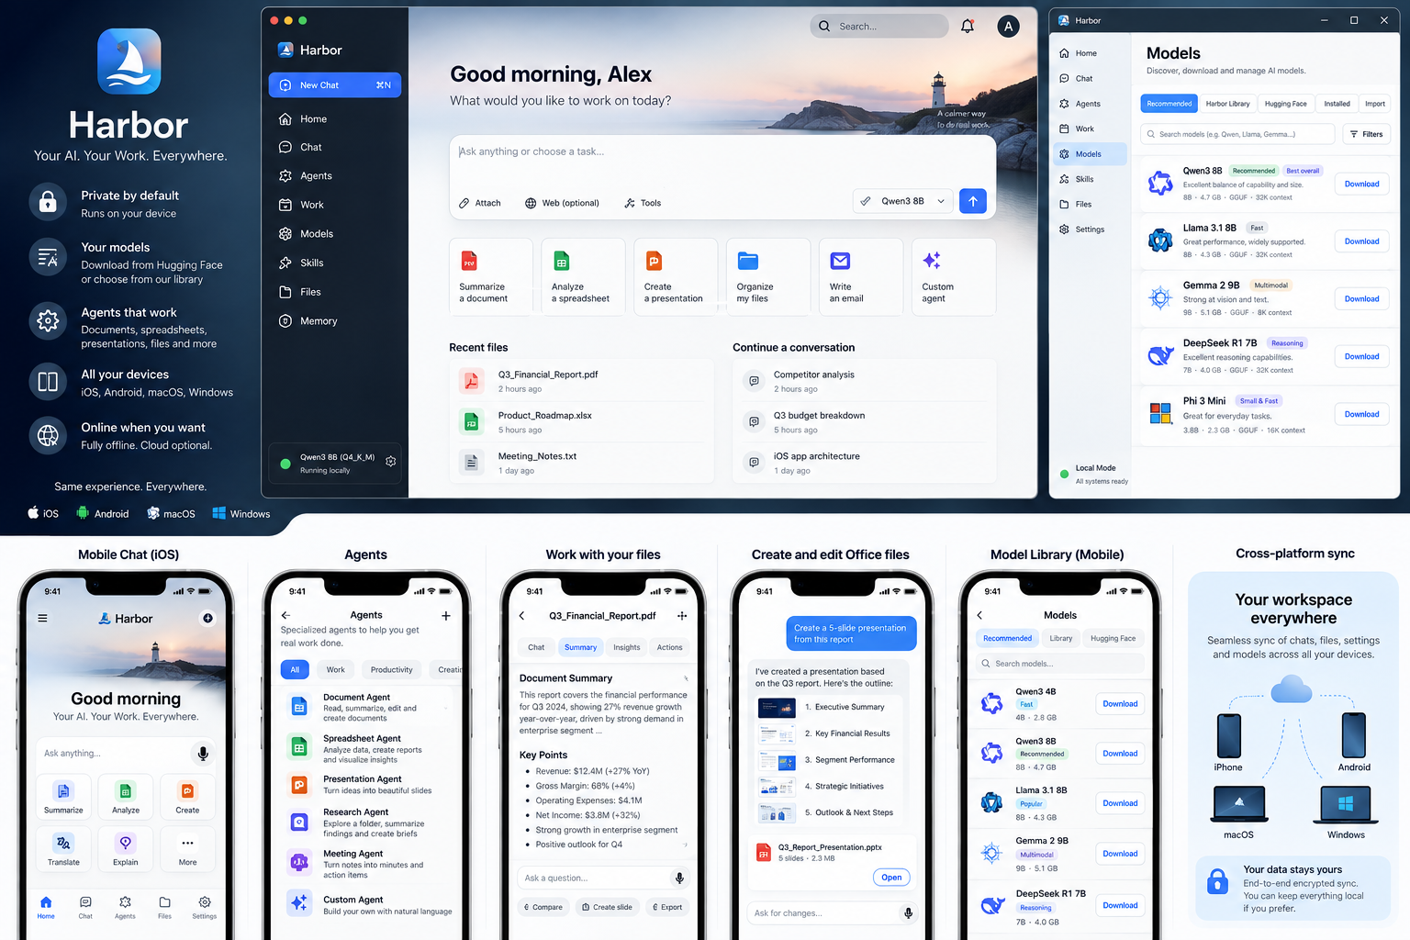

0 Authority and decision status
Revision 3 defines Harbor product and engineering contracts, release qualification and implementation sequencing. The eight schemas and normative CSV/JSON/Markdown files form one authority. A contradiction is a package validation failure; permissive schema acceptance never overrides a safety invariant. Product qualification remains blocked until runtime evidence and qualification identities are supplied.
Primary decision. Build one local-first Harbor product across iOS/iPadOS, Android, macOS and Windows. Use a shared Flutter shell and Rust core, GGUF/llama.cpp as the universal local-model baseline, OS-native model providers as optional accelerators, a Harbor-curated model library plus direct Hugging Face acquisition, and deterministic agent/tool/artifact execution. Cloud, connectors and sync are optional capabilities—not hidden dependencies.

1 Product lock
Dimension | Authority
Product | Private local-first AI workspace and agent runtime; not a generic model runner.
Primary surfaces | Home, Ask/Conversation, Work, Agents, Models, Skills, Knowledge, Activity, Settings.
Work artifacts | DOCX, XLSX, PPTX and PDF with typed operations, versioning, diff and approval.
Models | Harbor curated catalog + public Hugging Face search/download + local import; optional gated/private Hub access.
Privacy | Workspace Local/Hybrid/Remote policy plus visible actual execution location. No silent cloud fallback.
Languages | English and Arabic first-class UI; language-by-feature matrix governs OCR/model/RAG/speech/artifacts.
Platforms | One architecture; platform-specific native adapters only where OS integration requires them.
Release model | Evidence-backed acceptance gates by milestone/platform/feature; task priority is not a release rule.

2 Release scope is executable
Release descriptors identify platform, architecture, device/OS class, enabled features, commit and exact build digest. Validate feature closure and earliest activation milestone before selecting gates. Core safeguards cannot be disabled. Optional services need their own activation evidence; disabled authority paths are tested by ACC-064.
Milestone | Meaning | Exit condition
M0_CONTRACT | Architecture/readiness freeze | Schemas, features, semantic contracts and negative fixtures pass package validation; no future runtime task is a prerequisite.
M1_LOCAL_REFERENCE | One end-to-end local workflow | One declared target completes the cached/local-model workbook-to-deck workflow offline, including crash recovery.
M2_PLATFORM_BETA | All four platforms | All shipped platform/architecture targets repeat the reference workflow and qualify native, storage, network, Office and accessibility behavior.
M3_GA_CORE | Core public release | Every applicable blocking gate through M3 PASS with build-bound evidence; performance thresholds populated.
M4_OPTIONAL_SERVICES | Feature-specific activation | Every enabled feature passes its own activation gates and dependencies; disabled paths remain unavailable.

Validate descriptor and feature registry first.
Gate status: REQUIRED or N/A_PLATFORM, N/A_DISABLED, N/A_MILESTONE.
Required results: PASS, FAIL or BLOCKED.
PASS binds descriptor, commit, build, target and hashed test evidence.

3 Platform and device support contract
Framework support is wider than Harbor qualification. Harbor intentionally publishes a narrower product support floor and separately distinguishes shell support from custom-model qualification.
Platform | GA floor | Architectures | Custom local-model qualification | Primary acceleration
iOS/iPadOS | 18+ | arm64 | 6 GB physical RAM minimum for qualified custom models; lower-memory devices capability-limited | Metal/llama.cpp; optional Apple system model
Android | API 29+ | arm64-v8a | 6 GB physical RAM minimum for qualified custom models | CPU/Vulkan/qualified accelerator; optional Android system model
macOS | 13+ | Apple Silicon | 8 GB RAM minimum; 16 GB recommended | Metal/llama.cpp; optional Apple system model
Windows | 11 22H2+ | x64, arm64 | 8 GB RAM minimum; 16 GB recommended | CPU/Vulkan/CUDA/qualified backend; optional Windows system model

The resource governor admits a model only when predicted peak use leaves at least 1.5 GB mobile or 2.0 GB desktop reserve and satisfies the device-specific safe-memory envelope. Generation, indexing, rendering and download decompression share one process-wide resource budget.

4 System architecture
Layer | Owns | Must not own
Flutter product shell | Navigation, adaptive layout, view state, accessibility, local presentation logic | Permissions, network policy, effect idempotency, artifact commit semantics
Rust Harbor core | Run state, model routing, tools, approvals/effects, artifacts, knowledge, egress policy, persistence | Raw OS UI implementation details
Native adapters | Secure store, file capabilities, lifecycle/thermal, platform model APIs, safe replace primitives | Product policy or autonomous widening of authority
Model runtimes | Token generation/embeddings/structured output according to capability | OS/file/network authority
Optional service | Signed catalog metadata and optional E2EE sync ciphertext routing | Plaintext workspace content or private model tokens

5 Model runtime and provider contract
ModelRef has validated InstalledPackage, SystemManaged and RemoteEndpoint variants. Installed references require complete data files, digests, license/source identity and storage classification. System providers require provider/model identity; remote references require a local endpoint profile. Capabilities and availability are explicit, and unsupported operations cannot trigger silent substitution.
- GGUF + llama.cpp is the universal baseline for open local models; runtime/backend revision is pinned and part of benchmark identity.
- Provider load/generate/embed operations are cancellable. A cancelled or failed load must release mapped files, GPU allocations and temporary state.
- Router inputs include required capability, privacy policy, actual provider availability, context fit, measured device profile, thermal/resource state and user model lock.
- Actual execution location is emitted as a runtime fact and displayed separately from workspace policy.

6 Model library and Hugging Face
Path | Behavior | Security
Recommended | Device-aware Harbor catalog with Fast/Balanced/Quality/Coding/Vision/Arabic tags | Signed catalog, monotonic epoch, license/capability metadata
Harbor Library | Curated catalog index; weights may be fetched from publisher/Hub | Catalog signatures + package hashes; no arbitrary code
Hugging Face public | Search/inspect repo; choose compatible data files; direct download | No trust_remote_code; redirects and credentials brokered
Hugging Face gated/private | Optional M4 capability with user token | Token in OS secure store; per-user gated access; separately qualified
Import file | User-selected GGUF/package | Preflight parser, size/hash checks, immutable staged install

harbor.model/v3 supports verified multi-file data packages. Paths must be normalized, relative and noncolliding; invalid digests, missing weights and executable content are rejected. Private model packages use encrypted workspace storage. A package becomes visible only after every required file is verified and the staged installation commits. System providers have independent M4 gates.

7 Durable run state and single executor ownership
CREATED -> PLANNING -> RUNNING -> COMPLETED
Planning/running may pause, fail or enter CANCELLING.
CANCELLING -> CANCELLED only with acknowledgement/termination proof.
No acknowledgement after 5 s -> PAUSED/cancellation_unacknowledged.
Pause reasons and active-time/step/tool/context totals are durable. The complete legal transition table is in 02_Runtime_Effect_and_Artifact_Contracts.md. CREATED and PLANNING can cancel or fail; terminal states cannot resume. Model/provider events use typed v3 payloads and semantic validators.
- Exactly one executor owns a run through a generation-fenced transactional lease. Two windows/processes may observe a run but only one may append authoritative events or dispatch effects.
- Unknown state- or authority-affecting events stop replay. Only events whose generic envelope explicitly declares `ignorable_display` may be skipped by an older runtime.
- Cancellation revokes new dispatch authority. The generation acknowledgement SLO is <=250 ms p95; after 5 seconds without acknowledgement the run pauses visibly. CANCELLED requires provider acknowledgement or verified executor termination. A previously dispatched external effect may remain outcome_unknown independently of run cancellation.

8 Protected effects and uncertain outcomes
A local receipt cannot by itself make a remote API idempotent. Harbor therefore treats effect execution as a durable protocol with uncertain outcomes.
State | Meaning | Recovery
prepared | Canonical arguments, target, approval, generation and idempotency strategy persisted before dispatch | Dispatch only after current receipt, policy, capability and lease checks; otherwise abort.
dispatched | Request crossed provider boundary with attempt/idempotency metadata | Reconcile or retry using same provider key only if provider contract permits.
committed | External result reconciled and durable local result recorded | Never dispatch again; replay returns committed result.
outcome_unknown | Provider may have accepted action, but reliable reconciliation is unavailable | No automatic retry; user sees uncertainty and recovery choices.
aborted | Intent cancelled before external acceptance or explicitly reconciled as not applied | No further automatic dispatch.

harbor.approval/v1 receipts bind run, effect, device, executor generation, canonical arguments hash, target, effect class and policy version. Both allow-once and persistent-policy-derived receipts are single-effect and valid for at most 15 minutes. Artifact receipts also bind batch/base/output hashes. Consumed, denied, expired, revoked or post-termination receipts cannot authorize new dispatch.
Persist canonical arguments and their SHA-256 before dispatch. Harbor canonical JSON has sorted Unicode-scalar keys, exact 53-bit integers and decimal strings, no floating-point JSON, and no duplicate keys or Unicode normalization. Provider-key mode requires a stable key; reconcile mode requires a lookup adapter. Expired provider idempotency windows produce outcome_unknown. See tools/contracts.py and the negative fixtures.

9 Artifact commit and stale write protection
Every mutation—including spreadsheet cell changes and structural edits—uses a version-bound batch. No Office format receives an exception.
harbor.artifact_batch/v3
artifact/base version/hash; batch ID; typed operations and preconditions;
unique operation IDs; proposed output hash; receipt ID; timestamp
- Acquire a scoped capability and immutable base identity. Stage the complete proposal, validate it and verify the approved output hash.
- Collect a receipt bound to the exact batch, base, proposed output, effect, device and generation.
- Persist commit preparation, staged blob identity and predetermined destination before publication; consume the receipt transactionally with dispatch preparation.
- Reacquire capability and verify the base inside a qualified conditional-write or exclusive-write interval. External targets default to Save New Copy; atomic rename alone does not justify overwrite.
- Publish once, flush file/directory state where supported, then finalize the journal and version. Provider qualification and crash boundaries are defined in 27_Artifact_Commit_Qualification.md.
- Recover using the recorded output/destination identity. Existing approved output finalizes the same version; a third-party version produces conflict. Uncertain outcomes never trigger blind retry or a second copy destination.

10 Office engine calculation preservation and rendering
The bounded Office engine has separate calculation, structural preservation and rendering qualification. All 71 formula entries remain unqualified until the exact engine, adapter and fixture identity passes. File 26 defines numerical/date/error behavior, visual tolerances and benchmark methodology; file 21 defines supported and preserve-only features.
Area | GA strategy | Unsupported behavior
XLSX calculation | `harbor_formula` adapter with Formualizer 0.9.0 selected as baseline; production source revision/hash pinned by HBR-153; 22_Formula_Coverage.json controls function-by-function qualification; run-fixed clock for volatile time functions | Any function/dependency not PASS for the exact engine + adapter + fixture corpus is preserve-only/unverified and cannot support a verified numerical claim
DOCX rendering | Harbor IR renderer for paragraphs/runs/lists/tables/images/common styles/sections/headers/footers | Preserve advanced fields/drawing/layout where safe; show fidelity warning
PPTX rendering | Harbor renderer for text/shapes/images/themes/notes/qualified charts | Preserve transitions/animations/macros and unsupported charts; do not execute active content
XLSX rendering | Grid/merged cells/styles/number formats/qualified charts | Preserve pivots/slicers/macros/external data; mark not recalculated/rendered as applicable
Active content | Never executed by Harbor | Preserve/quarantine/reject according to feature matrix

Every import emits a compatibility report with four classes: supported; preserved_not_rendered; preserved_not_recalculated; rejected. A file opening without repair is necessary but not proof of numerical or visual correctness.

11 Office and file workload ceilings
Limit | Mobile default | Desktop default
Office compressed package | 100 MB | 250 MB
Expanded Office XML/media | 400 MB | 1.5 GB
PDF | 250 MB / 750 pages | 750 MB / 2500 pages
Workbook non-empty cells | 750k | 3M
Decompression | Never beyond preflight ceiling | Never beyond preflight ceiling

The resource governor may lower these limits dynamically. Harbor refuses or offers a reduced workflow before allocating beyond its safety envelope.

12 Workspace knowledge and local RAG
IndexIdentity = embedding_model_hash + vector_dim + chunker_id/version/config + tokenizer_id/version + normalization + language_policy + encryption_scope
- An identity change creates a new index namespace. Harbor rebuilds and validates before cutover; it never queries vectors from incompatible identities as one index.
- Removing/revoking a source excludes it from future retrieval immediately and schedules chunk/cache deletion.
- Existing chat text remains historical unless the user chooses purge-derived-content; old citations resolve as source_removed rather than masquerading as current evidence.
- EN/AR/mixed evaluation uses the per-language denominators, baseline thresholds and fixture-binding procedure in 26_Qualification_Profiles.json. Missing corpus/model/runtime identities block qualification. Security permits zero unauthorized effects; aggregate scores cannot hide a failing language stratum.
Source versions are immutable. Revocation filters both retrieval and queued context assembly; old citations retain their original source version. Purge-derived-content previews its cascade, while exported copies remain outside Harbor control.

13 Network policy and privacy enforcement boundary
Egress class | Default | Authorization / logging rule
Catalog/model search metadata | Off until user enters online model acquisition | No workspace content; brokered and logged as acquisition metadata.
Model weights | Explicit install/update only | Size/origin known; redirects reauthorized; auth stripped cross-origin.
Remote inference | Disabled | Hybrid/Remote workspace policy + visible destination/current execution.
Connector read/write | Disabled | Connector capability; writes are protected effects.
E2EE sync | Disabled | Only protocol ciphertext/metadata when feature enabled.
Diagnostics upload | Disabled | User previews payload and explicitly opts in.
OS-managed provisioning | Provider-specific | Classified separately; strict offline qualification disables providers whose traffic cannot be established.

Every app-controlled request passes the Egress Broker, including Flutter/native adapters. The Network Log distinguishes blocked attempt, dispatched request and completed traffic. Release verification uses independent packet/proxy capture; Harbor cannot prove its own privacy claim solely from its own log.

14 Storage encryption and deletion
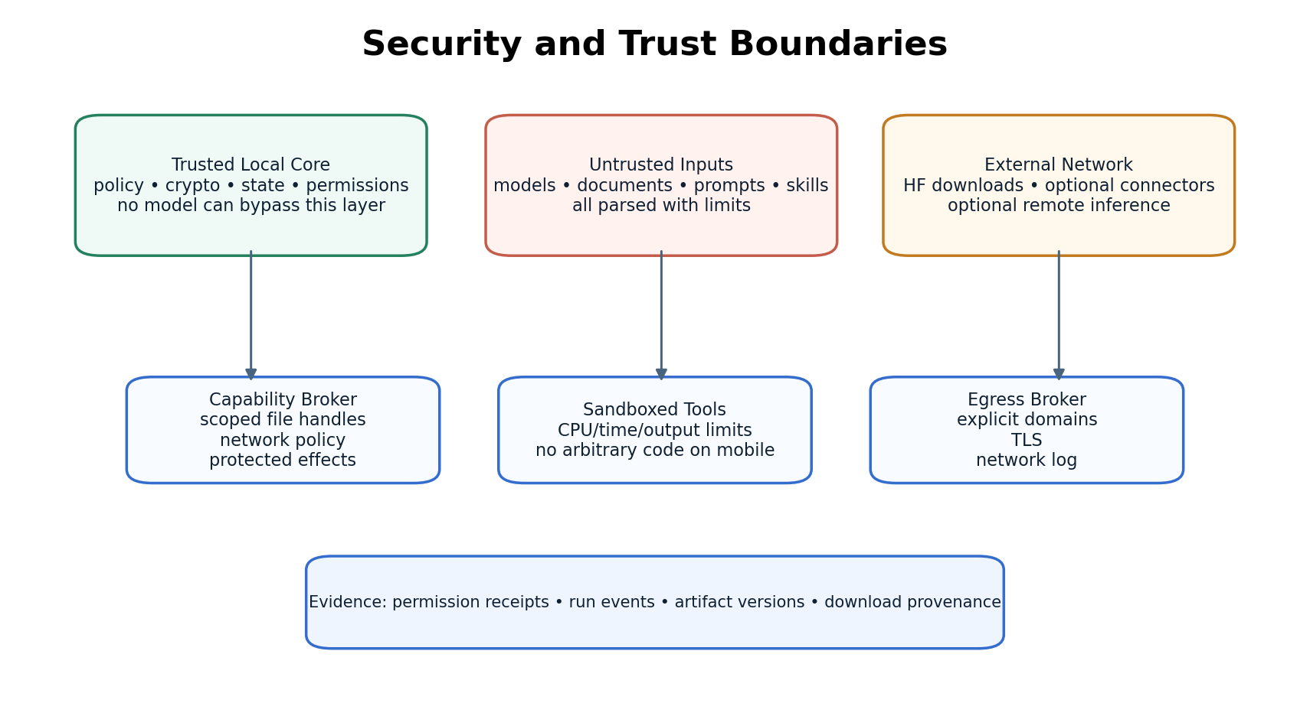
Data class | Protection
Public model weights/catalog | Integrity checked; may be shared/deduplicated; confidentiality not assumed.
SQLite state | Encrypted database; key in OS secure store; journals/temp behavior included in leak tests.
Private artifacts/extracts/embeddings/previews | Per-workspace encrypted blob store; cross-workspace private dedup disabled by default.
Temporary decrypted data | Authorized operation window; protected backup-excluded temp storage; completion/cancel/lock and restart cleanup; physical deletion best effort.
Backup | Explicit encrypted Harbor bundle; recovery secret/key lifecycle documented.

Keys wrap private workspace blobs. Deletion crypto-erases encrypted data keys and collects unreachable blobs; it cannot erase plaintext already materialized or exported. Temporary plaintext is operation-bound, protected and backup-excluded, with completion/cancel/lock and restart cleanup. Private Hub model files use encrypted workspace storage. Residual physical cleanup limits are disclosed and tested.

15 Optional sync protocol
Sync is not a hidden core dependency. It remains disabled until its feature-specific gate passes. Synced data never confers execution authority.
- Each device has signing/encryption identity in OS secure storage. A sync group uses epoch keys; revocation advances the epoch for future records.
- Sync records carry device sequence, key epoch, object ID, hybrid logical clock, previous-device hash, tombstone flag and authenticated ciphertext.
- Chats/run history are append-only; settings only use LWW where explicitly safe; artifacts fork on concurrent edits; delete-versus-edit is a visible conflict.
- Execution transfer requires an online coordinator and durable acknowledgement that the source stopped and lost dispatch authority. A missing source acknowledgement blocks transfer. The destination gets a fresh generation and reacquires local authority. Devices absent beyond 90 days expire and re-enroll; tombstones persist at least 120 days and until active-device watermarks acknowledge deletion.

16 Skills tools and Office agents
Primitive | Contract
Tool | Typed JSON schema, risk class, scoped capabilities, timeout/output bounds, evidence/artifact result envelope.
Skill | Instructions + declarative tool/capability/model policy + budgets; no executable code by default.
Agent profile | Reusable model/tool/knowledge/approval policy; cannot widen workspace privacy or OS capability.
Office agents | Document, Spreadsheet, Presentation, PDF profiles use only typed artifact operations and safe commit service.
Cross-artifact workflow | Spreadsheet values must be verified by calculator contract before Harbor may present them as authoritative and use them in deck generation.

17 UI UX integration points that are engineering contracts
- Trust Pulse shows two facts: allowed workspace policy and actual current execution location.
- Run Trail shows planning, running, paused reason, waiting approval, cancelling, completed, failed, cancelled and uncertain effect outcome.
- Work Canvas shows unverified formula/fidelity states and a first-class stale-artifact conflict resolver.
- Model Dock never silently substitutes an unavailable model; it offers explicit alternatives.
- At viewport widths >=1024, the desktop editor retains a 640 px canvas; below 1280 the Lens overlays, and below 1180 the rail collapses. Below 1024, controls fit the viewport and document content may scroll. Compact editing and approval/conflict actions are tested at 320/390 px and 200% text scale.

18 Accessibility and Arabic
Semantic colors now have separate text/fill/border/on-fill roles. Normal text must meet 4.5:1 unrounded contrast in every component state. Color is never the only status signal. Arabic line-height tokens are larger than Latin equivalents; RTL mirrors structure but not inherently directional data such as code, file paths or numeric expressions.
Capability | English | Arabic at core GA
UI | Full | Full RTL
Recommended model answers | Required | Required for bilingual recommended models
RAG/embeddings | Required | Required with multilingual default profile
Printed OCR | Full | Offline Arabic pack where feature enabled
Generated Office artifacts | Unicode/LTR | Unicode + qualified RTL paragraphs/cells
Speech | Unavailable until a new registry contract and activation gate are approved. | Same activation requirement; no implicit provider fallback.

19 Performance qualification is measured not guessed
The fixed generation cancellation SLO is <=250 ms p95. Other speed/throughput thresholds are calibrated per lowest qualified target, approved before an independent qualification run and bound to raw samples. File 26 fixes seeds, sizes, repetitions, percentile calculation and required identities. Missing model/runtime/device/fixture bindings remain BLOCKED.
- Cold/warm start, model load, TTFT, sustained tokens/s, peak RSS/accelerator memory.
- UI frame-miss rate while streaming; artifact open/save by fixture; RAG indexing throughput.
- Thermal state after sustained reference generation and recovery after memory/thermal pause.
- Concurrent generation + indexing + download backpressure under a single process-wide resource governor.
Qualification fixture source hashes are supplied; binary Office fixtures and production model/runtime/device identities must still be bound. Tests report actual raw results. Missing measurements are BLOCKED, not zero or PASS.

20 Testing strategy and fault injection
Suite | Mandatory evidence
Contract | JSON schema compatibility, unknown-event behavior, provider capability negotiation.
Run/recovery | Kill at every transition; approval after cancellation; concurrent resume lease.
Effects | Crash before dispatch, after remote acceptance, before local commit, retry/reconcile.
Artifacts | TOCTOU edits, batch replay, atomic-replace interruption, Office active-content non-execution.
Network | Independent capture vs broker log; redirects; native adapters; OS-managed provider classification.
Storage | Synthetic plaintext search, key rotation, backup/restore, one-workspace deletion.
Office | Known spreadsheet answers, stale caches, preserve-only corpus, golden renders.
RAG/eval | EN/AR citations, abstention, contradictory sources, source revocation, injection.
Accessibility | Component contrast, screen readers, keyboard focus, text scaling, RTL.
Performance | Minimum-device raw measurements and approved threshold file.

21 Support and source of truth files
File | Purpose
01_Release_and_Scope_Authority.md | Gate-selection and feature/milestone authority.
02_Runtime_Effect_and_Artifact_Contracts.md | Durable run/effect/artifact commit semantics.
03_Architecture_Contracts.md | Cross-subsystem normative architecture.
04_Implementation_Backlog.csv | 115 tasks with executable milestone ordering and generated acceptance backlinks.
05_Acceptance_Matrix.csv | 81 core and feature activation gates with target-specific evidence requirements.
06_Design_Tokens.json | Accessible semantic tokens + adaptive layout limits.
07_Screen_Inventory.csv | 47 routes/states with owner/milestone/tasks/evidence.
09_Security_Test_Matrix.csv | 47 security scenarios.
11_Sync_Protocol.md | Optional sync authority.
12_Office_and_Device_Feasibility.md | Selected Office strategy, support floors, ceilings.
13_Network_and_Storage_Policy.md | Egress and encrypted storage policy.
15_Performance_Qualification.yaml | Release-blocking measurement contract.
schemas/*.json | Eight schemas: run, effect, batch, model, approval, commit journal, release descriptor and gate result.
14_Language_Capability_Matrix.csv | English/Arabic support contract by UI, model, OCR, embeddings, speech and artifacts.
16_Index_and_Evaluation_Contract.md | Index identity, rebuild/isolation rules and grounded EN/AR evaluation authority.
17_Model_Provider_and_Package_Contract.md | Provider capabilities, cancellation, multi-file packages and catalog trust.
18_Reconciled_Release_Matrix.csv | Release/platform/feature applicability projection.
19_Structural_Validation.json + 20_Readiness_Validation_Report.md | Machine validation of graph, mappings and contrast contracts.
21_Office_Feature_Matrix.csv | Executable Office supported/preserve-only/reject feature authority.
22_Formula_Coverage.json | Formula qualification manifest; only exact PASS entries are verified.
23_Review_Reconciliation_Matrix.md | Finding-by-finding mapping from readiness review to contracts, tasks and gates.
25_Feature_Registry.json | Feature dependencies, supported platforms and earliest activation gates.
26_Qualification_Profiles.json | Pinned workload procedure, source fixtures and evidence-blocking production bindings.
27_Artifact_Commit_Qualification.md | Storage-provider overwrite qualification, copy fallback and crash recovery.
tools/validate_dossier.py | Reproducible package validation and release evidence evaluation.
28_Correction_Log.md | Revision 3 changes and the distinction between corrected contracts and unexecuted product gates.

22 Implementation order
- Freeze M0 contracts and make schema/gate validation run in CI. Do not implement autonomous breadth while these contracts remain mutable.
- Build M1 on one declared reference target: install a cached/local model, verify a known-answer workbook, create a deck, preview/diff, approve, safe-save and recover after process death with network disabled.
- At M2, repeat the local reference workflow on each shipped platform/architecture and qualify native adapters, egress, storage, parsers, accessibility and compact/desktop layouts.
- Finish M3 RAG/evaluation/performance/store qualification and ship the core product only when all applicable blocking gates have evidence.
- At M4, enable each optional capability only after its registry activation gates pass for the exact target/build. Authentication, gated access, connectors, diagnostics, sync, remote/system providers, desktop sandbox and app lock have separate gates.

23 Current ledger status
Measure | Reconciled authority
Implementation tasks | 115
Acceptance gates | 81
Screens/routes | 47
Security scenarios | 47
Dependency resolution | All dependencies resolve
Dependency cycles | None detected
Machine-readable schemas | 8
Explicit optional/capability flags | 14
Milestone dependency inversions | 0 after reconciliation
Product qualification | BLOCKED pending implementation evidence

The corrected package contains 115 tasks, 81 gates, 47 screens, 47 security scenarios and 8 schemas. Reproduce structure and contract regressions with tools/validate_dossier.py. Product release evidence remains absent; the 71 formula entries and unbound model/engine/device/evaluation identities are not qualified.

24 Technology reference sources
- Flutter currently supports iOS, Android, macOS and Windows; Harbor uses a narrower product qualification floor. Source: https://docs.flutter.dev/reference/supported-platforms
- llama.cpp currently publishes iOS XCFramework and Android/Windows/macOS builds/backends; Harbor pins a qualified revision rather than tracking latest at runtime. Source: https://github.com/ggml-org/llama.cpp
- Hugging Face gated model downloads require authenticated user access; Harbor keeps optional user tokens in OS secure storage. Source: https://huggingface.co/docs/hub/models-gated
- Formualizer is an embeddable Rust formula/workbook engine under MIT OR Apache-2.0; Harbor still qualifies a pinned revision against its own corpus before relying on it. Source: https://docs.rs/formualizer/
- Tesseract distributes Arabic traineddata; Harbor uses an offline Arabic OCR pack where native OCR is not qualified. Source: https://github.com/tesseract-ocr/tessdata
- WCAG 2.2 normal text contrast target is 4.5:1; Harbor token checks use unrounded contrast. Source: https://www.w3.org/WAI/WCAG22/Understanding/contrast-minimum.html

25 Final build instruction
Implementation rule. Do not mark Harbor “complete” because UI screens exist or tasks are checked off. A capability is complete only when its contracts are implemented, its applicable acceptance/security/evaluation gates are green, and the exact build carries reproducible evidence. Preserve the one-runtime architecture: model, tool, Office, RAG, connector and sync capabilities must compose through Harbor Core rather than creating parallel agent subsystems.

