HARBOR

Harbor UI and UX Design Authority
Revision 3 corrected specification
12 September 2026 | iOS | Android | macOS | Windows
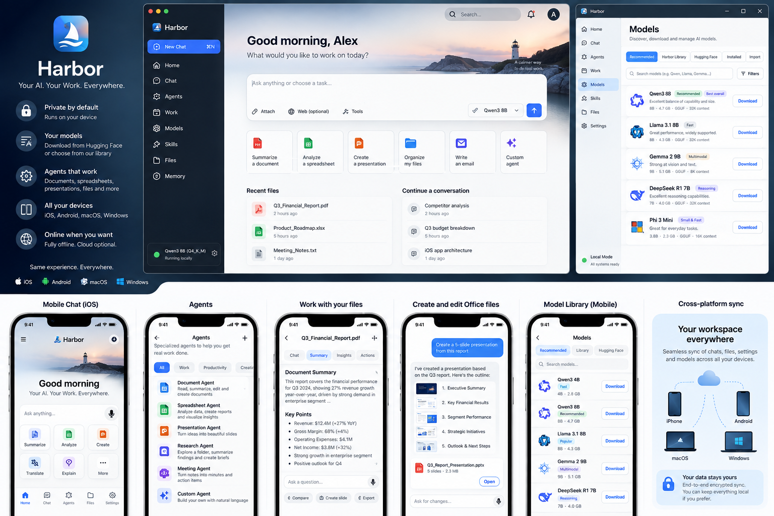

0 Design authority
Revision 3 defines Harbor product behavior across iOS/iPadOS, Android, macOS and Windows. This corrected design authority aligns routes, states, release features and implementation tasks with the normative ledgers. The product is local-first, observable and reviewable. Contract validation is separate from implemented UI or usability qualification.

1 Harbor experience principles
Principle | Product behavior
Work first | Artifacts, files, models and runs are durable objects; chat is a control surface, not the entire application.
Local is visible | Users can distinguish allowed policy from actual execution location at all times.
Agency is inspectable | Run Trail shows what Harbor is doing, why it paused, what it changed and what evidence it used.
High-impact actions are reviewed | Diff, version history, safe save and approval precede protected effects. Remote effects may be irreversible; uncertain outcomes are displayed explicitly.
Complexity is progressive | Normal users see Fit Score and recommended choices; experts can expand quantization/backend/revision details.
One product, adaptive surfaces | Desktop is multi-pane; mobile is sheet/navigation driven; terminology and object model stay consistent.

2 Harbor interaction language
Name | Meaning
Harbor Rail | Primary desktop navigation; expands/collapses without taking editing space below its threshold.
Work Canvas | Central artifact/conversation workspace. Desktop editing viewport >=640 logical px at viewport widths >=1024; compact controls fit the viewport.
Harbor Lens | Context/run/knowledge inspector; docked only on wide layouts, overlay/drawer on narrower layouts.
Model Dock | Current model/provider/execution location and model-switch surface.
Trust Pulse | Two-part privacy signal: workspace policy + actual current execution location.
Run Trail | User-readable event timeline with expandable technical details and evidence.
Harbor Sheet | Approval/review surface for protected effects and sensitive changes.
Fit Score | Device-specific model compatibility label derived from hardware/runtime measurements.
Artifact Diff | Human-readable + technical diff bound to a specific artifact base version.

3 Information architecture
Area | Primary purpose
Home | Command center, recent work, active runs, quick tasks.
Ask | Conversation attached to current workspace/artifact; not a separate universe.
Work | Documents, spreadsheets, presentations, PDFs and project folders.
Agents | Built-in/custom profiles, active and previous runs.
Models | Recommended, Harbor Library, Hugging Face, Installed, Import, Benchmark.
Skills | Signed built-ins and user-authored declarative skills.
Knowledge | Local collections, sources, index status, source citations.
Activity | Runs, downloads, network attempts/traffic and recovery events.
Settings | Privacy, remote endpoints, connectors, devices/sync, storage, language, appearance.

4 Responsive layout and collapse order
Viewport | Rail | Lens | Work Canvas
<600 compact | Bottom navigation | Modal sheet | Viewport-sized controls, 16 px gutters; structured editing and scrollable artifact content; test down to 320 px.
600–1023 medium | Compact side/bottom pattern by platform | Overlay/drawer | Responsive or structured editor with transient inspectors; no 640 px viewport minimum.
1024–1179 expanded-narrow | 72 px collapsed rail | Overlay/drawer | Minimum 640 px maintained
1180–1279 expanded | 220 px rail where room permits; collapse if canvas threatened | Overlay/drawer | Minimum 640 px maintained
≥1280 wide | 220 px rail | 320 px docked Lens optional | Remaining canvas, minimum 640 px
≥1440 wide+ | 220 px rail | 320 px docked Lens | Content can expand to 1440 max; artifact view centered as needed

Desktop and compact layout rule. At viewport widths >=1024, maintain a 640 px desktop canvas by collapsing navigation and making the Lens transient. Below 1024, controls fit the viewport; document content may scroll. At 320/390 px and 200% text scale, approval and conflict actions remain reachable without clipping.

5 Visual design and semantic roles
The visual language is calm, technical and productivity-oriented: bright surfaces in light mode, deep naval surfaces in dark mode, restrained blue brand, and semantic status colors with separate text/fill/border roles. Decorative gradients are not a primary identity element.
Role | Light | Dark | Usage
Brand / primary action | #1F5FCC with white text | #7EA9FF with #07111D text | Primary buttons, focus/selection.
Local status text | #1E6F4E | #7FE0AF | Always paired with icon/label; not color-only.
Hybrid status text | #8A5200 | #F6C36B | Warning/conditional local-first policy.
Remote status text | #4F46C8 | #C5C6FF | Remote-capable/current remote state.
Danger text | #A33126 | #FFAAA0 | Destructive/error status.

Normal-text pairs require 4.5:1 unrounded contrast. Use the explicit allowed text/surface pair list in 06_Design_Tokens.json. Light inkMuted is #5B6F84, including use on brandSoft. Actual hover/disabled/focus/error states require component-level qualification; token PASS does not certify the UI.

6 Typography and Arabic
Role | Latin | Arabic | Notes
Product UI | Inter or platform-equivalent | Noto Sans Arabic or qualified equivalent | Use platform fallback only after visual QA.
Monospace | JetBrains Mono or equivalent | Directional isolation around code/IDs | Code remains LTR inside RTL layouts.
Body | 14/21 | 14/24 | Arabic has additional line height.
Small | 12/17 | 12/20 | Avoid dense Arabic truncation.
Caption | 11/15 | 11/18 | Use for metadata, not critical approval copy.

- RTL mirrors structural navigation and alignment, but filenames, URLs, code, formulas and raw identifiers preserve intrinsic direction.
- Numerals follow locale/user preference consistently; mixed Arabic/Latin strings use directional isolation rather than manual punctuation hacks.
- Generated Office artifacts support explicit paragraph/cell direction rather than relying only on UI locale.

7 Home and universal composer
- Home opens with “What do you want to get done?” plus attach, model, privacy state and optional tool/agent affordances.
- Quick actions are work verbs (summarize document, analyze spreadsheet, create presentation, organize files) rather than model names.
- Active runs surface above recent history when user attention is required. Completed background work is summarized, not animated indefinitely.
- Model Dock defaults to an auto-selected qualified model; user lock is explicit and sticky per workspace/thread.

8 Work Canvas
Artifact | Canvas behavior | Agent affordances
DOCX | Paginated/structured preview, outline, comments/changes view, version banner | Summarize, rewrite selected blocks, create tables, compare versions.
XLSX | Grid, formula bar, selected range, calculation status, chart preview | Analyze, explain formula, clean data, create formulas/charts, generate deck.
PPTX | Slide navigator, canvas, notes, theme/fidelity status | Create/rewrite slides, apply structured content, compare deck versions.
PDF | Pages + extracted text/source handles | Summarize, compare, extract tables/actions, add to Knowledge.

A Work Canvas shows original/current version, unsaved proposal, compatibility warnings, unverified values, external-change conflict and pending approval. On compact screens, controls fit the viewport and artifact content may scroll. Save New Copy is the default for external files until the storage adapter qualifies safe overwrite.
The document, spreadsheet and presentation workspaces are UX-008, UX-009 and UX-010. Artifact commit evidence maps to these views and UX-047; Office rendering maps to UX-008/010. Formula-unverified/recalculating states belong to UX-009, while receipt expiry and denial belong to UX-017/043.

9 Artifact Diff approval and conflicts
State | UX contract
Proposal ready | Show concise summary first; user can expand exact paragraph/cell/slide operations.
Approval pending | UX-017/043 names target, scope, approved base/output and new-copy/overwrite mode. Show expiry, deny and cancellation states; changed bindings require a new approval.
Base changed | Do not present old approval as valid. Open Artifact Conflict Resolver with Reopen/Rebase/Save New Copy choices.
Commit uncertain | Use the durable commit journal to reconcile the exact destination. A third-party version produces conflict; an unknown provider outcome cannot trigger automatic retry or another copy.
Committed | Version history records run/model/operation provenance and provides restore/copy actions.

10 Models experience
Tab | Normal user | Advanced expansion
Recommended | Fast / Balanced / Quality / Coding / Arabic suggestions with Fit Score | Runtime/backend/context and measured profile.
Harbor Library | Curated searchable catalog | Publisher/revision/license/file manifest.
Hugging Face | Search or paste repo; show compatible files only | Revision/file/shard/quant details; optional sign-in for gated models.
Installed | Current size, default/profile use, unload/delete | Package hash, runtime build, benchmark identity.
Import | Choose local data package | Parser/architecture/package compatibility report.

Model unavailable is a first-class state. Provider absence cannot silently substitute another model. Core model screens remain available while authentication, gated access and system-provider actions are hidden or disabled until their own activation gates pass. Import accepts a validated data-only package or single GGUF, never executable repository code.

11 Agents and Run Trail
Run state | User-facing treatment
Planning | Short plan summary; no implication that tools already ran.
Running | Current step + elapsed active time + stop/pause control.
Waiting approval | Harbor Sheet blocks protected dispatch; expiry visible.
Paused | Reason badge: user/background/thermal/resource/source/network/uncertain effect. Resume only when safe.
Cancelling | Acknowledge the user action immediately and revoke new dispatch. After 5 seconds without provider acknowledgement, show a paused cancellation-recovery state.
Completed | Results, created artifacts and evidence summary.
Failed | Specific failure + recovery/retry boundary.
Cancelled | Terminal only after provider acknowledgement or verified executor termination. Any already dispatched effect may still be outcome_unknown and keeps its recovery entry.
Outcome unknown | Distinct red/amber uncertainty surface; do not call it failure or success.

12 Trust Pulse and Network Log
Trust Pulse example. Policy: LOCAL ONLY • Current run: ON DEVICE. Model acquisition session: ONLINE (explicit). This separation prevents users from confusing “remote allowed” with “this request was remote.”.

Network event | Displayed fields
Blocked attempt | Initiator, requested origin, reason, policy rule, timestamp; clearly marked not sent.
Dispatched request | Initiator, class (acquisition/inference/connector/sync/diagnostic), origin and authorization scope.
Completed traffic | Status, bytes if known, redirects/origin changes and completion timestamp.
OS-managed activity | Provider classification and disclosure that app-level attribution may be incomplete.

13 Knowledge experience
- Collections show source count, index identity/version, disk footprint, language and health.
- Source detail shows exact source version/checksum and the spans used by answers.
- After source removal, prior citations display “Source removed” rather than resolving to a different/newer file.
- Reindexing after embedding/chunker changes is visible as a new index build, not a silent mutation.

14 Mobile Capture
Capture type | Flow
File/share-in | Preview → choose workspace → grant scoped access/copy → agent action.
Document scan/photo | Detect language → verify required offline OCR pack → capture → local OCR → preview text → use/add to Knowledge.
Text/clipboard | Explicit paste/read action → preview → use in current context.
Audio | Unavailable in this registry. Future audio capability requires an explicit provider/privacy contract and activation gate before capture is shown.

Arabic OCR is enabled only after its offline pack and ACC-060 qualify on the target. Pack absence is disclosed before capture. Audio capture is unavailable in this release registry; adding speech requires a new provider contract and activation gate.

15 Accessibility
- Minimum mobile touch target 44 logical px; desktop targets may be 32 px where keyboard access is complete.
- Every interactive control has semantic name, role, state and accessible error/approval description.
- Screen-reader order follows visual/semantic task order, not implementation-tree order.
- Keyboard users can reach all primary desktop actions without the pointer; focus ring remains visible over every surface.
- Reduced Motion replaces spatial/continuous animations with opacity/state changes; token streaming does not force scroll position.
- Status meaning always includes text/icon/semantic label, never color alone.

16 Required recovery and exceptional states
First-class route/state | Why it exists
UX-043 Approval pending / uncertain effect | Separates normal approval, expiry/denial and unresolved external outcome.
UX-044 Permission revoked / capability recovery | Prevents silent authority widening when a file/connector scope disappears.
UX-045 Model unavailable / substitution | Prevents hidden router model changes.
UX-046 Offline / egress blocked | Explains privacy-policy block and explicit acquisition exceptions.
UX-047 Artifact conflict resolver | Prevents stale approved diff from overwriting external edits.

17 Screen ownership and evidence
Every route in 07_Screen_Inventory.csv has real implementation tasks, feature/platform applicability, required EN/AR and light/dark coverage, originating states and linked recovery routes. HBR-160 maintains mapping; it is not a substitute for a feature implementation owner. Optional routes become blocking when their capability is selected.
ID | Screen / state | Milestone | Task IDs
UX-001 | Privacy-first onboarding | M2 Platform beta | HBR-010; HBR-015
UX-002 | Device capability scan | M2 Platform beta | HBR-041; HBR-154
UX-003 | Starter model choice | M2 Platform beta | HBR-041; HBR-043
UX-004 | Home command center | M2 Platform beta | HBR-010; HBR-037
UX-005 | Universal composer | M2 Platform beta | HBR-010; HBR-037; HBR-073
UX-006 | Conversation workspace | M2 Platform beta | HBR-010; HBR-031; HBR-037; HBR-086
UX-007 | Work hub | M2 Platform beta | HBR-010; HBR-097
UX-008 | Document workspace | M1 Local reference | HBR-012; HBR-013; HBR-092; HBR-096; HBR-097
UX-009 | Spreadsheet workspace | M1 Local reference | HBR-012; HBR-013; HBR-093; HBR-096; HBR-097; HBR-153
UX-010 | Presentation workspace | M1 Local reference | HBR-012; HBR-013; HBR-094; HBR-096; HBR-097
UX-011 | PDF/research workspace | M1 Local reference | HBR-012; HBR-013; HBR-095
UX-012 | Artifact diff | M1 Local reference | HBR-096; HBR-151
UX-013 | Artifact version history | M1 Local reference | HBR-097
UX-014 | Agents gallery | M2 Platform beta | HBR-066
UX-015 | Agent builder | M1 Local reference | HBR-067
UX-016 | Agent run detail | M1 Local reference | HBR-064; HBR-065; HBR-148
UX-017 | Approval Harbor Sheet | M1 Local reference | HBR-063; HBR-149; HBR-151
UX-018 | Models recommended | M2 Platform beta | HBR-041
UX-019 | Harbor Library | M2 Platform beta | HBR-040; HBR-042
UX-020 | Hugging Face search | M2 Platform beta | HBR-043
UX-021 | Model detail | M2 Platform beta | HBR-040; HBR-041; HBR-047
UX-022 | Download manager | M1 Local reference | HBR-046; HBR-048
UX-023 | Installed models | M1 Local reference | HBR-031; HBR-048
UX-024 | Import local model | M1 Local reference | HBR-049
UX-025 | Benchmark lab | M2 Platform beta | HBR-050
UX-026 | Skills library | M3 Core GA | HBR-071; HBR-072
UX-027 | Skill editor | M3 Core GA | HBR-072
UX-028 | Knowledge collections | M3 Core GA | HBR-083; HBR-084; HBR-085
UX-029 | Knowledge source detail | M3 Core GA | HBR-081; HBR-083; HBR-085
UX-030 | Activity center | M2 Platform beta | HBR-065; HBR-100
UX-031 | Network log | M2 Platform beta | HBR-100; HBR-150
UX-032 | Privacy dashboard | M2 Platform beta | HBR-022; HBR-121; HBR-122
UX-033 | Connectors | M4 Optional services | HBR-102; HBR-103
UX-034 | Remote endpoints | M4 Optional services | HBR-036; HBR-124
UX-035 | Devices & sync | M4 Optional services | HBR-104; HBR-105; HBR-156
UX-036 | Storage manager | M2 Platform beta | HBR-048; HBR-122; HBR-152
UX-037 | Appearance/language | M2 Platform beta | HBR-011; HBR-015; HBR-158; HBR-159
UX-038 | Keyboard shortcuts | M2 Platform beta | HBR-014; HBR-015
UX-039 | Capture | M2 Platform beta | HBR-013; HBR-073; HBR-095; HBR-159
UX-040 | Share extension / intent | M2 Platform beta | HBR-073; HBR-114
UX-041 | Offline/error recovery | M1 Local reference | HBR-024; HBR-064; HBR-152
UX-042 | First-run Arabic preview | M2 Platform beta | HBR-011; HBR-015; HBR-159
UX-043 | Approval pending / uncertain effect | M1 Local reference | HBR-063; HBR-149
UX-044 | Permission revoked / capability recovery | M2 Platform beta | HBR-022; HBR-081
UX-045 | Model unavailable / substitution | M2 Platform beta | HBR-037; HBR-157
UX-046 | Offline / egress blocked | M2 Platform beta | HBR-100; HBR-150
UX-047 | Artifact conflict resolver | M1 Local reference | HBR-096; HBR-151

18 Design verification
- Golden snapshots cover 320, 390, 600, 1024, 1180, 1280 and 1440+ logical-pixel viewports at 100% and 200% text scale in both themes and languages.
- Automated unrounded contrast audit for every semantic text/fill pair plus manual focus and disabled/hover/pressed review.
- VoiceOver, TalkBack and Narrator scripts for onboarding, model install, Work Canvas edit, approval, conflict, run recovery and settings.
- Arabic/mixed-script stress set with long strings, numerals, filenames, formulas, tables and generated Office artifacts.
- Usability reference tasks: novice installs a recommended model; user completes workbook-to-deck flow; user understands Local policy versus actual run location; user resolves a stale artifact without data loss.
The repeatable screen-state matrix is route by applicable state by platform by language by theme. Run-state coverage belongs to UX-016, not the agents gallery. Disabled actions cannot be invoked through deep links or background jobs. ACC-062 checks completeness and ACC-064 checks activation boundaries.

19 Handoff rule
Design completion rule. A Harbor screen is implementation-ready only when its component tokens, responsive behavior, accessibility semantics, empty/offline/error/revoked/conflict states, linked tasks and acceptance evidence are specified. Do not create one-off platform designs that change the product object model or trust semantics.

