Import script to workbench:  
https://github.com/mossi4476/test_sql

Lược đồ cơ sở dữ liệu:

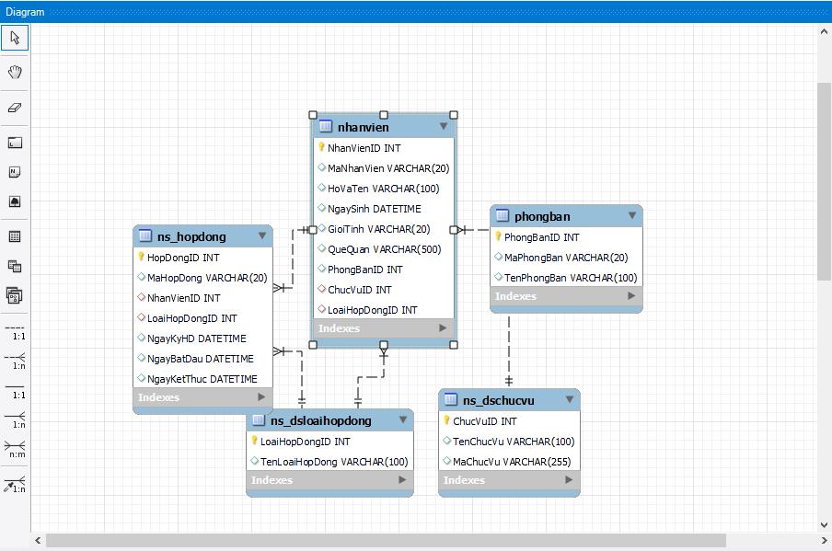

1/ Lấy thông tin nhân viên bao gồm các thông tin sau: Mã nhân viên, Họ và tên, Tên  
phòng ban, Tên chức vụ, ngày sinh

SELECT MaNhanVien, HoVaTen, TenPhongBan, TenChucVu, NgaySinh

FROM NhanVien

JOIN PhongBan ON NhanVien.PhongBanID = PhongBan.PhongBanID

JOIN NS_DSChucVu ON NhanVien.ChucVuID = NS_DSChucVu.ChucVuID;

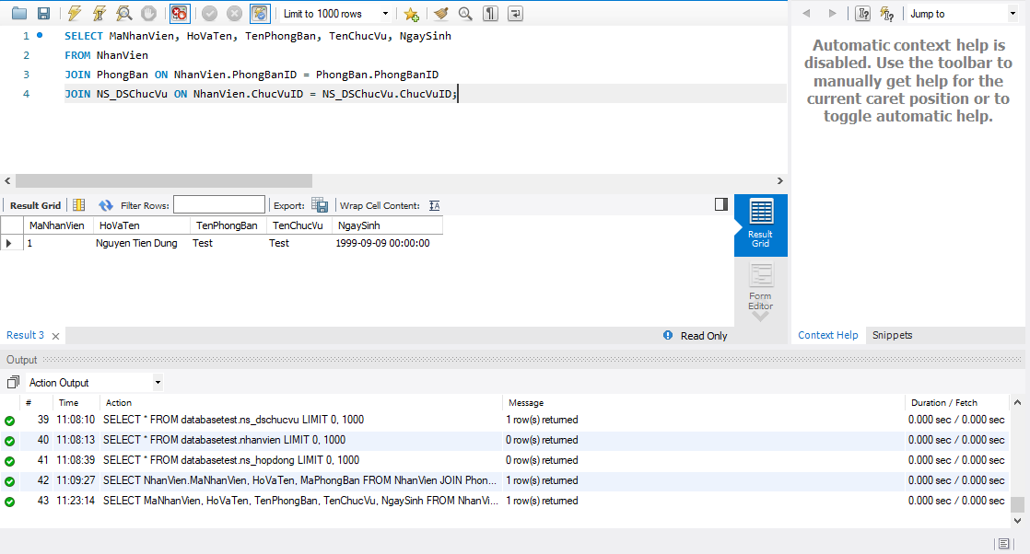

b/

SELECT NhanVien.MaNhanVien, HoVaTen, MaPhongBan

FROM NhanVien

JOIN PhongBan ON NhanVien.PhongBanID = PhongBan.PhongBanID

WHERE PhongBan.PhongBanID = (SELECT MIN(PhongBanID) FROM PhongBan)

LIMIT 0, 1000

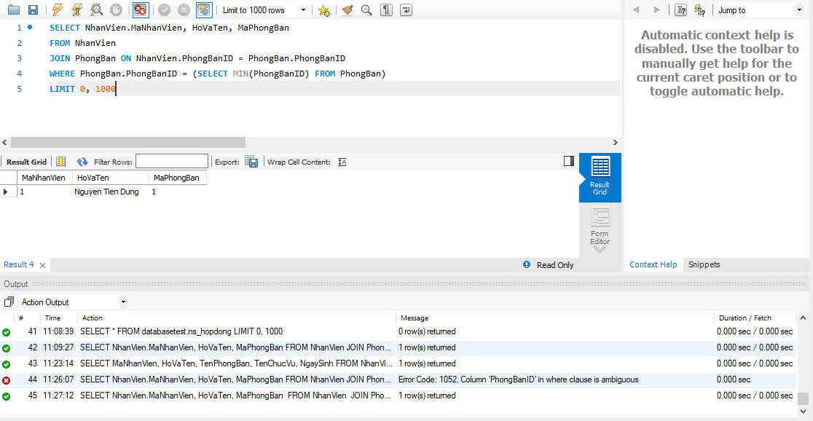

2/

a/

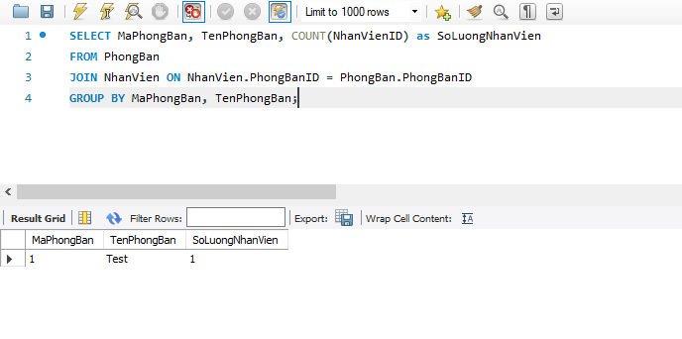

b/

SELECT MaChucVu, TenChucVu FROM NS_DSChucVu WHERE ChucVuID NOT IN (SELECT ChucVuID FROM NhanVien);

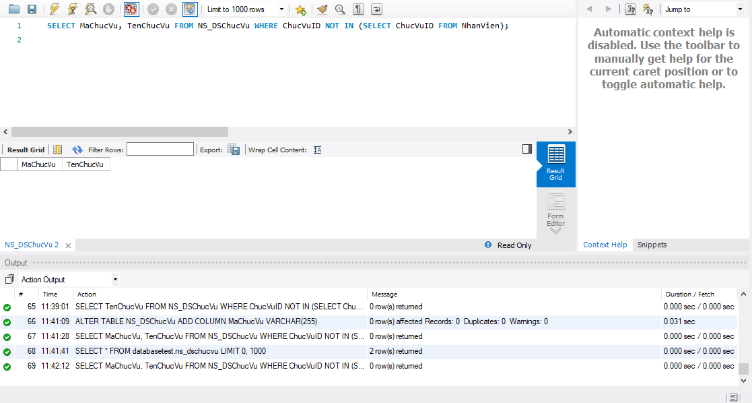

3/

A

SELECT MaNhanVien, HoVaTen, NgaySinh, QueQuan

FROM NhanVien

WHERE QueQuan LIKE '%Thai Binh%' AND YEAR(NgaySinh) > 1990;

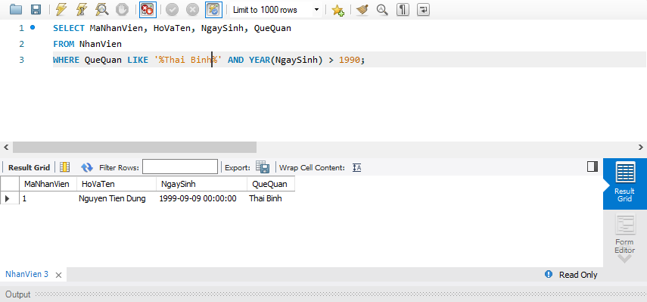

b/

SELECT MaNhanVien, HoVaTen, NgaySinh

FROM NhanVien

WHERE NgaySinh IN (SELECT NgaySinh FROM NhanVien GROUP BY NgaySinh HAVING COUNT(NhanVienID) > 1)

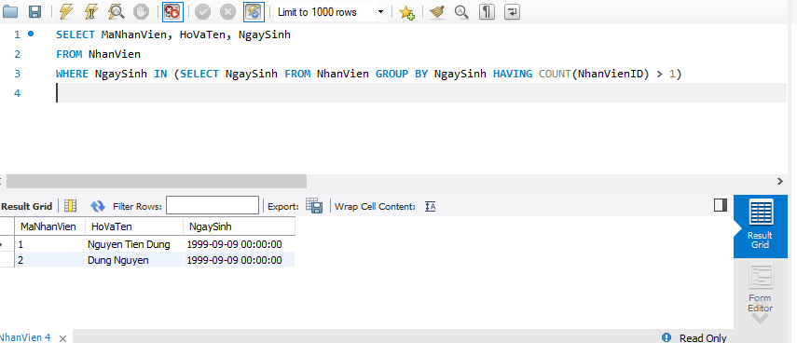

4

SELECT NhanVien.NhanVienID, HoVaTen, ns_dsloaihopdong.TenLoaiHopDong, NgayBatDau, NgayKetThuc

FROM NhanVien

JOIN (SELECT NhanVienID, MAX(NgayKyHD) AS MaxNgayKyHD

FROM ns_hopdong

GROUP BY NhanVienID) AS HD

ON NhanVien.NhanVienID = HD.NhanVienID

JOIN ns_hopdong

ON NhanVien.NhanVienID = ns_hopdong.NhanVienID

AND HD.MaxNgayKyHD = ns_hopdong.NgayKyHD

JOIN ns_dsloaihopdong

ON ns_hopdong.LoaiHopDongID = ns_dsloaihopdong.LoaiHopDongID

LIMIT 0, 1000

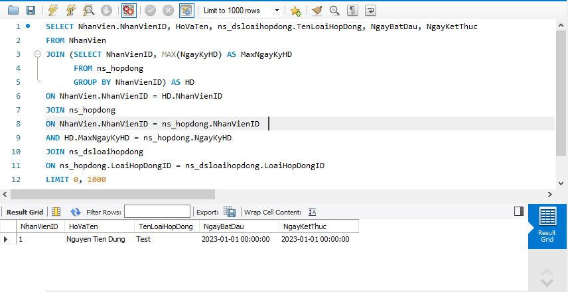

5

A

SELECT NhanVien.MaNhanVien, NhanVien.HoVaTen,

SUBSTRING(PhongBan.TenPhongBan, 4) AS PhongBan

FROM NhanVien

INNER JOIN PhongBan ON NhanVien.PhongBanID = PhongBan.PhongBanID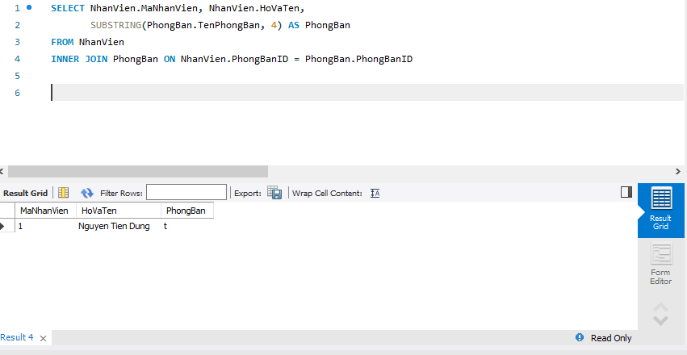

B

SELECT pb.MaPhongBan, SUM(IF(nv.GioiTinh = 'Nam', 1, 0)) AS SoLuongNam, SUM(IF(nv.GioiTinh = 'Nu', 1, 0)) AS SoLuongNu, SUM(IF(cv.TenChucVu = 'Truong_phong', 1, 0)) AS SoLuongTruongPhong, COUNT(nv.NhanVienID) AS SoLuongNhanVien

FROM PhongBan pb

JOIN NhanVien nv ON pb.PhongBanID = nv.PhongBanID

JOIN NS_DSChucVu cv ON nv.ChucVuID = cv.ChucVuID

GROUP BY pb.MaPhongBan;

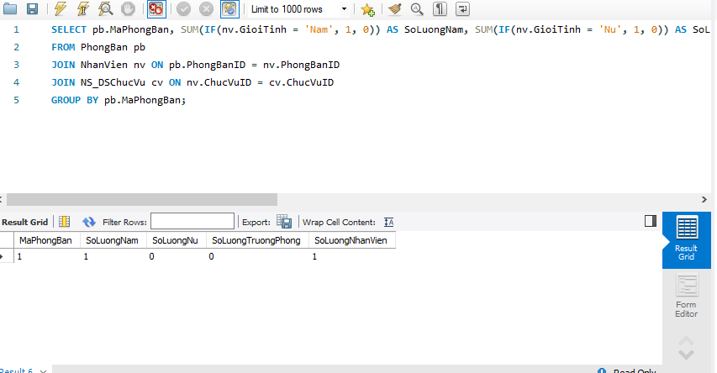

6.

a.

SELECT NhanVien.MaNhanVien, NhanVien.HoVaTen, PhongBan.TenPhongBan, ns_hopdong.NgayBatDau

FROM NhanVien

JOIN PhongBan ON NhanVien.PhongBanID = PhongBan.PhongBanID

JOIN ns_hopdong ON NhanVien.MaNhanVien = ns_hopdong.NhanVienID

WHERE MONTH(ns_hopdong.NgayBatDau) = @thang AND YEAR(ns_hopdong.NgayBatDau) = @nam

LIMIT 0, 1000

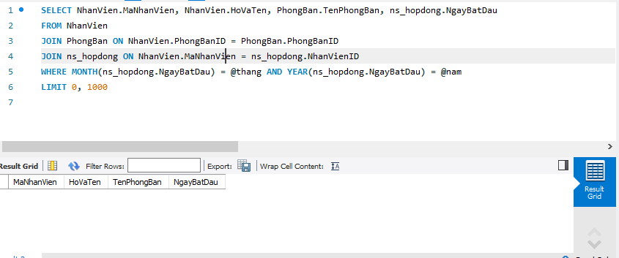

B

SELECT NhanVien.MaNhanVien, NhanVien.HoVaTen, PhongBan.TenPhongBan, ns_hopdong.NgayBatDau

FROM NhanVien

JOIN PhongBan ON NhanVien.PhongBanID = PhongBan.PhongBanID

JOIN ns_hopdong ON NhanVien.MaNhanVien = ns_hopdong.NhanVienID

WHERE ns_hopdong.NgayBatDau < LAST_DAY(CONCAT(@nam, '-', @thang, '-', '01'))

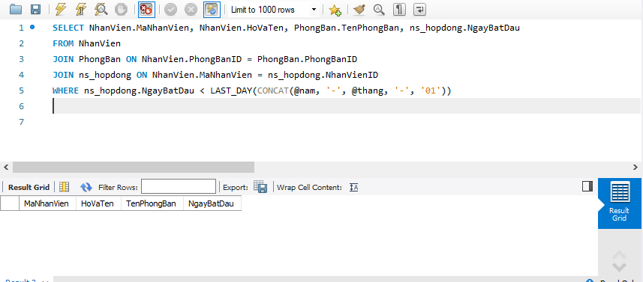

7

SELECT PhongBan.MaPhongBan, SUM(IF(MONTH(NhanVien.NgaySinh) = 1, 1, 0)) AS T1, SUM(IF(MONTH(NhanVien.NgaySinh) = 2, 1, 0)) AS T2, SUM(IF(MONTH(NhanVien.NgaySinh) = 3, 1, 0)) AS T3, SUM(IF(MONTH(NhanVien.NgaySinh) = 4, 1, 0)) AS T4, SUM(IF(MONTH(NhanVien.NgaySinh) = 5, 1, 0)) AS T5, SUM(IF(MONTH(NhanVien.NgaySinh) = 6, 1, 0)) AS T6, SUM(IF(MONTH(NhanVien.NgaySinh) = 7, 1, 0)) AS T7, SUM(IF(MONTH(NhanVien.NgaySinh) = 8, 1, 0)) AS T8, SUM(IF(MONTH(NhanVien.NgaySinh) = 9, 1, 0)) AS T9, SUM(IF(MONTH(NhanVien.NgaySinh) = 10, 1, 0)) AS T10, SUM(IF(MONTH(NhanVien.NgaySinh) = 11, 1, 0)) AS T11, SUM(IF(MONTH(NhanVien.NgaySinh) = 12, 1, 0)) AS T12

FROM NhanVien

JOIN PhongBan ON NhanVien.PhongBanID = PhongBan.PhongBanID

GROUP BY PhongBan.MaPhongBan

LIMIT 0, 1000

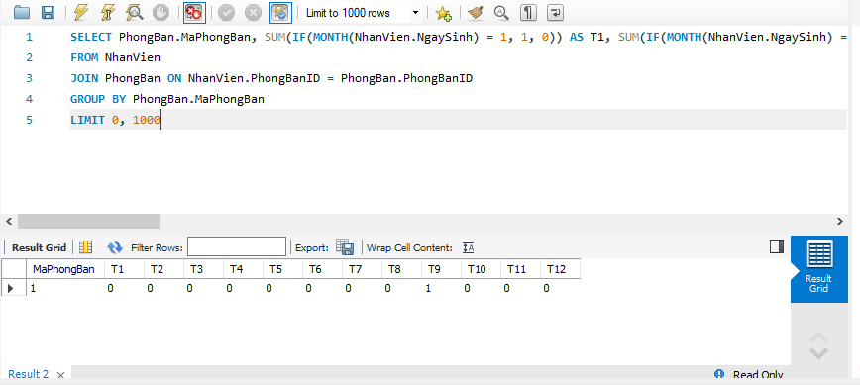

8/

SELECT NhanVien.MaNhanVien, NhanVien.HoVaTen,

HopDongMoiNhat.LoaiHopDongID AS LoaiHopDongMoiNhat,

HopDongMoiNhat.NgayBatDau AS NgayBatDauMoiNhat,

HopDongLienTruoc.LoaiHopDongID AS LoaiHopDongLienTruoc,

HopDongLienTruoc.NgayBatDau AS NgayBatDauLienTruoc

FROM NhanVien

LEFT JOIN (

SELECT NhanVienID, LoaiHopDongID, NgayBatDau

FROM ns_hopdong

WHERE NgayBatDau = (

SELECT MAX(NgayBatDau)

FROM ns_hopdong

WHERE NhanVienID = ns_hopdong.NhanVienID

)

) HopDongMoiNhat

ON NhanVien.MaNhanVien = HopDongMoiNhat.NhanVienID

LEFT JOIN (

SELECT NhanVienID, LoaiHopDongID, NgayBatDau

FROM ns_hopdong

WHERE NgayBatDau = (

SELECT MAX(NgayBatDau)

FROM ns_hopdong

WHERE NhanVienID = ns_hopdong.NhanVienID

AND NgayBatDau < ns_hopdong.NgayBatDau

)

) HopDongLienTruoc

ON NhanVien.MaNhanVien = HopDongLienTruoc.NhanVienID

LIMIT 0, 1000

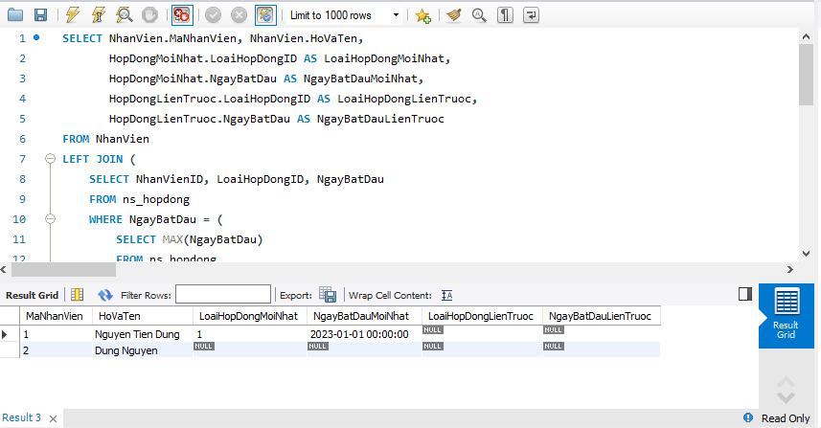

9/

a/

CREATE PROCEDURE GenerateCalendar (@thang INT, @nam INT)

BEGIN

DECLARE @start_date DATETIME, @end_date DATETIME, @current_date DATETIME

DECLARE @tbl TABLE (Ngay DATETIME, Thu INT)

SET @start_date = DATEFROMPARTS(@nam, @thang, 1)

SET @end_date = EOMONTH(@start_date)

SET @current_date = @start_date

WHILE (@current_date <= @end_date)

BEGIN

INSERT INTO @tbl (Ngay, Thu)

VALUES (@current_date, DATEPART(WEEKDAY, @current_date))

SET @current_date = DATEADD(DAY, 1, @current_date)

END

SELECT * FROM @tbl

END

Sau đó dùng Stored Procedures với tham số @thang, @nam như sau:

EXEC GenerateCalendar @thang = 2, @nam = 2022

b/

CREATE PROCEDURE GenerateCalendar (IN p_thang INT, IN p_nam INT)

BEGIN

DECLARE v_start_date DATE, v_end_date DATE, v_current_date DATE;

DECLARE v_tbl_count INT DEFAULT 0;

SET v_start_date = DATE_FORMAT(MAKEDATE(p_nam, 1), '%Y-%m-%d');

SET v_end_date = LAST_DAY(CONCAT(p_nam, '-', p_thang, '-01'));

SET v_current_date = v_start_date;

CREATE TEMPORARY TABLE tmp_calendar (ngay DATE, thu INT);

WHILE v_current_date <= v_end_date DO

INSERT INTO tmp_calendar (ngay, thu)

VALUES (v_current_date, WEEKDAY(v_current_date) + 1);

SET v_current_date = DATE_ADD(v_current_date, INTERVAL 1 DAY);

SET v_tbl_count = v_tbl_count + 1;

END WHILE;

INSERT INTO SinhNhat (Ngay, NhanVien)

SELECT NgaySinh, HoVaTen

FROM NhanVien

WHERE MONTH(NgaySinh) = p_thang AND YEAR(NgaySinh) = p_nam;

END

CREATE TABLE IF NOT EXISTS SinhNhat (

Ngay datetime,

NhanVien nvarchar(200)

);

INSERT INTO SinhNhat (Ngay, NhanVien)

SELECT NgaySinh, HoVaTen

FROM NhanVien

WHERE MONTH(NgaySinh) = p_thang AND YEAR(NgaySinh) = p_nam;

SET @p_thang = 2;

SET @p_nam = 2022;

CALL GenerateCalendar(@p_thang, @p_nam);