Road Trip Calculator

Software Requirements Specification

Version 0.1

1/31/2013

Zack Hyder
Lead Software Engineer
Jon Deery
Senior Software Engineer

Document Approval

The following Software Requirements Specification has been accepted and approved by the following:
Signature | Printed Name | Title | Date
 | Zack Hyder | Lead Software Engineer | 1/31/13
 | Jonathan Deery | Senior Software Engineer | 1/31/13

Table of Contents

Revision History ii
Document Approval ii
1. Introduction 1
1.1 Purpose 1
1.2 Scope 1
1.3 Definitions, Acronyms, and Abbreviations 1
1.4 References 1
1.5 Overview 1
2. General Description 2
2.1 Product Perspective 2
2.2 Product Functions 2
2.3 User Characteristics 2
2.4 General Constraints 2
2.5 Assumptions and Dependencies 2
3. Specific Requirements 2
3.1 External Interface Requirements 3
3.1.1 User Interfaces 3
3.1.2 Hardware Interfaces 3
3.1.3 Software Interfaces 3
3.1.4 Communications Interfaces 3
3.2 Functional Requirements 3
3.2.1 <Functional Requirement or Feature #1> 3
3.2.2 <Functional Requirement or Feature #2> 3
3.3 Use Cases 3
3.3.1 Use Case #1 3
3.3.2 Use Case #2 3
3.4 Classes / Objects 3
3.4.1 <Class / Object #1> 3
3.4.2 <Class / Object #2> 3
3.5 Non-Functional Requirements 4
3.5.1 Performance 4
3.5.2 Reliability 4
3.5.3 Availability 4
3.5.4 Security 4
3.5.5 Maintainability 4
3.5.6 Portability 4
3.6 Inverse Requirements 4
3.7 Design Constraints 4
3.8 Logical Database Requirements 4
3.9 Other Requirements 4
4. Analysis Models 4
4.1 Sequence Diagrams 5
4.3 Data Flow Diagrams (DFD) 5
4.2 State-Transition Diagrams (STD) 5
5. Change Management Process 5
A. Appendices 5
A.1 Appendix 1 5
A.2 Appendix 2 5

1. Introduction

1.1 Purpose
To explain the details of our project and to have a written agreement between customer and developer.

1.2 Scope
1. Road Trip Calculator
2. This project will create a tool to maximize road trip efficiency. It will give the user options to choose their make, model, year, and transmission. The user will then choose their source and destination and any points of interest in between. The next page will display text directions of the trip, a map of the route. It will also display fuel cost based time traveled on city and highway roads. It will also display the amount, in grams, of C02 produced on your trip.
3.
a. The benefits of our project are to provide users with an opportunity to plan out their road trip, not only distance wise but also cost wise. One can see if a pit stop on the road trip would fit into their budget. If CO2 emissions are a factor of a choice between one car or another, the user can see which car would produce the least amount.
b. This program will be browser based, so there should be no problem using it on any machine.

1.3 Definitions, Acronyms, and Abbreviations
Co2 = Carbon Dioxide.

1.4 References
All car data retrieved from: fueleconomy.gov

1.5 Overview
N/A

2. General Description

2.1 Product Perspective
We will be using the Google Maps API and improving upon, adding the features mentioned earlier.

2.2 Product Functions
1. Text Directions
2. Map with route
3. Total Co2 emissions (in grams) throughout the trip
4. Total amount of money spent on gas based off of cars MPG and route.
5. The MPG of your specific car

2.3 User Characteristics
The only knowledge needed to use the product is one’s type of car and where they want to go. We are making it simple enough to use that any person should be able to.

2.4 General Constraints
Cross Browser implementation.

2.5 Assumptions and Dependencies
Changes in browser preference of users could lead to potential formatting issues.

3. Specific Requirements

3.1 External Interface Requirements

3.1.1 User Interfaces
1. Drop down menus with:
a. Make
b. Model
c. Year
d. Transmission
2. Input box for source and destination
3. Optional button to add pit stops along the way
4. Page displaying:
a. Map with route
b. Text directions
c. MPG
d. Total cost of gas
e. CO2 Emissions

3.1.2 Hardware Interfaces
Computer running the server and database

3.1.3 Software Interfaces
MySQL

3.1.4 Communications Interfaces
MySQL Connector JAR
Spring

3.2 Functional Requirements
This section describes specific features of the software project. If desired, some requirements may be specified in the use-case format and listed in the Use Cases Section.

3.2.1 <Functional Requirement or Feature #1>
3.1.1. User picks vehicle
3.1.2. Make, Model, Year, and Transmission
3.1.3. Based off of user’s choice of Make, next drop down menu is populated with the proper
information I.E When Ford is chosen then only Ford Models will be in the model
dropdown menu.
3.1.4. When all vehicle is selected, the database is queried and the vehicles’ database
unique identification number which we will append to the URL.
3.1.5 When retrieving data based on user’s choice, if there is no data to be retrieved, then Java
will throw a SQL error.

3.2.2 <Functional Requirement or Feature #2>
3.2.1. User picks trip information
3.2.2. Source and Destination
3.2.3. Based off of user’s input it will translate the address into longitude and latitude.
3.2.4. Based on the longitude and latitude it will then be appended to the URL.
32.5. Javascript will check if a field is blank, if it is then the user will not be able to
continue.

3.3 Use Cases

3.3.1 Use Case #1
1. Input Make, Model, Year and Transmission
2. Input Source and Destination
3. Press go
4. View prepared information

3.4 Classes / Objects

3.4.1 <Class / Object #1>

3.4.2 <Class / Object #2>
…

3.5 Non-Functional Requirements

3.5.1 Performance
Performance is based user’s computers and network capabilities

3.5.2 Reliability
Reliability is based off of user’s :
- Good network connection
- Good browser choice.
Developers Reliability is based off of:
- Good network connection for server
- Proper coding

3.5.3 Availability
1. Browser choice of user
2. Server Crash
3. Power outage

3.5.4 Security
No personal data is given, so there is no need for personal security.

3.5.5 Maintainability
Database can be easily updated by adding the newest makes and models.

3.5.6 Portability
In order to move this to another host machine, connection URLS will have to be changed.

3.6 Inverse Requirements
This program will not compare cars or routes. This can still be done by running the program multiple and do your own comparison.

3.7 Design Constraints
Currently the server is being run off of a simple laptop and would not be able to handle heavy traffic.

3.8 Logical Database Requirements
A database will be used. All pieces of data will be strings and stored on the server PC. When the string is received it can be converted appropriately to handle every case. I.E MPG will come in as a string but is needed as an integer for the calculations.

3.9 Other Requirements

N/A

4. Project planning and risk management

4.1 Work Breakdown Structure

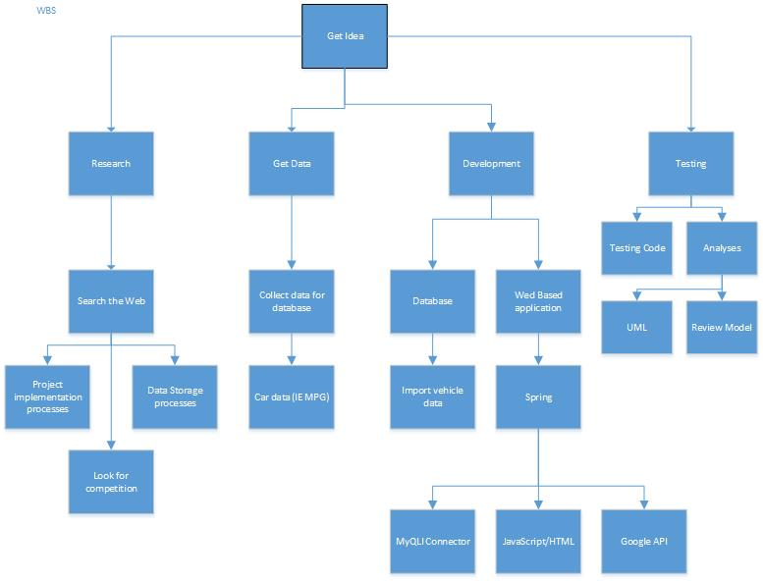

4.2 Time estimation

Research | 7 days
Create database | 2 days
Insert data into database | 5 days
Access database from web application | 5 days
Create framework for first page | 2 days
Implement Google direction API | 11 days
Implement Google maps API | 12 days
Create framework for second page | 3 days
Display all calculated data on second page | 4 days
Display Google API objects (map, directions) | 11 days
Make it pretty | 2 days
Test | 15 days

4.3 Activity sequencing diagram
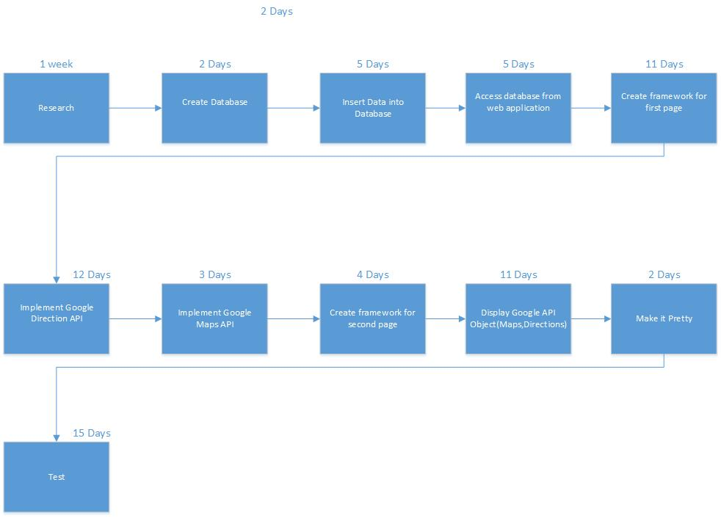

4.4 Gantt chart

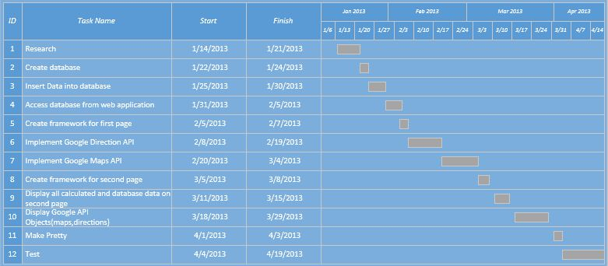

4.5 Risk management using RAG model

Risk | Likelihood: | Consequences | Total | Fix
Google API does not integrate well with how we deployed our project | 3 | 4 | 12 | Deploy web application using Google app engine as apposed to Spring
Cross Brower Problems | 2 | 2 | 4
Time | 1 | 1 | 1
Database and server problems | 1 | 3 | 3

A. Appendices
Appendices may be used to provide additional (and hopefully helpful) information. If present, the SRS should explicitly state whether the information contained within an appendix is to be considered as a part of the SRS’s overall set of requirements.

Example Appendices could include (initial) conceptual documents for the software project, marketing materials, minutes of meetings with the customer(s), etc.

A.1 Appendix 1
Add comments and suggestions that you received from your peers ( names for credit) during your presentation.

A.2 Appendix 2

