Software Requirements Specification Template

SmartSeat BTS
(Bus Tracking System)

Software Requirements Specification

1.0

2/7/2013

Benjamin Sewards
Lead Software Engineer

John Longo
John Piccolomini

Document Approval

The following Software Requirements Specification has been accepted and approved by the following:
Signature | Printed Name | Title | Date

Table of Contents

Revision History ii
Document Approval ii
1. Introduction 1
1.1 Purpose 1
1.2 Scope 1
1.3 Definitions, Acronyms, and Abbreviations 1
1.4 References 1
1.5 Overview 1
2. General Description 2
2.1 Product Perspective 2
2.2 Product Functions 2
2.3 User Characteristics 2
2.4 General Constraints 2
2.5 Assumptions and Dependencies 2
3. Specific Requirements 2
3.1 External Interface Requirements 3
3.1.1 User Interfaces 3
3.1.2 Hardware Interfaces 3
3.1.3 Software Interfaces 3
3.1.4 Communications Interfaces 3
3.2 Functional Requirements 3
3.2.1 <Functional Requirement or Feature #1> 3
3.2.2 <Functional Requirement or Feature #2> 3
3.3 Use Cases 3
3.3.1 Use Case #1 3
3.3.2 Use Case #2 3
3.4 Classes / Objects 3
3.4.1 <Class / Object #1> 3
3.4.2 <Class / Object #2> 3
3.5 Non-Functional Requirements 4
3.5.1 Performance 4
3.5.2 Reliability 4
3.5.3 Availability 4
3.5.4 Security 4
3.5.5 Maintainability 4
3.5.6 Portability 4
3.6 Inverse Requirements 4
3.7 Design Constraints 4
3.8 Logical Database Requirements 4
3.9 Other Requirements 4
4. Analysis Models 4
4.1 Sequence Diagrams 5
4.3 Data Flow Diagrams (DFD) 5
4.2 State-Transition Diagrams (STD) 5
5. Change Management Process 5
A. Appendices 5
A.1 Appendix 1 5
A.2 Appendix 2 5

1. Introduction

1.1 Purpose
All too many times a child is lost on his way to school. When a child is unaccounted for, it can leave parents uncomfortable. When parents put their child on the bus, they give the responsibility to the school until they retrieve their child off of the bus. Therefore, the product is intended for parents and schools. An easy way to know exactly where your child is from the moment he gets on the bus until he arrives at school and the moment he leaves school until the child is back in the parent’s supervision can be safely monitored. Parents will have the privilege of being notified of any unusual changes on pick-up, between, and drop-off of their child.

1.2 Scope

Schools will have a database with information about each bus route. We will be able to provide in real-time the names and the number of children in each bus. We will be able to provide pick-up and drop-off time for each child. We can determine these parameters by using geo-location data along with the addresses of the children. Parents can sign-up to receive notifications once the bus is approaching for a pick-up and/or a drop-off. They will receive notifications when the bus is coming late. In addition, a notification will be sent out if the driver skips an address on his/her route. In this case, the driver may have forgotten to pick-up or drop-of a child. Once sensors have been added to each seat of a bus, the system will notify the driver, the school, and the parents automatically a child is left behind.

1.3 Definitions, Acronyms, and Abbreviations
Android OS: The Android operating system is a Linux-based operating system designed primarily for touchscreen mobile devices such as smartphones and tablet computers
DB: An acronym for “Database”
Java: An object-oriented programming language used heavily for a better digital experience.
XML: Extensible Mark-up Language used to transport and store data like HTML.
RNS: Real-time Notification System is a term that is used to describe live updates.
RFID: Radio Frequency Identification is the use of a wireless non-contact system that uses radio-frequency electromagnetic fields to transfer data wirelessly.
API: Application Program Interface is an interface used by software components.

1.4 References
4.0 in SRS Document | Planning Management Diagram & Risk Management assessment

1.5 Overview
This overview will provide an extensive introduction to general project perspectives, user characteristics and function- ability that affects the stated requirements, and a client facing look at external and functional requirements.

The SRS will embody the client with an analysis of the SmartSeat BTS to help identify business problems and propose solutions.

2. General Description
Factors that affect the product requirements are as follows:

- To consider the system as accurate as possible without using RFID’s, the hardware will identify students based on weight difference, bus route, and bus stop for now.
- Allowing school bus integration with our complete system is crucial. But we have to keep in mind that it could entail privacy concerns, although the system will not be used for tracking students outside of the bus system.
- For the first phase of the project, using the weight sensors to identify student bodies will be a slow identification process depending on how many students get picked up and dropped off at each bus stop.
- There will be trial and error with geo-location and accelerometer predictions that may affect the outcome of real time updates to the server.

2.1 Product Perspective
Last month, Legacy Elementary School coordinated with transportation directory, Randy McKie, to start the procedure of monitoring the students only when they’re missing. This related idea will use a GPS-enhanced tracking system with hardware that needs to be installed on every bus and will cost the district upward of $114,311 after grants. Parents will also have to pay for these services to track their missing children. A tool that is more geared towards law enforcement than the actual community for privacy concerns, SmartSeat hopes to break this gap with lighter weight technology and an in-depth real time notification system.

2.2 Product Functions
The first software requirement introduces real time information display to the Bus Driver. This application will allow the driver to stay on course, track the bus route using geo-location and accelerometers, predict the bus stop and pick up arrival times, and notify certain parents when their student has not boarded the bus at their stop.

The second software requirement provides a mobile notification system for parents that receive information from the first software requirement above. This includes pick up and drop off times, and bus boarding.

2.3 User Characteristics
Parents of students that use the notification system will not be able to implement any function-ability to affect the system and will serve the purpose of displaying tracking information.

Students will have identities based on their weight and bus stop on a specific bus route. Student identities affect the outcome of checking certain requirements of which pertain to tracking information for the bus driver and the parents.

Law enforcement will not be part of the system and will come to effect only when a heavy incident occurs, such as a missing student. Any information regarding this identity can be passed on to them.

2.4 General Constraints
The following constraints identify how the overall system will adjust:

The Real-time Notification System (RNS) will rely heavily on a Tracking System API, to analyze, store and update appropriate data to the database.

Without the initial use of RFID readers, identification will be less strict and data pertaining to individual identities will not be included until the current system features are in place and a new scope is assessed.

2.5 Assumptions and Dependencies
The Android operating system will be designated for the software product. If cross-compatibility is needed with other mobile devices, this assumption will need to be changed.

If languages used in the Android SDK cannot meet the client requirements, JavaScript and HTML may be integrated.

The notification system (RNS) is dependent on the use of an open source tracking system that will require the sharing of location.

RNS is dependent on individual identity of each compatible student. In order to build the system, this identification will be anonymous until RFID readers are integrated.

3. Specific Requirements
This section will provide the Application system requirements that are used to guide the project’s software design, implementation, and testing.

3.1 External Interface Requirements

3.1.1 User Interfaces
The Android SDK will mainly be utilized to include a user interface using combinations of XML, JavaScript, and HTML.

3.1.2 Hardware Interfaces
Resistance pad/Pressure pads grouped together, communication hardware interface (Bluetooth, wireless, or hard wired)

3.1.3 Software Interfaces
The Android SDK will also be utilized to include the back-end structure using Java and the possibility of JavaScript.

3.1.4 Communications Interfaces
The Notification system is based off of the use of RNS. This system includes accelerometer, GPS, and a wireless connection between hardware for identity purposes. Communication interfaces used will contain HTML 5 geo-location and Google Maps API.

3.2 Functional Requirements
This section describes specific features of the SmartSeat BTS project.

3.2.1 <Functional Requirement #1 | Weight Resistance Detector and Recorder>
3.2.1.1 Introduction
The Weight Resistance hardware plays an important role in recording and tracking identity and quantity of students at each bus stop on a certain bus route.
3.2.1.2 Inputs
Students who enter the bus are placed onto the resistance pad, allowing the recording of weight and quantity.
3.2.1.3 Processing
This above information is processed to the main bus system application and interface, either through wire or wireless communication. Once at the main system application, the information is compared to database requirements of each the given bus stop and bus route information.
3.2.1.4 Outputs
Once compared with the database, feature #2 comes into play, below.
3.2.1.5 Error Handling
The size, time, and reliability of the Weight Resistance hardware is crucial for tracking the above information. If this information can’t be processed, a warning signal will appear on the bus system interface, stating to identify the student again.

3.2.2 <Functional Requirement #2 | Real-time Notification System>
3.2.1.1 Introduction
The Real-time Notification System gives parents of the system identified by a child the updated bus route schedule based on traffic delays, obstacles, and notifications likewise.
3.2.1.2 Inputs
The compared DB information will provide input.
3.2.1.3 Processing
The above information will be processed and one-to-many conditions will be met to output from the system.
3.2.1.4 Outputs
The system output will contain notification schemes to parent mobile devices regarding traffic conflicts and time delays, and with the assumption for now that each weight holds to the identity of a single student, an output of whether the student arrives to school and gets dropped off at a certain bus stop is pertained.
3.2.1.5 Error Handling
The communication interface for real time tracking will need to provide reliable updates. If downtime occurs during the system processing, notifications will commence to the Parents.

3.3 Use Cases
Use Cases are not necessary at this point.

3.4 Classes / Objects

3.4.1 <Driver>

3.4.2 <Bus>

3.4.3 <BusRoute>

3.4.4 <RouteSchedule>

3.4.5 <BusHardwareServices>

3.4.6 <Student>

3.4.7 <Parent>

3.4.8 <CompareIdentity>

3.4.9 <NotificationSystem>

3.5 Non-Functional Requirements

3.5.1 Performance
- Real time tracking efficiency controlled at 95% to provide consistent data output

3.5.2 Reliability
- Consistent data transfer through availability of the network service

3.5.3 Availability
- Network disconnection process recovery

3.5.4 Security
- No outsiders should be able to access the bus system network

3.5.5 Maintainability
- Database back-ups must be synchronized and real time updates should occur at a maximum of every 5 minutes.

3.5.6 Portability
- Usability of same API for mobile application and web application development for further scopes.

3.6 Inverse Requirements
The use of the RNS via Parents is untestable. This notification system will require the Parents to have prior knowledge of the Android OS, but SmartSeat documentation will be provided.

3.7 Design Constraints
If the given school system does not want to be provided with a System administrator that performs bus updates and maintenance, they will have the extended option of having our company design a front-end application that the administrators at the school can handle locally. This option is not included within the scope of the project, but can be provided by choice of maintenance by another contract fee.

3.8 Logical Database Requirements
A database will be used for this project. The database must have the storage capabilities to support an entire school system. In terms of data retention only administration should be able to access and edit data; authorized users may use the web app track/update/real time system.

3.9 Other Requirements
Each student is required to participate (many-mandatory) within the system and the Bus Driver will need to be up to date with the given software in order to maintain a reliable RNS.

4.0 Project Planning and Risk Management

4.1 Work Breakdown Structure
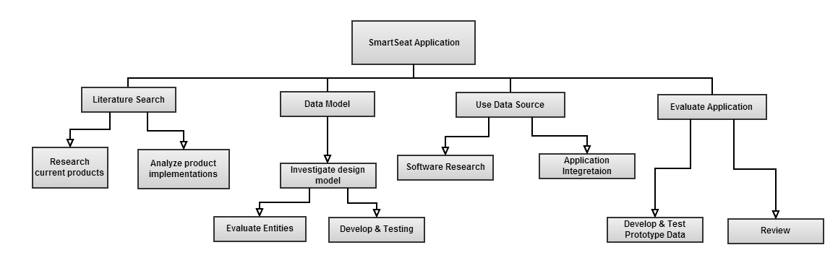

4.2 Time estimation

Activity | Weeks
Literature Search | 1
Research & Tutorials | 2
DB Design & Entity Relations | 1
DB Creation | 2
Software Application Development | 3
Software DB Integration | 1
Evaluation Testing & Analysis | 1
Total | 11 weeks

4.3 Activity Sequencing Diagram
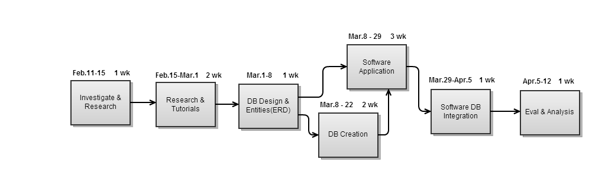

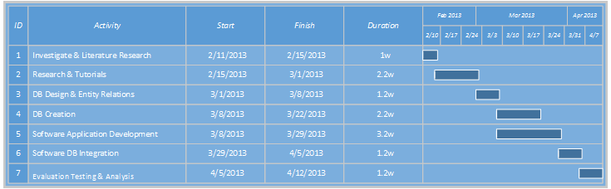
4.4 Gantt Chart

4.5 Risk management

12 High | Android Java development experience
4 Low | Connection from DB to Software Application
12 High | Hardware integration developing not developing on time, leading us to creating our own prototype using fake data and having to develop a fake example

A. Appendices
SmartSeat BTS upon delivery will integrate smoothly with all school systems and will provide a dynamic system based on the requirements of each integrated school.

Developer and Engineer meetings will be required bi-weekly to assess our current progress. Along with these meetings will include developer and networking meetings to provide feedback and development work.

