Mars rover designs to be tested in Australia
by Michael Paine mailto:mpaine@tpgi.com.au
The Planetary Society Australian Volunteers 17 May 2001
http://www4.tpg.com.au/users/tps-seti/
At a conference in Melbourne last weekend Australian scientists and space enthusiasts joined forces to help design rovers and other equipment for the exploration of Mars. Trials of prototype vehicles in Australia's rugged Red Centre are planned.
The Australian Mars Exploration Conference 2001 was organised by the Mars Society of Australia (MSA). The scene was set on the first day when experts in astrobiology (the search for life beyond the Earth), microbiology, robotics, Antarctic research and Mars geology described the latest research in these fields and the difficulties they had encountered that would be lessons for designers of Mars missions.
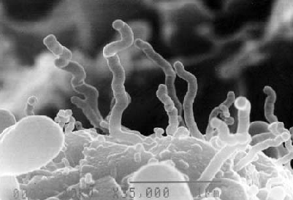
Electron microscope image of nanobes.
Credit: Centre for Microscopy and Microanalysis, University of Queensland
Speakers at the conference described:
- Research being carried out at Mt Painter in South Australia - an ancient, inactive hydrothermal system like Yellowstone National Park. If such systems are found on Mars they may offer the best hope of finding evidence of life.
- Tiny organisms from deep within the Earth that are similar in size to the controversial features in Martian meteorite ALH84001 - claimed by some scientists to be fossilised life.
- Experiments with a Russian-built minature Marsokod rover using simulated Mars terrain.
- Social lessons for Mars mission planners from experience at Antarctica research bases.
- The "White Mars" theory that many of the geological features seen on Mars can be attributed to carbon dioxide and not to water.
On the second day MSA members explained the Society's technical program for trials of Mars rovers and other equipment. In 2000 MSA was one of three international groups awarded funds to develop designs for prototype Mars rovers. Society volunteers are now building a Human Operations Prototype (HOP) rover that will be used in Mars-like terrain in the Red Center of Australia. Based on the chassis and engine of a four-wheel-drive passenger van, the HOP will be fitted out as a fully self-contained habitat, like a small motor home. Two people will drive the vehicle into remote areas. There they will simulate some of the operational difficulties of rover expeditions on Mars.
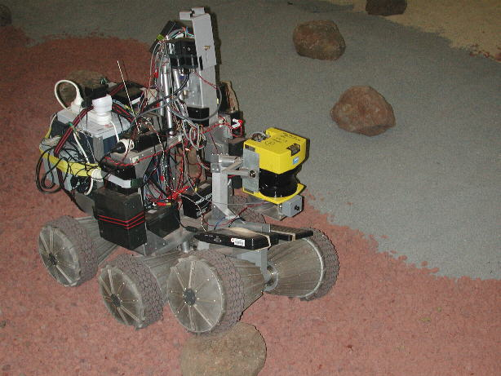
Marsokod rover on simulated Mars terrain
Credit: Intelligent Robotic Research Centre, Monash University.
Jason Hoogland from MSA then ran a brainstorming workshop. He described a proposed design for a Mars rover and invited the conference participants to comment on the functional design of the vehicle. He was overwhelmed by the response.
Astrobiologist Malcolm Walter was asked what he would like to take along if he was on Mars looking for evidence of life. He quickly responded "a mechanical engineer" and added that mechanical breakdowns were a frequent problem on geological expeditions in Australia. Walter also said he would want a new Australian invention, the PIMA spectrometer, for determining the mineral content of rocks.
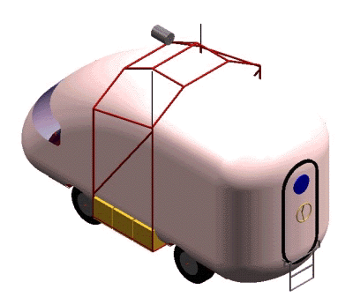
Proposed design for the HOP prototype Mars rover
Credit: Mars Society of Australia
The workshop discussed the difficulties of donning spacesuits to explore outside the rover. One suggestion was that the rover should have a "glove box" like those used for handling hazardous substances. Scientists within the rover would put their hands into rubber gloves that allowed them to manipulate objects on the outside of the rover. In this way dangerous and time-consuming extra-vehicular activities could be kept to a minimum.
The Red Center of Australia could also be used for a Mars habitat research station, like the one the Mars Society is currently operating in the arctic region of North America. A telephone conference with the Mars Society in the USA confirmed that Australia was a likely location for a second habitat station.

Links
Space.com report on the Conference
http://www.space.com/missionlaunches/missions/mars_society_conference_010515.html
Mars Society of Australia http://www.marssociety.org.au
Astrobiology Australasia http://www.aao.gov.au/local/www/jab/astrobiology/
PIMA spectrometer http://www.intspec.com/pima.htm Integrated Spectronics Pty Ltd
Nanobes http://www.uq.edu.au/nanoworld/uwins.html#nano-organisms
White Mars http://irian.geology.latrobe.edu.au/~nhoffman/Mars/Enter.html
Marsokhod rover http://www.ecse.monash.edu.au/centres/IRRC/index.html

Images
nanobes.gif
hopsolidreariso.gif
marsokhod.jpg

