The Australian MaRs Exploration Conference



The Australian MaRs Exploration Conference

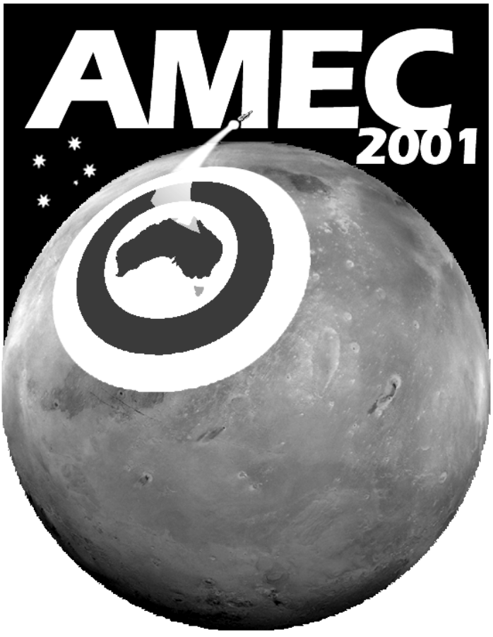 |   Conference  Program

Time | Speaker | Topic

Mobile Robot Navigation on Mars

Professor Ray Jarvis

This paper looks at some of the issues concerning the physical architectures, sensors and artificial intelligence associated with mobile robot navigation, both of an entirely autonomous kind and of a so called tele-autonomous variety, particularly in the context of the exploration of Mars.

Professor Ray Jarvis completed his BE (Elec.) and Ph.D. (Elec.) at the University of Western Australia in 1962 and 1968, respectively.

After two year at Purdue University he was appointed to the Australian National University (ANU) to teach Computer Science. There he was instrumental in establishing the Department of Computer Science at ANU, and was its first Head of Department.

He joined Monash University in 1985 and established the Intelligent Robotic Research Centre in 1987. He has been the Centre’s Director since then. His research interests are in Computer Vision and Robotics. Both robotic manipulators and mobile robots of various sizes have been part of his interests. Most recently he has been working on autonomous and teleoperated vehicles and vessels including a tacked vehicle, several boats, an amphibious craft, an excavator and a half scale Russian built Martian Rover. He has also recently developed a research interest in Humanoid Robotics. From an AI perceptive his main interests are in Computer Vision and Path Planning.

The Mars Society Australia's Technical Program

Mr Jason Hoogland

The Mars Society Australia's Technical Programme consists of five projects, collectively known as Operation Red Centre.

Project Jarntimarra will involve experts in various scientific disciplines including geology and microbiology developing a valuable electronic database containing comprehensive information on Australian Mars Analogue sites.

In 2000 Mars Society Australia was one of three international groups awarded seed funding to develop a “flight-like” Mars rover vehicle to undertake unique analogue research. Project Marsupial is constructing a family of vehicles intended to assist with the design of future Mars rovers. The Human Operations Prototype (HOP) is the first vehicle in the series.

Analogue simulation depends on subjecting crew members to the same kinds of constraints expected for human crews on the surface of Mars. A key element of Operation Red Centre is therefore a Mars analogue surface suit. Project Mars Skin will apply the latest research in such systems to develop realistic Mars suits for use in analogue research activities.

The international Mars Society has established a research station on arctic Devon Island. The facility is designed to be “flight-like”, similar to the kind of planetary entry, descent and landing habitats used in leading humans-to-Mars mission proposals andallow realistic simulations to help test mission planning hypotheses. It is proposed that three additional stations around the world will be built, including a Mars Australian Research Station (Mars-Oz).

Mars Society Australia will operate a communications payload aboard an Australian satellite Jaesat in 2002, a key component of the Store and Forward Mars Analogue Research System (SAFMARS) project.

Jason Hoogland is a 28 year old Phd candidate in Mechanical Engineering at the University of Queensland. His Doctoral thesis is investigating the aerothermodynamic influence of ablative injection on superorbital entry heat shield flowfields. This involves novel simulation of the vapourisation of these kinds of thermal protection systems in the hypersonic expansion tubes at the Centre for Hypersonics, focussing on the heat shield of the Japanese Muses-C asteroid sample return mission scheduled to launch in 2002. Prior to this he worked as a Graduate Engineer with the Robe River Mining Company, based in Perth. His work involved R&D on vibrational removal of fines from lump iron ore, and project management of a $9 million Lump Rescreening Plant. Jason has a BE (mech, Hons) from teh University of Western Australia and a BSc (physics) from the University of Melbourne.
Antarctica as an Analogue for Mars
Dr John Webb
Antarctica has been used as an analogue for Mars in terms of its physical environment and also in terms of the social interactions between the people in the small groups who work there. The ice-free areas of Antarctica (so-called ‘oases’) are similar to the surface of Mars in that they are arid deserts, characterised by very low temperatures and humidities and very windy conditions, although of course the atmospheric pressure is much higher and the atmospheric composition different. Weathering of the rocks exposed in Antarctica is dominated by physical processes, e.g. wind erosion and salt wedging, and the same is likely to be true on Mars, although salt wedging is probably absent. Downslope movement of regolith in Antarctica is dominated by debris flows and slumping in the water-saturated material overlying the permafrost in summer, and has been regarded by some workers as analogous to the processes forming apparently active gullies near the Martian poles, although this is arguable.
Any human exploration of Mars will be based around small parties, isolated for long periods, undertaking field work from a base, and therefore resembles the current practices in Antarctica. Studies of the social interactions between personnel in Antarctica give insights into likely problems that could arise on Mars, particularly conflicts due to differences in background (scientific/military), age and gender. Particularly at bases, social problems can be more important than the physical demands of the surrounding hostile environment.
Environmental concerns that have recently become important in Antarctica may also be applicable to Mars, particularly the removal or disposal of all waste.
I attended Queensland University, where I obtained my Honours (with a University Medal) and PhD degrees (the latter in 1982). My thesis was on Triassic palaeobotany of southeastern Queensland, but since completing it my interests have broadened, to include geomorphology and Antarctic geology. After finishing my thesis I taught for 5 years at Melbourne University Geology Department, then moved to La Trobe University Earth Sciences in 1985, where I teach sedimentology and environmental geology. At the moment I'm Head of Department. Over the summer of 1989-1990 I went to Antarctica for a field season in the northern Prince Charles Mountains, studying Permo-Triassic sedimentology and the recent geomorphology.
Earth Analogues for Martian Environments
Prof Malcolm Walter
Places such as Devon Island are analogues for the present environment of Mars. But another category of analogues is also important: those places that resemble ancient environments that might have hosted life, such as former lakes and thermal springs. In Australia we have numerous such places, including gold deposits in central Queensland, a giant lead-zinc-silver deposit in the NT, Mount Painter in SA, and many sites in WA. Some of these are also analogues for aspects of the current environment on Mars. Mt Painter is one such; it is one of the World's largest ancient thermal spring systems, has an active thermal spring nearby, and is flanked by arid plains, dunes and salt lakes. It is an excellent site for conducting simulation experiments.
Malcolm Walter is Adjunct Professor of geology at Macquarie University in Sydney, Director of the Australian Centre for Astrobiology based at that university, and Director of M. R. Walter Pty Ltd. He has worked for 35 years on the geological evidence of early life on Earth, including the earliest convincing evidence of life. Since 1989 he has been funded by NASA in their "exobiology" and "astrobiology" programs, focussing on microbial life in high temperature ecosystems, and the search for life on Mars. During 1999 his book "The Search for Life on Mars" was published by Allen & Unwin. He has published more than 100 articles and several other books. He also works as an oil exploration consultant and a consultant to museums, and is currently curator of a special Centenary of Federation exhibition on space exploration (for the new Museum of Australia in Canberra, Museum Victoria, and elsewhere).

Novel nano-organisms (Nanobes): living analogues for Martian "nanobacteria"?
Dr Philippa Uwins
On August 7th 1996 NASA made the historic announcement that Martian Meteorite ALH84001 could contain evidence for past life on Mars. Central to the thesis, and perhaps the most controversial aspect of the findings, were the fossil remnants of sub-bacteria sized "cells" called nannobacteria. While the results were of great scientific interest they fuelled a fierce and highly contentious debate, not only concerning the existence of Martian microbes, but a controversy surrounding the minimum possible size of life on earth.
The identification and existence of nanobacteria was not new and had been proposed previously by a number of workers. However, the likelihood of such small cells existing was strongly questioned, since it was argued that these cells would have been far too small to carry out the metabolic and reproductive processes essential for life. It has remained unresolved to this day whether these mineralised nannobacteria were fossilised remnants of independent life forms, artefacts of sample preparation or unusual mineral deposits.

However, more recently, we reported on the existence of novel nano-organisms (nanobes) growing on Triassic and Jurassic sandstones collected from petroleum exploration boreholes offshore Western Australia. These filamentous, pleomorphic and yeast-like cells provide further evidence for nano-scopic life. Because these cells were so much smaller than any known microbe, they were given the name 'nanobe'.

Nanobes will be described, illustrated and discussed within the context of the nanobacterial debate. If nanobes are novel life forms as claimed, how will their existence impact on our understanding of three fundamental questions, What is life? How did it evolve? and Is there life beyond earth?

BIO: Dr Philippa Uwins is a Senior Research Fellow at The University of Queensland, Centre for Microscopy and Microanalysis. She has a degree in Geology from the University of Edinburgh (1982), and a Ph.D in Palynology (the study of organic microfossils) from the University of Aberdeen (1987). She then worked for one year at Robertson Research International's head office in North Wales as a palynologist. She has been at the University of Queensland, Centre for Microscopy and Microanalysis since 1989. Her research has focussed on phytoplankton ecology and water quality monitoring, clay mineralogy, catalyst chemistry, microscopy research and techniques (specialising in Environmental Scanning Electron Microscopy (ESEM) and ultra-high resolution Field Emission SEM (FESEM)). More recently her work has focussed on the molecular, morphological and ultrastructural characterisation of novel nano-organisms called nanobes.

White Mars
Dr Nick Hoffman
On Earth, life requires water, therefore our search for life beyond the Earth is a search for water. For this reason we target Europa, a moon of Jupiter that may have a liquid ocean beneath a thick icy crust, and also Mars where huge erosional channels suggest the flow of fluids across the surface in the geological past. Many scientists believe that rivers and lakes existed in the past on Mars, and perhaps even oceans. However, this search on Mars may be ill-founded. Despite intense research, the evidence for water on Mars is scarce. Now a new theory suggests that the single strongest line of evidence for water on Mars - the "outburst flood channels" may have been formed not by liquid water but by cold dry eruptions of gas, dust and rock, fuelled by exploding liquid CO2.
Nick obtained his B.Sc. in Geophysics from Edinburgh University, Scotland in 1980, graduating with 1st class Honours. He then moved to Cambridge University where he completed a Ph.D. in 1983 on the topic of numerical studies of Mantle Convection and Geochemical Mixing. After Cambridge, Nick entered the Oil Industry, working for Britoil in Glasgow. Commencing in the Production & Development division and moving progressively to Exploration and New Ventures he worked on a variety of assignments in and around the North Sea. In 1991, Nick moved to Melbourne Australia to join BHP Petroleum's Asia Division. He left BHP in 1999 and joined the active structural geology group at La Trobe University in Melbourne to carry out Geological Research on extensional basins and compressional margins of Australia, Indonesia, & New Guinea .

Dr Robert Zubrin
Robert Zubrin, formerly a Staff Engineer at Lockheed Martin Astronautics in Denver is now president of his own company, Pioneer Astronautics. He holds Masters degrees in Aeronautics and Astronautics and a doctorate in Nuclear Engineering. He is the inventor of several unique concepts for space propulsion and exploration, the author of over 100 published technical and non-technical papers in the field, as well the book "The Case for Mars: The Plan to Settle the Red Planet and Why We Must" published by the Free Press. He is a Fellow of the British Interplanetary Society and Senior Vice President of the National Space Society. Most recently, he founded the Mars Society; an international organization dedicated to furthering the exploration and settlement of Mars by both public and private means. Prior to his work in astronautics, Dr. Zubrin was employed in areas of thermonuclear fusion research, nuclear engineering, radiation protection, and as a high school science teacher.

