FIRST COMPARATIVE FIELD TEST OF PRESSURISED ROVER PROTOTYPES

Graham A. Mann
School of Information Technology, Murdoch University,
South St. Murdoch, WA 6150
g.mann@murdoch.edu.au

Jonathan D. A. Clarke
Visiting Fellow, Department of Geology,
Australian National University, ACT 0200
jdac@alphalink.com.au

Abstract

The conceptual designs, interior layouts and operational performances of three pressurised rover prototypes - Aonia, Ares and Everest - were field tested during a recent simulation at the Mars Desert Research Station in Utah. A human factors experiment, in which the same crew of three executed the same simulated science mission in each of the three vehicles, yielded comparative data on the capacity of each vehicle to safely and comfortably carry explorers away from the main base, enter and exit the vehicle in spacesuits, perform science tasks in the field, and manage geological and biological samples. As well as offering recommendations for design improvements for specific vehicles, the results suggest that a conventional SUV would not be suitable for analog field work; that a pressurised docking tunnel to the main habitat is desirable; that better provisions for spacesuit don/doffing and storage are required; and that a crew consisting of one driver/navigator and two field science crew specialists may be optimal. From a field operations viewpoint, a recurring conflict between rover and habitat crews at the time of return to the habitat was observed. An analysis of these incidents suggests the need for refinements of operational protocols, specific crew training for rover returns and again points to the need for a pressurised docking tunnel. A 'leap-frog' incremental development methodology aimed at producing ever higher fidelity rover analogs is advocated.

Opportunity for Field Testing of Pressurised Rovers

Most plans for Mars exploration agree on the need for at least one pressurised rover [1,2,3,4], a vehicle capable of safely and comfortably carrying explorers tens to hundreds of kilometres away from the main landing site habitat, in scientific sorties lasting days or even weeks. Since the explorers will be a long way from home, a pressurised rover must be a self-contained oasis of comfort, providing everything needed for human life: air, water, food, heat, shelter, communications, a toilet and bathroom, sleeping and working facilities. Safety is at a premium, so all critical equipment must be reliable and allow alternatives in the case of breakdown, either by redundancy, multiple use, or at least the possibility of repair. A pressurised rover would be different from an unpressurised rover, such as those used in the later Apollo missions, because it would be larger, have a greater range and provide a shirtsleeves environment. Most specifications include at least partial automation, so that the vehicle could navigate, and perform some manipulation tasks under remote guidance, or even fully autonomously.

The Mars Society has seed-funded several analogy rover prototypes around the world. A group based at Queens University in Kingston, Canada has completed its ARES analogue vehicle [5]. Similarly, a US chapter at the University of Michigan in Ann Arbor is developing Everest, the first of two planned prototypes [6]. The Mars Society of Australia is now constructing the Starchaser Marsupial rover [7]. The current work evaluates the two North American machines; it is intended that the Starchaser vehicle will in future be added to the comparative study.

Of what value are these analogue mockups in preparing for Mars exploration? Given that they are all low-fidelity analogues, meaning essentially modified commercial trucks, with fossil-fuel power plants, conventional transmission to the wheels, no real pressurised cabin, and rudimentary navigation and communications equipment, how will they help us toward future sophisticated vehicles meeting the above requirements? Clearly, one cannot at this stage properly model some aspects of driving on Mars, such as the low gravity, the very low temperatures and pressures, the radiation levels, etc. Nor does the current level of technology development support experiments with realistic fuel and power systems (but see the University of Michigan's plans for the second prototype, Olympus [6]). No pressurised rover projects known to the author presently include actual autonomous driving or manipulation capabilities, though this will almost certainly be adapted from autonomous vehicle [8] or exploratory rover [9] projects. Yet some very basic questions about pressurised rovers can be addressed using current analogues including:

- Size. How large does the vehicle need to be? What sort of mass should be budgeted for?

- Interior layout. How should the interior space be partitioned? What rooms are needed and
of what size?

- Crew. How many crew should the rover support? What would be their roles?

- Equipment. What equipment is needed for living, maintenance, science operations,
navigation and communications?

- Operations management. How should rover missions be planned and executed to best
support exploratory work?

- Integration. How does the rover relate to the main habitat (physically, when communicating,
in terms of command protocols)?

It is important to understand that the Mars Society's research is currently the only real development path which might lead to a pressurised rover. Ideally, these tests would represent the beginning of a process of incremental technology development, building ever higher-fidelity vehicles and subjecting them to ever more rigorous testing. The process should end with contractors manufacturing the real flight hardware, or at least provide information in support of that end.

The Canadian Mars Society's Expedition One, which in the spring of 2003 brought the Ares and Everest rovers to the Mars Desert Research Station (MDRS) in south western Utah, provided a unique opportunity (Figure 1). For the first time, different concepts of pressurised rover could be directly compared in a realistic Mars-like setting. The third vehicle, Aonia, is an unmodified Nissan Pathfinder Sports Utility Vehicle (SUV) and was opportunistically included in the test program to serve as a baseline datapoint on a familiar type of vehicle. The logistics plan for Ex-One called for the Ares and Everest machines to be rapidly made ready for field tests and then to travel great distances across North America in extreme weather conditions. Both vehicles suffered breakdowns and other problems which could have delayed or prevented their arrival at MDRS for field trials. It is a tribute to the dedication and skill of the rover teams that they were able to overcome these obstacles and deliver on schedule.

In what follows, the experimental design and data collection methods will first be outlined. Then principle observations and results for each vehicle will be individually described. Following this, the usability, strengths and weaknesses of the three designs will be quantitatively compared and specific lessons will be
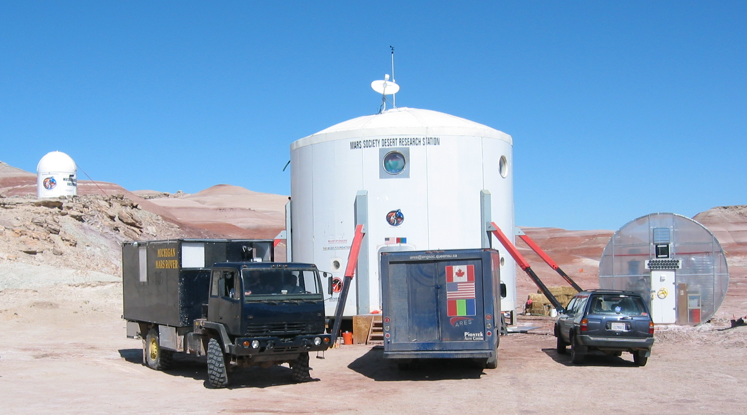
Figure 1. The three prototypes at the MDRS station. Left to right: Everest, Ares and Aonia

drawn. Finally, some conclusions with a view to improved vehicles and for future experimental field testing of pressurised rovers will be discussed.

Experimental Method

The point of a pressurised rover is to provide safe and comfortable travel in support of scientific exploration of the Martian surface. This implies that a good design will have at least two crucial aspects. First, the vehicle should be well-engineered as a human tool - that is, it should be a good ergonomic fit to the human users. Therefore the usability of the vehicle in terms of human ergonomics should be measured in the context of such active science exploration work. This can be done using existing usability methods as described below. Secondly, the vehicle must properly support scientific exploration work - principally, it should help geologists and biologists to locate, access, observe, sample and assess the scientific potential of various sites. This aspect is more difficult to measure quantitatively. One can record work output during a mission, such as weight of samples taken, or number of photographs taken, but most scientists would argue that it is the quality of the data and their subsequent interpretation, rather than the quantity of material gathered, which represents good science. The true value of a given day's work may not become apparent until much later, after analysis and interpretation, and even then, this ultimately yields a qualitative assessment (e.g. acceptance/non-acceptance into a peer-reviewed journal).

For practical reasons, then, it is necessary to rely on the judgements of experienced field scientists about how well a rover supports their work, as they do it. Since these judgements would likely vary across individual scientists and different scientific tasks might impose different requirements on a rover, a comparison of rover designs should hold these variables constant by using the same crew and the same mission for each vehicle tested. A crew of three professionals consisting of one engineer/driver, one geologist and one biologist was recruited from the Ex-One rotation. Then a suitable simulated mission was prepared in advance. It had to be challenging enough to properly exercise the crew and the rovers, yet not so difficult as to run overtime and frustrate or endanger the crew. After consultation with the crew, a sample collecting mission to Lith canyon, 7km from the MDRS habitat, plus two stops on the way was created. The mission sequence was designed to repeat the tasks, usually three or more times. The Ex-One organising meetings encouraged careful advance planning of sorties away from the MDRS habitat such that multiple science goals could be accomplished. It was consistent with the goals of the experiment that the science crew (geologist and biologist) would perform real scientific work of their own while participating. This both actualised the human factors task context and helped the physical scientists carry out their research. It was, for instance, convenient to leave a microorganism-collecting trap at a site during one trial and collect it later in another rover.

Three approaches were taken to gathering the required information. First, each task component of the simulated mission was rated by each crew member using NASA's Task Load Index (TLX) [10]. The TLX is a multidimensional scale which combines six factorial components of workload: mental demand, physical demand, temporal demand, own performance, effort and frustration. These components, weighted according to the relative significance they hold to the rater, quantify how hard an individual is working, mentally, physically and emotionally on a scale of 0-100. Since the TLX is commonly used in aerospace, commercial and military human factors testing, data on a wide range of tasks is available. helps determine whether the work expended within a given rover is comparable with working machines of similar complexity, though only under similar conditions of task difficulty and operator training. For example, with POPCORN, a challenging supervisory control simulation in which operators choose how best to respond to multiple task contingencies by executing procedures, the instrument typically returns weighted workload (WWL) scores in the range 47-73 [10, p.175], while in Boeing 757 simulations where experienced copilots monitored emerging alerts, scores in the range 28-43 were obtained [11]. Under normal conditions, trained operators in well-engineered human-machine systems should return 'low' WWL scores, meaning in the lowest quartile.

Second, six common subsystem components for the prototype rovers were isolated: driver's/navigators station, kitchen, bathroom, crew table, laboratory, and airlock. A set of ten-point usability scales captured each crewmember's judgement about particular aspects of each subsystem, such as amount of space. Averages over all individuals who used a subsystem are reported as Mean Usability (MU). Each crewmember was also encouraged to report good and bad experiences with rover subsystems, both during and after the mission sequence. Third, as each rover mission unfolded, a chase crew of three observers in radio contact photographed, videotaped, audio-recorded, timed and wrote down observations about almost every aspect of the crews experiences. More observations were gathered at debriefings which followed each mission. Together with logs of long range communications to the habit, these recordings provided detail on specific incidents.

Because the analogue rovers are based on commercial vehicles, they can up to a point inherit some of the benefits of the well-established ergonomic design processes used by automobile makers. It is reasonable to expect that driving on Mars will be similar in many ways to off-road driving on Earth. In fact, driving a well-appointed, all-terrain camper would be good approximation. However, a pressurised rover is different in that it requires an environmentally-controlled cabin, an airlock, provision for spacesuits and probably specialised science equipment such as a sample transfer port, a glovebox, and science workstation. The Everest and Ares designs did aim to approximate these, but delivered with mixed degrees of success. At this stage, many items of equipment were rudimentary, such as the rover-to-habitat radio link, which consisted of short range UHF handheld units via a repeater for all trials, and which was less than perfectly reliable. Furthermore, most operational procedures were being tried for the first time, such as the crew size and composition, the driving speed, EVA times and communication protocols.

Results

The trials were carried out during a week of favourable weather in March, 2003. Crews were able to complete nearly all required measurements. An attempt to estimate non-endothermic physical activity of the crew with pedometers did not succeed due to instrument failure. The trials conformed to the mission plan in all but one instance, where a suit helmet accident in the Everest forced an alteration to made to the third science EVA and subsequent transfer to habitat. The TLX data collection was adjusted accordingly. Given the rudimentary facilities available in the vehicles, few differences were expected between certain subsystem ratings. For example, all navigation was performed using a handheld GPS unit, rather than a built-in navigation console.

Aonia. This is an unmodified Nissan 1998 Pathfinder SUV 4.6m long, 1.8m wide and 1.7m high. . Not part of the original test plan, this vehicle was included in response to a request from the University of Michigan team. Critics had argued that their building a special vehicle was unnecessary, since an ordinary SUV would serve. These arguments were attended by general questions about the minimum practical size for a pressurised vehicle. Relative to orthodox vehicle designs, could a smaller, less massive pressurised vehicle, with the associated payload transport savings, adequately serve? Would it be practical to depressurise the whole vehicle interior each EVA, eliminating the bulky and heavy airlock? Such a vehicle would be approximately analogous to the Apollo LEM.

In some ways the Aonia did not fit well into the experimental design: with no kitchen, bathroom or crew table, those elements could not be assessed. Having the most glass, it was favoured in terms of visibility (MU= 7.7) and lighting (MU=8.4), but although Aonia was comfortable to drive (MU=8.0) - probably on account of being the smallest, most conventional vehicle - it was not otherwise practical for this day-long sampling mission. Even over the mission duration of approximately 6 hours, the lack of toilet and washing facilities made working in the field uncomfortable; longer sorties would be out of the question1. Most noticeable was the discomfort of ingress/egress, which was rated on average over 4 points less useable than the other vehicles. Furthermore, in Figure 2 the TLX scores show that during ingress/egress the crew were loaded much higher in Aonia (mean WWL=68.4) than with ARES and Everest (mean WWL=45.9 and 45.3, respectively). The subjects were observed to have difficulty donning and doffing suit helmets and life support backpacks within the cabin. The low roof (172cm from ground), non-deformable seat backs and interior fitments substantially interfered with these operations drawing comments such as "...the conditions were physically uncomfortable, approaching painful" and "...so awkward that muscle strains and bruises are possible". It was not possible to move about inside the vehicle when sealed, and the engineer/driver was forced out of the shirt-sleeve environment during the science EVAs. Finally, with no laboratory, options for science work are limited to on-site sample collection and storage only. These constraints would not sufficiently distinguish a vehicle of this kind from an unpressurised rover to make it a viable option.

.

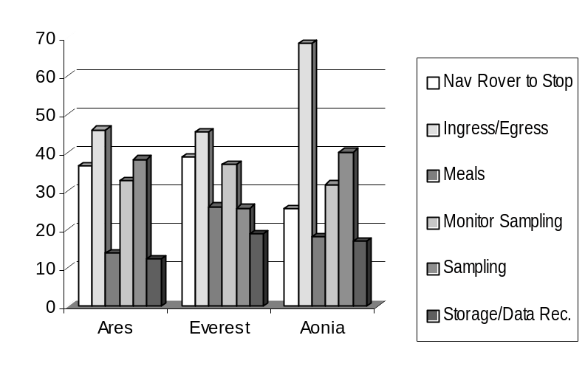
Figure 2. Mean TLX WWL scores for the six task
components by vehicle design

Ares. This is a modified GMC Vandura 2500 light truck, 6.35m long, 2.41m wide and 2.84m high. Electrical power is provided from a 110V 100W inverter on the vehicle battery. Potable water is supplied from an internal 40 gallon tank; at present no recycling is enabled. Extra equipment includes two lateral sample transfer hatches at the rear sides, one of which opens into a custom-built glove box for samples, and a curtained-off RV shower/toilet cubicle.

Pilot/engineer observations agreed with preliminary assessments: the Ares handles well for a road truck with single driven axle, even on narrow, rocky or poorly finished roads (drivability MU of 7.6). The low sample transfer hatches, the natural lighting via portholes, and high visibility were all favourably commented upon by the crew. However with no spare tire, and no provision in case of breakdown, it is not safe to take off-road. There was no seatbelt on passenger side, and no seat for the third crewmember, which was a problem for this experiment. Design problems included a low transverse beam between the cabin and crew living space, lack of a step at the rear airlock exit, and lack of suit and sample storage.

The most important design issue to emerge from the Ares trial is that of airlock size and placement with respect to the sample glovebox. The original design for the Ares called for a central airlock as a wide lane between two lateral glovebox/science tables with a door opening into a bathroom (Figure 3a). The actual delivered design departed from this configuration in that a smaller 1.4m x 1.5m x 1.8m airlock with a side door was placed off-centre and the shower/toilet was shifted to a single cubicle in the midcabin (Figure 3b). This airlock was judged too small (MU=1.9 for amount of space and 3.2 for ease of use) and providing insufficient storage for spacesuit equipment. The configuration caused difficulty in moving through the narrow 40cm gap between the inner door and the glovebox. The crew recommended that the glovebox be either shifted forward and made smaller. The second glovebox is not needed and this space should be used for suit storage. Also, since the smaller airlock could not simultaneously hold all three crew, there was a delay of more than 10 minutes in transferring between the rover and the habitat, relative to the other vehicles. This consideration suggests that a pressurised docking tunnel between the rover and the habitat would be worthwhile.

(a)
(b)
glovebox
glovebox
bed table
bathroom kitchen
airlock
sample
bed table
shelf bathroom kitchen
airlock
glovebox

Figure 3. Interior layout of Ares as originally planned (a) and actually delivered (b).
Arrow shows suggested shift of glovebox position, which might also be made smaller.

Everest. This is a 2.5 ton diesel Stewart & Stevenson Army truck 6.4m long, 2.6m wide and 3.8m high. A 1.2m x 0.75m x 0.75m tunnel connects the standard cabin to a purpose-built rear living space that measures approximately 3.0m x 2.4m x 1.9m. Two side mounted plastic Ronco RV exterior tanks supply clean water and a grey water tank is mounted under the vehicle at the rear. Interior equipment includes a transfer hatch for passing samples from outside into a Trinco science glove box, and a Thetford Bravura RV toilet within an Aker Plastics shower cubicle.

Figure 4 shows that the Everest was overall the best-appointed vehicle even though some electrical subsystems were not shown to the best advantage. The vehicle was good to drive with excellent visibility (MU=8.4), and handling (MU=8.5). Since this mission did not take the vehicle off-road, the special drive capabilities of the Everest were not exercised. Attention to detail in the living quarters was particularly well received by the crew. They commented favourably on the large windows, excellent storage cabinetry, the computer facilities, and the carpeting. One did, however, remark that fold-down chairs would make a good addition to the crew area.

A number of design issues arose during the Everest trial. First, electrical power for the vehicle is provided by a built-in 6kW petrol generator, but during these experiments this unit was not functioning, so equipment such as water pumps, lights, heaters and computers were not available. Consequently these aspects of the vehicle's design could not be properly assessed by the crew. Second, the shape and placement of the lower grey-water tank was problematic in that it compromised the Everest's clearance and departure angle. While the nominal ground clearance on the Everest is approximately 63cm, the grey water tank reduced this to 36cm. Further, the tank projected aft so as to substantially reduce the rated departure angle of 40° for clearance from a gully. The water tank was observed to strike the ground hard enough to dislodge its mounting frame while departing from a stream bed on a slope of just 12°.

Third, serious difficulties were experienced during ascent and descent to the outer airlock door, due to the rear folding ladder. There was some awkwardness due to placement of the ladder lateral to the landing, which forced the crew to sidestep, but most difficulty was observed in folding and securing the ladder before and after an EVA. It was difficult to control the lower section of the ladder from the landing. A simple lanyard coupled to the lower ladder would eliminate this. The hockey strap fastener was not only inadequate, but dangerous: at the end of the second EVA, this caused an accident in which the strap smashed a 2cm hole in the visor of the crew geologist, forcing him into an emergency repressurisation, then remain inside the vehicle for the remainder of the sortie in order to stay in simulation. (In this task component, TLX workload factors indicate that the geologist was under pressure: MD=100;PD=100;TD=50; EF=100;OP=5;FR=70;WWL=61). The lower section of the ladder was subsequently damaged when the vehicle was accidentally moved with the ladder in contact with the ground. It would be best if the ladder did not touch the ground, and an indicator was placed inside the cabin that signalled when the ladder was deployed.

Although the Everest airlock was larger than that of Ares at 1.1m x 2.4m x 1.9m, and capable of holding three, it was also judged too small and in need of storage space (MU=5.1). The patterns of TLX workload factors and WWL totals during ingress/egress was not readily distinguishable between the two vehicles, yet the rated ease of access was actually lower for Everest (MU=2.9), possibly because of the severe ladder problem and because the airlocks were both crowded when filled to maximum occupancy.

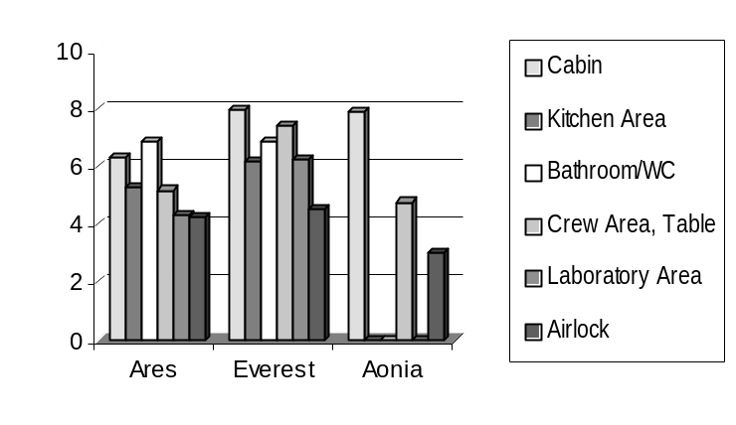
Figure 4. Mean Usability (MU) ratings over all subsystem
components of vehicle designs (0=useless, 10=ideal).

Conclusions

A wealth of information on what Martian rover operations might be like was gathered, from which three main observations will be considered here. First, the crew size and composition of one pilot/engineer, one biologist and one geologist seemed ideal, at least for what Muelbergers's group called 'intermediate-stage reconnaissance' - sorties to the limit of a single days' traverse [3]. Longer traverses involving one or more night away (or 'extended EVAs') could also be possible with three. The pilot/engineer has a prevailing responsibility for effectively and safely transporting the science crew and is primarily concerned with rover systems, driving, navigating, communicating with the habitat and monitoring the science EVAs. This frees the attention of the science team for EVA operations, site prospecting, site assessment, sampling, photography, data recording and other field science activity. A crew of two would have to abandon the rover during EVAs, and divide their attention between two complex and possibly conflicting roles, while a larger crew could adversely deplete the compliment remaining at the habitat, impose a greater load on the rover's consumables, and create problems due to space restrictions, especially in the airlock.

Second, there was room for improvement in the built-in science equipment provided by the vehicles. Both Ares and Everest had external hatches to transfer sample to a glovebox, but the hatch on Everest was approximately 2.5m above ground level, making it impossible for EVA crews to deposit materials without a step ladder. Better sample storage facilities were suggested for all vehicles. This could be a simple as a few 20L plastic pails in a rack outside the shirtsleeves environment, or as elaborate as environment-controlled chambers. The science crew commented that glovebox units on both vehicles were too large, and even questioned the need for such a device on the rover at all. Provision of a glovebox and other laboratory equipment presupposes that detailed science on material could and should be done in the rover. Given that conditions on a pressurised rover could be less than ideal, perhaps the crew should only aim to label, store and carry samples back to the habitat laboratory. The crew biologist suggested that a relatively simple laboratory facility, consisting of a bench approximately 1.3m long and 0.5m wide with a microscope, racks for bottles, a good light and power points should be included, in order to decide whether a particular site warranted further sampling. Similarly, a small lighted bench with a vice and basic tools should also be provided, to facilitate field repairs. This might double as a geology station.

Third, a significant operations management problem emerged during these and other rover sorties. Rover-habitat interactions were being handled for the first time, so some procedures were necessarily ad hoc. Long range communications were sufficiently unreliable that, when unforeseen circumstances cropped up in the field, it was generally necessary for the pilot and/or crew to decide on a course of action, though they were expected to report regularly to the habitat and seek advice, especially on safety matters. But when the rovers were close to the habitat, conflicts frequently arose between the rover crews and the habitat crews. This was particularly noticeable at dusk, when two or more parties returned the habitat at about the same time. This was observed to happen on at least four occasions. One incident will be expanded for illustration.

The Ares and Aonia arrived almost simultaneously at sunset, forcing the Habcomm officer, who by agreement controlled habitat area traffic, to request that the Aonia crew to wait until the Ares crew had cycled through the airlock. From there the situation quickly become complicated. The Aonia crew asked for permission to depressurise and quit the rover to stretch their legs, which was granted. Inside the Ares, the pilot's backpack malfunctioned, and the crew decided that the rover geologist should visit the habitat, and bring back a fully functional backpack. The second part of their message was not fully understood by habitat personnel. The human factors specialist suggested that the Aonia crew, thought to be already depressurised and nearby, should transfer the backpack, so the airlock was repressurised and the unit placed inside. The Habcomm officer tried to contact the Aonia crew to request this, but they had departed the local area for a hilly region which took them out of radio contact. During this time the Ares geologist was waiting outside the habitat. His backpack batteries were low, and he signalled an emergency. As a result of the confusion, however, the habitat was slow in getting the airlock door open, and within the terms of the simulation, his life was jeopardised. It was many minutes before the Aonia crew returned to the vicinity, by which time it was too late for them to help.

While a complete analysis of these problems is outside the scope of this investigation, two comments are in appropriate. From an engineering design standpoint, this problem might not have arisen if a flexible, pressurised tunnel connecting the habitat to the rover was available. This would be safer, would drastically simplify and shorten rover loading and unloading (especially with small rover airlocks) and would provide extra living space when the rover was docked at the habitat. Additionally, the problem could be seen to stem from inadequate radio communications, suggesting the need for improved equipment and training.

From an operations standpoint, when using heavy vehicles like rovers, broadly agreed-upon operations ground rules of safety, simulation and science are needed and that all crewmembers should make a firm, public commitment to these, if trouble is to be avoided in future. As in this example, most of the four incidents were complex, cascading failures, where the interaction of several mishaps, possibly minor in themselves, add up to a dangerous whole. The elements were technical (e.g. poor radio reception, suit equipment malfunctions), personal skill (e.g. insufficient radio communication skills, fatigue, stress) and social contract (missing protocol or disagreement about protocol interpretation, different command models) related. Lack of experience with simulations as well as the existence of overlapping crew subgroups, operating under differing organisational assumptions, undoubtedly contributed to the various misunderstandings and poor decisions. Many such problems could be eliminated if the crews had time to familiarise themselves with each other, and specifically train together for situations of this kind.

Committing the necessary resources, time and money to such training is a challenge for future simulation work of this kind. Technology development can be an expensive and time-consuming affair. The continuing goal of the Mars Society's pressurised rover projects should be to learn from each such trial, and build that learning into the next generation of analogue rover. and conduct further trials on that. The importance for this goal of conducting methodologically sound field trials and widely circulating the results cannot be overstated. In this way each new rover, wherever it is built, can aim to improve upon the last.

References

1. Hoffmann, S.J. & Kaplan, D.I. (Ed.s) Human Exploration of Mars: The Reference
Mission of the NASA Mars Exploration Study Team. NASA Special Publication
6107,July,1997 pp.3/105-110. Available at
http://www-curator.jsc.nasa.gov/sn/PlanetaryMissions/EXLibrary/docs/MarsRef/contents.html

2. Zubrin, R. The Mars Direct Plan. Scientific American, Vol 282, 3, 2000, pp. 52-55.
3. Muehlberger, W., et.al. Team 1 Approach to Mars Field Geology. In Mars Field
Geology, Biology and Palaeontology Workshop: Summary and Recommendations.
Lunar and Planetary Institute Contribution No. 968, November, 1998., pp. 9-10.
4. French, J.R. An Overview of Mars Surface Mobility Justification and Options. In Stoker,
C. (Ed) The Case for Mars III, American Astronautical Society Vol. 74, 1987, pp.619-
632.
5. Engineering Society, Queens University. Queens University's Mars Analogue Rover
Experimental System. Unpublished Sponsorship Proposal. Available from ARES
website at http://engsoc.queensu.ca/ares/
6. Michigan Mars Rover Team. Michigan Mars Rover: Design, Accomplishment and
Schedule Report. Unpublished document, University of Michigan, April, 2001.
Available at http://www.marsrover.engin.umich.edu.
7. Mann, G.A. Design, Construction and Operations Plan for the Marsupial Rover.
Proceedings of the 2nd Australian Mars Exploration Conference (AMEC2002).
University of Sydney, Australia July, 2002.
8. Herbert, M. et.al. Intelligent Unmanned Ground Vehicles: Autonomous Navigation
Research at Carnegie-Mellon. New York: Kluwer Academic Publishers, 1997.
9. Apostolopoulos, D. Wagner, M. and Whittaker, W. Technology and Field
Demonstration Results in the Robotic Search for Antarctic Meteorites. Proceedings
of the 2nd International Conference on Field and Service Robotics, Carnegie-Mellon
University, Pittsburgh, USA, 1999, pp.185-190.
10. Hart, S.G. & Staveland, R.J. Development of a multidimensional workload rating scale:
results of empirical and theoretical research. In P.A. Hancock & N. Meshkati (Eds)
Human Mental Workload. Amsterdam, The Netherlands: Elsevier, 1988, pp 139-183.
11. Trujillo, A.C. Pilot Performance with Predictive System Status Information.
1997 IEEE International Conference on Systems, Man, and Cybernetics,
Orlando, Florida, 1997, pp. 1972-1977.

1 Note, however, that qualitative trials using the Aonia rover the previous field season were much more successful, and included an overnight mission, with the crew sleeping in the vehicle The primary difference was only two crew took part in this mission. We were aware of this difference, however chose to use a three-person crew to maximise similarity with the other rover tests.

