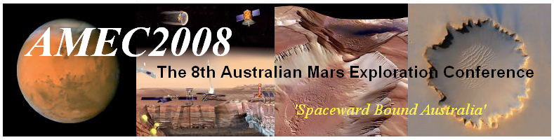
A Weekend on Mars!
The 8th Australian Mars Exploration Conference (AMEC2008) will be held in Adelaide over this coming weekend. Presentations over this exciting three-day event will cover a range of issues concerned with exploring and pioneering Mars.

7.30pm  Friday 4th July | Public Lecture  Professor Russell Boyce, DSTO Chair of Hypersonics  'Australian Hypersonic Research and the Road to Mars'  (Entry by gold coin donation).
9am  Sat/Sun 5th-6th July  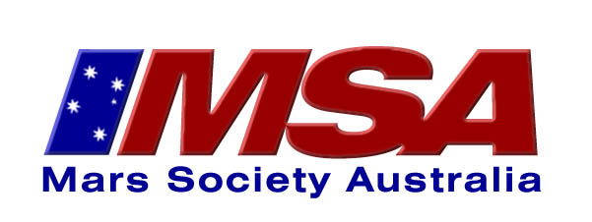 | Conference  Speakers include  Professor Rob Morrison, ‘Rob’ from the Curiosity Show  Dr Mark Bishop, on Martian Geography  Dr Jonathan Clarke, on the Phoenix Lander  Dr Lizabeth K Coe, NASA Education Division  Artemis Westenberg, Mars Society Netherlands  and more …
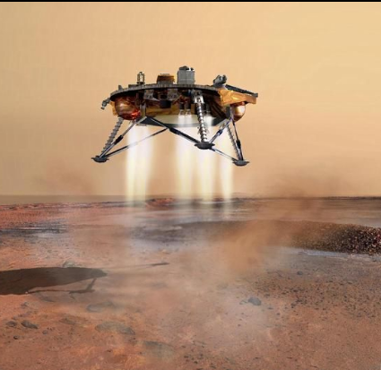 | Where?  Both events are at the  Centenary Building,  Level 3 - Room 16 (C3-16),  University of South Australia,  City East Campus,  Corner of North Terrace & Frome Road, ADELAIDE.
Find out more and register now at
www.marssociety.org.au

