AMEC2009 – HOW TO GET THERE

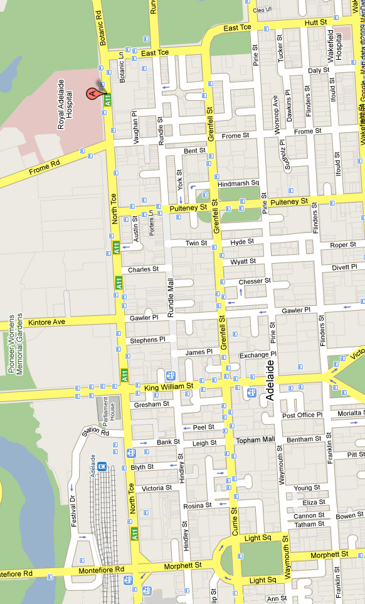
PUBLIC LECTURE & CONFERENCE VENUE
University of S.A.
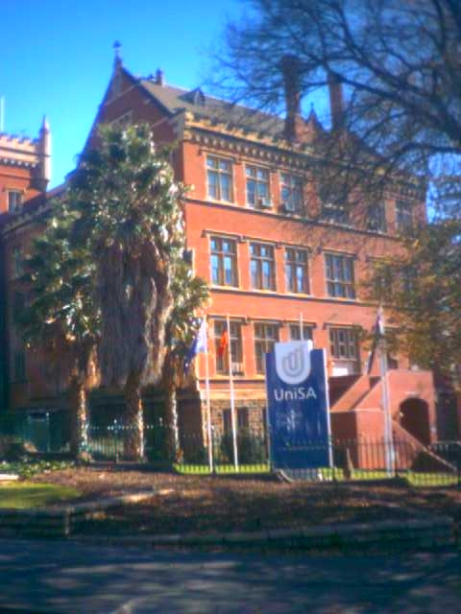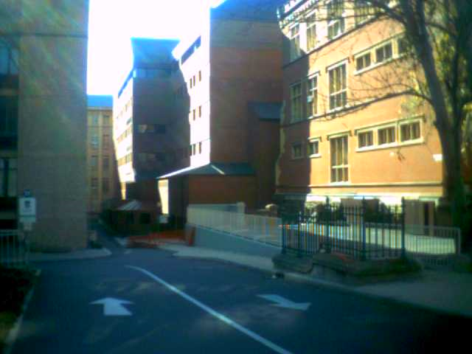

DR CHRIS MCKAY PUBLIC LECTURE

'Results of the Phoenix Mission to Mars and Analog Sites on Earth'

When: 7.30pm, Friday 17th July
Where: Centenary Building,
Level 3 - Room 16 (C3-16), University of South Australia,
City East Campus,
Cnr North Terrace and Frome Rd, ADELAIDE.

9TH AUSTRALIAN MARS EXPLORATION CONFERENCE

When:
Saturday-Sunday 18th-19th July

Where: Centenary Building,
Level 3 - Room 16 (C3-16), University of South Australia,
City East Campus,
Cnr North Terrace and Frome Rd, ADELAIDE.

CONFERENCE BANQUET

When: 7.30pm, Saturday 18th July

Where:
Ayers House Restaurant,
88 North Terrace,
ADELAIDE.

Dress smart casual/semi-formal, prior booking through the Mars Society Australia essential.
CONFERENCE BANQUET
Ayers House Restaurant,
