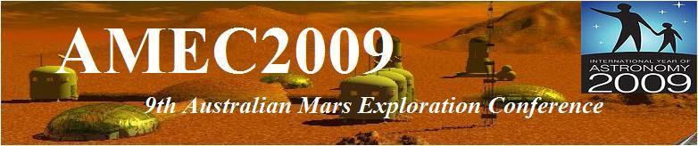

Adelaide July 17th-20th


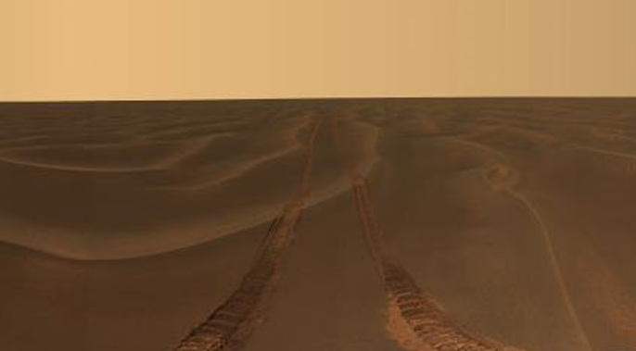
AMEC 2009 –Program
(May be subject to further revision without notice, check www.marssociety.org.au for latest information)

VENUES  All speaking events to be held at -  Centenary Building,  Level 3 - Room 16 (C3-16),  University of S.A., City East Campus,  Cnr North Terrace and Frome Rd,  Adelaide. |  |  |  | Conference Banquet Venue -  Ayers House Restaurant  38 North Terrace  Adelaide  5000.
FRIDAY 4th JULY
Session | Time | Event |  |  | Speaker
 | 4.30pm | MSA AGM |  |  | -
Public Lecture | 7.30pm | Results of the Phoenix Mission to Mars and Analog Sites on Earth |  |  | Dr Chris McKay

SATURDAY 5th JULY
Session | Time | Topic | Speaker
Registration | 8.00
Start | 9.00-9:15 | Opening Remarks | David Cooper,  MSA President
Guest Speaker | 9:15-9:45 | Opening Address | Dr Ian Chessell - Chief Scientist of South Australia
Morning Tea | 9:45-10:15
Session 1 | 10.15-12.45 | Planetary Science and Astrobiology
 | 10.15-11:00 | A Summary of Australian Mars Analogues | Jonathan Clarke
 | 11.00-11:30 | To What Extent Does Terrestrial Life ‘Follow The Water’? | Eriita Jones & Charles Lineweaver
 | 11.30-12:15 | Preservation of Biosignatures in Phyllosilicates vs. Iron-rich Environments as Mars Analogue | Rosalba Bonaccorsi et al.
 | 12.15-12:45 | Statistical Analysis of Martian Data | Eriita Jones et al.
Lunch | 12:45-1:45
Session 2 | 1:45-5.00 | Planetary Science and Astrobiology
 | 1:45-2:30 | Temporal Biodiversity of Potential Diazotrophs in Stromatolites, Shark Bay, Western Australia | Reut Sorek-Abramovich et al.
 | 2:30-3:00 | Dune form on Earth and Mars: Climatological controls and geomorphological effects. | Mark Bishop
Afternoon Tea | 3.00-3:30
 | 3:30-4:15 | Geophysical and Chemical Characterisation  of Water Sources at Arkaroola, South Australia | Shannon Rupert
 | 4:15-5:00 | TBA | Paulo de Sousa
Conference Banquet | 7.00 | Ayers House Restaurant, 38 North Terrace, Adelaide 5000 (Booking required)

SUNDAY 6th JULY
Session | Time | Topic | Speaker
Registration | 8.00
Session 3 | 9.00-10.30 | Mars Education and Outreach
 | 9.00-9:30 | Student Field Expeditions: Improving Conceptual Understanding in Earth, Planetary and Space Science | Mark Gagarno
 | 9.30-10:00 | Space Science: Developing scientific awareness amongst Middle to Senior School Students | Brittany Hunter
 | 10.00-10:30 | The Science Education of Spaceward Bound | Berriman et al.
Morning Tea | 10.30-11:30
Session 4 | 11.00-200 | Mars Education and Outreach
 | 11.00-11:30 | The Victorian Space Science Education Centre | Mark Gargano & Naomi Mathers
 | 11.30-12:00 | Special Publication on Australian Space Education | Jon Clarke (convener)
 | 12.00-12:30 | TBA | David Cooper
Lunch | 12.30-1:30
Session 5 | 1:30-4.00 | Engineering and Robotics
 | 1.30-2:00 | Advanced Mining Automation: Space Technology Transfer | John Malos and Jonathon Ralson
 | 2.00-2:30 | Mission support for FMARS 2009 Expedition | Jason Held
 | 2.30-3:00 | TBA | David Willson
 | 3:00-3:15 | Concluding Remarks. | Dr Jonathan Clarke
Afternoon Tea | 3.15-3:45

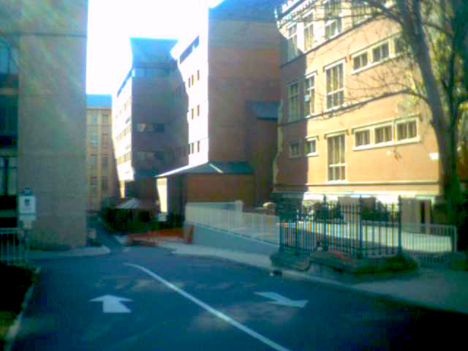  Conference Venue, North Terrace Entry | 