
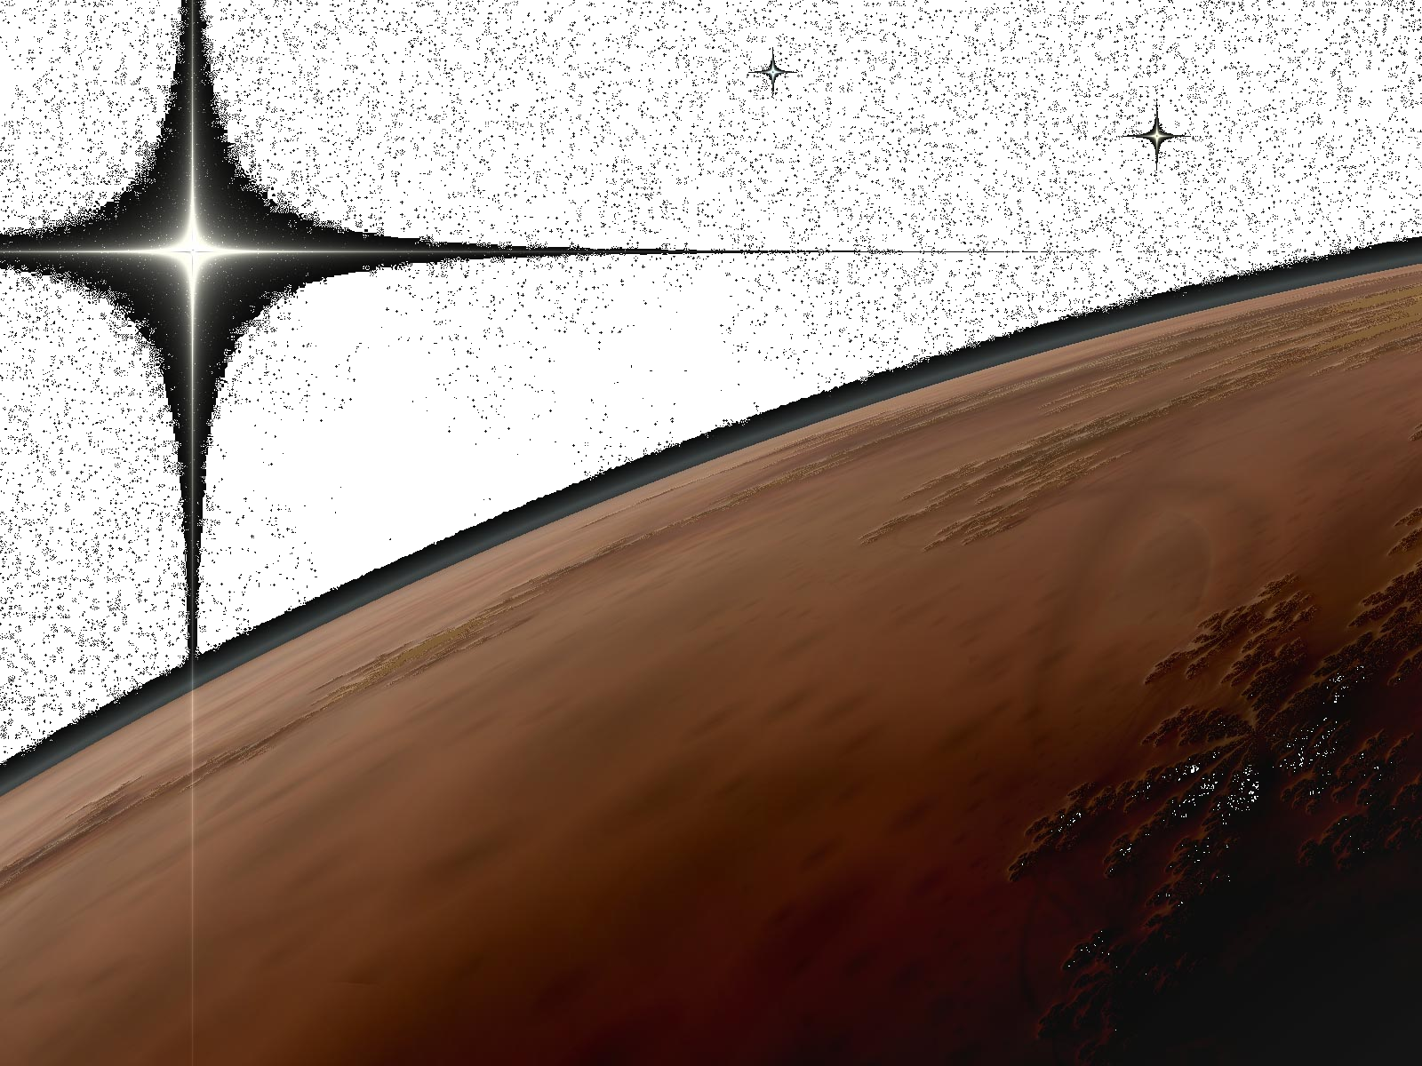
CPSS
Centre for Planetary and Space Studies

Welcome to the Mars Society Australia (MSA) Student essay competition

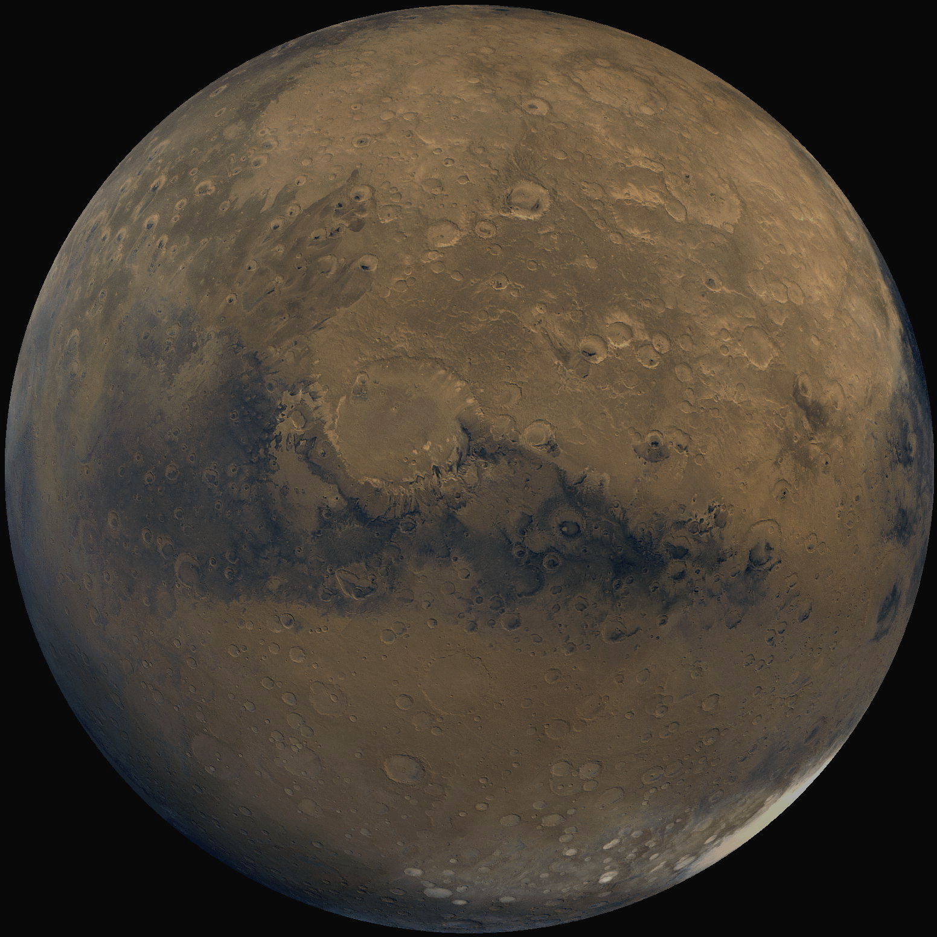
If you are in a WA Secondary School and have an interest in space, if you feel the need for speed- light speed that is, this is the competition for you.

MSA is a Research and Development organisation aimed at developing technologies that will assist in the exploration and settlement of the Red Planet. Mars is within reach. The fourth planet from the sun is a potential new frontier for all humanity. It is the nearest body in the solar system known to possess all the mineral resources necessary to sustain a permanent human presence. It has landscapes billions of years old that can shed light on the early history of the earth and the solar system. Mars is the next most likely place in the solar system where life may once or may still exist, the discovery of which would offer deep insights into the origins of life and the biological sciences. In the last decade, major strides toward feasible, affordable human missions have been made and the question is no longer, “Can humans go?” but “When will humans go?”

MSA is aiming to achieve this through various projects that will take science, technology and engineering into the next phase of the 21st Century and enhance the prominence of science in Australian Education. You too can be a part of the push to Mars, entering this competition will be the first step on the long and ultimate journey into the new exciting frontier.

For further information about MSA and their projects, please consult the website at;
http://www.marssociety.org.au

To begin this exciting adventure, choose to write a essay on one of the following
Space Science topics-

Earth and Mars: So similar and yet so different. What are the conditions for life and how do we look for them?

Extremophiles- fun, friendly and full of lots of good stuff for budding Space Scientists.

Space Robots- utilising robot technology to lay the groundwork for human exploration of the red planet.

Martian plants-would we, could we, should we?

Energy management: What can we learn for space missions, to apply back here on Earth?

Why should we develop space technologies and go to Mars?

This essay needs to be no more than 1500 words, correctly referenced and with suitable diagrams that enhance your content. The due date for submitting is Friday 20th of May.

From here, the best judged essay will be recommended for presenting their information in a visually stimulating format to an audience of peers and scientists at the 11th Australian Mars Exploration Conference (AMEC) to be held at the University of Western Australia over the weekend of 23rd & 24th of July. The winner will receive free entry to AMEC, and a prize for their efforts and achievement along with a special presentation to be given during AMEC.

Check the website (http://www.marssociety.org.au) for further information and for questions or final submissions, please email them to MSA Education Officer at; education@marssociety.org.au.

Paper submission-please fill in all details

Please fill in the relevant details (all personal details will remain private and will not be supplied to outside parties without prior consent from applicants and their parent/s) and email this with your paper

First Name_____________________________________________________________________

Last Name _____________________________________________________________________

Date of Birth ___________________________________________________________________

Year ___________________

School Name ___________________________________________________________________

School Address _________________________________________________________________

______________________________________________________________________________

______________________________________________________________________________

School Telephone _______________________________________________________________

School Fax ____________________________________________________________________

Teacher Contact (Name) __________________________________________________________

Teacher email __________________________________________________________________

Principal Name _________________________________________________________________

Essay topic- please circle/highlight your choice

Earth and Mars: So similar and yet so different. What are the conditions for life and how do we look for them?

Extremophiles- fun, friendly and full of lots of good stuff for budding Space Scientists.

Space Robots- utilising robot technology to lay the groundwork for human exploration of the red planet.

Martian plants-would we, could we, should we?

Energy management: What can we learn for space missions, to apply back here on Earth?

Why should we develop space technologies and go to Mars?

Please ensure you adhere to the 1500 word limit, all diagrams, charts, pictures need to referenced and referred to and all materials and websites used are acknowledged, all work must be yours. An essay submission must not be greater in size than 3 MB.

Check the website (http://www.marssociety.org.au) for further information and for questions or final submissions, please email them to MSA Education Officer at; education@marssociety.org.au.

Due date- Friday 20th of May 2011

