**Toon Tanks Document**

A simple project to explore movement rotation functionality in a C++ Pawn class.

The parent pawn class “PawnBase” will include the similar components and functions that all different pawn classes will have e.g. (Capsule Components, Mesh Components, Particle System, Shooting Function, …)

This project has two child pawns in the scene one is the playable “PawnTank” which focuses on camera and movement implementation.

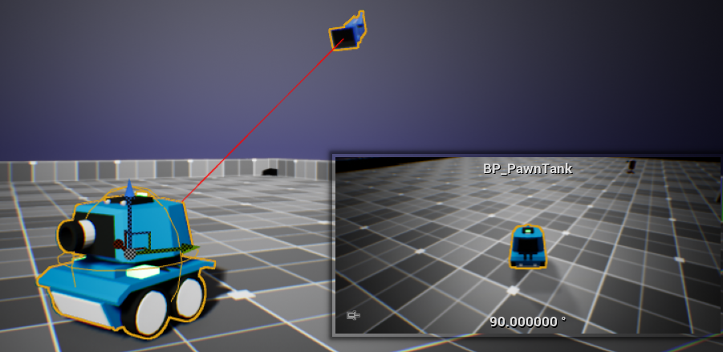

The other pawn “PawnTurret” is stationary which focuses more on having a simple AI that handles events like the distance of the PawnTank (the player pawn) and the rotation to face the player pawn to shoot at it.

