DataCraft Academy
Python ETL Pipeline

FINAL PROJECT REPORT
Bike Store Data Warehouse & Business Intelligence
April 2026

Team Members
Menna Allah | Mustafa Atef

4,729  Fact Records | $8.77M  Total Revenue | 1,445  Total Orders | 31.7%  Late Deliveries

Python · pandas · sqlite3 · matplotlib · seaborn ·

1. What We Built
We built a full ETL pipeline that pulls raw data from a fictional bike store chain, cleans it up, transforms it, and loads everything into a structured database ready for analysis. The end result is a data warehouse with eight business charts showing real insights — sales trends, top products, delivery problems, and more.

The data covers three U.S. stores from 2016 to 2018, with over 4,700 order records and $8.77M in total revenue. Along the way, we found problems in the data — duplicates, missing values, wrong formats — and fixed them all automatically.

Key Results at a Glance
- $8.77M total revenue across 1,445 orders (2016–2018)
- Mountain Bikes was the top revenue category
- Trek Slash 8 27.5 was the best-selling product — $555K alone
- 2017 was the best year, nearly double 2016's revenue
- 31.7% of orders arrived late — a clear problem worth fixing
- 47 duplicate rows and 1,275 missing values found and cleaned automatically

2. How the Pipeline Works
We split the work into five steps. Each step takes the output of the previous one, so if anything breaks, we know exactly where to look.

Step | What it does
Step 1 — Extract | Pulls data from three places: a database (via SQLite), a folder of CSV files, and a live currency exchange rate API
Step 2 — Clean | Finds and fixes nulls, duplicates, wrong data types, and out-of-range values. Saves clean files to staging_1/
Step 3 — Transform | Adds calculated columns: EGP prices, delivery days, late-delivery flags, order status labels. Saves to staging_2/
Step 4 — Model | Builds the Star Schema — one fact table connected to 6 dimension tables. Saves to Information_Mart/
Step 5 — Visualize | Generates 8 business charts using matplotlib and seaborn. Saves PNGs to Visualization/

Where the Data Comes From
- Database (SQLite): orders and order_items — 1,445 orders, 4,764 line-items
- Data Lake (CSV files): brands, categories, customers, products, staffs, stocks, stores
- API (openexchangerates.org): live USD exchange rates for converting prices to EGP

3. Data Cleaning
Before doing anything with the data, we ran it through a set of quality checks. The table below shows what we found in each dataset.

Dataset | Rows In | Nulls Found | Dups Removed | Rows Dropped | Rows Out
orders | 1,445 | 0 | 0 | 0 | 1,445
order_items | 4,764 | 0 | 34 | 1 | 4,729
customers | 1,445 | 1,267 | 0 | 0 | 1,445
products | 334 | 0 | 13 | 0 | 321
staffs | 10 | 6 | 0 | 1 | 9
stores | 3 | 2 | 0 | 0 | 3
brands | 9 | 0 | 0 | 0 | 9
categories | 7 | 0 | 0 | 0 | 7
stocks | 939 | 0 | 0 | 0 | 939

The 1,267 missing phone numbers in the customers table were filled with 'unknown' rather than dropping those customers — we didn't want to lose valid order records just because a phone number was blank.

4. What We Added to the Data
After cleaning, we enriched the data with new calculated columns that make analysis much easier.

Currency Conversion
All prices were in USD. We converted them to EGP (Egyptian Pound) using the exchange rate from the API (1 USD = 48.65 EGP). We also calculated the final price after applying each order's discount.

Delivery Metrics
We calculated how many days it took from order placement to shipment, and flagged any orders that arrived after the customer's required date. This is how we found the 31.7% late delivery rate.

Order Status Labels
The original data had order statuses stored as numbers (1, 2, 3, 4). We converted those to readable labels: Pending, Processing, Rejected, and Completed.

Product Enrichment
Each product only had a brand ID and category ID. We joined those to their actual names so charts and reports show 'Mountain Bikes' instead of 'category_id: 6'.

5. The Data Model
We used a Star Schema — one central fact table holding all the sales numbers, connected to six dimension tables that describe the who, what, when, and where of each sale.

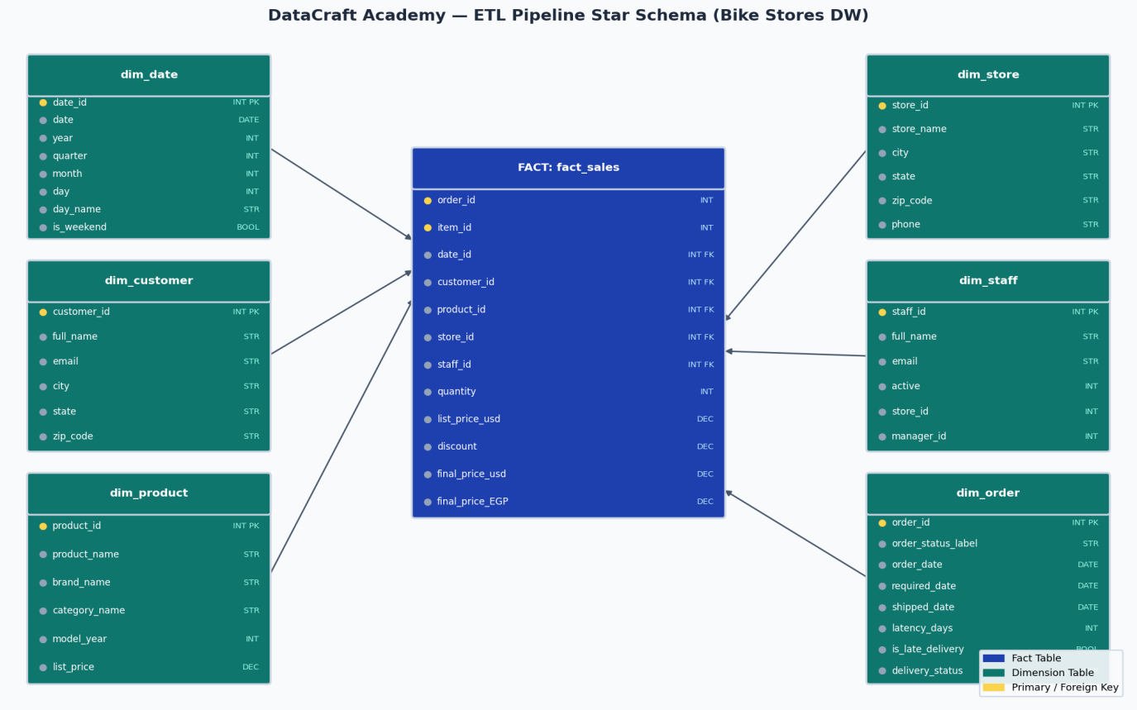
Figure 1 — Star Schema: fact_sales connected to 6 dimension tables

Table | Description
fact_sales | 4,729 rows — one per order line-item. Stores quantity, prices, discount, and foreign keys to all dimensions
dim_date | 680 rows — calendar info: year, quarter, month, week, day name, weekend flag
dim_customer | 1,445 rows — customer name, email, city, and state
dim_product | 321 rows — product name, brand, category, model year, and price
dim_store | 3 rows — store name and location (Santa Cruz CA, Baldwin NY, Rowlett TX)
dim_staff | 9 rows — staff name, email, and which store they work at
dim_order | 1,445 rows — order status, delivery status, and latency days

6. What the Data Tells Us
We built eight charts to make the data easy to understand. Here are the most important findings.

Sales Over Time
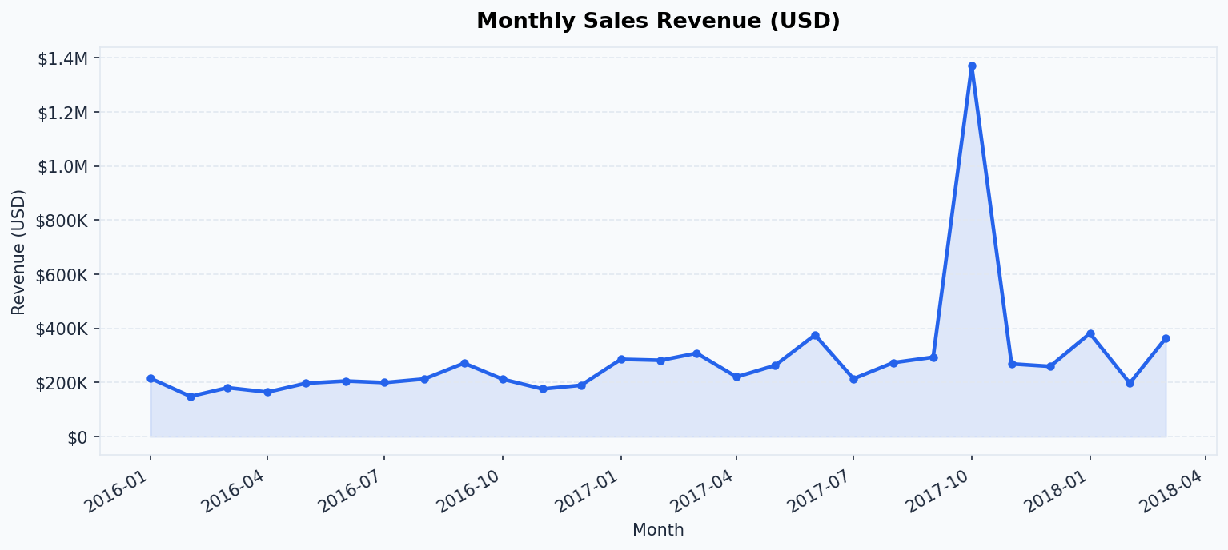
Figure 2 — Monthly revenue, Jan 2016 to mid-2018
Revenue grew steadily through 2017, with clear seasonal peaks in spring and autumn. The drop in 2018 is just because the data ends mid-year, not an actual decline.

Top Selling Products
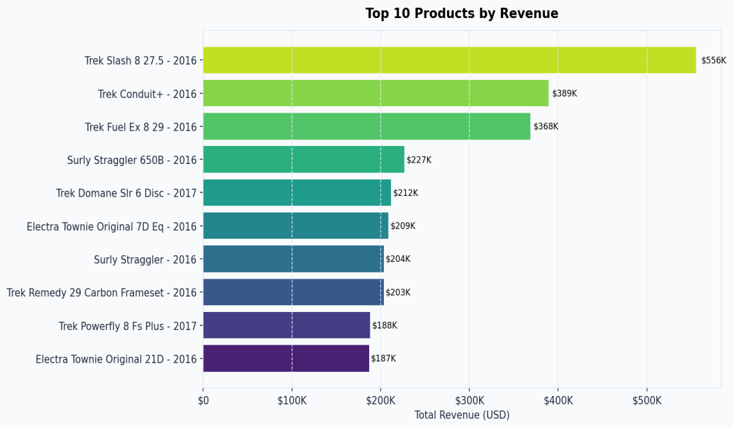
Figure 3 — Top 10 products by total revenue
Trek and Surly premium bikes dominate the top 10. The highest earner, Trek Slash 8 27.5, brought in $555K by itself. High-end bikes clearly drive most of the revenue.

Revenue by Category
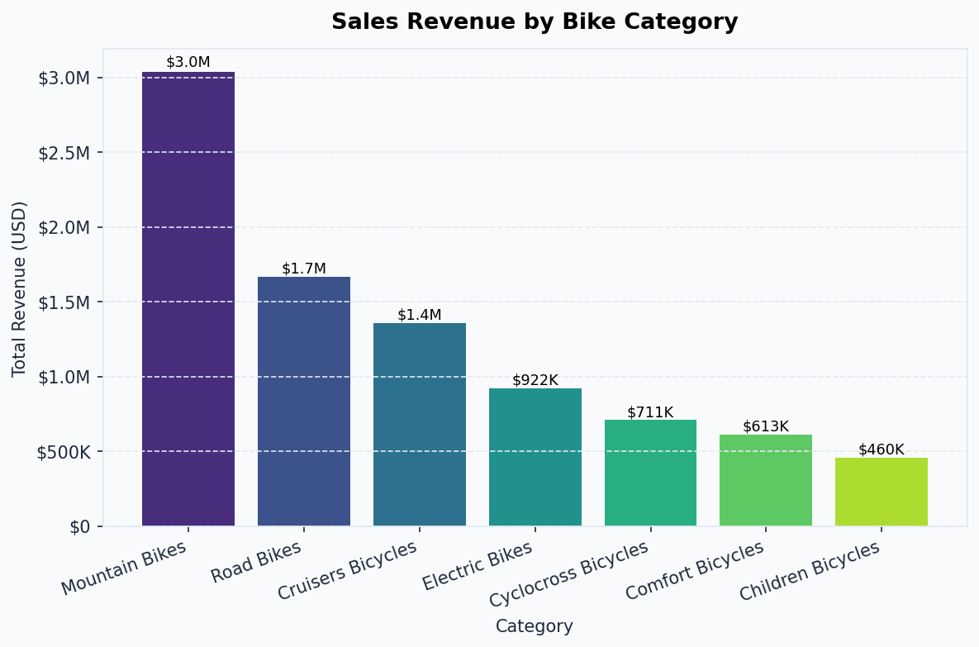
Figure 4 — Revenue by bike category
Mountain Bikes take the top spot, followed by Road Bikes and Cyclocross. Children and Comfort bikes are the smallest categories — lower prices, not necessarily fewer sales.

Order Status
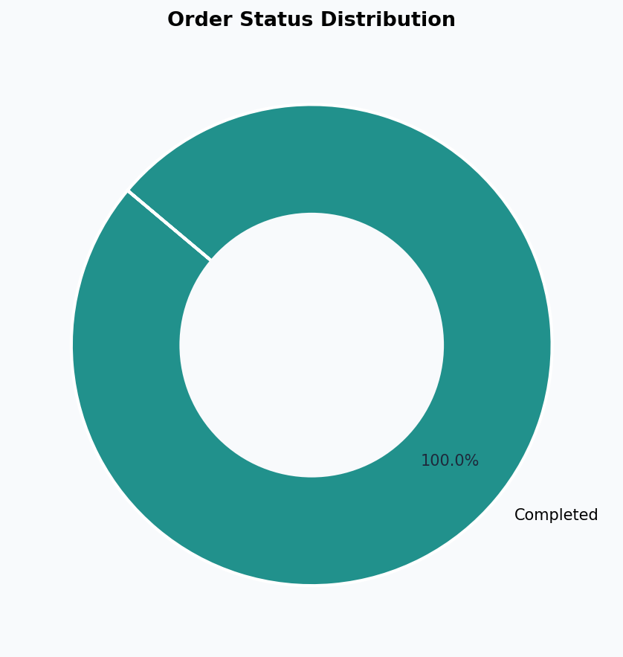
Figure 5 — Breakdown of order statuses
Most orders completed successfully. A small percentage were rejected — worth looking into to understand why.

Delivery Performance
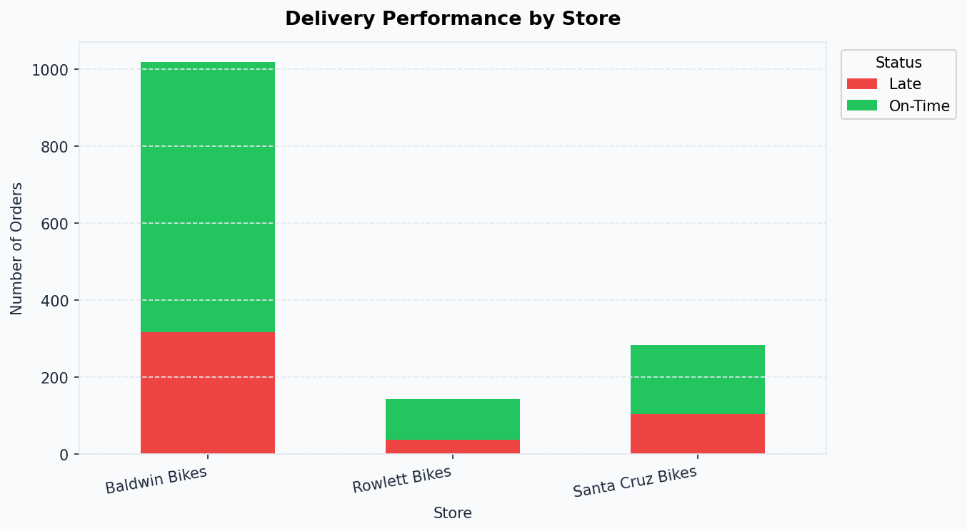
Figure 6 — On-time vs. late deliveries by store
All three stores have nearly the same late-delivery rate (~31%). This tells us it's not a single store's problem — it's something in the overall fulfilment process that needs fixing.

Where Customers Come From
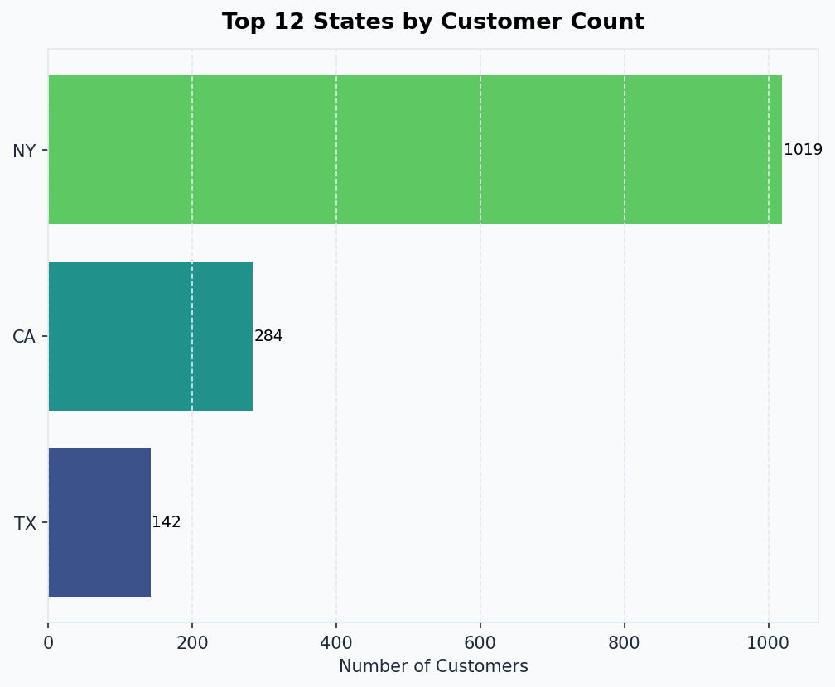
Figure 7 — Top states by customer count
New York, California, and Texas are the top three — which makes sense since that's exactly where the three stores are. The stores are well-placed to serve their local markets.

Year-over-Year Revenue
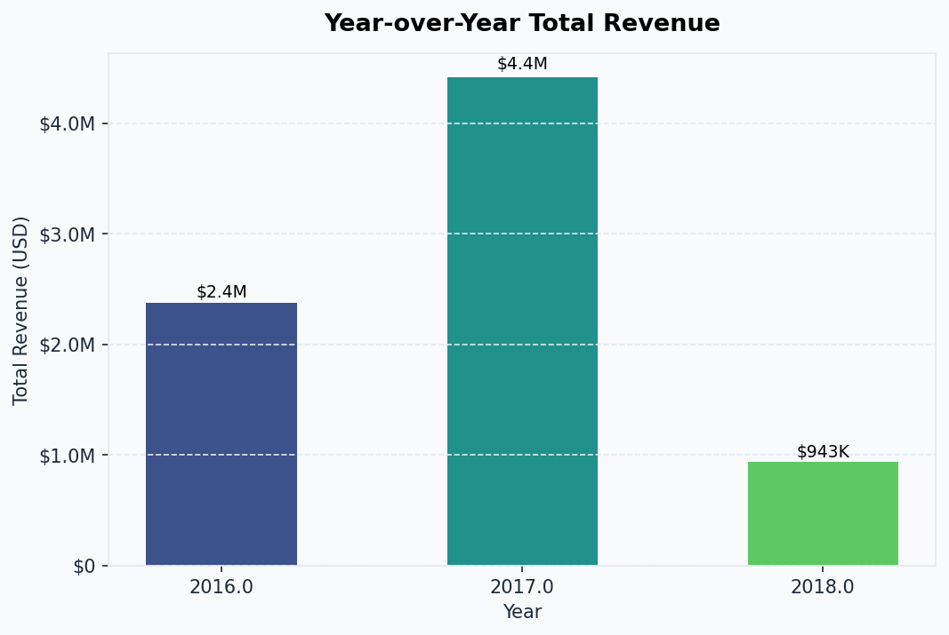
Figure 8 — Annual revenue comparison
2017 was the standout year at $4.41M — almost double 2016. The business was clearly growing fast before the dataset ends.

Discounts vs Revenue
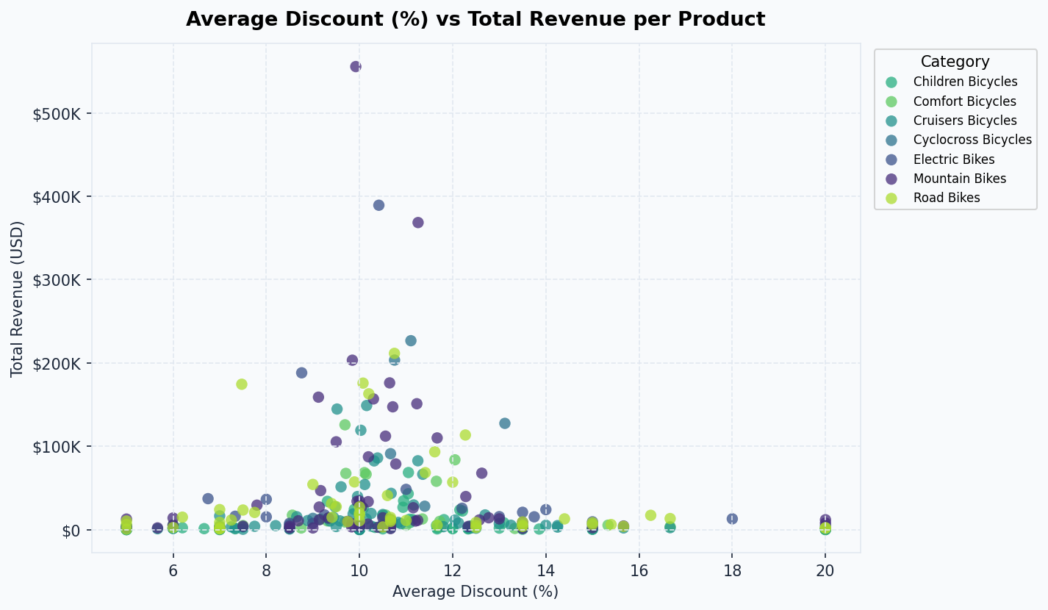
Figure 9 — Discount rate vs. revenue per product
There's no clear pattern between how much discount is offered and how much revenue a product makes. Discounts seem to be applied evenly across products rather than strategically.

7. Problems We Ran Into
Every real project has surprises. Here are the main ones we hit and how we solved them.

Problem | How We Fixed It
Dates stored as numbers | The extraction timestamp was a Unix epoch integer (e.g. 1714563465). We converted it to a readable date using pd.to_datetime(col, unit='s').
String 'NULL' values | The source data had the word 'NULL' as text, not actual empty values. We wrote a step to replace all null-like strings with real nulls before any checks.
34 duplicate order items | Exact duplicate rows appeared in order_items — likely an extraction glitch. We removed them with drop_duplicates().
API not always available | If there's no internet or no API key, the pipeline would crash. We added a fallback with hardcoded rates so it always runs.
Float year/month values | Year and month columns came out as 2016.0 instead of 2016, breaking date formatting. Fixed with a simple .astype(int) conversion.
Partial 2018 data | The data ends in mid-2018, so year-over-year comparisons looked like a big drop. We added a note in the charts to explain this.

8. What We'd Recommend

Fix the Late Deliveries
A 31.7% late-delivery rate across all stores is too high to ignore. We'd suggest looking at where the delays actually happen — is it the warehouse, the carrier, or something else?

Be Smarter with Discounts
Right now discounts are applied pretty uniformly. It would make more sense to offer bigger discounts on slower-moving products and protect margins on the top sellers.

Think About a 4th Store
NY, CA, and TX cover most customers. States like Florida or Washington could be worth exploring — the customer base just isn't there yet because there's no nearby store.

Automate the Pipeline
Right now you have to run it manually. Setting up a scheduler (like Apache Airflow or even a simple cron job) would let it refresh automatically every day or week.

9. Tools Used
Library | What we used it for
pandas | Reading, cleaning, and transforming all the data
numpy | Handling nulls and numerical calculations
sqlite3 | Loading the database tables into memory for extraction
requests | Calling the exchange rate API
matplotlib | Building all 8 charts
seaborn | Color palettes and chart styling
mysql-connector-python | Loading the final data warehouse into MySQL

To run the full pipeline: python main.py

DataCraft Academy — Menna Allah & Mustafa Atef — April 2026

