*Face Recognition/ Analysis Report*

Mlogix (6) - ML

Mustafa Bayram

Huda Alquzah

Masa Anabtawi

Rashed Kattan

Tasneem Drou

Nour Elhilo

# The Unseen Gatekeepers: How AI is Redefining Security and Interaction

Imagine a world where your identity is your key, your face your password, and your expressions a window into your thoughts. This isn't science fiction; it's the rapidly evolving reality of face recognition technology. From unlocking our smartphones to securing national borders, these intelligent systems are becoming the unseen gatekeepers of our digital and physical lives. But how do they work? What complex algorithms and cutting-edge models power their ability to distinguish one face from millions? This report delves into the fascinating world of real-time face recognition, dissecting a Python-based system that not only identifies

individuals but also analyzes their age, gender, and emotions, offering a glimpse into the profound impact of artificial intelligence on our daily interactions and security paradigms.

# Main Idea and Problem Solved

The provided Python code implements a real-time face recognition system that leverages the power of computer vision and deep learning. At its core, the system addresses the fundamental problem of **identifying individuals and analyzing their facial attributes (age, gender, emotion) from live video streams or static images.** This capability is crucial in numerous applications, ranging from enhanced security and access control to personalized user experiences and demographic analysis.

## The Problem: Bridging the Gap Between Pixels and Identity

Traditional methods of identification often rely on physical credentials (IDs, keys) or manual verification, which can be prone to human error, ineﬃciency, and security vulnerabilities. In a world increasingly reliant on digital interactions and automated processes, there's a growing need for robust, accurate, and swift identity verification. Furthermore, understanding demographic information and emotional states can provide valuable insights in fields like marketing, human-computer interaction, and even psychological research.

Specifically, the challenges addressed by this system include:

1. **Real-time Face Detection:** Accurately locating human faces within a dynamic video feed, often under varying lighting conditions, angles, and occlusions.
2. **Individual Identification:** Distinguishing between different individuals, even those with similar appearances, by comparing their unique facial features against a known database.
3. **Facial Attribute Analysis:** Beyond mere identification, extracting additional meaningful information such as age, gender, and emotional state, which adds a layer of intelligence to the recognition process.
4. **Scalability and Eﬃciency:** The need for a system that can process video frames in real-time and handle a growing database of known individuals without significant performance degradation.
5. **User-Friendly Data Collection:** Providing a straightforward method for users to create and manage their own datasets for training the recognition model.

## The Solution: A Hybrid Approach with OpenCV and DeepFace

This system tackles these challenges by adopting a hybrid approach, combining the robust image processing capabilities of **OpenCV** with the advanced deep learning models provided by the **DeepFace** library. The solution is structured into three main phases:

1. **Dataset Creation:** A module that allows users to capture their own facial images from a webcam, forming a personalized dataset for training. This addresses the need for custom and controlled data collection.
2. **Dataset Training (Embedding Generation):** This crucial phase processes the collected facial images using DeepFace's FaceNet model to generate unique numerical representations (embeddings) for each individual. These embeddings act as a 'fingerprint' for each face, enabling eﬃcient comparison and identification.
3. **Real-time Face Recognition and Analysis:** The core operational module that continuously captures video from a webcam, detects faces using Haar Cascades (via OpenCV), and then utilizes the pre- trained DeepFace models to:

 Generate embeddings for detected faces.

 Compare these live embeddings with the stored embeddings to identify known individuals using cosine similarity.

 Analyze and display real-time age, gender, and emotion predictions.

By integrating these powerful libraries and structuring the process into distinct, manageable phases, the system provides a practical and effective solution for real-time face recognition and attribute analysis, making advanced AI capabilities accessible for various applications.

# Code Dissection: A Line-by-Line Explanation

This section provides a detailed breakdown of the Python code, explaining the purpose and functionality of

each significant line or block of code. The system is built upon several key libraries: (OpenCV) for

cv2



os

numpy

computer vision tasks,

for operating system interactions,

for numerical operations, and

deepface for advanced facial analysis.

**import cv2 import os**

**import numpy as np**

**from deepface import** DeepFace

**import cv2** : Imports the OpenCV library, a powerful open-source computer vision and machine learning software library. It is used here for video capture, image processing, and displaying visual output.

**import os** : Imports the module, which provides a way of using operating system dependent



os

functionality. It is used for tasks like creating directories and joining file paths.

**import numpy as np** : Imports the NumPy library, fundamental for scientific computing with Python. It provides support for large, multi-dimensional arrays and matrices, along with a large collection of high-level mathematical functions to operate on these arrays. In this code, it's used for numerical operations on face embeddings.

DeepFace

deepface

**from deepface import DeepFace** : Imports the

class from the

library. DeepFace

is a lightweight face recognition and facial attribute analysis framework that simplifies the use of state-of-the-art deep learning models for tasks like face verification, recognition, and attribute analysis (age, gender, emotion, race).

**dataset_dir = "Dataset"** : Defines a string variable and assigns it the value "Dataset".

*# Directory to save the dataset* dataset_dir = "Dataset" os.makedirs(dataset_dir, exist_ok=**True**)

dataset_dir

This will be the name of the directory where all captured face images for different individuals will be stored.

**os.makedirs(dataset_dir, exist_ok=True)** : This line creates the directory specified by

dataset_dir if it doesn't already exist. The exist_ok=True argument prevents an error from being raised if the directory already exists, making the operation idempotent.

*# Load face detector once*

face_cascade = cv2.CascadeClassifier(cv2.data.haarcascades + "haarcascade_frontalface_default.xml")

**face_cascade = cv2.CascadeClassifier(...)** : Initializes a Haar Cascade classifier object. Haar

Cascades are machine learning-based object detection models.

cv2.data.haarcascades

the path to pre-trained Haar Cascade XML files that come with OpenCV.

provides

is a specific XML file containing the trained data for detecting frontal human faces. This classifier will be used to eﬃciently detect faces in video frames.

"haarcascade_frontalface_default.xml"

## Function

**create_dataset(name)**

This function is responsible for capturing images of a person's face from a webcam and saving them to a designated directory, effectively building a dataset for a new individual.

**def** create_dataset(name):

person_dir = os.path.join(dataset_dir, name) os.makedirs(person_dir, exist_ok=**True**)

cap = cv2.VideoCapture(0) count = 0

print("[INFO] Starting to capture face images. Press 'q' to quit early.")

**while True**:

ret, frame = cap.read()

**if not** ret:

print("Can't capture image")

**break**

gray = cv2.cvtColor(frame, cv2.COLOR_BGR2GRAY) faces = face_cascade.detectMultiScale(gray, 1.3, 5)

**for** (x, y, w, h) **in** faces: count += 1

face_image = frame[y:y + h, x:x + w] *# capture in color*

face_path = os.path.join(person_dir, f"**{**name**}**_**{**count**}**.jpg") cv2.imwrite(face_path, face_image)

cv2.rectangle(frame, (x, y), (x + w, y + h), (255, 0, 0), 2)

cv2.putText(frame, f"Image Count: **{**count**}**", (10, 30), cv2.FONT_HERSHEY_SIMPLEX, 0.7,

(0, 255, 0), 2)

cv2.imshow("Face Capture", frame)

**if** cv2.waitKey(1) & 0xFF == ord('q') **or** count >= 100:

**break**

cap.release() cv2.destroyAllWindows()

print(f"[INFO] Dataset created: **{**count**}** images saved in **{**person_dir**}**")

**def create_dataset(name):** : Defines a function named

create_dataset

(the name of the person for whom the dataset is being created).

name

that takes one argument:

**person_dir = os.path.join(dataset_dir, name)** : Constructs the full path for the person's specific dataset directory (e.g., "Dataset/JohnDoe").

**os.makedirs(person_dir, exist_ok=True)** : Creates the person-specific directory if it doesn't exist.

**cap = cv2.VideoCapture(0)** : Initializes a object to access the default webcam (index

VideoCapture

0). If you have multiple cameras, you might need to change the index.

**count = 0** : Initializes a counter to keep track of the number of images captured for the current person.

**print("[INFO] Starting to capture face images. Press 'q' to quit early.")** : Informs the user about the capture process and how to stop it.

**while True:** : Starts an infinite loop to continuously capture frames from the webcam.

**ret, frame = cap.read()** : Reads a frame from the video capture. is a boolean indicating if the

ret

frame was successfully read, and is the actual image frame (a NumPy array).

frame

**if not ret:** : Checks if the frame was not successfully read (e.g., camera disconnected). If so, it prints an error and breaks the loop.

**gray = cv2.cvtColor(frame, cv2.COLOR_BGR2GRAY)** : Converts the captured color frame (BGR format, common in OpenCV) to grayscale. Face detection using Haar Cascades is typically more eﬃcient on grayscale images.

**faces = face_cascade.detectMultiScale(gray, 1.3, 5)** : This is the core face detection step. It applies the pre-loaded Haar Cascade classifier to the grayscale image:

 gray : The input grayscale image.

1.3 : scaleFactor . Specifies how much the image size is reduced at each image scale. A value of 1.3 means the image is scaled down by 30% at each step. This parameter compensates for faces that are closer to the camera (larger) or further away (smaller).

 5 : minNeighbors . Specifies how many neighbors each candidate rectangle should have to retain it. Higher values result in fewer detections but with higher quality.

The function returns a list of rectangles, where each rectangle represents a

(x, y, w, h)



x



y



w



h

detected face:

and

are the coordinates of the top-left corner, and

and

are the width

and height of the face bounding box.

**for (x, y, w, h) in faces:** : Iterates through each detected face in the current frame.

**count += 1** : Increments the image counter for each detected face.

**face_image = frame[y:y + h, x:x + w]** : Extracts the region of interest (ROI) corresponding to the detected face from the original color frame . This crops the face out of the image.

**face_path = os.path.join(person_dir, f"{name}_{count}.jpg")** : Constructs the file path for saving the cropped face image (e.g., "Dataset/JohnDoe/JohnDoe_1.jpg").

face_image

**cv2.imwrite(face_path, face_image)** : Saves the extracted as a JPEG file.

face_path

to the specified

**cv2.rectangle(frame, (x, y), (x + w, y + h), (255, 0, 0), 2)** : Draws a rectangle around the detected face on the original frame :

 (x, y) : Top-left corner of the rectangle.

 (x + w, y + h) : Bottom-right corner of the rectangle.

 (255, 0, 0) : Color of the rectangle (Blue in BGR format).

 2 : Thickness of the rectangle line.

**cv2.putText(frame, f"Image Count: {count}", (10, 30), cv2.FONT_HERSHEY_SIMPLEX, 0.7,**

**(0, 255, 0), 2)** : Displays the current image count on the frame :

 f"Image Count: {count}" : The text to display.

 (10, 30) : Coordinates of the text's bottom-left corner.

 cv2.FONT_HERSHEY_SIMPLEX : Font type.

0.7 : Font scale.

 (0, 255, 0) : Color of the text (Green).

 2 : Thickness of the text line.

**cv2.imshow("Face Capture", frame)** : Displays the in a window titled "Face Capture".

frame

with detected faces and the image count

**if cv2.waitKey(1) & 0xFF == ord('q') or count >= 100:** : Checks for user input or if 100 images have been captured:

cv2.waitKey(1) : Waits for 1 millisecond for a key event. It returns the ASCII value of the pressed key.

& 0xFF == ord('q') : Checks if the pressed key is 'q'. is a bitmask used to get the last 8 bits of the key value, which corresponds to the ASCII value.

0xFF

 count >= 100 : Breaks the loop if 100 images have been saved.  If either condition is true, the loop breaks.

**cap.release()** : Releases the webcam resource, making it available for other applications.

**cv2.destroyAllWindows()** : Destroys all OpenCV windows created.

**print(f"[INFO] Dataset created: {count} images saved in {person_dir}")** : Informs the user about the completion of dataset creation and the number of images saved.

## Function

**train_dataset()**

This function processes the captured face images for all individuals in the dataset directory and generates their unique face embeddings using DeepFace's FaceNet model. These embeddings are then stored for later use in face recognition.

**def train_dataset():** : Defines a function named that takes no arguments.

**def** train_dataset():

print("[INFO] Starting training process...") embeddings = {}

**for** person_name **in** os.listdir(dataset_dir):

person_path = os.path.join(dataset_dir, person_name)

**if** os.path.isdir(person_path): embeddings[person_name] = []

**for** image_name **in** os.listdir(person_path):

image_path = os.path.join(person_path, image_name)

**try**:

embedding = DeepFace.represent(img_path=image_path, model_name="Facenet", enforce_detection=**False**)[0]["embedding"]

embeddings[person_name].append(embedding)

**except Exception as** e:

print(f"Failed to process image **{**image_path**}**: **{**e**}**") print("[INFO] Training completed.")

**return** embeddings

train_dataset

**print("[INFO] Starting training process...")** : Informs the user that the training process has begun.

**embeddings = {}** : Initializes an empty dictionary named embeddings . This dictionary will store the face embeddings, with person names as keys and lists of their corresponding embeddings as values.

**for person_name in os.listdir(dataset_dir):** : Iterates through each item (directory or file)

within the directory.

Dataset

**person_path = os.path.join(dataset_dir, person_name)** : Constructs the full path to the current person's directory.

**if os.path.isdir(person_path):** : Checks if the current item is indeed a directory (i.e., a person's dataset folder).

**embeddings[person_name] = []** : If it's a directory, initializes an empty list for that person's

embeddings in the dictionary.

embeddings

**for image_name in os.listdir(person_path):** : Iterates through each image file within the current person's directory.

**image_path = os.path.join(person_path, image_name)** : Constructs the full path to the current image file.

**block**: This block handles potential errors during image processing.

**try...except**

**embedding = DeepFace.represent(img_path=image_path, model_name="Facenet", enforce_detection=False)[0]["embedding"]** : This is the core of the embedding generation:

 DeepFace.represent() : A DeepFace function that generates a numerical representation (embedding) of a face.

 img_path=image_path : Specifies the path to the image file to be processed.

 model_name="Facenet" : Instructs DeepFace to use the FaceNet model for embedding generation. FaceNet is a highly accurate deep learning model for face recognition.

 enforce_detection=False : This parameter tells DeepFace not to enforce strict face detection before generating embeddings. This is useful here because faces have already been detected and cropped by OpenCV's Haar Cascade.

[0]["embedding"] : The function returns a list of dictionaries (one for

DeepFace.represent

each detected face). We take the first detected face ( [0] ) and extract its which contains the actual numerical vector.

"embedding"

**embeddings[person_name].append(embedding)** : Appends the generated

embedding

person_name

embeddings

key,

to the list

associated with the current

in the

dictionary.

**except Exception as e:** : Catches any exception that occurs during the processing of an image and prints an error message.

**print("[INFO] Training completed.")** : Informs the user that the training process has finished.

**return embeddings** : Returns the dictionary containing all generated face embeddings.

embeddings

## Function

**recognize_face(embeddings)**

This function performs real-time face recognition and attribute analysis using the pre-trained embeddings and live webcam feed.

**def** recognize_face(embeddings): cap = cv2.VideoCapture(0)

print("[INFO] Starting face recognition. Press 'q' to quit.")

**while True**:

ret, frame = cap.read()

**if not** ret:

print("Can't capture image")

**break**

gray = cv2.cvtColor(frame, cv2.COLOR_BGR2GRAY) faces = face_cascade.detectMultiScale(gray, 1.3, 5)

**for** (x, y, w, h) **in** faces:

face_image = frame[y:y + h, x:x + w]

cv2.rectangle(frame, (x, y), (x + w, y + h), (255, 0, 0), 2)

**try**:

*# Age, gender, emotion*

analysis = DeepFace.analyze(face_image, actions=["age", "gender", "emotion"], enforce_detection=**False**)

**if** isinstance(analysis, list):

analysis = analysis[0]

age = analysis["age"]

emotion = max(analysis["emotion"], key=analysis["emotion"].get)

gender = analysis["gender"] **if** isinstance(analysis["gender"], str) **else**

max(analysis["gender"], key=analysis["gender"].get)

*# Face embedding*

face_embedding = DeepFace.represent(face_image, model_name="Facenet", enforce_detection=**False**)[0]["embedding"]

*# Find best match* match = "Unknown" max_similarity = -1

**for** person, person_embeddings **in** embeddings.items():

**for** emb **in** person_embeddings:

similarity = np.dot(face_embedding, emb) / (np.linalg.norm(face_embedding)

* np.linalg.norm(emb))

**if** similarity > max_similarity: max_similarity = similarity match = person

**if** max_similarity > 0.7:

label = f"**{**match**}** (**{**max_similarity**:**.2f**}**)"

**else**:

label = "Unknown"

255, 0), 2)

display_text = f"**{**label**}**, Age: **{**int(age)**}**, Gender: **{**gender**}**, Emotion: **{**emotion**}**" cv2.putText(frame, display_text, (x, y - 10), cv2.FONT_HERSHEY_SIMPLEX, 0.5, (0,

**except Exception as** e:

print("Failed to analyze face:", e)

cv2.imshow("Face Recognition", frame)

**if** cv2.waitKey(1) & 0xFF == ord('q'):

**break**

cap.release() cv2.destroyAllWindows()

print("[INFO] Face recognition stopped.")

**def recognize_face(embeddings):** : Defines a function named that takes one

recognize_face

argument: (the dictionary of pre-trained face embeddings).

embeddings

**cap = cv2.VideoCapture(0)** : Initializes to access the default webcam, similar to

create_dataset .

VideoCapture

**print("[INFO] Starting face recognition. Press 'q' to quit.")** : Informs the user about the recognition process.

**while True:** : Starts an infinite loop for continuous frame processing.

**ret, frame = cap.read()** : Reads a frame from the webcam.

**if not ret:** : Checks for successful frame capture.

**gray = cv2.cvtColor(frame, cv2.COLOR_BGR2GRAY)** : Converts the frame to grayscale.

**faces = face_cascade.detectMultiScale(gray, 1.3, 5)** : Detects faces in the current frame using the Haar Cascade classifier.

**for (x, y, w, h) in faces:** : Iterates through each detected face.

**face_image = frame[y:y + h, x:x + w]** : Extracts the detected face region from the original color frame.

**cv2.rectangle(frame, (x, y), (x + w, y + h), (255, 0, 0), 2)** : Draws a bounding box around the detected face.

**block**: Handles potential errors during DeepFace analysis or embedding generation.

**try...except**

**analysis = DeepFace.analyze(face_image, actions=["age", "gender", "emotion"],**

**enforce_detection=False)** : Performs facial attribute analysis:

 DeepFace.analyze() : A DeepFace function that analyzes various facial attributes.

 face_image : The cropped face image to analyze.

 actions=["age", "gender", "emotion"] : Specifies the attributes to analyze. DeepFace will predict the age, gender, and dominant emotion.

 enforce_detection=False : Similar to DeepFace.represent , this prevents redundant face detection as the face is already cropped.

**if isinstance(analysis, list): analysis = analysis[0]** : DeepFace can return a list if multiple

face_image

faces are detected in the This line ensures

analysis

(though unlikely here as we've already cropped to one face). is a single dictionary for easier access.

**age = analysis["age"]** : Extracts the predicted age.

**emotion = max(analysis["emotion"], key=analysis["emotion"].get)** : Extracts the dominant

analysis["emotion"]

max()

emotion.

key=...get

is a dictionary of emotions and their probabilities; finds the emotion with the highest probability.

with

**gender = analysis["gender"] if isinstance(analysis["gender"], str) else max(analysis["gender"], key=analysis["gender"].get)** : Extracts the predicted gender. DeepFace might return gender as a string directly or as a dictionary of probabilities; this line handles both cases.

**face_embedding = DeepFace.represent(face_image, model_name="Facenet", enforce_detection=False)[0]["embedding"]** : Generates the FaceNet embedding for the live detected face, identical to the process in train_dataset .

**match = "Unknown"** : Initializes

match

**max_similarity = -1** : Initializes score will be greater.

max_similarity

to "Unknown" for cases where no confident match is found. to a very low value to ensure any valid similarity

**for person, person_embeddings in embeddings.items():** : Iterates through each person and their

stored embeddings in the dictionary.

embeddings

**for emb in person_embeddings:** : Iterates through each individual embedding stored for the current person.

**similarity = np.dot(face_embedding, emb) / (np.linalg.norm(face_embedding) \***

**np.linalg.norm(emb))** : Calculates the cosine similarity between the live and a

stored emb . This mathematical operation determines how 'similar' the two face representations are.

face_embedding

**if similarity > max_similarity:** : If the current similarity is higher than max_similarity , it

max_similarity

match

updates

and sets

to the current person .

**if max_similarity > 0.7:** : After comparing with all stored embeddings, if the

max_similarity

label

found is greater than 0.7 (a threshold for confidence), the and their similarity score.

is set to the matched person's name

**else: label = "Unknown"** : Otherwise, if no match exceeds the threshold, the "Unknown".

label

remains

**display_text = f"{label}, Age: {int(age)}, Gender: {gender}, Emotion: {emotion}"** :

Formats the text to be displayed on the frame, including the recognized name (or "Unknown"), age, gender, and emotion.

**cv2.putText(frame, display_text, (x, y - 10), cv2.FONT_HERSHEY_SIMPLEX, 0.5, (0, 255,**

**0), 2)** : Displays the above the detected face bounding box.

**except Exception as e:** : Catches and prints any errors during the analysis or recognition process.

display_text

**cv2.imshow("Face Recognition", frame)** : Displays the with recognition results.

frame

 **if cv2.waitKey(1) & 0xFF == ord('q'):** : Checks if the 'q' key is pressed to quit the recognition loop.

 **cap.release()** : Releases the webcam.

 **cv2.destroyAllWindows()** : Destroys all OpenCV windows.

 **print("[INFO] Face recognition stopped.")** : Informs the user that recognition has stopped.

## Main Execution Block

This block serves as the entry point of the program, providing a menu-driven interface for the user to choose between creating a dataset, training the dataset, or performing face recognition.

**if**  **name** **== "** **main** **":** : This standard Python construct ensures that the code inside this block only runs when the script is executed directly (not when imported as a module).

*# Main*

**if**  name == " main ": print("**\n**Choose an option:") print("1. Create a new dataset")

print("2. Train dataset and save embeddings")

print("3. Recognize face using saved embeddings**\n**") choice = input("Enter your choice (1/2/3): ")

**if** choice == "1":

name = input("Enter name for the dataset: ") create_dataset(name)

**elif** choice == "2":

embeddings = train_dataset() np.save("embeddings.npy", embeddings)

print("[INFO] Embeddings saved to 'embeddings.npy'")

**elif** choice == "3":

**if** os.path.exists("embeddings.npy"):

embeddings = np.load("embeddings.npy", allow_pickle=**True**).item() recognize_face(embeddings)

**else**:

print("[ERROR] 'embeddings.npy' not found. Please train the dataset first.")

**else**:

print("Invalid choice. Please enter 1, 2, or 3.")

**print(...)** : Displays a menu of options to the user.

**choice = input("Enter your choice (1/2/3): ")** : Prompts the user to enter their choice and

stores it in the variable.

choice

**if choice == "1":** : If the user chooses '1':

 name = input("Enter name for the dataset: ") : Prompts for the person's name.

 create_dataset(name) : Calls the name.

create_dataset

**elif choice == "2":** : If the user chooses '2':

 embeddings = train_dataset() : Calls the from the existing dataset.

train_dataset

function to capture images for the entered

function to generate embeddings

np.save("embeddings.npy", embeddings) : Saves the generated dictionary to a

embeddings

file named using NumPy. This allows the trained embeddings to be persistent

embeddings.npy

and reused without retraining.

 print("[INFO] Embeddings saved to 'embeddings.npy'") : Confirms that embeddings have been saved.

**elif choice == "3":** : If the user chooses '3':

**if os.path.exists("embeddings.npy"):** : Checks if the crucial because recognition requires pre-trained embeddings.

embeddings.npy

file exists. This is

embeddings = np.load("embeddings.npy", allow_pickle=True).item() : If the file exists, it

allow_pickle=True

loads the embeddings from embeddings.npy . Python objects saved with np.save , and

.item()

is necessary for loading converts the loaded NumPy array (which

holds the dictionary) back into a Python dictionary.

recognize_face(embeddings) : Calls the recognition using the loaded embeddings.

recognize_face

function to start real-time

**else: print("[ERROR] 'embeddings.npy' not found. Please train the dataset**

**first.")** : If is not found, it informs the user to train the dataset first.

embeddings.npy

 **else: print("Invalid choice. Please enter 1, 2, or 3.")** : Handles invalid user input for the menu choice.

# Technical Foundations: The Pillars of Face Recognition

The real-time face recognition system is built upon several advanced concepts and powerful libraries in the field of computer vision and deep learning. Understanding these underlying technologies is key to appreciating the system's capabilities and design.

## OpenCV: The Swiss Army Knife of Computer Vision

**OpenCV (Open Source Computer Vision Library)** is an indispensable tool for anyone working with image and video data. It is a massive, open-source library providing a rich set of programming functions primarily for real-time computer vision, machine learning, and image processing [2]. Developed by Intel and later supported by Willow Garage, OpenCV has become the de-facto standard for various computer vision applications due to its eﬃciency and comprehensive feature set [3].

### Key functionalities utilized in this system include:

 **Video Capture ( cv2.VideoCapture ):** Enables seamless interaction with webcam devices to capture live video streams, forming the input for the face recognition process.

 **Image Pre-processing ( cv2.cvtColor ):** Facilitates the conversion of image color spaces, such as converting BGR (Blue, Green, Red) frames to grayscale, which is often a prerequisite for certain image processing algorithms like Haar Cascades.

 **Drawing Utilities ( cv2.rectangle , cv2.putText ):** Provides functions to overlay visual information directly onto video frames, such as bounding boxes around detected faces and textual labels for recognized individuals or attributes. This is crucial for real-time user feedback.

 **Image Display ( cv2.imshow ):** Allows for the real-time display of processed video frames, enabling users to visualize the system's operation.

OpenCV's role in this project is foundational, handling the low-level image and video manipulation, making it possible to extract and present visual data effectively.

## Haar Cascades: Rapid Object Detection

At the heart of the system's initial face detection capability lies **Haar Cascade classifiers**. This is a machine learning-based approach for object detection, specifically trained to identify objects (in this case, frontal human faces) in images or video streams [4]. The method, proposed by Viola and Jones, is renowned for its speed and effectiveness, making it suitable for real-time applications.

### How it works:

Haar cascades operate by analyzing **Haar-like features** within an image. These features are simple rectangular filters that calculate the difference in intensity between adjacent regions. For example, one

feature might detect an edge by comparing the brightness of a dark region next to a light region. A cascade of these classifiers is then applied: simpler classifiers are used first to quickly discard non-face regions, while more complex classifiers are applied only to promising regions, progressively refining the detection [5].

In the provided code, loads a pre-

cv2.CascadeClassifier("haarcascade_frontalface_default.xml")

trained model specifically designed for frontal face detection. This allows the system to rapidly and accurately locate faces within each video frame, providing the necessary regions of interest for further analysis by DeepFace.

## DeepFace: Unlocking Facial Intelligence

**DeepFace** is a powerful and lightweight Python framework that simplifies the application of state-of-the- art deep learning models for face recognition and facial attribute analysis [6]. While the original DeepFace

was a deep learning system developed by Facebook AI Research (FAIR) [7], the library wraps

deepface

various cutting-edge models, including Google's FaceNet, VGG-Face, and others, making them easily accessible for developers.

### The library is instrumental in two key aspects of this system:

**deepface**

1. **Face Embedding Generation ( DeepFace.represent ):** This function is used to convert a face image into a high-dimensional numerical vector, known as a **face embedding**. These embeddings are compact, discriminative representations of a face, where faces of the same person are clustered closely together in the embedding space, while faces of different people are far apart. The system specifically uses the **FaceNet** model for this purpose.
2. **Facial Attribute Analysis ( DeepFace.analyze ):** Beyond mere identification, DeepFace can analyze various facial attributes. In this project, it's used to predict the **age, gender, and dominant emotion** of a detected face. This adds a rich layer of demographic and emotional intelligence to the system, expanding its utility beyond simple recognition.

DeepFace abstracts away the complexities of deep learning models, allowing the system to leverage their power with just a few lines of code.

## FaceNet: The Power of Embeddings

**FaceNet** is a groundbreaking facial recognition system proposed by Google researchers in 2015 [8]. Unlike traditional methods that might involve a classification layer, FaceNet directly learns a mapping from face images to a compact Euclidean space, where distances directly correspond to face similarity. This means that faces of the same person will have embeddings that are very close to each other, while faces of different people will have embeddings that are far apart [9].

### Key principles of FaceNet:

 **Unified Embedding:** The core idea is to learn a single embedding for each face that can be used for various tasks like verification, recognition, and clustering.

 **Triplet Loss:** FaceNet is typically trained using a **triplet loss function**. This loss function minimizes the distance between an anchor image and a positive image (both of the same person) and maximizes

the distance between the anchor image and a negative image (of a different person). This training strategy ensures that the learned embeddings are highly discriminative [10].

In this system, FaceNet is crucial for generating the unique

numerical representations (embeddings) that allow for accurate comparison and identification of faces.

## Cosine Similarity: Measuring Facial Resemblance

Once face embeddings are generated by FaceNet, the system needs a way to quantify the similarity between these high-dimensional vectors. This is where **cosine similarity** comes into play. Cosine similarity is a metric used to measure how similar two non-zero vectors are by calculating the cosine of the angle between them [11].

### Mathematical Intuition:

 The cosine similarity value ranges from -1 to 1.

 A value of 1 indicates that the vectors are identical in direction (perfect similarity).  A value of 0 indicates that the vectors are orthogonal (no similarity).

 A value of -1 indicates that the vectors are exactly opposite in direction (complete dissimilarity).

In the context of face recognition, a higher cosine similarity score between two face embeddings implies a greater likelihood that the two faces belong to the same person. The formula for cosine similarity between two vectors A and B is:

Similarity = (A · B) / (||A|| * ||B||)

Where: *

A · B

is the dot product of vectors A and B. *

and

are the Euclidean magnitudes

(or L2 norms) of vectors A and B, respectively.

||A||

||B||

In the function, the system calculates the cosine similarity between the embedding of a

recognize_face

live-detected face and all the stored embeddings in the dataset. By finding the stored embedding with the highest similarity score, and if that score exceeds a predefined threshold (e.g., 0.7 in this code), the system can confidently identify the person. This robust mathematical approach allows for accurate and eﬃcient comparison of facial features in the high-dimensional embedding space.

# Real-World Applications and Impact

Face recognition technology, as demonstrated by this system, has transcended the realm of science fiction to become an integral part of our daily lives, offering solutions across various sectors. Its ability to identify individuals and analyze facial attributes in real-time opens up a myriad of possibilities, alongside important ethical considerations.

## Security and Access Control

One of the most prominent applications of face recognition is in enhancing security. This system can be adapted for:

 **Biometric Authentication:** Replacing traditional passwords or keycards for unlocking devices, accessing buildings, or logging into secure systems. This offers a more convenient and often more secure method of verification [1].

 **Surveillance and Monitoring:** In public spaces or restricted areas, the system can identify known individuals (e.g., persons of interest) or detect unusual behavior, contributing to public safety and crime prevention [14].

 **Border Control and Immigration:** Expediting passenger processing at airports and border crossings by quickly verifying identities against databases of travelers or watchlists [9].

## Personalization and User Experience

Beyond security, face recognition can significantly enhance user experience:

 **Smart Devices:** Unlocking smartphones, tablets, and computers with a glance, providing seamless access to personal information [18].

 **Retail and Marketing:** Analyzing customer demographics (age, gender) and emotional responses to products or advertisements can provide valuable insights for personalized marketing strategies and store layouts [1].

 **Automotive Industry:** Detecting driver fatigue or distraction, and personalizing in-car settings (seat position, music preferences) based on the recognized driver.

## Healthcare and Wellness

Emerging applications in healthcare include:

 **Patient Identification:** Ensuring accurate patient identification in hospitals and clinics, reducing medical errors.

 **Emotional Analysis for Therapy:** Assisting therapists in understanding patient emotional states during sessions, particularly in tele-health or for individuals with communication diﬃculties.

## Law Enforcement and Forensics

 **Criminal Identification:** Matching faces from crime scene footage or surveillance cameras against criminal databases to identify suspects [14].

 **Missing Persons:** Aiding in the search for missing individuals by comparing their images against public databases or live feeds.

## Ethical Considerations and Challenges

While the benefits are substantial, the widespread adoption of face recognition technology also raises critical ethical and privacy concerns:

 **Privacy Invasion:** The ability to identify individuals without their explicit consent in public spaces can lead to concerns about mass surveillance and the erosion of privacy [18].

 **Bias and Discrimination:** Facial recognition systems can exhibit biases based on race, gender, and age, leading to misidentification or discriminatory outcomes, particularly for marginalized groups.

This highlights the importance of diverse training data and rigorous testing [18].

 **Data Security:** The storage and security of sensitive biometric data (face embeddings) are paramount. Breaches could have severe consequences.

 **Misuse and Abuse:** The potential for misuse by authoritarian regimes or for malicious purposes (e.g., stalking, unauthorized tracking) is a significant concern.

As the technology continues to advance, it is imperative to develop robust regulatory frameworks and ethical guidelines to ensure its responsible and equitable deployment, balancing innovation with the protection of individual rights and societal well-being.

# References

1. Innovatrics. *Facial Recognition Technology - How it Works*. Available at: [https://www.innovatrics.com/facial-recognition-technology /](https://www.innovatrics.com/facial-recognition-technology/)
2. OpenCV. *Open Computer Vision Library*. Available at: <https://opencv.org/>
3. Wikipedia. *OpenCV*. Available at: <https://en.wikipedia.org/wiki/OpenCV>
4. Machine Learning Mastery. *Using Haar Cascade for Object Detection*. Available at: <https://www.machinelearningmastery.com/using-haar-cascade-for-object-detection/>
5. Medium. *Haar Cascades, Explained*. Available at: [https://medium.com/analytics-vidhya/haar-cascades-](https://medium.com/analytics-vidhya/haar-cascades-explained-38210e57970d) [explained-38210e57970d](https://medium.com/analytics-vidhya/haar-cascades-explained-38210e57970d)
6. GitHub (serengil/deepface). *A Lightweight Face Recognition and Facial Attribute Analysis Framework for Python*. Available at: <https://github.com/serengil/deepface>
7. Wikipedia. *DeepFace*. Available at: <https://en.wikipedia.org/wiki/DeepFace>
8. GeeksforGeeks. *FaceNet - Using Facial Recognition System*. Available at: <https://www.geeksforgeeks.org/machine-learning/facenet-using-facial-recognition-system/>
9. CV-Foundation. *FaceNet: A Unified Embedding for Face Recognition and Clustering*. Available at: [https://www.cv-](https://www.cv-foundation.org/openaccess/content_cvpr_2015/papers/Schroff_FaceNet_A_Unified_2015_CVPR_paper.pdf) [foundation.org/openaccess/content_cvpr_2015/papers/Schroff_FaceNet_A_Unified_2015_CVPR_paper.pdf](https://www.cv-foundation.org/openaccess/content_cvpr_2015/papers/Schroff_FaceNet_A_Unified_2015_CVPR_paper.pdf)
10. ScienceDirect. *FaceNet recognition algorithm subject to multiple constraints*. Available at: <https://www.sciencedirect.com/science/article/pii/S2468227623004611>
11. Sefik Ilkin Serengil. *Cosine Similarity in Machine Learning*. Available at: <https://sefiks.com/2018/08/13/cosine-similarity-in-machine-learning/>
12. Medium. *Face Embedding and what you need to know*. Available at: [https://medium.com/mlearning-](https://medium.com/mlearning-ai/face-embedding-and-what-you-need-to-know-a623c7111b5) [ai/face-embedding-and-what-you-need-to-know-a623c7111b5](https://medium.com/mlearning-ai/face-embedding-and-what-you-need-to-know-a623c7111b5)
13. The Regulatory Review. *Facial Recognition Technologies*. Available at: <https://www.theregreview.org/2024/12/28/seminar-facial-recognition-technologies/>
14. NEC Corporation. *Face Recognition: Biometric Authentication*. Available at: <https://www.nec.com/en/global/solutions/biometrics/face/index.html>
15. DHS. *Facial Recognition Technology*. Available at: [https://www.dhs.gov/publication/facial-recognition-](https://www.dhs.gov/publication/facial-recognition-technology) [technology](https://www.dhs.gov/publication/facial-recognition-technology)
16. Kaspersky. *What is Facial Recognition & How does it work?*. Available at: <https://www.kaspersky.com/resource-center/definitions/what-is-facial-recognition>
17. TSA. *Facial Recognition Technology*. Available at: [https://www.tsa.gov/news/press/factsheets/facial-](https://www.tsa.gov/news/press/factsheets/facial-recognition-technology) [recognition-technology](https://www.tsa.gov/news/press/factsheets/facial-recognition-technology)
18. ACLU-MN. *Biased Technology: The Automated Discrimination of Facial Recognition*. Available at: [https://www.aclu-mn.org/en/news/biased-technology -automated-discrimination-facial-recognition](https://www.aclu-mn.org/en/news/biased-technology-automated-discrimination-facial-recognition)

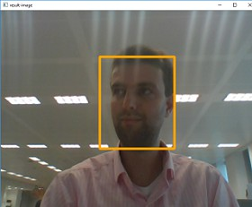

*Figure 1: An example of real-time face detection, highlighting the bounding box around a detected face.*

## Haar Cascades: Rapid Object Detection

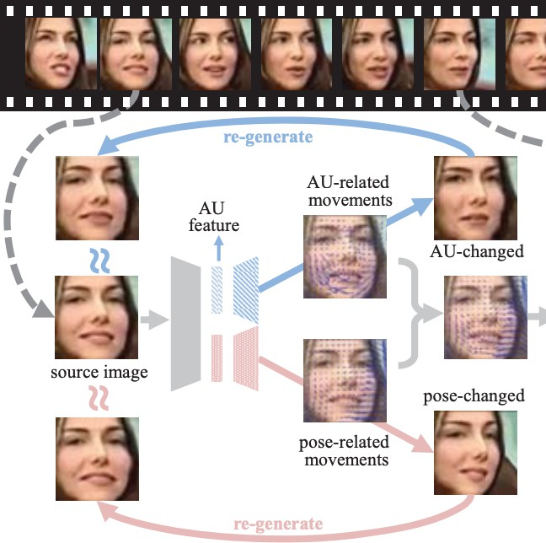

*Figure 2: Illustration of Haar-like features used in Haar Cascade classifiers for object detection.*

## DeepFace: Unlocking Facial Intelligence



*Figure 3: The DeepFace library logo, representing its role in facial analysis.*

## FaceNet: The Power of Embeddings

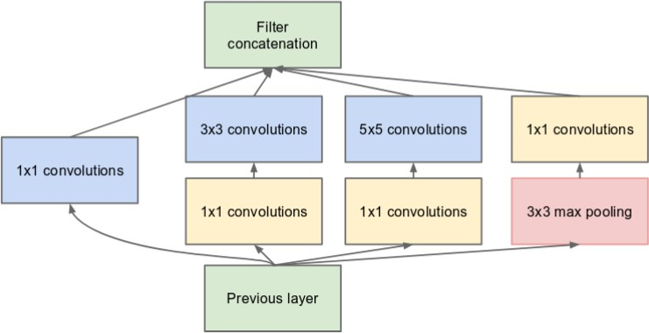

*Figure 4: A simplified representation of the FaceNet architecture, illustrating how face images are mapped to embeddings.*

# Real-World Applications and Impact

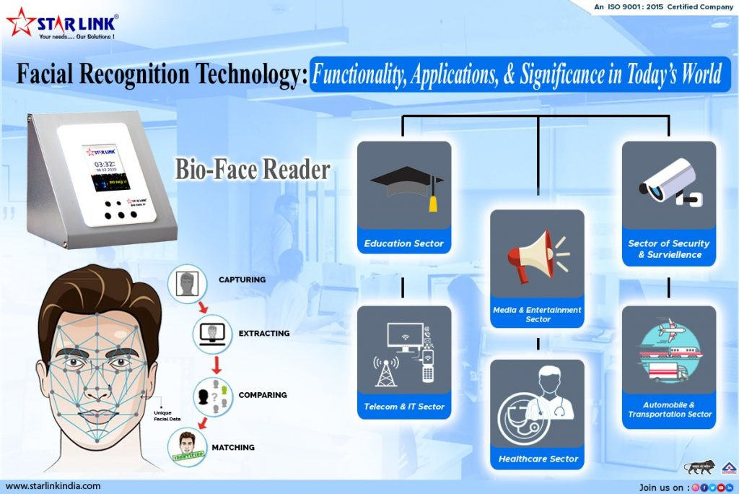

*Figure 5: Various real-world applications of facial recognition technology, from security to everyday convenience.*