**The output of the code:**

1: a = 0x7ffe6747c0f0, b = 0x55de01d1c260, c = 0xf0b5ff

2: a[0] = 200, a[1] = 101, a[2] = 102, a[3] = 103

3: a[0] = 200, a[1] = 300, a[2] = 301, a[3] = 302

4: a[0] = 200, a[1] = 400, a[2] = 301, a[3] = 302

5: a[0] = 200, a[1] = 128144, a[2] = 256, a[3] = 302

6: a = 0x7ffe6747c0f0, b = 0x7ffe6747c0f4, c = 0x7ffe6747c0f1

**Justifications and Memory:**

1: Justification: The printf statement prints the memory location that each pointer is pointing to through the “%p” identifier. Pointer (a) is pointing to a memory location in the stack, (b) is pointing to memory location in the heap, the value of (c) is garbage.

|  |  |  |
| --- | --- | --- |
| a = 0x7ffe6747c0f0 | b = 0x55de01d1c260 | c = 0xf0b5ff |

|  |  |
| --- | --- |
| Memory location | Value |
| a[0] | garbage |
| a[1] | garbage |
| a[2] | garbage |
| a[3] | garbage |

|  |  |
| --- | --- |
| Memory location | Value |
| b[0] | garbage |
| b[1] | garbage |
| b[2] | garbage |
| b[3] | garbage |

2: Justification: Before the for loop, the instruction (c = a) makes (c) and (a) point to the same memory location. The for loop initializes the elements of a[i] with 100 + i, so a[0] = 100, a[1] = 101, a[2] = 102, a[3] = 103. Then c[0] which is the same as a[0] is set to 200.

|  |  |  |
| --- | --- | --- |
| a = 0x7ffe6747c0f0 | b = 0x55de01d1c260 | c = 0x7ffe6747c0f0 |

|  |  |
| --- | --- |
| Memory location | Value |
| a[0] | 200 |
| a[1] | 101 |
| a[2] | 102 |
| a[3] | 103 |

|  |  |
| --- | --- |
| Memory location | Value |
| b[0] | garbage |
| b[1] | garbage |
| b[2] | garbage |
| b[3] | garbage |

3: Justification: c and a are pointing to the same memory location, so c[0] = 200, c[1] which is a[1] is set to 300.

*(c + 2) = c[2] = a[2] = 301. 3[c] = c[3] = a[3] = 302.

|  |  |  |
| --- | --- | --- |
| a = 0x7ffe6747c0f0 | b = 0x55de01d1c260 | c = 0x7ffe6747c0f0 |

|  |  |
| --- | --- |
| Memory location | Value |
| b[0] | garbage |
| b[1] | garbage |
| b[2] | garbage |
| b[3] | garbage |

|  |  |
| --- | --- |
| Memory location | Value |
| a[0] | 200 |
| a[1] | 300 |
| a[2] | 301 |
| a[3] | 302 |

4: Justification: The expression (c = c + 1) makes c points to a[1] (it advances the pointer by 4 bytes because the size of int is 4 bytes) which means that (c[0] = a[1]). The statement (*c = 400) sets a[1] to 400.

|  |  |  |
| --- | --- | --- |
| a = 0x7ffe6747c0f0 | b = 0x55de01d1c260 | c = 0x7ffe6747c0f4 |

|  |  |
| --- | --- |
| Memory location | Value |
| a[0] | 200 |
| a[1] | 400 |
| a[2] | 301 |
| a[3] | 302 |

|  |  |
| --- | --- |
| Memory location | Value |
| b[0] | garbage |
| b[1] | garbage |
| b[2] | garbage |
| b[3] | garbage |

5: Justification: The pointer (c) is casted to char* then it is advanced by 1 (which means it is advanced by only one byte because the size of char is one byte) so (c) now is pointing to the second byte of a[1], and then casting it to be int* which means that it is currently pointing to a four bytes int (second byte of a[1], third byte of a[1], fourth byte of a[1], first byte of a[2]). The initial memory diagram is shown in the following figure.

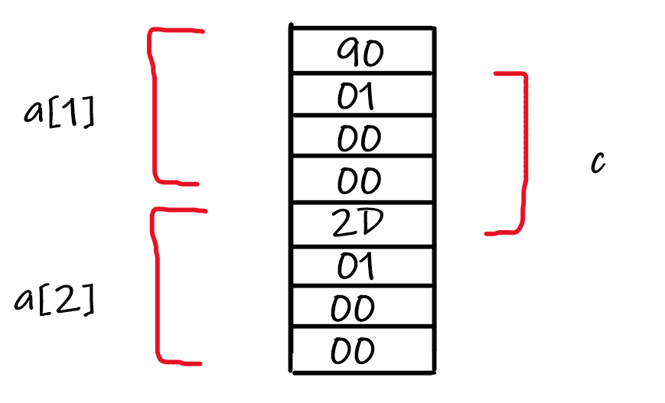

After executing the statement (*c = 500 = 0x000001F4), The memory diagram is shown in the following figure (note that the memory is little endian).

|  |  |  |
| --- | --- | --- |
| a = 0x7ffe6747c0f0 | b = 0x55de01d1c260 | c = 0x7ffe6747c0f5 |

|  |  |
| --- | --- |
| Memory location | Value |
| b[0] | garbage |
| b[1] | garbage |
| b[2] | garbage |
| b[3] | garbage |

|  |  |
| --- | --- |
| Memory location | Value |
| a[0] | 200 |
| a[1] | 128144 |
| a[2] | 256 |
| a[3] | 302 |

6: Justification: The address which (a) is pointing to is not changed so it is the same as the initial address. The statement “b = (int *) a + 1” causes pointer b to point four bytes after the pointer (a), so (b) is pointing to a[1]. The statement “c = (int *) ((char *) a + 1)” causes pointer (c) to point one byte after the pointer (a).

c[0] = 0x90000000 = -1879048192 (if it is signed int) = 2415919104 (if it is unsigned int).

|  |  |  |
| --- | --- | --- |
| a = 0x7ffe6747c0f0 | b = 0x7ffe6747c0f4 | c = 0x7ffe6747c0f1 |

|  |  |
| --- | --- |
| Memory location | Value |
| b[0] | 128144 |
| b[1] | 256 |
| b[2] | 302 |
| b[3] | garbage |

|  |  |
| --- | --- |
| Memory location | Value |
| a[0] | 200 |
| a[1] | 128144 |
| a[2] | 256 |
| a[3] | 302 |