**Micro-Processors Report Milestone 4**

in this milestone we started using Scatter and Gather rather than using send and receive, or broadcast

The main difference between using Scatter and Gather rather than send and receive or broadcast is that with gather we no longer have to manually assemble the pointers coming from every other process.

Moreover, we don’t have to use a for loop to receive from/send to all processes we still use broadcast or gather to receive from all processes

both Scatter and Gather can be used in the code,

Scatter to send to all processes the part of the weights that they need to work on,

Gather can be used when doing the dot product as concatenating the output array into an array of array for the input. However, we didn’t use scatter since the weights were already initialize for every process since sending the part of the matrix to be used then sending it would take more time than having it initialized at every process.

So, we used Gather in our implementation however we chose not to implement Scatter since the weights are already initialized.

Here’s 4 images showing the time difference for every implementation type.

Using Sequential algorithm: -

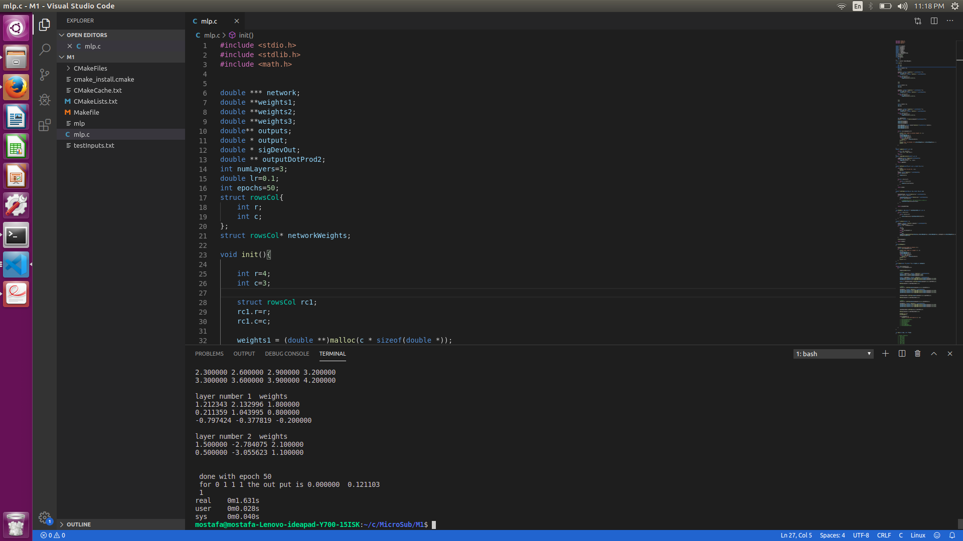

Using Send and receive: -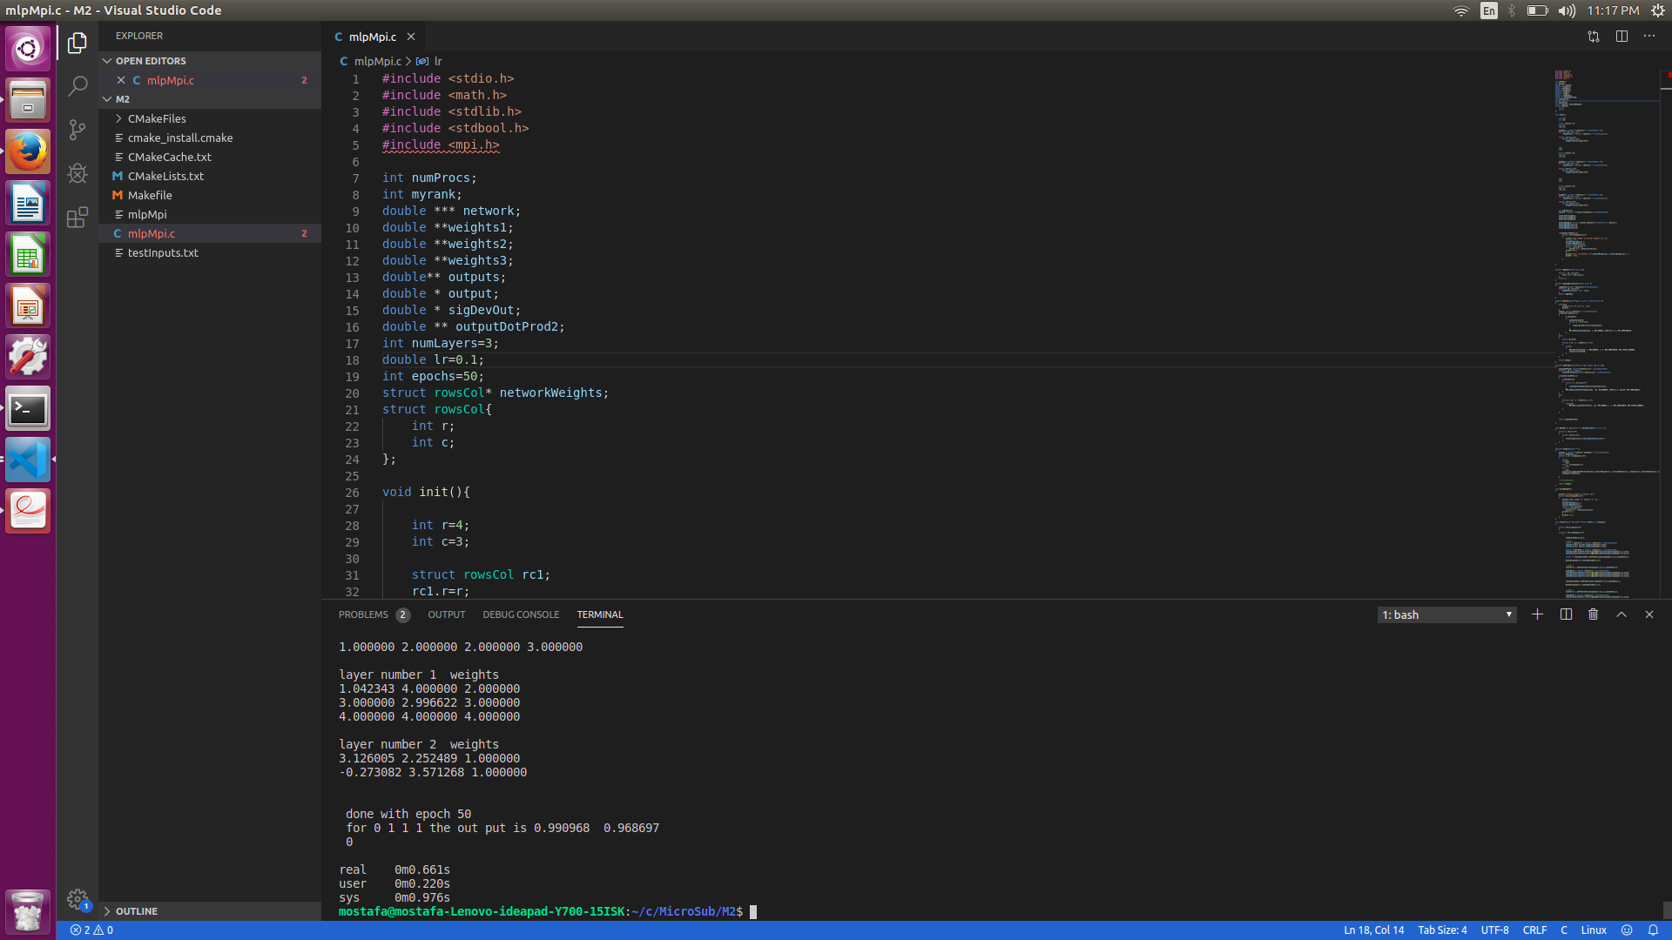

Using Bcast and Reduce: -

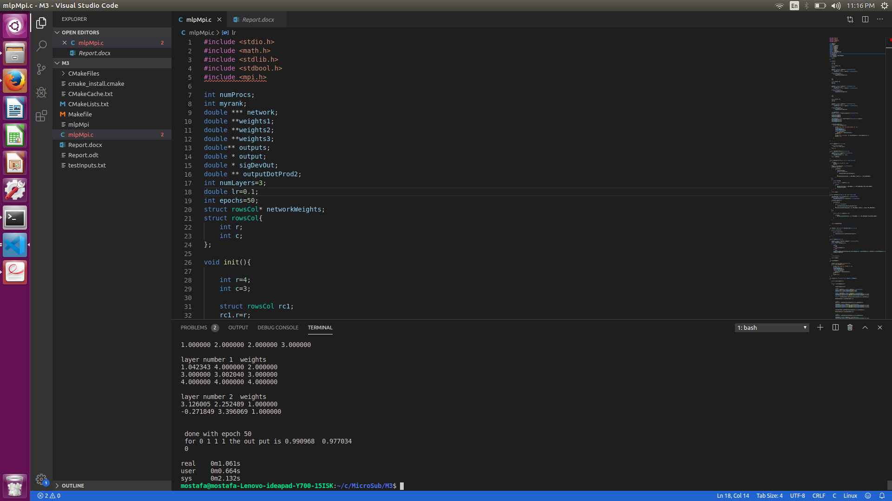

Finally Using Gather and Scatter: -