Day 01

*Assignment: Creating a very simple contact form*

It’s required to convert the existing HTML code in the resources folder to a dynamic php contact form.

The Form Features:

* Validating the name is submitted and less than 100 characters
* Validate the email is submitted and valid
* Validating the message is submitted and less than 255 characters
* If any of the validation process failed an error message should appear in the screen as the following

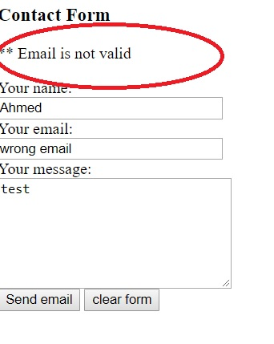

* If all validations passed correctly
* If All validations are passed correctly a thank you message should appear to the user such as “Thank you for contacting Us” in addition to listing all the data which have been submitted by the user

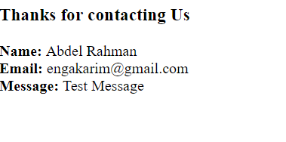

**Bonus Work**

* If the user add all fields yet one is wrong a validation message should appear but the for should remember the user’s other entries (even the wrong one) so he just correct his mistakes and not enter the whole thing again
* All Configurations such as max length and thank you message should be in a config file

Good Luck 😊