Day 02

*Assignment: Working with files*

It’s required to add the following features in contact form which was done yesterday

* If all validations passed correctly then before displaying the Thank you message please store the in a text log file in the following formats:

*Visit date, visit time, user ip address, user email (submitted in the form, user name (submitted in the form)*

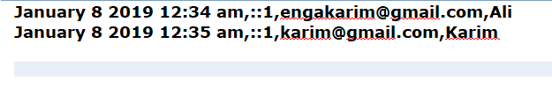

* Create an interface (another php file) for the log file that shows all the data stored in the log file as in the following image

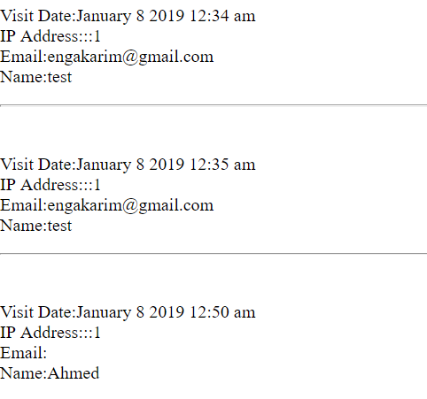

**Notes and Remarks:**

* All Configurations such as max length, log file paths,..etc should be in a config file
* The date formats for storing the visit time should be:  
   "F j Y g:i a" No Commas

Good Luck 😊