To begin, please note that the following information is based on personal diligence and may contain inaccuracies, missing details, or misunderstandings.
— Team Roben
Contents
What is a UAV? 1
How UAV Drive Itself? 3
What is Pixhawk? 3
How Does Pixhawk Work? 5
Which Pixhawk we use ? 5
UAV Parameters 6
Ground control station 6

Important links :
Custom firmware server
Orange cube firmware
MAVlink explained

What is a UAV?
A UAV (Unmanned Aerial Vehicle) or UAS (Unmanned Aerial System) is a semi- or fully automated drone that operates independently. UAVs have been utilized in various projects to address a range of issues.
Examples of Civilian Uses:
- Aerial Photography: Film, video, still images, etc.
- Agriculture: Crop monitoring and spraying; herd monitoring and management.
- Coastguard: Search and rescue operations; coastline and sea-lane monitoring.
- Conservation: Pollution and land monitoring.
- Customs and Excise: Surveillance for illegal imports.
- Electricity Companies: Powerline inspection.
- Fire Services and Forestry: Fire detection and incident control.
- Fisheries: Protection of fisheries.
- Gas and Oil Supply Companies: Land survey and pipeline security.
- Information Services: News information and pictures; feature images (e.g., wildlife).
- Lifeboat Institutions: Incident investigation, guidance, and control.
- Local Authorities: Surveying and disaster control.
- Meteorological Services: Sampling and atmospheric analysis for forecasting.
- Traffic Agencies: Monitoring and control of road traffic.
- Oil Companies: Pipeline security.
- Ordnance Survey: Aerial photography for mapping.
- Police Authorities: Search for missing persons; security and incident surveillance.
- Rivers Authorities: Water course and level monitoring; flood and pollution control.
- Survey Organizations: Geographical, geological, and archaeological surveys.
- Water Boards: Reservoir and pipeline monitoring.
Military Roles:
- Navy:
  - Shadowing enemy fleets.
  - Decoying missiles by emitting artificial signatures.
  - Electronic intelligence.
  - Relaying radio signals.
  - Protecting ports from offshore attacks.
  - Placement and monitoring of sonar buoys and other anti-submarine warfare measures.
- Army:
  - Reconnaissance.
  - Surveillance of enemy activity.
  - Monitoring of nuclear, biological, or chemical (NBC) contamination.
  - Electronic intelligence.
  - Target designation and monitoring.
  - Location and destruction of land mines.
- Air Force:
  - Long-range, high-altitude surveillance.
  - Radar system jamming and destruction.
  - Electronic intelligence.
  - Airfield base security.
  - Airfield damage assessment.
  - Elimination of unexploded bombs.

How UAV Drive Itself?

What is Pixhawk?
A UAV operates autonomously thanks to its onboard control system, often referred to as its "brain." This system controls every movement and mission the UAV performs.
If you've ever built an RC car that navigates a maze using an Arduino, you might have written code to read from sensors and control the motors based on those readings.
Now, imagine applying this concept to a UAV, which has more than four control surfaces moving simultaneously and over ten sensors providing data at the same time. Making decisions based on all these readings is quite complex.
To manage this, specialized devices called flight controllers are used. Flight controllers are designed specifically for aircraft and come with their own firmware (code) and an IMU unit (a collection of sensors). They function similarly to an Arduino but are more advanced and powerful.
We use a flight controller named Pixhawk. It is a versatile device that offers a variety of firmware options and supports numerous modules, such as GPS, LiDAR, and servos. These features enable us to build and customize an effective UAV.
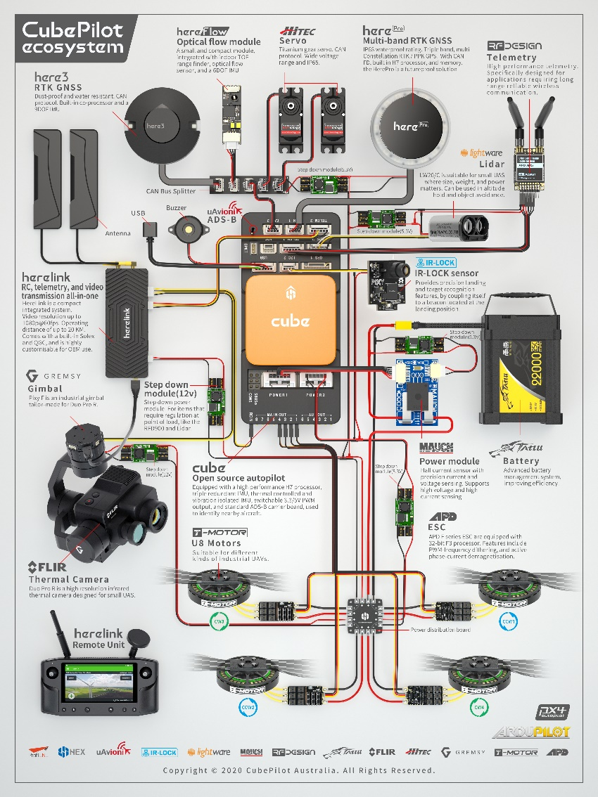

How Does Pixhawk Work?
- Sensors and Input: Pixhawk collects data from various sensors, including accelerometers, gyroscopes, magnetometers, and barometers. It also receives positional information from GPS modules for navigation and positioning.
- Processing: The flight controller processes this sensor data to determine the UAV’s orientation, altitude, and position. This involves sophisticated algorithms for stabilization, navigation, and control.
- Control Algorithms: Pixhawk employs control algorithms, such as PID (Proportional-Integral-Derivative) controllers, to adjust the UAV’s actuators (motors, servos) to maintain stable flight and adhere to a planned trajectory.
- Mission Planning and Autonomy: It can execute pre-planned missions using waypoints and other parameters. Mission planning software (e.g., Mission Planner or QGroundControl) communicates with Pixhawk to set flight paths, actions, and mission details.
- Communication: Pixhawk communicates with ground control stations and other peripherals using various protocols (e.g., MAVLink). It transmits telemetry data and receives commands or updates.
- Actuation: Based on processed data and control algorithms, Pixhawk sends commands to the UAV’s actuators to adjust flight controls, such as motor speeds for stability and directional changes.
- Failsafe and Safety: It includes safety features, such as failsafe mechanisms, to handle situations like loss of signal or critical system failures. This ensures the UAV can safely land or return home if necessary.

Which Pixhawk we use ?
In our setup, we use two Pixhawk flight controllers: the Pixhawk 2.4.8, which is commonly used, and the Orange Cube. When you purchase a Pixhawk, it initially comes without firmware. You need to choose the firmware based on the type of aircraft you are building. For instructions on how to install firmware, refer to the document: Loading Firmware onto Pixhawk. After selecting the appropriate firmware, connect the necessary modules to the Pixhawk and verify their functionality. Below are the parameters for our components:

Firmware
There is a lot of firmware in the industry of UAS the most common are px4 and ardupilot
So what specifically is firmware .
Firmware is a specialized type of software that is embedded directly into hardware devices to control their operations. It acts as the intermediary between the hardware and higher-level software, providing low-level control over the device's functions. Firmware is typically stored in non-volatile memory, such as ROM (Read-Only Memory), EPROM (Erasable Programmable Read-Only Memory), or flash memory, so it persists even when the device is powered off.
Here are some key characteristics of firmware:
- Low-Level Control: Firmware provides the essential instructions needed for a device to function. For example, it might control how a microcontroller in a drone processes signals from sensors, operates motors, or manages communication.
- Device-Specific: Unlike general software that can run on multiple platforms (like apps on a computer), firmware is usually written for specific hardware and designed to optimize the performance of that particular device.
- Examples of Devices with Firmware:
  - Drones: The firmware controls flight dynamics, sensor integration, and communications.
  - Routers: Firmware governs data transmission and network management.
  - Smartphones: Firmware handles booting processes, connectivity features, and hardware integration (like cameras and sensors).
  - Embedded Systems: Devices like washing machines, printers, and microwaves all rely on firmware to execute their functions.
- Updates: Firmware can sometimes be updated by the user to add new features, fix bugs, or improve performance. However, updating firmware usually requires caution, as improper updates can render a device inoperable ("bricked").
- Interaction with Other Software: Firmware works alongside higher-level software such as operating systems and applications, providing the fundamental commands for the device to operate correctly.
In the context of drones like those using ArduPilot, the firmware handles core functions like flight stabilization, sensor data processing, and mission execution.
ArduPilot firmware is the core software that runs on supported flight controllers (like Pixhawk, Cube, etc.) and is responsible for managing the autonomous control and behavior of drones, rovers, boats, planes, and other unmanned vehicles. It is part of the larger ArduPilot project, which is an open-source autopilot system used widely across various types of autonomous vehicles.
Key Aspects of ArduPilot Firmware:
- Types of Firmware:
  - ArduCopter: Firmware for multirotor vehicles (quadcopters, hexacopters, etc.).
  - ArduPlane: Firmware for fixed-wing aircraft.
  - ArduRover: Firmware for ground-based vehicles (cars, rovers, etc.).
  - ArduSub: Firmware for underwater vehicles (submarines, underwater drones).
  - ArduBoat: Firmware for watercraft, such as autonomous boats.
- Features:
  - Autonomous Navigation: Provides waypoint navigation and mission execution capabilities, allowing the vehicle to autonomously follow pre-defined routes using GPS waypoints.
  - Flight Stabilization: Ensures stable flight or movement by processing data from IMUs (Inertial Measurement Units), gyroscopes, and accelerometers.
  - Fail-Safe Mechanisms: Includes critical safety features like Return to Launch (RTL), low-battery detection, and signal loss handling.
  - Sensor Integration: Supports a wide range of sensors (GPS, LiDAR, cameras, barometers, etc.) for tasks like obstacle avoidance, altitude hold, and precise landing.
  - Telemetry: Enables real-time monitoring and control of the vehicle’s status through ground control software like Mission Planner or QGroundControl.
  - Customizable Parameters: Users can modify various flight parameters to adjust behavior for different types of missions (e.g., changing flight modes, tuning control loops, setting sensor thresholds).
- Hardware Compatibility: ArduPilot firmware is compatible with a variety of flight controllers, including:
  - Pixhawk series
  - Orange Cube
  - Pixhawk 2.4.8
  - BeagleBone
  - Various STM32-based controllers
  - ArduPilot firmware abstracts the hardware, so as long as the controller meets the basic requirements, it can run the firmware.
- Real-Time Operation: The firmware runs in real-time, meaning it processes sensor data and controls the vehicle’s motors and other actuators in real-time to ensure smooth and responsive operation.
- Open-Source and Customization: As open-source firmware, ArduPilot can be customized for specific needs. Developers can modify the source code to implement new features, adapt the firmware for custom vehicles, or integrate it with new sensors or systems.
- Modes of Operation:
  - ArduPilot firmware supports various modes that change how the vehicle behaves:
    - Manual Mode: The user has full control over the vehicle.
    - Auto Mode: The vehicle follows pre-programmed missions autonomously.
    - Stabilize Mode: Provides manual control with automatic stabilization.
    - Loiter Mode: Keeps the vehicle in a fixed position.
    - RTL (Return to Launch): Automatically returns the vehicle to the takeoff point.

File Types
Within the build directories you will find files of the following types:
- *.apj files: these are “ArduPilot JSON” firmwares, which contain a firmware that can be loaded by ArduPilot compatible ground station software
- *.px4 files: these are an older name for an apj file, and use the same format
- *.hex files: these are firmwares in Intel hex format, for loading with DFU loading tools. These are used for boards which don’t come with an ArduPilot compatible bootloader
- *_with_bl.hex files: these are variants of the hex files with the bootloader built-in. They can be used to install both the bootloader and ArduPilot vehicle firmware in one step using a DFU loading tool

Orange cube characteristics
Servo rail high-power (7 V) and high-current ready

The Cube connector pin assignments
TELEM1, TELEM2 ports
Pin | Signal | Volt
1 (red) | VCC | +5V
2 (blk) | TX (OUT) | +3.3V
3 (blk) | RX (IN) | +3.3V
4 (blk) | CTS | +3.3V
5 (blk) | RTS | +3.3V
6 (blk) | GND | GND
GPS1 port
Pin | Signal | Volt
1 (red) | VCC | +5V
2 (blk) | TX (OUT) | +3.3V
3 (blk) | RX (IN) | +3.3V
4 (blk) | SCL I2C2 | +3.3V
5 (blk) | SDA I2C2 | +3.3V
6 (blk) | Button | GND
7 (blk) | button LED | GND
8 (blk) | GND | GND

GPS2 port
Pin | Signal | Volt
1 (red) | VCC | +5V
2 (blk) | TX (OUT) | +3.3V
3 (blk) | RX (IN) | +3.3V
4 (blk) | SCL I2C1 | +3.3V
5 (blk) | SDA I2C1 | +3.3V
6 (blk) | GND | GND
ADC
Pin | Signal | Volt
1 (red) | VCC | +5V
2 (blk) | ADC IN | 6.6Vmax,pin 8
3 (blk) | GND | GND
I2C2
Pin | Signal | Volt
1 (red) | VCC | +5V
2 (blk) | SCL | +3.3 (pullups)
3 (blk) | SDA | +3.3 (pullups)
4 (blk) | GND | GND
CAN1&2
Pin | Signal | Volt
1 (red) | VCC | +5V
2 (blk) | CAN_H | +12V
3 (blk) | CAN_L | +12V
4 (blk) | GND | GND
POWER1
Pin | Signal | Volt
1 (red) | VCC | +5V
2 (red) | VCC | +5V
3 (blk) | CURRENT | up to +3.3V,pin 15
4 (blk) | VOLTAGE | up to +3.3V,pin 14
5 (blk) | GND | GND
6 (blk) | GND | GND
POWER2
Pin | Signal | Volt
1 (red) | VCC | +5V
2 (red) | VCC | +5V
3 (blk) | CURRENT | up to +3.3V,pin 4
4 (blk) | VOLTAGE | up to +3.3V,pin 13
5 (blk) | GND | GND
6 (blk) | GND | GND
USB
Pin | Signal | Volt
1 (red) | VCC | +5V
2 (blk) | D_plus | +3.3V
3 (blk) | D_minus | +3.3V
4 (blk) | GND | GND
5 (blk) | BUZZER | battery voltage
6 (blk) | Boot/Error LED

UAV Parameters
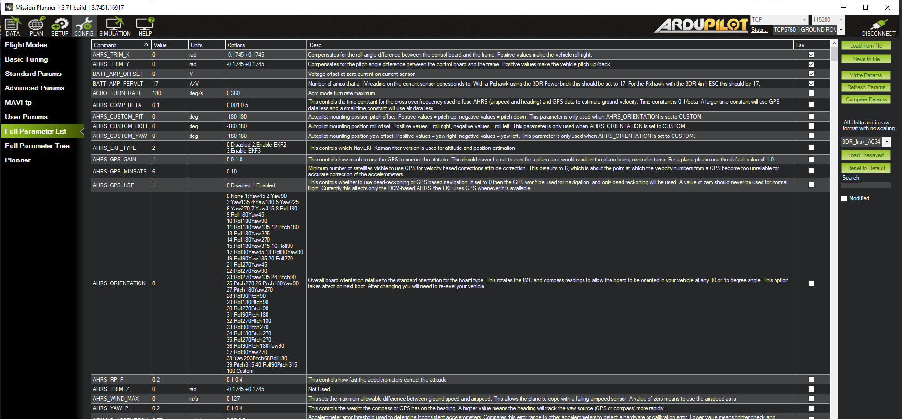
What are the parameters in Pixhawk?
The parameters are the values you set for the controller to operate as you prefer, similar to adjusting game settings to enhance your gameplay experience. For instance, if you find the camera in a Valorant game moves too fast, you would go to the options and decrease the camera speed to play better. Similarly, the plane has options not only to control itself but also to manage the devices connected to it.

Pid tunning
If you Have bought new car and in the drive test the instructor ask you to drive for 500 meter
You will drive but of course you are not going to drive the 500
You maybe drive 600 or 700 or maybe 300 or 400 but of course as you don’t drive a lot you are not going to do it exactly
So you will repeat the test many times until you can correctly identify the distance you drive and you have achievd

communication

Ground control station
So, of course, you may ask yourself how to change these parameters, not just that, but also how to interact with this device called Pixhawk. The easiest way is through software GCS (Ground Control Station) like Mission Planner or QGroundControl.
- Connect Pixhawk to a Computer:
  - Use a USB Type-A to Micro USB cable to connect your Pixhawk to your laptop or computer.
  - Open Mission Planner or QGroundControl.
- Identify the Pixhawk Port:
  - In the software, you’ll find a dropdown menu listing possible connection ports.
  - If you're unsure which port corresponds to your Pixhawk, try this:
    - Unplug the Pixhawk. The number of available ports in the dropdown menu should decrease by one.
    - Reconnect the Pixhawk. The number of ports should increase by one, revealing the correct port.
    - 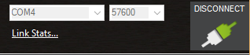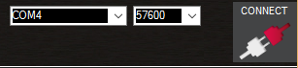
- Access the Parameter List:
  - Navigate to the "Full Parameter List" in the GCS software.
  - Here, you'll find all the parameters related to the firmware installed on your Pixhawk, which you can modify as needed.
2. Using MAVProxy on a Microcomputer
If you're connecting the Pixhawk to a microcomputer like a Raspberry Pi or a Jetson Nano, you'll likely use MAVProxy, a command-line-based GCS. MAVProxy allows you to adjust every parameter on the Pixhawk, similar to the GUI-based GCS tools but via the terminal.
- Set Up Serial Communication:
  - Connect the Pixhawk to the microcomputer using the same USB Type-A to Micro USB cable.
- Install and Run MAVProxy:
  - Install MAVProxy on your microcomputer if you haven't already.
  - Use the terminal to start MAVProxy and establish a connection with the Pixhawk.
- Adjust Parameters:
  - Once connected, you can use various MAVProxy commands to interact with and modify the Pixhawk's parameters directly from the terminal.

In this GCS, you can navigate the world map and create the mission you want to execute. You can also create a geofence to prevent the plane from flying into restricted areas, arm or disarm the vehicle, and start or abort missions.

Mavlink
So what is mavlink?
MAVlink stands for micro air vehicle link . is is specific messages set to communicate with the unmanned systems and ground station

