Responses to Reviewer Comments for: FPE-D-18-00726

**Coexistence Calculation Using the Isothermal-Isochoric Integration Method**

S. Mostafa Razavi, Richard A. Messerly, J. Richard Elliott

Dear Ioannis,

Thanks for your extension of the time for us to respond to reviewers’ comments. They were more extensive than expected and some of them required further simulations to prove the points. The reviewers’ raised a number of valid points and we thank them for their thoroughness. I am never quite sure how much detail of the classical thermodynamics to include in a paper like this. Mostafa dealt with a number of these issues in his thesis but his previous analyses were based on flexible bonds whereas we have now reached the conclusion that rigid bonds are to be preferred. Therefore, we needed to reconstruct a lot of simulations in order to present a consistent perspective throughout this manuscript. We still feel that some of these details may be distracting for readers, so we added a few of them to the Supplementary Material, while moving a few into the main text that were in supporting information previously. At least one reviewer mentioned that they could not find the supporting information file, so I hope more detailed instructions can be provided to ensure that all reviewers have access to all the necessary files. If we have erred again and placed too much information in the Supplementary Material, please advise. It will be a simple matter to move whatever is wanted into the main text.

J. Richard Elliott

**Response to Reviewer #1**

**General**

This paper presents a new procedure to compute coexistence curves based on the integrating isothermal and isochoric paths. In addition to the undeniable technical merit, I especially like the fact that the presentation begins with the overall description of the method, followed by a discussion of its many details. This facilitates the reading, while providing enough information to a reader who might be interested in implementing the method. The comparisons with results from other methods show that the proposed procedure works as intended. I am definitely in favor of this paper's publication but I do have a few minor issues, as follows:

We appreciate that the reviewer is in favor of this manuscript being published with only minor revisions.

**Comment #1**

Section 2.4 contains the sentence: "In order to reach the densities of interest and maintain an acceptable accuracy of VLE data to a reduced temperature of 0.45, one needs at least 9 data points on the isotherm and three data points on the isochore for each saturation point." In this and other points of the manuscript, there is not a clear statement of "acceptable accuracy" (or similar terms) means? What are the tolerances used in different parts of the procedure?

We agree that this sentence is ambiguous. We modified this sentence to:

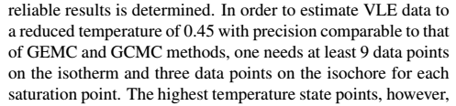

**Comment 2#**

Integrations along the isotherm and isochores are performed using Simpson's rule: what stops you from using, say, Gaussian quadrature, which should be more accurate for the same number of sampled points?

We use Simpson's rule mostly due to its simplicity. It is also important to the method that a fixed step size be used for the integration so that simulations can be re-used for different isochores. Gaussian quadrature varies the density states depending on the range of integration. We clarified this in the second paragraph of Section 2.4

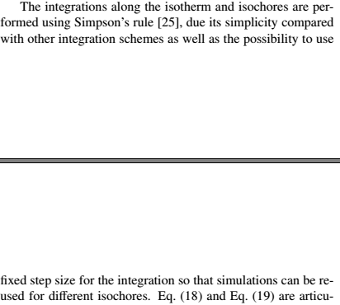

**Comment 3#**

Why use fixed-point iterations to solve equation (14)? Why not some quasi-Newton iteration, which should be potentially faster?

We would like to point out that speed of fixed-point iteration is not necessarily a deciding factor because these iterations do not require additional simulations. We mainly chose fixed-point iterations for simplicity. We now modified the sentence after Equation 14 to:

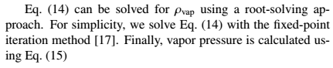

**Comment 4#**

Elsevier journals provide a lot of flexibility for references in manuscripts but there is a mix of capitalization or not in paper and journal titles that may lead to mistakes in the final version. I suggest a full review of the references. For example, I call attention to reference [23], in which GPU, Gibbs, Monte Carlo, and Lennard-Jonesium are not capitalized.

We thank the reviewer for thorough review of the references. We fixed reference 23 and modified several references to improve their consistency.

**Comment 5#**

Right after Eq. (1), it should be "… where G represents the molar Gibbs free energy, …".

We now use molar in the mentioned sentence.

**Comment 6#**

There is a missing "." at the end of the first paragraph of subsection 3.3.

We have fixed this problem.

**Comment 7#**

In the first line of the second paragraph of subsection 3.3, it should be "… method does not …"

We appreciate the reviewer pointing out this issue. We now fixed this issue.

As mentioned, these are minor points. I recommendation publication after the authors address them.

We appreciate that the reviewer recommends publication of the revised manuscript.

**Response to Reviewer #2**

**General Comments**

This manuscript proposes a new integration method for solving liquid vapor coexistence of a pure compound along a continuous path of monophasic fluid states circumventing the critical point. The method makes use of isochoric integration in the liquid state from the initial estimate to a supercritical temperature, then an isothermal expansion from liquid to vapor state and finally an isochoric temperature decrease down to the saturated vapor. An iterative loop on the investigated temperature is implemented to satisfy the requirements of phase coexistence. The method makes a combined use of molecular simulations, equations of state based on system-specific truncated viral expansions, and empirical formulae for critical pressure and acentric factor. Application examples on methane, ethane, isobutane , isohexane, dodecane, and water are presented in good agreement with earlier results from the literature.

The data shown do not allow a complete assessment of the manuscript (the Supplementary Information file mentioned by the authors was not available for this review). Information is indeed lacking about initialization of saturation temperature in the examples investigated. The origin of the equation used for updating the departure of free energy (eq. 17) when iterating on temperature is unclear. It does not seem consistent with the fundamental equation (6). It is unsatisfactory that increasing systematic deviations are observed when initial temperature estimate (Figure 7). As the purpose of the article is the method, it is necessary that for each coexistence state point computed with the ITIC method, the initial conditions (liquid density and temperature) are provided. It is also necessary that the article documents not only the iteration steps on vapor density as in figure 5, but also the iteration steps on temperature. When the coexistence curve is unknown (e.g. new compounds), the computational load required by the ITIC method is probably underestimated by the authors as they do not seem to account for the temperature loop.

Another important concern about the proposed method is its heterogeneity. At times the integration is using NIST Refprop properties to perform integration (e.g. n-dodecane in Figure 3) while in other cases a forcefield (TraPPE-UA, Mie, TIP4P-2005) is used. Some properties are obtained by simulation (energy changes along liquid isochore and supercritical isotherm) but others are obtained from a virial equation truncated to the second or third order. The critical pressure and the acentric factor are fitted (equations 27 and 28) without applying the definition of the acentric factor, but an empirical correlation developed by Lee-Kesler. It is also likely that gas pressure is evaluated with different routes in MC (molecular virial route) and in MD with flexible bonds (atomic virial). Unfortunately the authors do not document this point, which is needed to assess convergence problems in the low density limit (Figure 9).

The proposed method does not involve transfer moves and this is a significant advantage over of the Gibbs ensemble Monte Carlo (GEMC) which is delicate to code and display low acceptance rates at low temperature. However, the application range of the proposed method is rather narrow : Tr=0.45 to Tr=0.8. The performance in near critical conditions (Tr=0.8 to Tr=1) appears uncertain, because the virial-based expansions are approximate in high density vapor. As a consequence, obtaining critical coordinates by near-critical scaling is subject to important uncertainties. Application to reduced temperatures lower than 0.45 is neither considered, the main reason being probably the limitations of the packing software , Packmol, to produce liquid configurations at the desired density without molecular overlaps. It is unacceptable that the authors compare their method with GEMC only or GCMC only. This referee is aware of numerous published studies showing that GEMC + TI cover a larger range of coexistence conditions (Tr=0.3 to 0.95) as needed in applications. The citation of Ahunbay et al (2004) by the authors is just one of these articles. A more appropriate reference would be the earlier article of the same team (Ungerer et al, JCP 2000) in which ethane and dodecane are considered, two compounds studied in the proposed manuscript.

For these reasons, the manuscript requires significant additional checks and modifications along the points listed below, before publication can be considered.

**Responses to General Comments**

> The data shown do not allow a complete assessment of the manuscript (the Supplementary Information file mentioned by the authors was not available for this review).

The Supplementary Information was provided as a link in the generated PDF file. We made sure that this time the reviewers have access to Supplementary Material.

> Information is indeed lacking about initialization of saturation temperature in the examples investigated.

We used the DIPPR database to get initial estimates of *Tsat.* Tables 1-10 in Supplementary Material contain the temperatures and densities of NVT simulations, as well as the simulation results. The following sentence was added to the Example Simulation section to clarify the Tsat initializations:

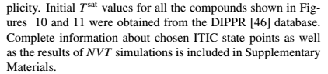

> The origin of the equation used for updating the departure of free energy (eq. 17) when iterating on temperature is unclear. It does not seem consistent with the fundamental equation (6).

Discussed below in “detailed comments.”

> It is unsatisfactory that increasing systematic deviations are observed when initial temperature estimate (Figure 7).

According to Figure 7 even 10 % error in the *Tsat* initial guess causes only 0.1-0.4 % deviation in Psat and 0.2-0.4 % deviation in rhoL. Most force fields provide an accurate representation of Tsat. For example, TraPPE-UA and Mie-UA force fields that are used in this study, predict rhoL with less than 1 % deviation from experimental data. Therefore, in this study experimental data is used to estimate the initial Tsat values. For compounds for which experimental Tsat vs. rhoL data is not available, accurate estimation of *Tsat* is possible at each density by using a linear interpolating or extrapolating of compressibility factor vs reciprocal temperature. An example of such situation was added to the Example Simulations section.

> As the purpose of the article is the method, it is necessary that for each coexistence state point computed with the ITIC method, the initial conditions (liquid density and temperature) are provided.

The initial conditions are now provided in Supplementary Material.

> It is also necessary that the article documents not only the iteration steps on vapor density as in figure 5, but also the iteration steps on temperature. When the coexistence curve is unknown (e.g. new compounds), the computational load required by the ITIC method is probably underestimated by the authors as they do not seem to account for the temperature loop.

Using Tsat instead of rhoV as the stopping criterion resulted similar convergence behavior and computational load. It should be noted that iterations of Tsat do not require further simulations because the isochoric integration can be performed with interpolated values of the compressibility factor, noting the smooth behavior of Z vs. 1/T. We clarify that these iterations do not require additional simulations in the second and last paragraph of Section 2.3.

> Another important concern about the proposed method is its heterogeneity. At times the integration is using NIST Refprop properties to perform integration (e.g. n-dodecane in Figure 3) while in other cases a force field (TraPPE-UA, Mie, TIP4P-2005) is used. Some properties are obtained by simulation (energy changes along liquid isochore and supercritical isotherm) but others are obtained from a virial equation truncated to the second or third order.

We agree that this study incorporates different types of data (simulation, experimental, virial coefficient, etc.), however, the ITIC method itself relies only on simulation data. We do use DIPPR data to initialize Tsat, but in the absence of such database, those initial Tsat values can come from simple inter- or extrapolation of two points on isochore (Z vs. 1/T). In Example Simulations section, we have added a case study for an unfamiliar molecule where no experimental data are available. We used REFPROP data only to validate the ITIC method and discuss its sensitivities.

> The critical pressure and the acentric factor are fitted (equations 27 and 28) without applying the definition of the acentric factor, but an empirical correlation developed by Lee-Kesler.

Discussed below in “detailed comments.”

> It is also likely that gas pressure is evaluated with different routes in MC (molecular virial route) and in MD with flexible bonds (atomic virial). Unfortunately the authors do not document this point, which is needed to assess convergence problems in the low density limit (Figure 9).

Discussed below in “detailed comments.”

> The proposed method does not involve transfer moves and this is a significant advantage over of the Gibbs ensemble Monte Carlo (GEMC) which is delicate to code and display low acceptance rates at low temperature. However, the application range of the proposed method is rather narrow : Tr=0.45 to Tr=0.8. The performance in near critical conditions (Tr=0.8 to Tr=1) appears uncertain, because the virial-based expansions are approximate in high density vapor. As a consequence, obtaining critical coordinates by near-critical scaling is subject to important uncertainties.

In the absence of B3, calculating critical properties in ITIC method is indeed subject to important uncertainties. We now modified the following paragraph in the Section 7 (Example Simulations)

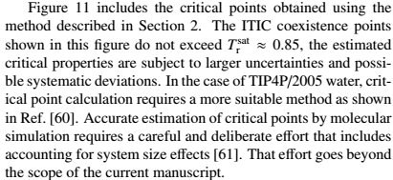

> Application to reduced temperatures lower than 0.45 is neither considered, the main reason being probably the limitations of the packing software, Packmol, to produce liquid configurations at the desired density without molecular overlaps.

Discussed below in “detailed comments.”

> It is unacceptable that the authors compare their method with GEMC only or GCMC only. This referee is aware of numerous published studies showing that GEMC + TI cover a larger range of coexistence conditions (Tr=0.3 to 0.95) as needed in applications. The citation of Ahunbay et al (2004) by the authors is just one of these articles. A more appropriate reference would be the earlier article of the same team (Ungerer et al, JCP 2000) in which ethane and dodecane are considered, two compounds studied in the proposed manuscript.

Discussed below in “detailed comments.”

**Responses to Detailed Comments of Reviewer 2:**

**Section I. Introduction**

> 1.1 There is no reason that coexistence calculations must extend to a reduced temperature of 0.45 only. The industrial needs extend over the whole liquid-vapor coexistence curve down to the triple point and this may be down to Tr=0.30 for many compounds (eg isooctane, toluene, heavy iso-alkanes,… ). The Peng-Robinson EOS loses accuracy between Tr=0.3 and Tr=0.45. The current text is misleading. The text must indicate that prediction methods are required down to Tr=0.3 and that the PR EOS is not accurate in the range Tr=0.3 to 0.45.

We modified the text to emphasize that the reduced triple point temperature may go as low as 0.3 in some cases.

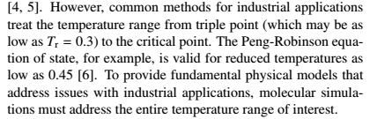

> 1.2 The authors state about Gibbs-Duhem integration implemented by Ahunbay et al. [FPE, 2004, vol 224, page 73] that it does not predict vapor density. This statement is untrue, as vapor density is always an output of GEMC calculations above the normal boiling point. Below the normal boiling point, the GEMC +TI method considers that vapor density can be approximated by the ideal gas law. If a more accurate vapor density is desired, NPT simulation of the vapor phase may also provide vapor density a posteriori, using saturation pressures obtained by TI. The text must acknowledge that GEMC + TI allows computation of vapor density.

We changed the text to avoid this confusion:

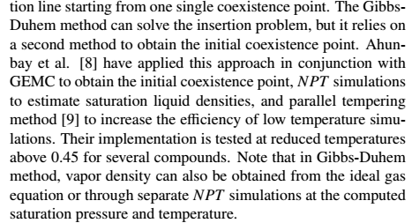

> 1.3 The citation of Ahunbay et al (2004) by the authors is just one of the numerous articles applying the GEMC +TI method. A more appropriate reference would be the earlier article of the same team (Ungerer et al, JCP, 112, (2000), 5499) in which ethane and dodecane are considered, two compounds studied in the proposed manuscript. The text must acknowledge that GEMC + thermodynamic integration has been applied to the prediction of coexistence of large alkanes (eg dodecane) in a large range of conditions (Tr= 0.45 to Tr=0.9) using several forcefields (including TraPPE-UA).

We thank the reviewer for the Ungerer2000 reference. This paper does have TraPPE-UA dodecane, but it does not have TraPPE-UA ethane. We now included TraPPE-UA dodecane data from Ungerer2000 to Figure 10 (unfilled black triangles). Reasonable agreement between ITIC and GEMC+TI is observed in Figure 10.

**Section II - Integration method**

> 2.1 Figure 1 is drawn as if the coexistence curve is already known, i.e. a case when most of the problem is solved. This is not the general case as the proposed method includes an iterative process to find the saturation temperature. The figure must be modified to show the general case when the initial estimate of the saturation temperature is different from the effective saturation temperature.

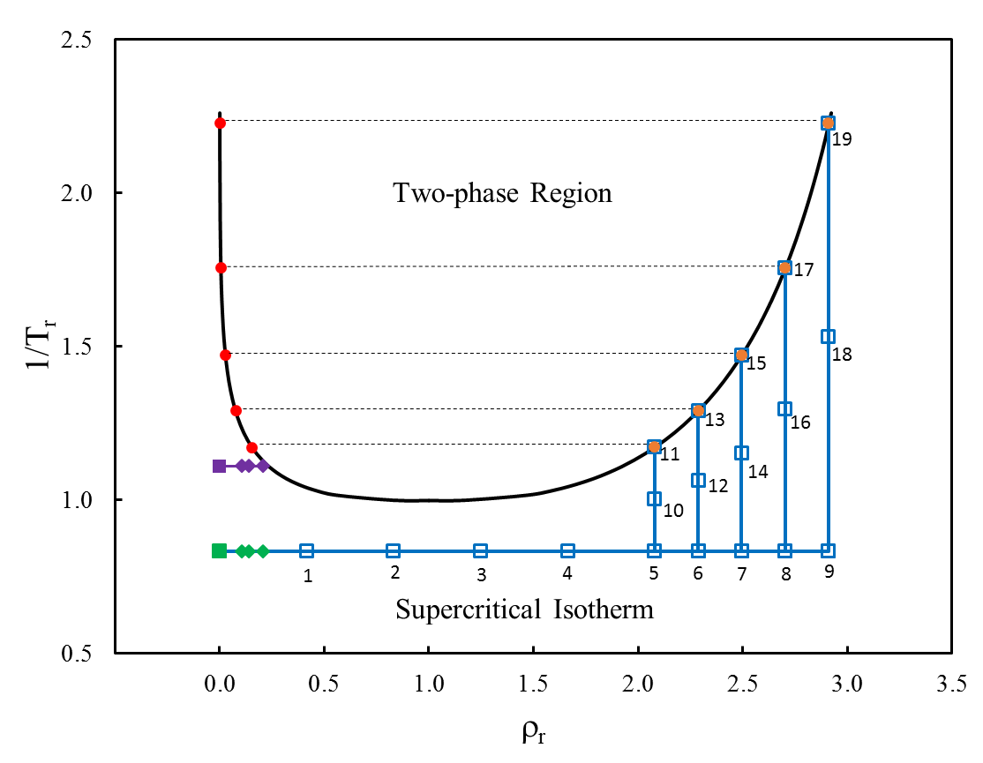

The purpose of this figure is to schematically show the location of ITIC points relative to the coexistence curve. The reviewer is correct that the saturation temperature is not known a priori and, therefore, the simulation temperature is not identical to the actual coexistence temperature. To clarify this point, the caption now reads, “points 11, 13, 15, 17, and 19 correspond to the initial Tsat estimate, i.e., Tsat_est. To further clarify this, we have added to the Example Simulation section, a new case study for a rare aromatic molecule for which no experimental information is available.

> 2.2 In equation 8, the variable Aig is the free energy of the ideal gas state. The text must specify that Aig is defined in the same temperature and volume conditions as the liquid. It is thus an imaginary state.

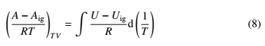We added the subscript TV to the left hand side of Eq(8)

> 2.3 The origin of the equation (17) used for updating the departure of free energy when iterating on temperature is unclear. Equation (17) does not seem consistent with the fundamental equation (6). The authors must check or correct the derivation of this equation. If Equation (17) is corrected, the authors must redo a significant fraction of their coexistence calculations and investigate whether the behavior of Figure 7 is still observed.

Eq. 17 is using trapezoid rule to integrate UdepT vs. 1/T (i.e. (U-Uig)/R vs. 1/T) according to Eq. 8 and calculate Adep at the new Tsat. Since UdepT vs. 1/T is linear (See Fig 1-10 in Supplementary Material) within proximity of Tsat, using trapezoid rule results in good approximation of Adep. This explanation is now included before Eq.(17).

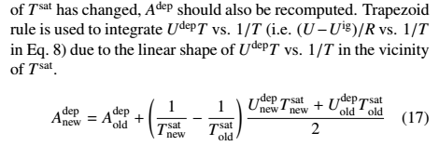

> 2.5 Equations 27 and 28 may not be consistent with the fundamental definition of the acentric factor from the force field considered ; the parameters of equation 28 have been derived by Lee and Kesler based on a compilation of experimental data about different fluids comprising light n-alkanes. The authors must recall the usual definition of the acentric factor and explain that equations 27-28 are an approximation that may not be relevant for every compound.

We admit that predicting Pc with the Lee-Kesler equation is not common in simulation studies. The standard approach, for practically any system, is to fit simulation data to the Antoine equation. For example, even Pc for TIP4P/2005 is well represented with the Antoine equation (J. Chem. Phys. 125, 034503 (2006); doi: 10.1063/1.2215612). For this reason, we reprocessed all of the ITIC data using the more traditional Antoine equation approach. Interestingly, we found that the Antoine Pc values were statistically indistinguishable from their Lee-Kesler counterparts for the systems studied here, with the exception of TIP4P/2005.

Figure 10 has been updated with the Antoine Pc values while Equations 27 and 28 have been replaced by the Antoine equation. This section also includes the following recommendation for computing critical constants with ITIC.

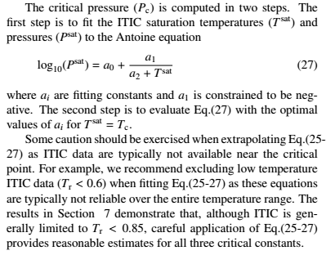

**Section III - ITIC validation**

> 3.1 In the case of n-dodecane illustrated by Figures 3 , 4 and 5, the manuscript must provide the initial estimates of the saturation temperature for the state points considered.

Testsat values are now listed in Supplementary material (Table XXI and XXII)

> 3.2 In Figure 4, the saturation temperature seems identical for the two series (2nd order virial and 3d order virial). However very different solutions are found for vapor density and vaporization enthalpy. In other words there is a satisfactory convergence of saturation temperature in both series while vapor density and vaporization enthalpy diverge for the 2nd order virial series. Is there an explanation to this behavior ? The authors must indicate the iterative sequence of saturation temperature followed in both series.

As mentioned in paragraph 2 of Section 2.3, Tsat is determined by extrapolating or interpolating Z along the isochore, so it is fairly insensitive of the virial coefficients. The only impact the virials have on Tsat is the value of Zliq (from Psat and rhovap), but this dependence is very small as Zliq is always around 0. We added a paragraph to the end of Section 3.2, to explain our observation of Tsat sensitivity to virial coefficients.

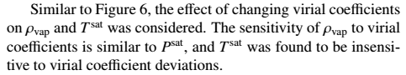

> 3.3 In Figure 5, the iterative process on vapor density is abundantly illustrated but not the iterative process on saturation temperature. This figure must be complemented by a specific graph showing how saturation temperature converges to the solution when initialized some distance away from the coexistence curve.

The below figure is a modified version of Figure 3(b) by initializing the ITIC calculation away from coexistence curve. As can be seen, Tsat nearly converges in one iteration and the sequence of (rhoV,Tsat) represented by red X symbols are practically identical even when initial Tsat estimate (black X) is deviated from true Tsat by ~10 %. We added this figure to the Supplementary Material to show how Tsat converges when it is initialized away from coexistence curve.

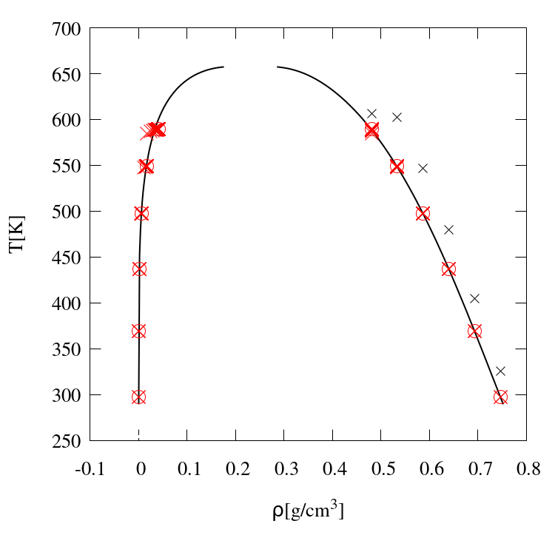

> 3.4 In Figure 6 showing deviations on saturation pressure, how is it possible that round values of Tsat are mentioned in legend ? As Tsat is the result of an iterative process it is unlikely that round values are obtained. What is the explanation of the authors of this ? The legend must be changed to indicate the imposed variable (liquid density). The manuscript must also indicate whether saturation temperature is significantly changed when the virial coefficients are modified.

We believe that using equal sign in the legend adds to confusion. We also agree that it is less confusing if the legend includes the imposed densities, however we have based our comparisons on Tr values, because the readers are more familiar with temperature than density. We now changed the legend and used “≈” instead of “=” to emphasize that Tsat values are not imposed. We also plotted rhoV and Tsat sensitivity vs B2, B3, and B2_IT deviation. We added this paragraph to explain our observations:

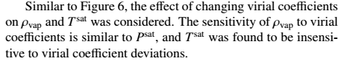

> 3.5 In Figure 7 it is unsatisfactory that increasing systematic deviations are observed when the initial saturation temperature is estimated at increasing distance from the true solution. This behavior may reveal a problematic convergence of the iterative scheme on Tsat (see point 2.3).

Figure 7 presents the error incurred by deviations in the simulated Tsat^est. This figure is not related to the iterative scheme for computing Tsat that is mentioned in point 2.3.

The deviations in Figure 7 are mainly due to lack of extrapolation precision when Tsat is away from real Tsat values. As we discussed in general comments, according to Figure 7 even 10 % error in Tsat initial guess causes only 0.1-0.4 % deviation in Psat and 0.2-0.4 % deviation in rhoL. This amount of error is satisfactory compared to typical (GEMC/GCMC) simulation uncertainty. Tsat can be accurately estimated for most force fields by using experimental values, because typical force fields characterize Tsat-rhoL relationship within less than 1 % error. If experimental values cannot be found for the molecule of interest a simple two point extrapolations on corresponding Z vs. 1/T plot can give an accurate estimation for Tsat at a given density (See last two paragraphs of Section 7)

> 3.6 Did he authors investigate other accuracy requirements on vapor density than 0.1% ? Is it possible to reach a better accuracy ?

We use 0.1 % as the stopping criterion for iteration. In our experience setting this number to a even smaller number does not improve the accuracy. We now mention this in Section 2.3.

**Section IV - Simulation details**

> 4.1 It is surprising to read that "the MC method with fixed bond lengths is favored due to lower fluctuations at low density" . Indeed fluctuations are characteristic of the NVT ensemble (e.g. energy fluctuations are related with heat capacity ) and should not depend on the simulation engine used to generate the ensemble. The statement must be removed or carefully reformulated.

We show in Figure 9 that at low densities on IT, MC has smaller pressure uncertainties than MD and fixed-bond MD has smaller uncertainties than harmonic-bond MD. We changed “fluctuations” to “uncertainties” to avoid confusion.

> 4.2 In the paragraph devoted to the computational cost of the ITIC method, how is it possible that the authors apply the ITIC method at imposed Tsat = 0.65, 0.75 and 0.85 in reduced units, as the method consists in imposing liquid density and finding Tsat ? This sentence must be reformulated.

We agree that this sentence is not clear enough. We are using Tsat as a basis to compare ITIC range and GEMC range, because it is easy to understand for the reader. We are also aware that Tsat in ITIC is calculated and Tsat in GEMC is imposed. Therefore, we changed

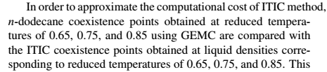

> 4.3 When evaluating the computational cost of ITIC versus GEMC the authors seem to underestimate the computation time required by successive iterations on saturation temperature in ITIC.

We would like to emphasize that NVT simulations are simulated only once, and the Tsat iterations do not require new simulations. When the simulations are done, the method converges quickly after 3-50 iterations, therefore we did not discuss the negligible computational cost of ITIC analysis. This explanation is now added to the second and last paragraph of Section 2.3.

> 4.4 the final statement "for reduced temperatures of 0.45 and 0.55 … GEMC is not feasible for n-dodecane" is misleading, because simple monophasic NPT simulations allow to extend GEMC coexistence curve calculations down to reduced temperatures of 0.45 for this compound (see point 1.3 above). Comparing ITIC with GEMC only is irrelevant. The authors must compare instead with GEMC + thermodynamic integration.

In this paragraph we are trying to prove that ITIC is comparable to GEMC with respect to computational cost. In this study, we do not intend to compare ITIC to Gibbs-Duhem. Furthermore, Gibbs-Duhem can be used for ITIC as well, so it seems to be fair to compare ITIC and GEMC methods. However, it is fair to briefly mention that GEMC can be extended to lower Tsat's if Gibbs-Duhem is used. So we changed this paragraph to:

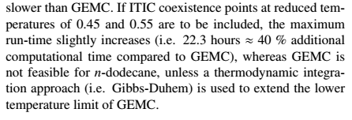

> 4.5 The initialization of NVT simulations of the liquid phase is a delicate task that the authors achieve with the Packmol software. What is the lower reduced temperature allowing safe initialization by Packmol and subsequent simulation by Cassandra ? The authors must discuss briefly this point.

As mentioned in Simulation Details, the Packmol was used only for GOMC and LAMMPS simulations. Cassandra and Gromacs have a a powerful internal tool that performs initialization.

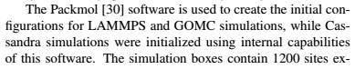

**Section V Calculation of virial coefficients Section VI Finite size effects**

> 6.1 It seems to this referee that Figure 9 is illustrating the divergence of the pressure determination in the zero density limit when the molecule has internal degrees of freedom. This behavior is frequent when the atomic virial route is used for pressure determination because the atomic virial expresses as PV = nkT + W , where n is the number of atoms (not the number of molecules!) and the virial term W contains contributions from internal forces and from intermolecular forces. Depending on the numerical approximations in computing intra- and intermolecular forces in the atomic virial, Z may not tend toward 1 in the zero density limit. MC predicts better the compressibility factor Z in low density phases, because MC codes are generally using the molecular virial route in which PV = NkT + W' where N is the number of molecules (not the number of atoms) and where the virial W' contains contributions from intermolecular forces only. Thus Z tends toward 1 in the low density limit. If this interpretation is correct, there is no reason to use a large number of molecules for vapor phases in MC. The authors should discuss these points more thoroughly. They may also consider merging the section "Finite size effects" with "Simulation details" .

In light of the reviewer’s comments, we examined the virial contributions for ethane in greater detail, as shown in the figure below. It is clear from the figure that the intermolecular contribution to the virial is approaching zero as expected, but the bonded contribution deviates significantly from its steady approach to -1 as the density approaches zero. The discrepancy is magnified in the computation of (Z-1)/ρ owing to the division by density. The bonded contribution to the virial is a quantity reported by LAMMPS with little recourse for user intervention. Presumably, the problem is the small number of intermolecular collisions at low density relative to the large number of intramolecular collisions, inhibiting the equilibration of the various components of momentum. To illustrate one manner of correcting for this deficiency, we used a linear extrapolation of the intramolecular virial, enforcing a value of -1 at zero density. Then we recomputed the total virial. As shown below, this procedure reduces the problem, but requires considerably more effort than switching to fixed bond lengths.

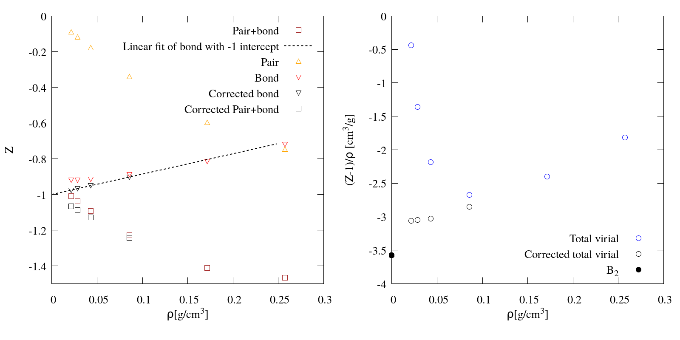 We include this figure with a detailed explanation in the Supplementary Material. We also briefly mention the nature of the correction in Section 6.

Furthermore, we agree with the reviewer that the section name is not appropriate, since we also investigate MC vs MD and fixed vs flexible bonds. For this reason, we have modified the section name to, “Accurate Low Density Simulations.”

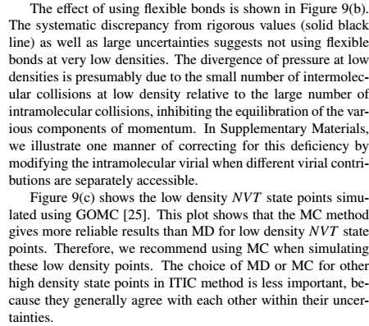

> 6.2 Finite size effects on the compressibility factor Z and on the internal energy U are not discussed for dense (liquid) phases. Packing effects are sometimes important in such conditions. The authors should briefly mention the steps taken in their method to avoid significant finite size effects in the simulation of liquid phases.

It is true that finite size effects can impact dense phases. We investigated this impact and found no clear trend to report. We include this figure in Supplementary Material but recommend a more thorough investigation in future work.

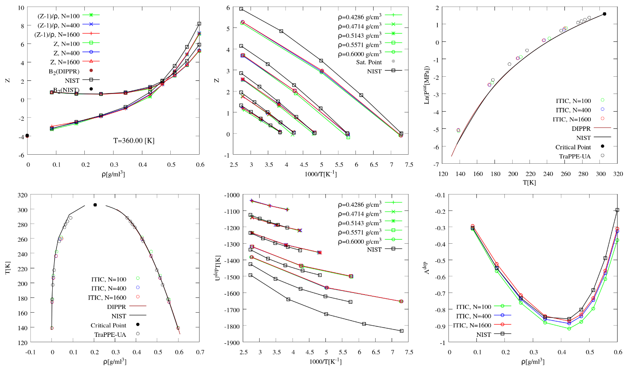

**Section VII Example simulations**

> 7.1 : Figures 10 and 11 : The agreement of ITIC with previous simulation results on methane, ethane, isobutane , isohexane, dodecane and TIP4P/2005 water is very good ; In order to asses the relevance of this comparison it is necessary to mention how far the initialization (vapor density and saturation temperature) was from the final coexistence curve. The authors must add this precision in text or in tables. A few cases of significant differences (e.g. TIP4P water at 473K) merit specific explanation from the authors.

All ITIC results of example simulations are initialized at DIPPR Tsat values. In Supplementary Material, we include a set of ethane simulations with deviated Tsat values which shows that final coexistence curve is weakly influenced by initial Tsat values.

> 7.2 Figure 11 : Dodecane has been already investigated by GEMC + thermodynamic integration with TraPPE-UA [ Ungerer et al. , JCP, 112, (2000), 5499] in a larger temperature range than the GEMC results shown in this graph. The authors must include the related GEMC+TI results in Figure 11 a.

We added Ungerer2000 results for TraPPE-UA n-dodecane to Figure 10 (See unfilled black triangles), which show that ITIC is in relatively good agreement with GEMC+TI for n-dodecane at low temperatures.

**Section 8. Conclusions**

> 8.1 In the conclusion as in the rest of the manuscript, the authors are considerably underestimating the application range of "classical" molecular simulation methods (Tr=0.3 to 0.95) , which is in fact larger than the ITIC proposed here (0.45 to 0.85). Restricting comparison to GEMC alone or GCMC alone should be avoided in the conclusion as in the rest of the article.

The conclusion has been modified to say,

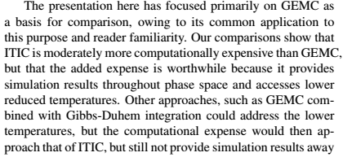

> 8.2 The authors may insist on a very significant advantage of their method, i.e. it avoids the implementation of transfer moves in Gibbs Ensemble Monte Carlo simulations, which is always a delicate task involving statistical bias and configurational bias.

We added a statement in the Conclusions to emphasize the need for transfer/insertion moves in conventional methods.

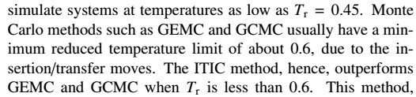

Furthermore, an important advantage of the ITIC method is the possibility of calculating saturation properties using MD. We emphasize on the cross-platform feature of ITIC in the Conclusions.

**Response to Reviewer #3**

**General**

The manuscript describes a method predict phase behavior using NVT simulations along two isotherms and several isochores based on previous work to do the same for a square-well fluid. The method utilizes estimates of virial coefficients to characterize the vapor phase. The manuscript is well structured and provides comparisons with GEMC and GCMC predictions of phase behavior. The method has potential to be a useful route to obtain coexistence, but there are a number of issues that need to be addressed before publication.

**Comment #1**

> A general comment is that the manuscript often notes how much results differ from REFPROP values ("reproduces NIST REFPROP vapor pressure within 1 % deviation" in the conclusions), with the implication that this indicates the method is working well. This isn't quite right since REFPROP data describes the behavior of real molecules and may differ (by more than 1%) from the properties of the models considered. Validating the method is then supported by comparing against GCMC and GEMC while agreement with REFPROP primarily indicates the quality of the model.

Section 3 (ITIC validation) focuses on understanding the convergence behavior of the ITIC method, sensitivity analysis, and more importantly assessing the accuracy of the formulas discussed in Section 2. Reproducing the REFPROP Psat values using ITIC state points obtained from REFPROP is really a test of the spacing of the quadrature points since all the REFPROP thermodynamics are derived from NIST’s analytical equation of state. It does not necessarily mean that the method will work for simulation data as well because the simulation data include uncertainties whereas the REFPROP equation of state does not. Therefore, extensive simulation results are provided in Section 7, in order to complement the validations. To clarify, the following sentence was added to Section 3.1 on Page 5

“Reproducing the REFPROP Psat values using ITIC state points obtained from REFPROP is effectively a test of the spacing of the quadrature points since all the REFPROP thermodynamics derive exactly from their analytical equation of state.”

**Comment #2**

> The authors rightly point out that the method has several advantages over GEMC and GCMC (working at low temperature, not requiring insertions and being possible with MD). However, GDI does not have any of those restrictions, only requiring the coexistence properties at one point. If a point is known (perhaps from GEMC/GCMC), does the method ITIC approach offer advantages over using GDI to get the rest of the coexistence points?

We have not compared the performance of ITIC against GDI from a simulation cost perspective. Assuming that these two methods have similar costs, one advantage of ITIC method is that it generates valuable data along the paths of integration, as mentioned in the Introduction. This information could be particularly valuable in the process of force field development. Also, with combination of derivative properties as in the work of Lustig et al (2015), it should be feasible to make use of this data to generate high accuracy multi parameter equations of state, similar to the work of Thol et al (2015). Another advantage of the ITIC method is that it is more homogeneous compared to GDI, as it only uses one type of ensemble (NVT). We added a sentence to the Introduction to explain these advantages.

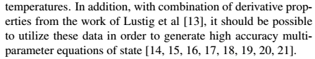

**Comment #3**

> The manuscript states in the introduction that it is necessary to avoid a phase transition in the path between coexisting phase. While it is not a bad idea to avoid such transitions where it is practical, the GCMC approach which the authors compare against does exactly this by design. The authors may not wish to pursue such options, but it doesn't seem necessary to dismiss them entirely unless they have actually tested it and found it to fail.

The IT at Tr<1 would be very scattered between rhoVsat and rhoLsat, and unlikely to be very accurate. We thank the reviewer for this suggestion, but exploring this option would be beyond the scope of the current manuscript.

**Comment #4**

> The derivation of the working equations for vapor and liquid free energies and for phase coexistence seems to be unnecessarily complicated, a bit confusing and perhaps not quite correct. The primary issue seems to be due to trying to write everything in terms of departure functions (deviations from ideal gas properties).

We address this comment in combination with comment #5.

**Comment #5**

> Eq. 2 is correct, but only if both G_ig correspond to the same coexistence pressure (rather than the corresponding liquid and vapor densities). This is unclear from the equation itself although it might be inferred from the discussion of eq 3. Still, it is not easy to get to eq. 3 from 2.

We modified Eq.(2) to emphasize the constant T and P conditions. The derivation of Eq.(3) from Eq.(2) is explained in Ref[16]. It should also be noted that the adjustment to go from the actual volume reference to the actual pressure is a term of ln(*Z*) ie. (*G-Gig*)*TP* = (*G-Gig*)*TV* – *RT*ln(*Z*). Since that term appears on both sides of the equation relating liquid fugacity to vapor, it can be expressed as ln(*ZV/ZL*) = ln(*ρL/ρV*) because the *T* and *P* are the same in numerator and denominator. This reverts that pressure dependency into the term *ρV*, since *ρL* is exactly specified.

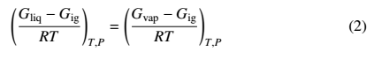

**Comment #6**

> Eq. 7 and 8 are written as indefinite integrals, but they not useful in this form. Eq. 8 is used to construct Eq. 10, where it becomes a definite integral. It would be simpler to write them as definite integrals from the start.

I would suggest that the derivation would be simpler and less confusing if the derivation targets full free energy

A(rho,T^IT) = A_id(rho,T^IT) + integral[rho'=0,rho (d(A-A_ig)/drho) drho']

beta A(rho,T) = beta A(rho,T^IT) + integral[beta'=beta^IT,beta (d betaA/dbeta) dbeta']

Splitting the free energy into ideal and non-ideal parts is necessary for density integration (because the full integrand would diverge at rho=0), but it's unclear what it accomplishes for the temperature integration, except perhaps to make the results incorrect: the authors later (in section 4.1) describe subtracting out the intramolecular energy (taking U_ig = U_bond + U_intra).



This seems wrong. The U_bond and U_intra contributions in a simulation at some finite density are not the energy an ideal gas would experience. The ideal gas contribution might instead be determined from a simulation of a single molecule where U_ig = U_tot = U_bond + U_intra.

Stated another way, the path from coexisting vapor to coexisting liquid might be represented as

(ρV,Tsat) ==1==> (0,Tsat) ==2==> (0,TIT) ==3==> (ρL,TIT) ==4==> (ρL,Tsat)

Rather than explicitly accounting for the change in ideal gas free energy in stage 2, the authors instead attempt to avoid it entirely by subtracting it out in stage 4. But the energy used for this purpose seems not to be the ideal gas energy (as would have been seen in stage 2), but the intramolecular (including bonding) energy seen in stage 4. I don't see how that can be right. If the authors are computing ideal gas energy for stage 4 (using a single molecule in a box), the they should state this explicitly. And, in practice, the whole thing would be simpler if the ideal gas contribution to the full free energy were included along (in stage 2) instead of trying to subtract the same from stage 4.

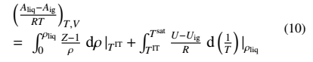

The reviewer raises a point that has worried us for several years. We agree wholeheartedly with the reviewer’s statement that “U_bond and U_intra contributions in a simulation at some finite density are not the energy an ideal gas would experience.” After following the reviewer’s recommendation of performing single molecule simulations to determine the ideal gas contribution, we did find some significant improvement for large molecules while smaller molecules were unaffected. This makes intuitive sense as a large molecule in a condensed phase cannot sample the same intramolecular configurations as a large molecule at zero density (single molecule simulation), while a smaller molecule samples similar intramolecular configurations at both finite and zero density.

The following figures (included in Supplementary Material) help demonstrate the need for this subtle (but important) correction. These figures compare the ITIC results (filled symbols) with GEMC results from the literature (open symbols). The different shapes/colors for ITIC correspond to different ways for computing Udep. These figures compare deviations from REFPROP values as a baseline to make the magnitudes of the discrepancies more clear. In other words, the best ITIC method is the one that agrees with the open symbols (GEMC), not the one that has lower deviation from REFPROP.

TraPPE n-dodecane:

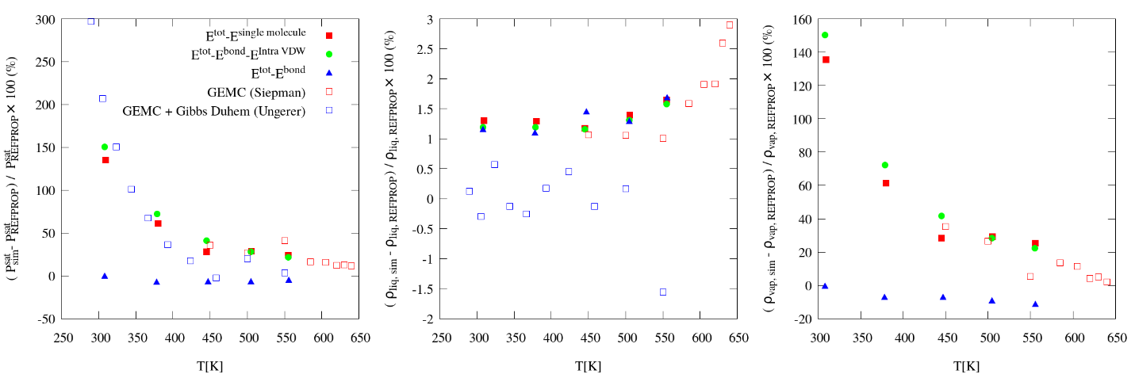

Mie n-dodecane:

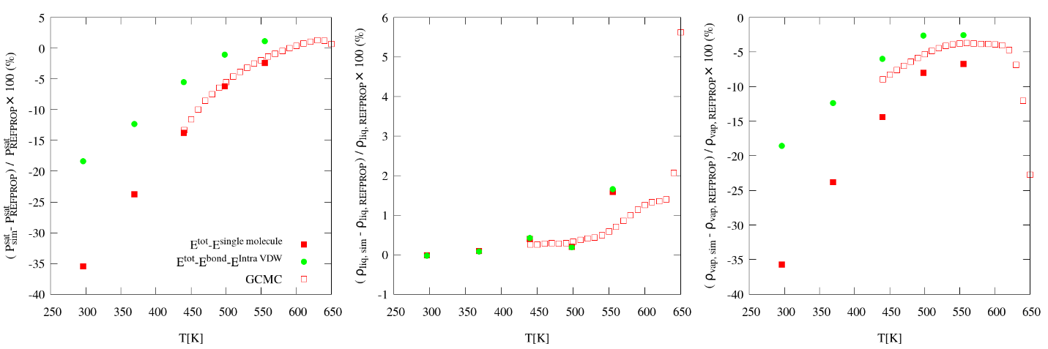

TraPPE isohexane

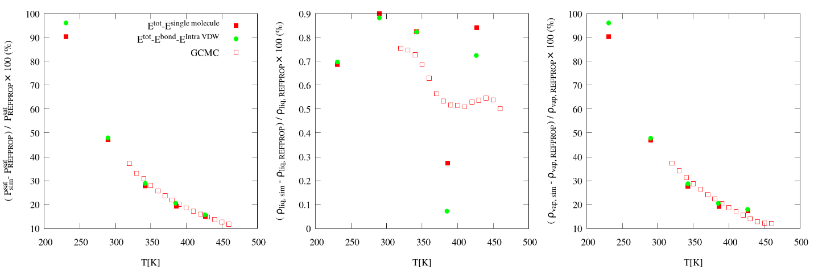

TraPPE isobutane

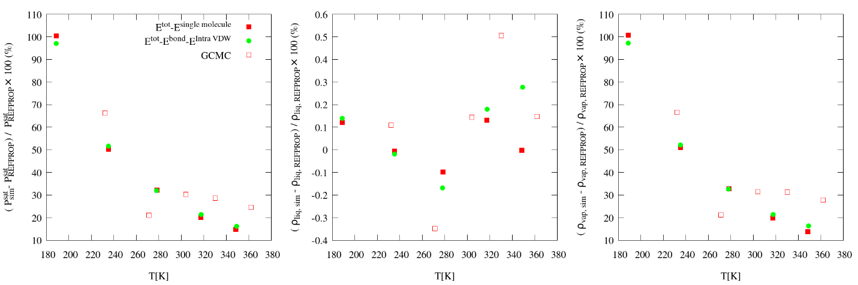

The red filled squares (ITIC single molecule method) provide the best agreement in Psat and rhov for n-dodecane (C12). However, the green filled circles (ITIC original intra method) provide indistinguishable values for smaller molecules, e.g., isobutane (iC4). The blue filled triangles (ITIC without subtracting intra method) is simply wrong and will not be discussed further.

The difference between uDep calculated using the single molecule approach is on average around 1.7 % for C12. This small difference causes a significant deviation in Psat and rhov which increases with decreasing temperature, while the rhol values are essentially the same. Psat differences for C12 and iC6 are 10-15 % for Tr=0.45 and 1-4 % for Tr=0.85.

The improvement with the single molecule method is most evident for the Mie-C12 results, where the single molecule method completely resolves the discrepancy between the ITIC and GCMC Psat values. However, note that the single molecule method did not reduce the deviation between the ITIC and GCMC rhov values.

It is also important that the difference between the single molecule method and the original (intra) method for TraPPE-C12 is of a similar magnitude as the difference between GEMC and GEMC+Gibbs Duhem from the literature. Therefore, the deviations introduced by our original assumption are still less than the statistical uncertainty in the simulation data.

In brief, the single molecule method is clearly the most rigorous approach. However, the original (intra) method is not obsolete as it has some benefits for smaller molecules compared to the single molecule method. For example, although the additional single molecule simulations are extremely fast, this adds to the complexity of the ITIC method. Furthermore, single molecule simulations are ill-suited for traditional molecular dynamics simulations where a thermostat couples many degrees of freedom to a single bath, e.g., Nosé-Hoover. Stochastic dynamics (which is available in some molecular dynamics packages, e.g., GROMACS) is better suited for single molecule simulations, but this again adds complexity that is not needed for smaller molecules. For this reason, we did not remove the original (intra) method from the manuscript.

We have made the following modifications to address the reviewers well-founded concerns. Section 4.1 now recommends the single molecule method but presents the original (intra) method as an alternative for smaller molecules. A more detailed comparison is included in Supplementary Material. The C12 and iC6 ITIC results in Figures 10 and 11 and the 1-naphthalenyl,4-phenanthrenyl butane results in Figure 12 have been recomputed with the single molecule method. The figure captions and discussion in Section 7 clearly denote this distinction.

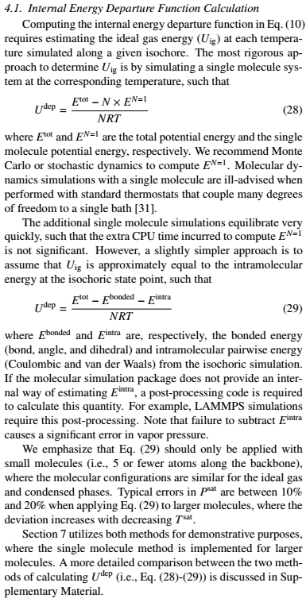

**Comment #7**

> The manuscript states that eq. 14 "can be solved for ρV using" using an iterative technique. It does not seem to make sense to say that eq. 14 is solved, but rather eq. 14-17, as described later.

The iterative technique for solving equations 14-17 is different than the root-solver used for solving Eq 14 for rhov. A root-solver is necessary because rhov is found in both the left-hand-side and the right-hand-side of Eq 14.

**Comment #8**

> Eq. 14 imposes equality of Gibbs free energy between the phases while eq. 16 (indirectly) imposes equality of pressure. It would be helpful to identify that it accomplishes this and perhaps relabel P^sat to P_vap from eq. 15 to make it clearer.

We agree that using Pvap in Eq.(15) makes the equation more clear. Instead of removing Psat we now have both:



**Comment #9**

> In describing how T^sat is updated, the manuscript states that Z vs. 1000/T is extrapolated or interpolated. This is confusing because it's unclear what Z refers to (it seems to be the liquid simulation data) and it's unclear how using 1000/T could be meaningfully different from using 1/T. It's also unclear what scheme was used to interpolate or extrapolate the data.

Z refers to compressibility factor from simulation data on liquid isochores. We obtain the same Tsat for either 1/T or 1000/T, but to avoid any confusion we have modified the sentence to read ‘reciprocal temperature’ and converted 1000/T to 1/T.

**Comment #10**

> The manuscript describes using 3 points on an isochore for temperature integration. This seems rather sparse. Do the isotherms lack curvature (linear)? Or are they reasonably approximated by a quadratic? From the discussion, it seems that whatever errors are introduced by this are commensurate with other sources of error in the overall approach, but it would be helpful to understand what sort of approximation this is. Would it be better to run shorter simulations at more temperatures (same computational effort) and have more confidence in the behavior? The interpolation of Z (as mentioned previously) and U faces similar issues.

The plot of UdepT vs 1/T is usually slightly curved, as seen in figures in Section III of Supplementary Material. Using 3 points on isochores is enough for the densities of interest (Tr>0.45), but as the density increases the curvature of the isochore increase. Since we are using three point Simpson’s rule for integrating along isochore, this curvature is captured. We are also using a 2nd order polynomial along the Z vs. 1/T to update Tsat (See our response to Comment 9). For high density isochores it is not recommended to run short simulations, because those are the hardest to equilibrate, especially at lower temperatures.

**Comment #11**

> The figure 5 caption states that B3 helps the iterations converge, but the figure actually shows that convergence fails without B3 (as described in the main text). Is that correct?

Using B3 term helps the iteration to converge. Figure 5a (with B3) converges and Figure 5b (without B3) diverges. As this statement already seems to be consistent, we did not modify the caption.

**Comment #12**

> In section 3.2, the manuscript states that "Vapor pressure precision is very weakly influenced...". It seems this is actually referring to accuracy (tendency to deviate by a particular amount) rather than precision (tendency to fluctuate due to stochastic effects).

To avoid confusions we changed the sentence to:

“Vapor pressure estimate is very weakly influenced ...”

**Comment #13**

> The figure 8 caption states that "Diamond points are very low density simulations that are not used in B_2 and B_3 calculations." It's unclear why they should be excluded. They are the most important data to estimate virial coefficients (because virial coefficients describe behavior in the limit of low density). Their uncertainties are larger than other densities, but this should have the effect of diminishing their impact on the virial coefficient fits so long as the fits account for uncertainty.

In the proposed ITIC procedure, we show that simulating circles in Figure 8(a) is enough to obtain reliable B_2 values, and we do not need to simulate diamonds points. Since they are unnecessary, we do not recommend performing these simulations as part of the method. We simply show them in Figure 8(a) for illustration. We now clarify this point in the caption of Figure 8.

**Comment #14**

> The authors attribute the deviation of the fitted B3 from the rigorous values due to being "effective" coefficients that capture effects from B4 or higher. If true, then shouldn't B4 be included as a fitting parameter. Are the simulation data too uncertain to justify a 3-parameter fit? The manuscript does state that B3eff was better able to describe the simulation data than rigorous B3 and B4 and refers to figure 9 to support that. The figure has curves for the VEOS using rigorous B2 & B3 and also using rigorous B2, B3 & B4. Without a curve for B3eff, I'm not sure how the figure supports the claim in the main text.

As the reviewer points out, the simulation data shows too much uncertainty to justify a 3-parameter fit. We apologize that the curve for B3eff has been overlooked. We now include this curve in Figure 9(c) (purple dashed line).

**Comment #15**

> Does the vapor description by virial coefficients work for strongly interacting models like water as it does for more weakly interacting models like ethane?

The study of TIP4P water in the Example Simulations section shows that, second virial coefficients can be obtained using Eq.(30) for this model. We added a sentence to Example Simulations section to emphasize on this point.

**Comment #16**

> The error bars in figure 8a seem to be too large; they are much larger than the scatter in the data and the fitted lines go right through most of the points.

The dashed blue lines in Figure 8(a) are actually representing rigorous B2 and B3 values of TraPPE-UA ethane, as expressed in the caption of Figure 8(a) “Blue dashed lines represent Schultz values of B_2 (intercept) and B_3 (slope)”

**Comment #17**

> The manuscript states that "we need 3200 ethane molecules to achieve low enough uncertainties..." It's unclear why the authors have coupled the uncertainty to the system size. The authors have apparently chosen to run each system size for the same number of MD steps, but this is unfair and especially so if the MC simulations were also run for the same number of MC steps regardless of system size. MD CPU time per step increases with system size, but the simulation will yield increasing precision with system size (commensurate with the additional effort). In MC, the CPU time and uncertainty are both relatively independent of system size for a given number of steps. It would make for a fairer comparison to run the MD simulations for a number of steps that is inversely proportional to system size. Although the number of steps for MC is described in section 4, the number of MD steps does not seem to be specified.

First, we would like to emphasize that the statement "we need 3200 ethane molecules to achieve low enough uncertainties..." only refers to MD rigid. We modified the second paragraph in Section 6 to avoid this confusion.

Furthermore, in light of the reviewer’s comment, we replotted Figure 9a and 9b by modifying the number of MD steps depending on the number of molecules. The number of MD steps used in calculating the averages is now inversely proportional to the number of molecules, as specified in the caption of Figure 9. We also increased the number of samples by splitting each run into two blocks, hence eight blocks of data are used to calculate error bars based on 95 % confidence intervals. The first paragraph of Section 4.2 reflects the new approach to calculate the uncertainties.

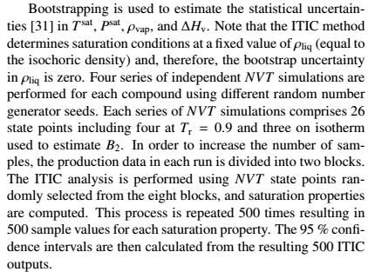

**Comment #18**

> I find the behavior in figure 9b and the attribution to lack of equilibration a bit disturbing. United-atom ethane is a very simple molecule and the bond length should not need much time to equilibrate in the vapor phase. Have the authors been able to collect better data using longer equilibration times? Does the divergence at low density at least decrease with increasing equilibration length? This should not be hard for the smallest system size (N=120). If not, then I suspect something is just broken.

Running long simulations revealed that the behavior in Figure 9b is not due to lack of equilibration. Therefore, we removed the sentence in the manuscript that attributed this behavior lack of equilibration. As discussed in our response to Comment 6.1 of Reviewer 2, the divergence of pressure is due to inaccuracies in the intramolecular bonded virial at low densities. In Supplementary Material, we illustrate a method to correct for these inaccuracies if the simulation package provides different virial contributions, i.e. pair virial, bond virial, kinetic virial, etc. Below are the paragraphs containing the above explanation.



**Comment #19**

> The manuscript describes the relative standard deviation between runs (STD2) being much smaller than the average standard deviation within a run (STD1). Is STD1 then the standard deviation of the samples (how much Z fluctuates from configuration to configuration)? Or is it based on block averages? And STD2 shows how much the average value (from a simulation) fluctuates when the simulation is repeated? It's unclear why these values are being reported in this way, or why STD1 is reported at all. The authors chose to use STD2 for uncertainty (error bars), but this is inappropriate if the value being plotted is the average across the runs. Please compute a proper uncertainty ("standard deviation of the mean", "standard error", etc.) for error bars. Also, computing a standard deviation from 4 points is not likely to yield an accurate result. Uncorrelated block averages are more likely to yield a good estimate of the uncertainty.

We agree with the reviewer that 4 samples is not enough for computing reliable uncertainties, however we believe that block averaging can also be problematic when the block lengths are too small that the data remain correlated. Therefore, we now combine the two approaches, i.e. calculating uncertainties from replicate simulations and from block averaging. In the current text, uncertainties are calculated based on 95 % confidence intervals from eight decorrelated samples, i.e. two blocks on four separate runs. Note that, since most of the data in the table that contained STD1 and STD2 data is plotted in Figure 9, we decided to remove this table from the manuscript.

**Comment #20**

> In some cases, the data shown in figure 10 shows agreement between ITIC and GEMC/GCMC methods. In other cases, the agreement is not so good. The level of agreement or disagreement ought to be discussed in the text, since this (rather than agreement with REFPROP) is what determines if the method is working. Is it due to stochastic effects (where are the error bars? are they smaller than the symbols?)? Or is there systematic disagreement? If so, which results are inaccurate? Also, figure 10a appears to show that the vapor pressure may deviate from REFPROP data by up to 100%, certainly more than 1% as asserted in the conclusions. Is the statement in the conclusion referring to a different type of comparison?

It is challenging to add error bars for ITIC results in Figure 10, because we have uncertainties in both Tsat and Psat. Also, adding error bars to Figure 10 makes it very hard to read. Therefore we only include the error bars in Figure 11.

Note that in Figure 10, we calculate the deviation between ITIC and REFPROP and the deviation between literature data and REFPROP, then we compare these two deviations together. Therefore, REFPROP serves as a baseline for comparison, such that the discrepancies are more visible than on a logarithmic plot. Only the difference between the two deviations matter, not the deviation values themselves.

In the Conclusion section, it is shown that the REFPROP Psat value is in agreement with ITIC Psat values obtained using REFPROP state points. This agreement validates the ITIC formula and the choice of ITIC points.

The level of agreement between ITIC and literature data shown in Figure 10, is now discussed in a more specific manner in the first paragraph of Section 7.

**Comment #21**

> Additional discussion of the method's limitations is needed to help readers if and how they could use the method for their own purposes.

One limitation of ITIC method is the need for reasonable initial estimates for Tsat. This limitation and our approach to address it is included in last two paragraphs of Section 7.

**Comment #22**

> The inability of ITIC to yield coexistence properties at a given temperature or pressure receives little attention in the manuscript; liquid density is specified and other properties are determined. Interest in a given temperature or pressure is far more likely and inability to specify temperature makes it difficult to compare results against other methods (GDI can do T or P; GCMC and GEMC can do T). The authors are able to make comparisons by subtracting REFPROP values from the predictions of each method, but this is not always possible and may not be adequate. It would be helpful if the authors could suggest an approach (Clapeyron equation, interpolation, running one more simulation, etc.) that would allow estimates to be obtained for a condition that is near one that was actually solved for.

We added a sentence in Section 2.3 to emphasize that in ITIC method, rhoL is imposed and the rest of saturation properties including Tsat are calculated.

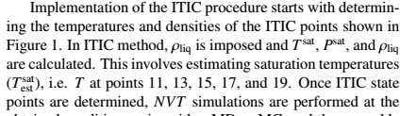

**Comment #23**

> Finally, the manuscript addresses sensitivity of the results to the guess for T^sat, but it is unclear how to identify appropriate saturation temperatures for a given model. If the coexistence behavior is unknown, how can a researcher determine these temperatures? Is it necessary to use another method (GDI, GCMC and GEMC do not require such knowledge) to get an estimate coexistence point for each liquid density? Or should we be unconcerned with getting it right and add temperatures as necessary (above or below the initial guess)

For an unknown molecule, crude Tsat estimation at each rhoL is possible by obtaining two points on each isochore (Z vs. 1/T) and interpolating or extrapolating to Z=0.0. An example of such situation (1-naphthalenyl, 4-phenanthrenyl butane) is added to the Example Simulations section to explain the necessary steps taken to use ITIC method when no Tsat-rhoL information is known. This adds to the cost of the ITIC method, since extra simulations are performed at each isochore, but one can use that additional information to improve the integration accuracy and the ultimate knowledge of the equation of state for the molecule.