**Response to Reviewer #2**

A significant number of changes and corrections have been made in revision R2. However there are still problematic items that need corrections, especially the definition of departure function and the derivation of equation 13. See the attached file.

Comments to the authors :

===================

The comments below address the points listed in the previous report made on revision R1. The authors have answered several points with acceptable answers among those raised in this report. Only those points still unsatisfactory in revision R2 are listed below.

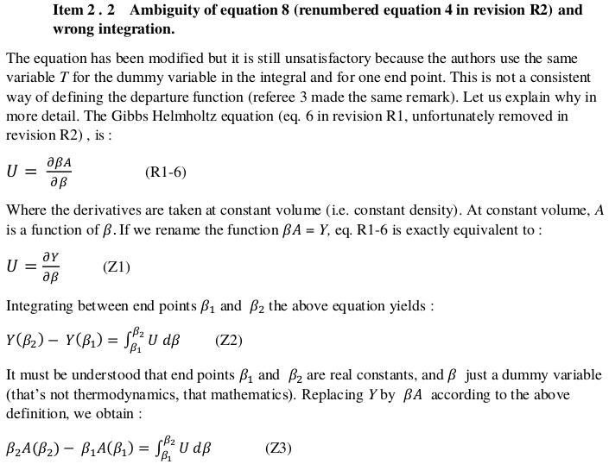

We agree with the reviewer that T should not be used as both a dummy variable inside the integral and in the limits of integration. However, we would like to emphasize that Eq.(4) in the previous report did not provide a definition for departure function; it simply gave the change in Helmholtz energy when going from (T1, rho) to (T2, rho), namely an isochoric path. In order to resolve this ambiguity, the Eq.(5) in the new version is written as



This equation is consistent with Eq.(Z3) derived by the reviewer above.

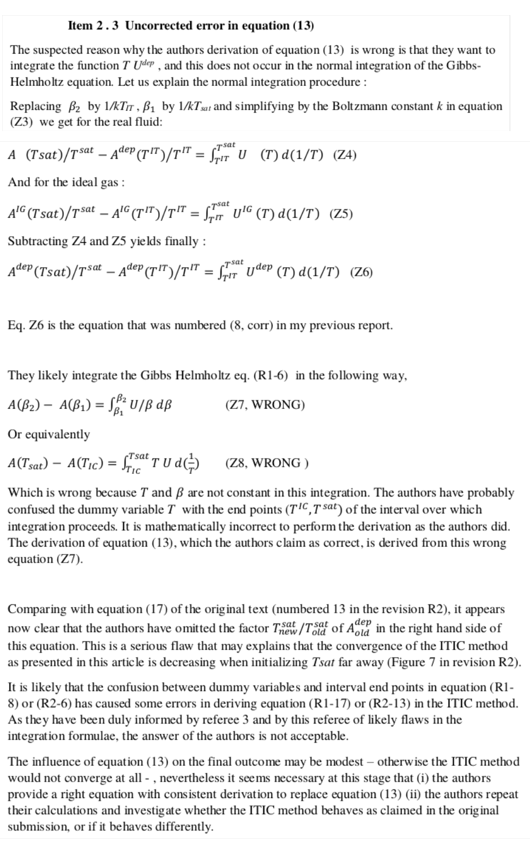

Assuming that Adep in Eq.(Z4) is a typo (it should be A), Eq.(Z6) is now correct, but it is NOT equivalent to Eq(8,corrected) from the previous report, even though they look exactly the same. This is due to inconsistency between the reviewer and the manuscript in the definition of Udep and Adep. Let us explain more. In Eq(Z6) of the reviewer’s comments, Udep is clearly defined as U-Uig, whereas the reviewer’s Eq(8,corrected) in the previous report and in the first paragraph of Section 2.3 was actually derived based on the assumption that Udep has T in the denominator. In point 2.2 on Page 3 of our last response, the reviewer wrote the following sentence before deriving Eq.(8,corrected):

“U*sing the same notations Adep(T,V) = (A(T,V)-AIG(T,V))/RT and Udep(T,V) = (U(T,V)-UIG(T,V))/RT ...* ”

Similarly in Eq.(Z6), Adep is defined as A-Aig, whereas in Eq.(8,corrected), and in the last paragraph of page 2, Adep was defined as (A-Aig)/RT. That is why we mentioned in our previous report that Eq.(8,corrected) was NOT “correct”. Let’s continue assuming that the reviewer and the authors agree that the following equation which is the same as Eq.(Z6) derived by the reviewer is correct:

In the derivation of Eq.13 (now Eq.21), we multiply and divide (U-Uig)/R by T to obtain TUdep, assuming that temperature is non-zero. We do this because we prefer to deal with dimensionless quantities (like Udep) as our default basis. Many authors use subtly different notation with respect to intensive vs. extensive variables, number of moles vs. molecules, and the like. We feel that the dimensionless basis ensures that these kinds of confusion are minimized at key stages in the derivations when the key quantities are expressed in dimensionless form. In Eq. (13) (now Eq.21), it is clear that Udep is dimensionless, so multiplying by T and d(1/T) in close proximity clearly keeps the resulting integral dimensionless, consistent with the Adep on the left hand side (also dimensionless). Assuming that T≠0, we can integrate TUdep instead of (U-Uig)/R and obtain exact same result.



First, we assume that TIC in Eq.(Z8) and in the reviewer’s above paragraph is a typo (it should be TIT). Second, we would like to emphasize that we are not confusing the dummy variables with interval endpoints. The reviewer’s Eq.(Z7) and Eq.(Z8) are simply wrong and unrelated to any equation that we have written. What we use to derive Eq.(13) (now Eq.21) is Eq.(5) in the current version



which is equivalent to Eq.(4) in the previous version



Eq.(13) (now Eq.21) was not derived based on Eq.(Z7) or Eq.(Z8). Before explaining how this equation is derived, let us emphasize again that we define Helmholtz and internal energy departure functions as Adep=(A-Aig)/RT and Udep=(U-Uig)/RT, respectively.

Adepcorrection is the difference between dimensionless Helmholtz energy departure function between two consecutive iterations, i.e.:

Assuming T≠0, we can multiply and divide the integrand by T:

Since the temperature difference between consecutive iterations is small and TUdep has a linear shape, we approximate the integral using trapezoid rule as shown in the figure below:

Hence, Eq.(13) ( Eq.21 in the current version) is obtained

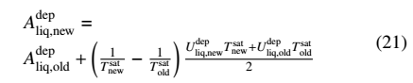

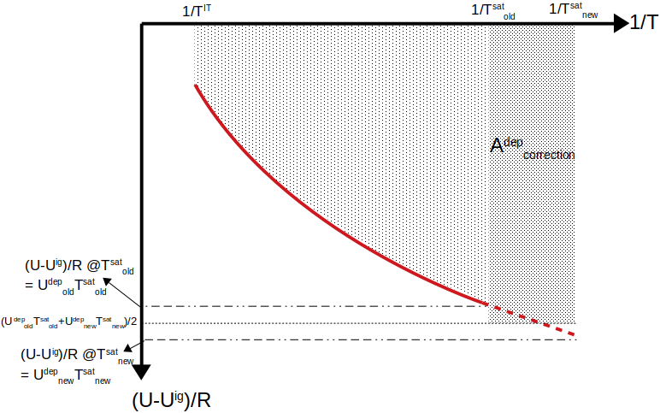

In brief, there is no missing factor of in Eq.(13) (now Eq.21). For this reason, the ITIC calculations need not be repeated prior to publication.

We are very sorry that our definition of departure function as a dimensionless quantity seems to have confused this reviewer so badly. Unfortunately, we believe that altering our definition at this stage would only add to the confusion. We have now carefully articulated the definitions of Adep and Udep as dimensionless numbers in the first paragraph of Section 2.1 and Equation 1:

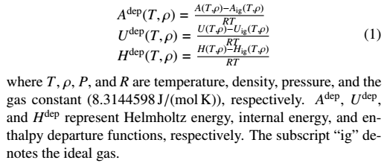

We have been entirely consistent in all derived equations throughout the text of the manuscript. We have added explicit subscripts to distinguish the integration variables vs. dummy variables. Eq. (Z6), which we all agree on, is entirely consistent with our dimensionless definition of Udep and the resulting Eq. (14) of the current version. There is no missing factor of . We believe that readers will see these definitions where first introduced in the current version, and the carefully articulated subscripts, and that will prevent them going down the wrong path. We thank the reviewer for bringing our attention to these details and taking the time to perform such a thorough review.

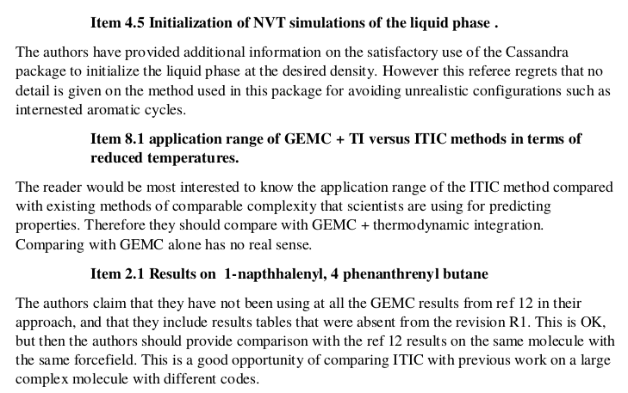We now explain, in a separate paragraph in Section 4, a technique that can potentially be used for initialization of very high density simulations of complex molecules. It’s worth mentioning that, any challenges in initialization would be quite similar to those experienced with GEMC, GCMC, NVT, or NPT simulations.

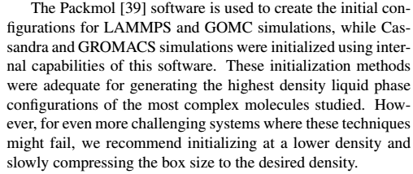



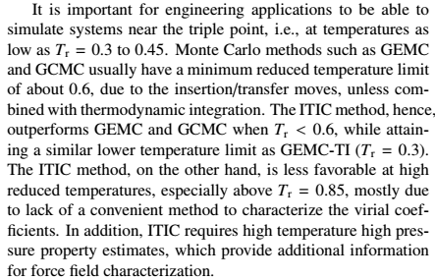We now address the application range of ITIC and GEMC+TI methods in the Conclusions section. The following paragraph was modified to clearly state that ITIC and GEMC+TI have similar performance in terms of lower temperature limit.



We updated Figure 12b and 12c by adding the GCMC results obtained from GOMC and GEMC results of Ref. 12. The GCMC results are also included in Supplementary Materials.

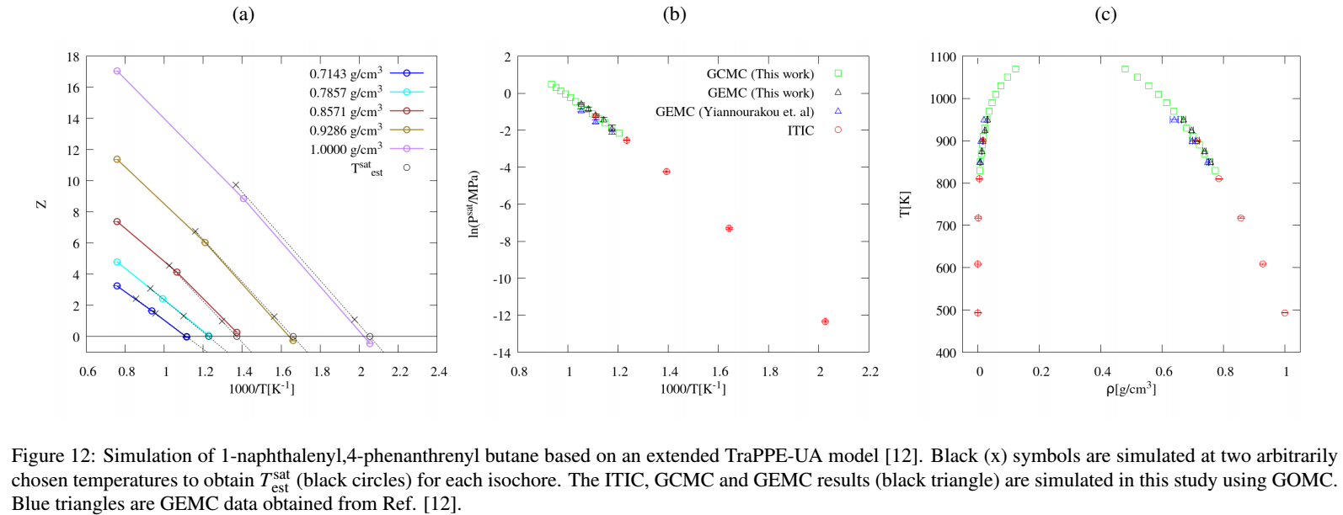

**Response to Reviewer #3**

The authors have adequately addressed the issues described in the previous reviews and the manuscript is ready to be published except that the notation in the derivation is still a bit sloppy and (for a couple of equations) still incorrect.

The authors use both subscripts (T,P,rho) outside of parentheses as well as subscripts on vertical bars to indicate that the expression is evaluated at the subscripted conditions. The usage is not always clear or helpful. For instance, in eq. 2, T and P subscripts are used but the variable T^sat is inside the expression. Is T^sat set equal to T? It doesn't really make sense. Instead, it is perhaps indicating that both LHS and RHS are evaluated at the same T and P.

Eq. 3 has T and V subscripts the free energy differences; in this case, the expressions on the LHS and RHS should *not* be evaluated at the same V, but rather different volumes; do the subscripts mean that the expressions are functions of T and V?. And it's unclear why the free energy difference needs a subscript while Z does not (is Z not a function of T and V?).

In general, I would suggest using notation like "G(T,P)/RT" rather than "(G/RT)_T,P" to indicate that G is a function of and/or evaluated at T and P.

We appreciate the reviewer’s recommendation. The revised manuscript has adopted the notation “G(T,P)/RT” rather than “(G/RT)_T,P” in Eq.(1), (5), and (6). All instances of subscripts outside of parentheses have been removed from the manuscript.

Eq. 4 is also confusing.



The LHS suggests that a difference in two free energy functions is being computed at the same condition (rho). In fact, the temperature is different. Also, "ref" in eq. 4 and 5 seem to indicate the "ideal gas" state. The use of "ref" to indicate both the reference system (ideal gas) and reference condition (T_ref, rho_ref) is also confusing. Is A_ref the ideal gas free energy or the free energy of the real system at the reference condition? If A_ref is the ideal gas free energy, why not use "ig" instead of "ref"?

Eq.(4) of the previous version (Eq.(5) in the revised manuscript) gives the change in dimensionless Helmholtz energy along an isochoric pathway. The term “ref” originally indicated the initial condition of an isochoric path; not necessarily ideal gas. We agree that this could cause confusion as we define the “reference state” in previous paragraph as “ideal gas at saturation temperature”. In the new version we modified Eq.(4) (now Eq.(5)) to clarify the initial and final points during an isochoric path. Also, using T_1 and T_2 for limits of integral in Eq.(5) and T for dummy variable inside integral, resolves the concern of reviewer #2 about using T as both integral limit and dummy variable inside integral.



If A_ref is the free energy at the reference condition, then the integrand of eq. 5 is wrong; it should be Z/rho instead of (Z-1)/rho.

If rho_ref != 0, then eq. 5 is wrong even if A_ref=A_ig. For rho_ref!=0, then the LHS should be  
  
A(rho)/RT - A(rho_ref)/RT - (A_ig(rho) - A_ig(rho_ref))/RT  
  
If rho_ref=0, then A(rho_ref) = A_ig(rho_ref) and those terms cancel, leaving the terms in the manuscript. The manuscript states only that the reference state is the ideal gas, so it is unclear to the reader that the authors have made the choice rho_ref=0.

We agree with the reviewer that, as written, Eq.(5) of the previous manuscript was not completely correct. Although our original intent was that rho_ref = 0, the general expression necessary for a clear derivation should not include the -1/rho term. The revised Eq.(6) now reads:



With the revised Eq.(6) we have significantly rewritten the derivation in Section 2. However, we would like to emphasize that the final equations that are actually utilized in the ITIC approach have not changed. Therefore, no modifications are required for the ITIC results.

The revised derivation utilizes Eq.(5) and (6) which have been endorsed by reviewers 2 and 3, respectively. Eq.(7-10) are specific applications of Eq(5) and (6) that correspond to the four pathways (two isochores and two isotherms). The revised derivation is much more thorough in demonstrating the origin of the Z-1/rho term (Eq.(11-13)). Again, the final ITIC expression, Eq.(19), is identical to that found in previous (although admittedly less clear/rigorous) derivations.

A similar issue exists with eq. 4 except that rho!=0 and so there is no cancellation on the LHS. It seems that the LHS needs 4 terms. Neglect of these terms does not cause real problems because they will cancel for the liquid and vapor states (eq. 10), but it is still incorrect to leave them out of eq. 4.

Eq.(4) (Eq.(5) of the revised manuscript) as mentioned above is equivalent to Eq.(Z3) obtained by reviewer 2:



I suggest using rho instead of V where it appears (currently as subscripts) as rho is the variable that is actually used in the formulas.

We appreciate the reviewer’s suggestion. The current version utilizes rho throughout.

Finally, I noticed that toward the end of page 3 there is a parenthesis missing:  
"the new vapor density (<rho>_new^vap is calculated"

We thank the reviewer for pointing out this typo.

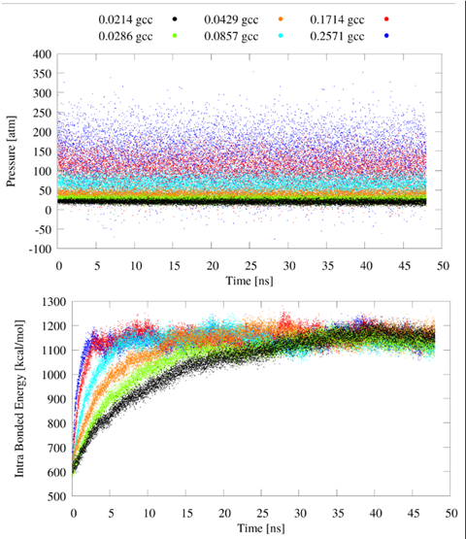**Comment # 18**

I find the behavior in figure 9b and the attribution to lack of equilibration a bit disturbing. United-atom ethane is a very simple molecule and the bond length should not need much time to equilibrate in the vapor phase. Have the authors been able to collect better data using longer equilibration times? Does the divergence at low density at least decrease with increasing equilibration length? This should not be hard for the smallest system size (N=120). If not, then I suspect something is just broken.

In the first review, we reported that the abnormal behavior in Figure 9b for MD flexible was not due to equilibration. This conclusion was based on visual inspection of pressure vs time plots for 16 ns simulations. However, after investigating the convergence of the bonded energy vs time for even longer simulations (48 ns), we conclude that equilibration was the actual cause of the peculiar MD flexible results. For example, this figure demonstrates that (at low densities for N = 3200) there is still a significant drift in bonded energies for equilibration times as long as 30-40 ns. The lack of equilibration is much less obvious in the pressure plots due to the extremely large fluctuations in pressure for MD flexible. By averaging the pressure only after the bonded energy has equilibrated (around 40 ns at the lowest density) we obtain much better agreement between MD flexible and the theoretical trend for Z-1/rho. This can be seen in the updated figure below:

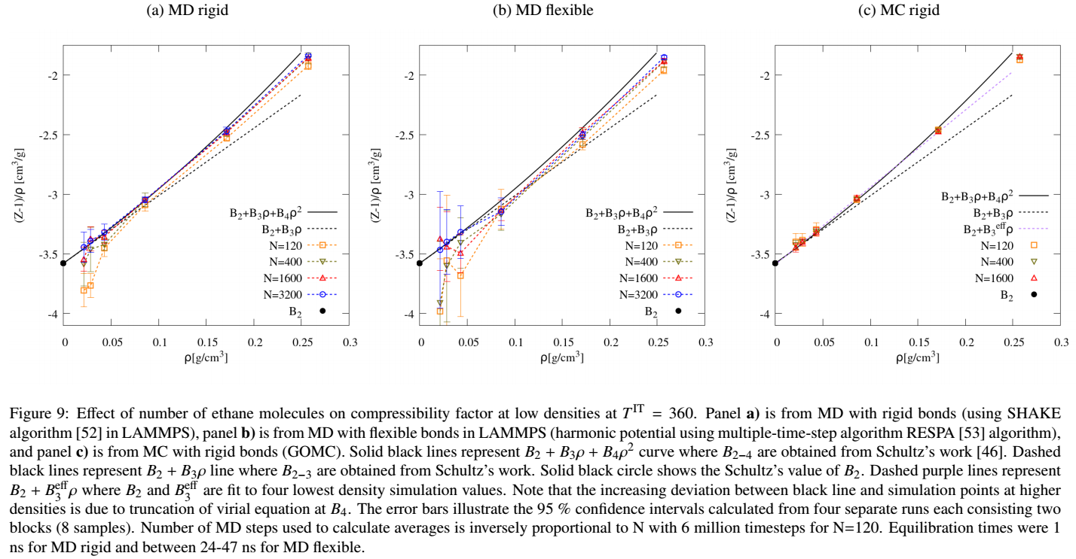

It is still important to note that MD flexible has two primary disadvantages. First, the required equilibration time is 1-2 orders of magnitude larger than MD rigid (which required an equilibration time of less than 1 ns). Second, the uncertainties are much larger than MD rigid for the same number of frames, i.e., MD flexible has larger fluctuations. The discussion on page 11 now reads:

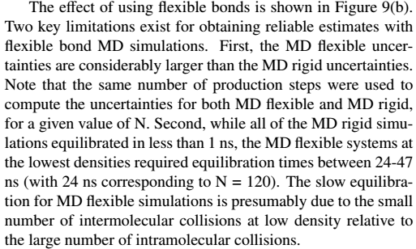

We also removed Figure 15 from the Supporting Information. This figure was added after the second review. The purpose of this figure was to present an empirical approach for correcting the MD flexible issue. However, after updating Figure 9b, Figure 15 of SI is no longer needed.