Day 3 Lab Assignments

- Make a navbar with rounded corners, and use Font awesome, to add some icons to the navbar items.

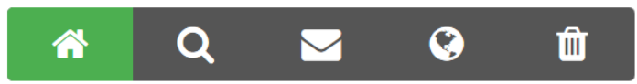

  - Use the icons from Font awesome.
  - Make the navbar items as list (ul), and inside each list item (li), add a link for each menu item.
  - Use list style type: none for the list items.
  - Use display: inline-block for the list items. (Why?).
  - Handle that when mouse over an item its background color , color to be changed, and the icon color also to be changed gradually (Use transition).

2-Make contact chip like this one:
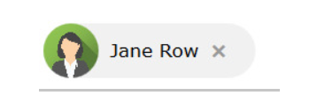

When user clicks (x) the div next to the image should be closed to the left gradually (use transition or animation and play it using JS), and when click the image it opens again.

3 - Make this fan move using switch buttons and each button control the speed of the fan

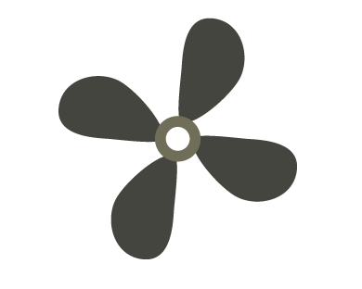

Bonus:
- Add an ON/OFF switch to start or stop the fan.
- Add a second switch to reverse the direction of the fan's rotation.


5 - Make this heart beat smoothly using only CSS. When the mouse hovers over it, the heart should stop beating, and when the mouse moves away, it should start beating again. Do not use JavaScript.


Right eye

Use Svg to draw simple face (use circles) and handle when mouse over on each part (eyes, mouse, and nose) its background color changes, and back to its original color on mouse over. When moving over any organ, show tooltip or a floating div with the organ name.

Create a simple avatar game using the HTML5 canvas.
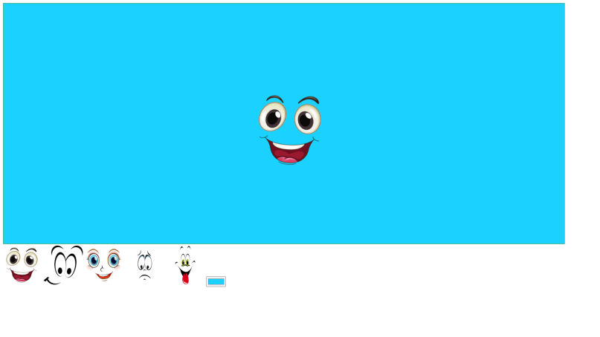
Use the canvas as an avatar board where the user can pick and change its color. Allow the user to select one of the provided face images and place it on the board at the specific position where they click.
Bonus:
• Resizable Face Image:
- Allow the user to resize the face image by providing an input (e.g., slider) to change the size of the face before placing it on the canvas.
• Show Placeholder of the Face:
- Show a preview or placeholder of the face image at the current mouse position, giving the user an idea of where the image will be placed before they click
Bonus Assignments:
- Make an analog clock using Canvas.
- Follow the following tutorial, and create the explained game: https://www.w3schools.com/graphics/game_intro.asp .
- Create some SVG drawings (Circle, rectangle, square...), in the left side of page as a toolbox, and beside them make a canvas and when drag a shape and drop it on the canvas, draw it in the canvas.
- Make animated bar chart (bars or lines or pie chart) using canvas (changed values every interval).
- Create an animated button (effects on background) using SVG.
- Draw smiley face that converted to sad face when clicked (using drawings not images, in a Canvas).
Enrich your Skills (big bouns!):
- Search for D3.js library, and make a demo on it.
- Search for SVG.js library, and make a demo on it.
- Search for three.js Library, and make a demo on it.
- Follow the following examples for:
  - https://css-tricks.com/click-svg-to-focus/
  - https://codepen.io/miguelra/pen/NAjNYA
  - https://codepen.io/manabox/pen/BvmCE
- Follow the following tutorials to make interactive SVG clickable maps:
  - http://www.creativebloq.com/netmag/create-responsive-svg-image-maps-51411831
  - https://www.jonathan-petitcolas.com/2013/07/18/create-clickable-svg-france-regions-map.html
  - JQuery library for SVG maps: https://jqvmap.com
- Follow the following SVG examples, and redo them by yourself:
  - https://www.w3schools.com/graphics/tryit.asp?filename=trysvg_polygon3
  - https://www.w3schools.com/graphics/tryit.asp?filename=trysvg_path
  - https://www.w3schools.com/graphics/tryit.asp?filename=trysvg_text
  - https://www.w3schools.com/graphics/tryit.asp?filename=trysvg_text5
  - https://www.w3schools.com/graphics/tryit.asp?filename=trysvg_animatemotion
  - https://www.w3schools.com/graphics/tryit.asp?filename=trysvg_animatemotion2
- Review the following Google Maps API tutorial, and apply a demo on it: https://www.w3schools.com/graphics/google_maps_intro.asp
- Review the following Canvas demos, and redo it by yourself: http://corehtml5canvas.com/code-live
https://developer.mozilla.org/en-US/docs/Games/Tutorials/2D_Breakout_game_pure_JavaScript
- Review the following canvas demo, and redo it by yourself: https://www.w3schools.com/graphics/tryit.asp?filename=trycanvas_clock_start
https://developer.mozilla.org/en-US/docs/Games/Tutorials/2D_Breakout_game_pure_JavaScript

<Thank>YOU </Thank>

