HTML5&CSS3

DAY1 ASSIGNMENT

Assignment 1: Create a Contact Form

Create a basic HTML contact form with the following fields:

Name (Required): with id = “required”

Age (Min 18, Max 60):

Birthday (date)

Message (textarea)

Submit Button (button)

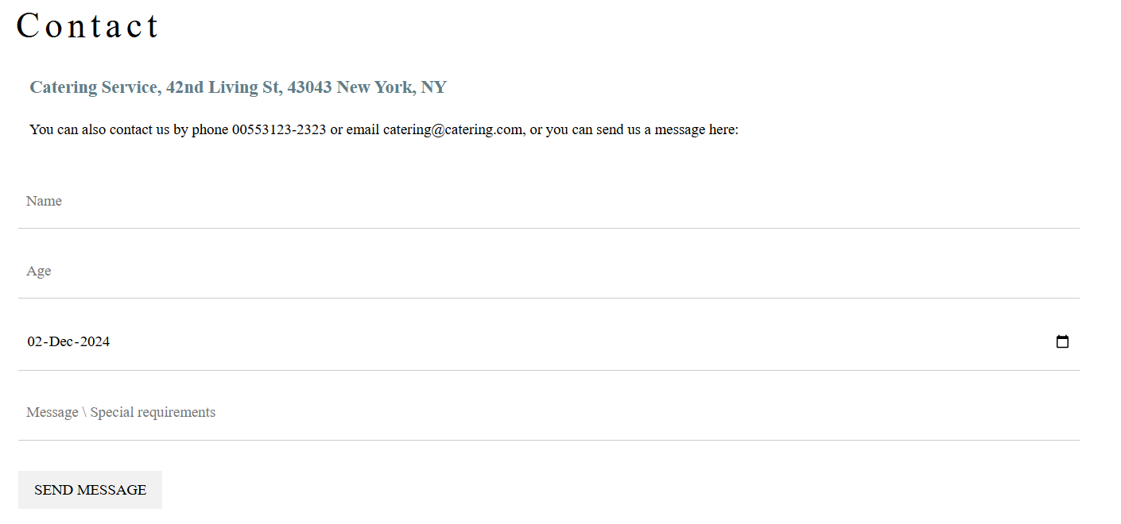

Assignment 2: Create a Font Size Slider

Create an <h1> element that contains any text of your choice. With class welcome

Add a range slider <input type="range"> below the <h1> element.

Use JavaScript to adjust the font size of the <h1> element as the slider is moved.
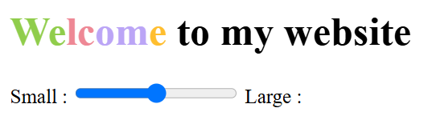

Assignment 3: Create an Expandable Feedback List
Design a feedback section with multiple user comments.
For each user, include:
A small icon or image representing the user (as shown).
The user's name.
A toggle button (or arrow) that expands/collapses the user's feedback message.

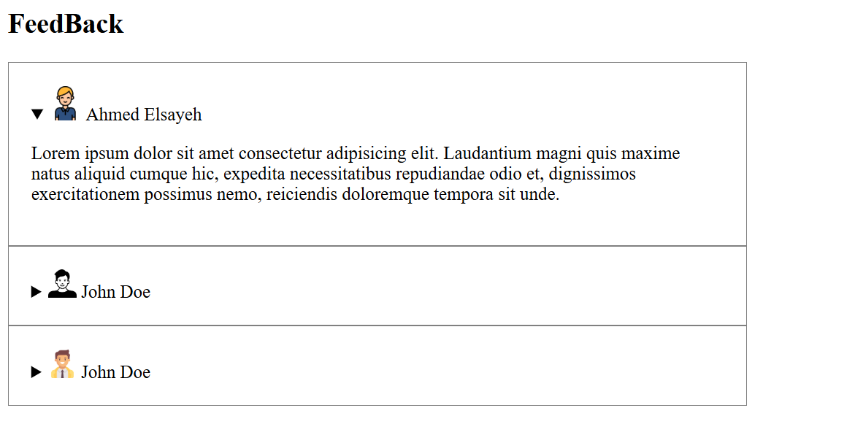
*note* don’t use javaScript

Assignment 4 : Creating a Help Button with an Alert Modal

create a "Help" button that, when clicked, opens a modal window containing a message, an image, and a link for further information



“Use dialog “

Assignment 5 : Embed a Video Using the <video> Tag with its controls

