Weekly Project Progress Report & Deployment Preparation

1. Project Overview
Project Title: TaskFlow — Real-Time Collaborative Task Management Platform with Sentiment-Aware Feedback Analysis
Short Description: TaskFlow is a full-stack MERN web application that enables users to manage personal and project-based tasks, collaborate with teammates in real time, track audit logs, and gain intelligent insights from user feedback through a built-in NLP sentiment analysis engine.
Current Completion: 100% — Fully deployed and live
Live URL: https://github-publish.replit.app
Demo Video: https://drive.google.com/file/d/1gp-gPlHlvm6GAQ9Tfdmhyx5xqWWj0YOj/view?usp=drivesdk

2. Team Contributions

Member 1: Mostafa Tfaily (120080)
Tasks Completed:
  - Designed and implemented all Mongoose schemas (User, Task, Project, Friendship, Notification, Log, Feedback)
  - Built all backend routes: users, tasks, projects, friendship, notifications, logs, feedbacks
  - Implemented JWT authentication middleware and session security
  - Engineered real-time Socket.io server — room management, event emission for friend requests, project invitations, task assignments, and accepted requests
  - Implemented audit logging system for full traceability of all user and admin actions
  - Integrated Nodemailer for password reset and change-password confirmation emails
  - Implemented all API data fetching and integration on the frontend — connecting every page to its backend endpoint with proper error handling, loading states, and auth headers
  - Implemented the Sentiment Analysis engine from scratch in TypeScript (VADER-inspired weighted lexicon, negation detection, score normalization — no external library)

Contribution:
Full backend architecture, Socket.io real-time layer, audit logs, and all frontend API integration logic.

Member 2: Wassem Abou Arab (120581)
Tasks Completed:
  - Designed and implemented the full UI of all application pages using React, Tailwind CSS, and custom dark-theme styles
  - Built reusable frontend components: Navbar, Sidebar, Footer, TaskStructure, ProtectedRoute
  - Designed the friends interface, project dashboard UI, admin dashboard layout, and all form pages
  - Prepared the frontend project environment and component structure for backend integration

Contribution:
Frontend UI design and implementation — all visual layouts, component architecture, and user experience.

3. Work Completed (Full Feature List)
- User registration, login, and JWT-based authentication
- Forgot / reset password flow via email (Nodemailer)
- Change password from Profile with bcrypt verification and email confirmation
- Personal task CRUD — create, edit, delete with priority, due date, start/end time
- Done / Undone / All task views with priority filtering
- Project management with owner and member roles
- Assign tasks to project members with priority, description, and due date
- Friends system — send, accept, and block friend requests
- Real-time notifications via Socket.io (friend requests, project invitations, task assignments, accepted requests)
- Global Socket context wrapping the entire app for live event propagation
- Analytics dashboard with circular progress charts (react-circular-progressbar)
- Admin dashboard — manage users, update roles, ban/unban, delete accounts
- Admin username filter input for fast user lookup
- Registration Date column in admin user table
- Audit logs page — full traceability for both user and admin actions
- User feedback submission and admin review
- Sentiment Analysis on user feedback — VADER-inspired NLP algorithm with weighted lexicon (~60 words, −3 to +3), negation detection, score normalization, live badges, and summary panel
- Profile management — edit username and email
- Full deployment on Replit with MongoDB Atlas, environment secrets, and Socket.io proxying

4. Demonstration
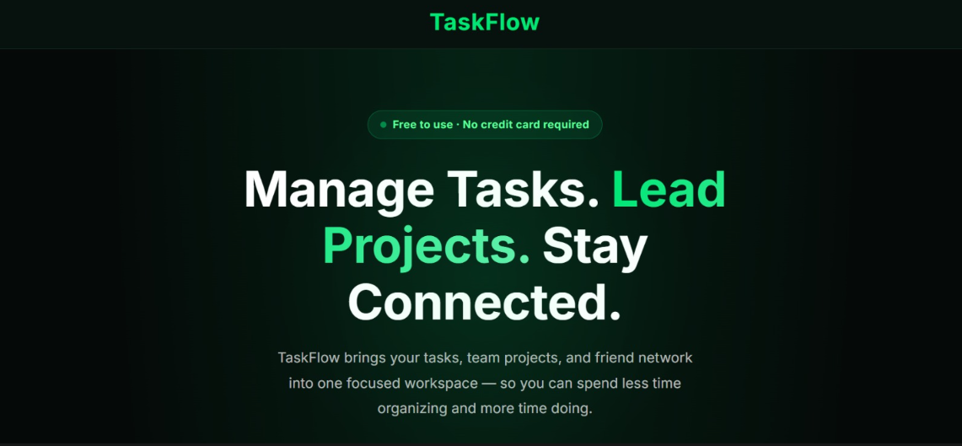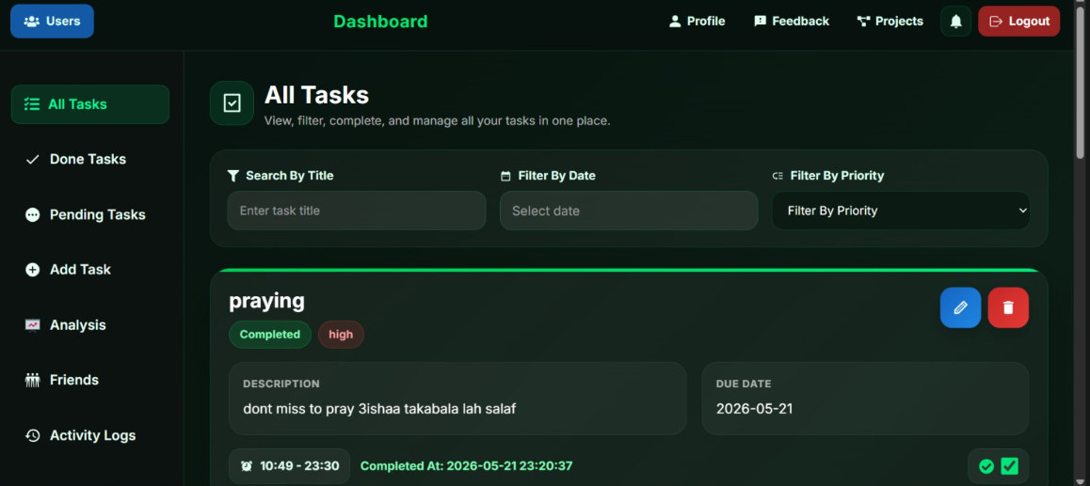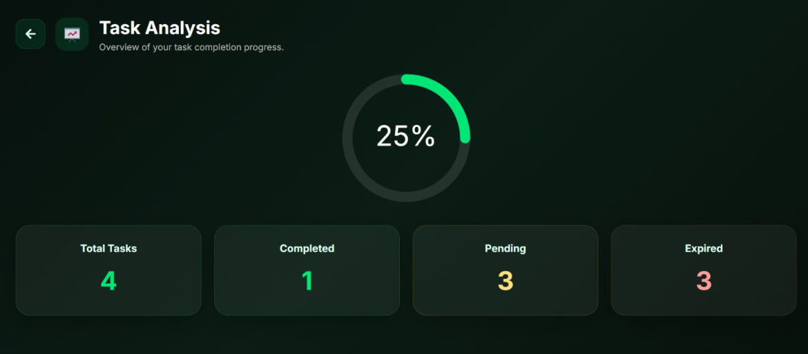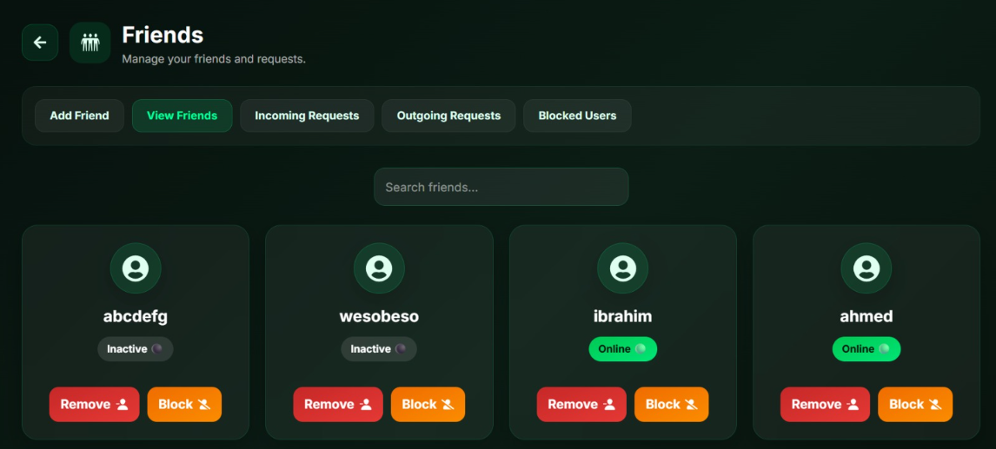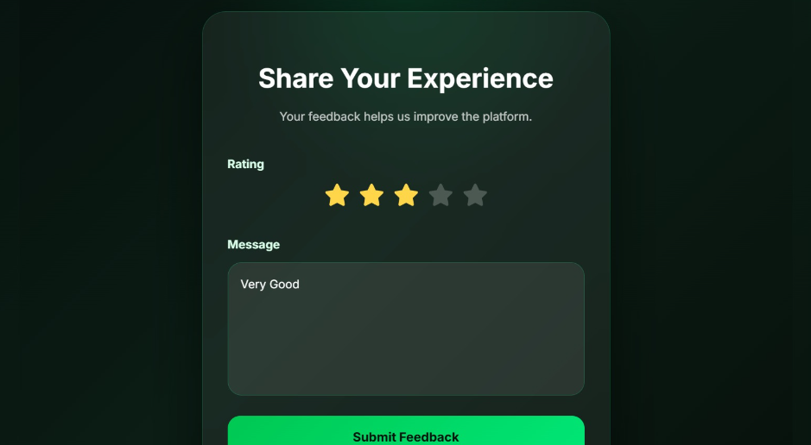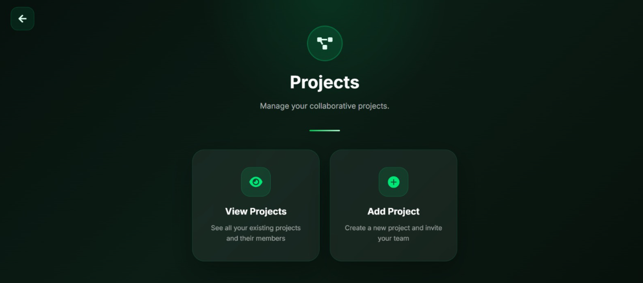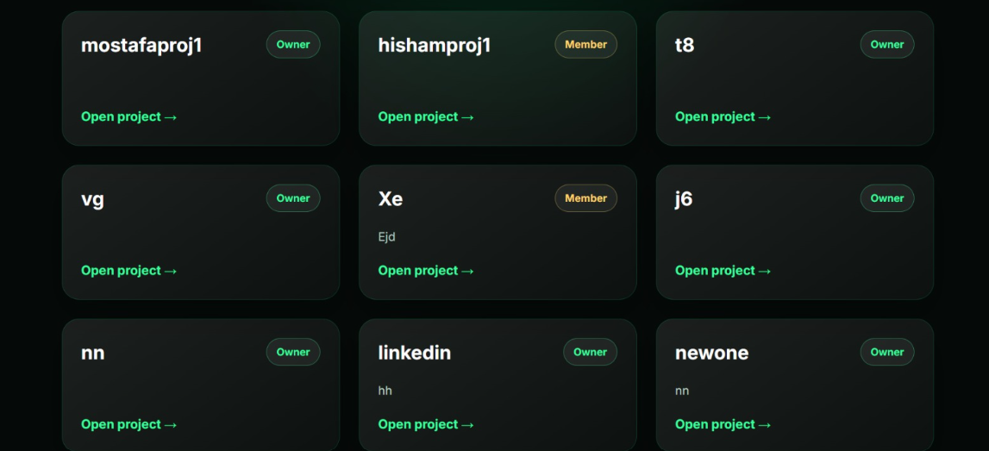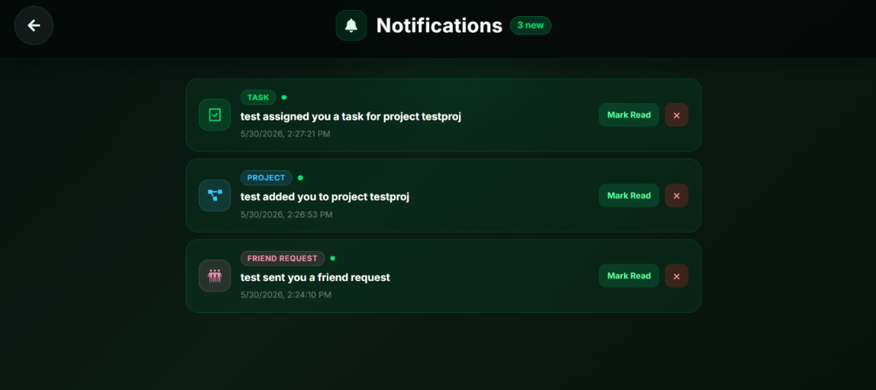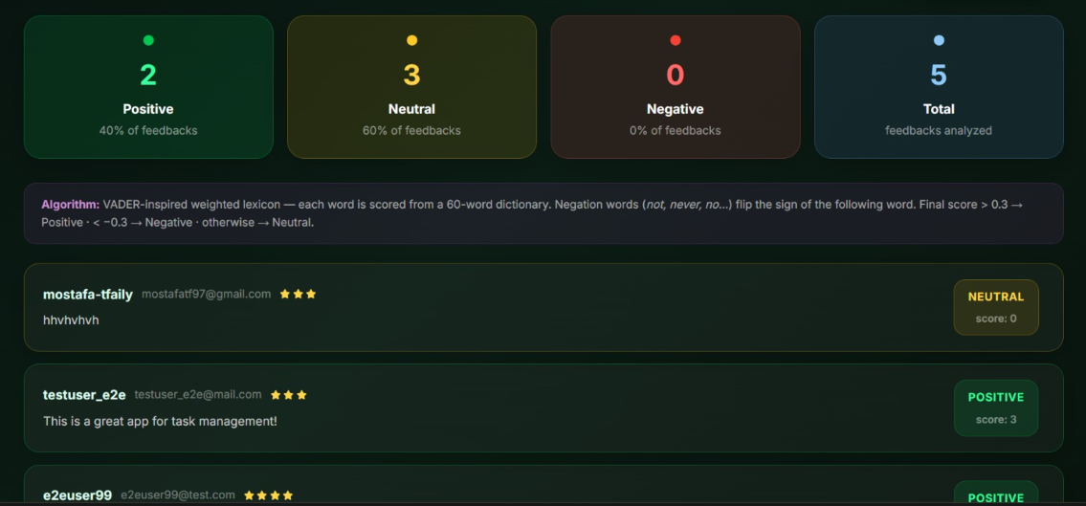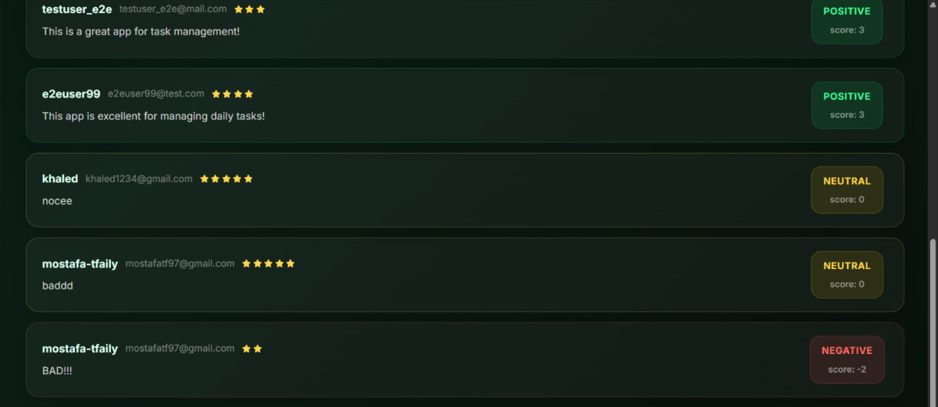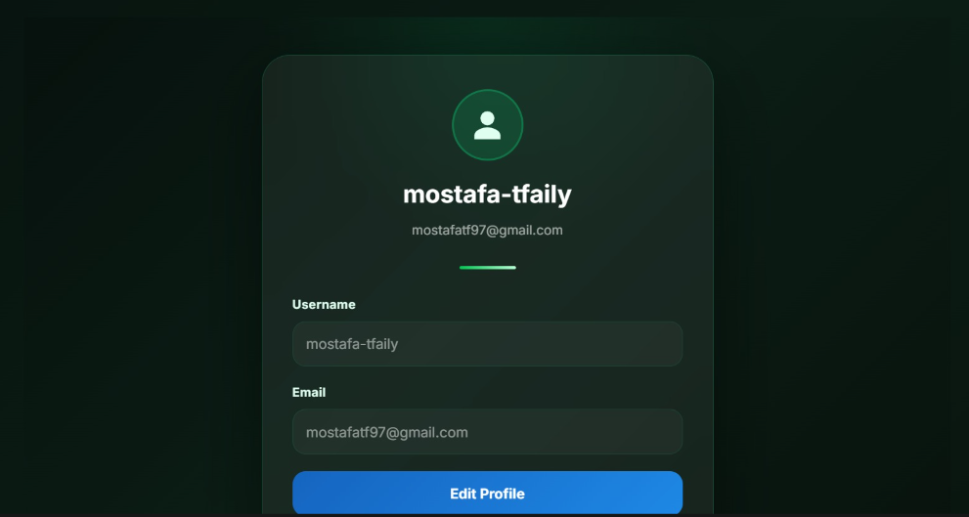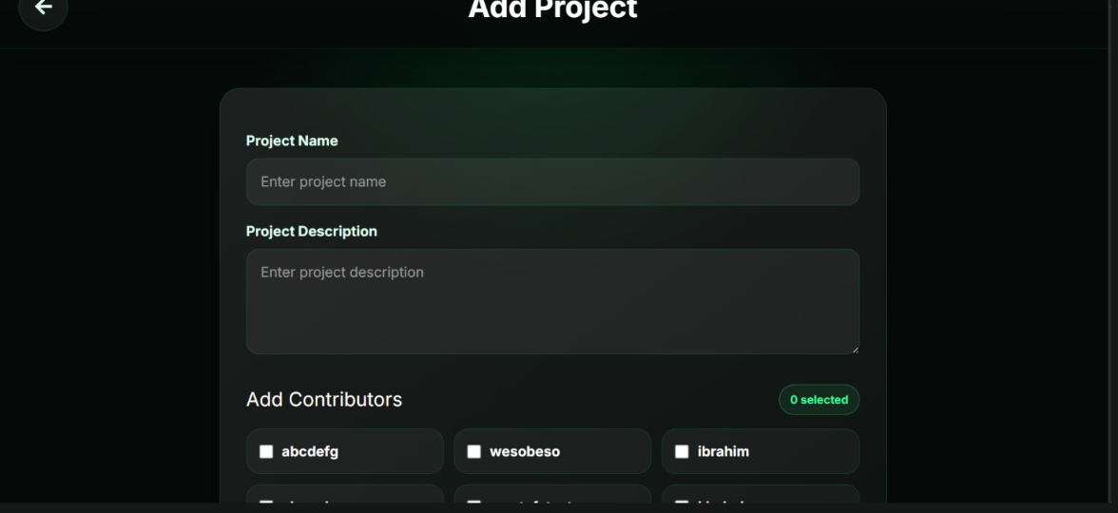
Demo Video : https://drive.google.com/file/d/1gp-gPlHlvm6GAQ9Tfdmhyx5xqWWj0YOj/view?usp=drivesdk

5. Challenges & Solutions

Challenge | Resolution
Socket.io rooms not receiving events cross-route | Used a global SocketContext with useState so the socket instance persists across all pages via React context
White dropdown popup in native <select> elements | Applied solid hex #0b1a12 background with color-scheme: dark via global CSS — rgba falls back to white in native dropdowns
Aggregation for audit logs and analytics | Resolved using Mongoose populate + manual aggregation on backend routes
Bi-directional friendship prevention | Enforced in the addfriend route by checking both directions of the relation before inserting
MongoDB Atlas connectivity from Replit | Set Network Access to 0.0.0.0/0 in Atlas to allow all IPs

6. Deployment Checklist
✔ Application runs without errors
✔ MongoDB Atlas connected and seeded
✔ All environment variables configured (MONGODB_URI, JWT_KEY, SESSION_SECRET, MAIL_USER, MAIL_PASS)
✔ Backend deployed and serving at /api
✔ Frontend build deployed and serving at /
✔ Socket.io proxied correctly through /api/socket.io
✔ Full end-to-end testing completed
✔ Live at https://taskflow.replit.app

