Weekly Project Progress Report & Deployment Preparation

1. Project Overview
• Project Title: Task Management and Jira-like App
• Short Description: A task management system that helps users organize personal tasks, track project progress, and assign tasks to contributors in a simple and efficient way.
• Current Completion: ~70%

2. Team Contributions
- Member 1: Mostafa Tfaily (120080)
• Tasks Completed: Designed friendship and project schemas, implemented routes, and tested them.
• Tasks In Progress: Improving routes for better security and reliability, working on API data fetching in frontend.
• Contribution: Backend development (routes, middleware, schemas, security) and frontend API integration with error handling.
- Member 2: Wassem Abou Arab (120581)
• Tasks Completed: Designed friends interface and prepared environment for backend integration.
• Tasks In Progress: Designing project interface for mini Jira feature.
• Contribution: Frontend development (UI implementation and design).

3. Work Completed This Week
• Implemented analysis page
• Implemented reset password page
• Implemented friends feature (frontend and backend)

4. Demonstration

Screenshots

Home Page
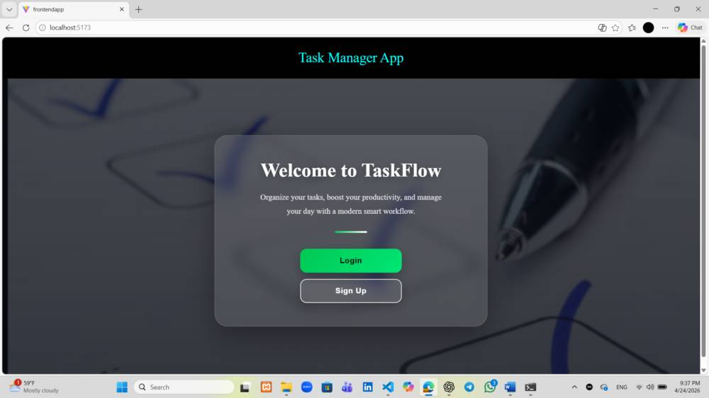

Login Page
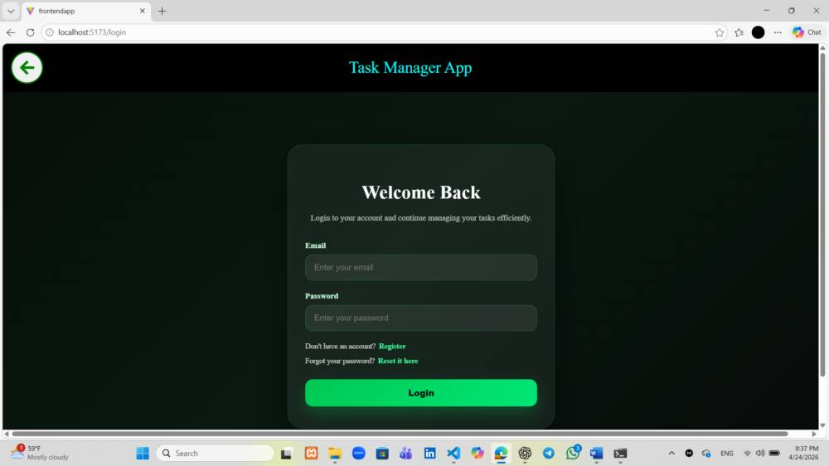

All Tasks Dashboard
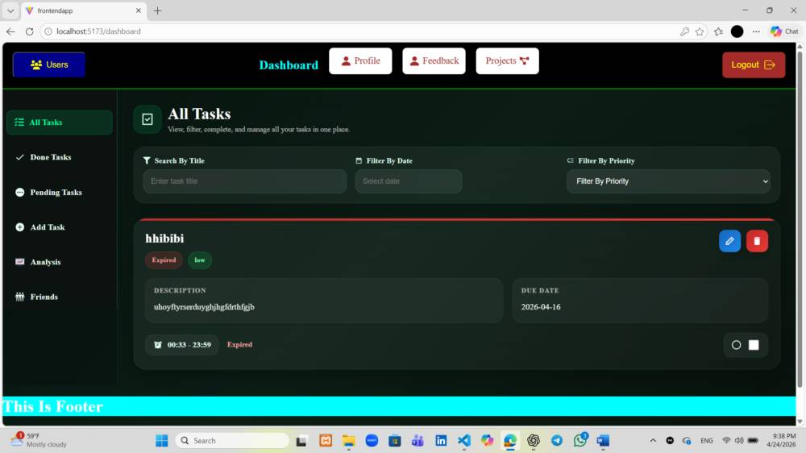

Profile Page
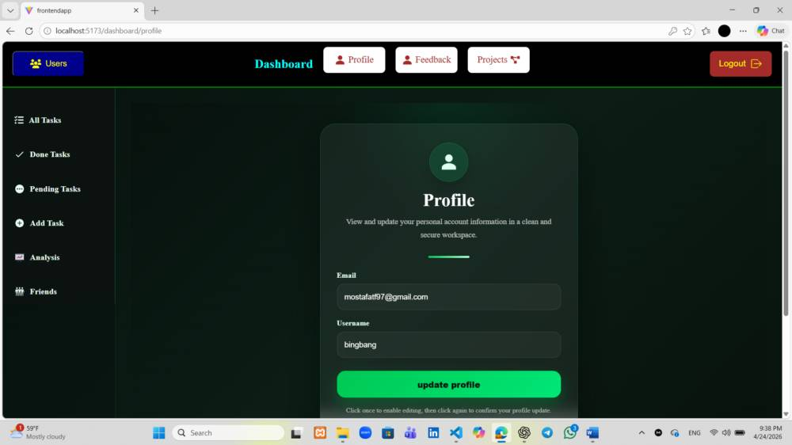

Feedback Page
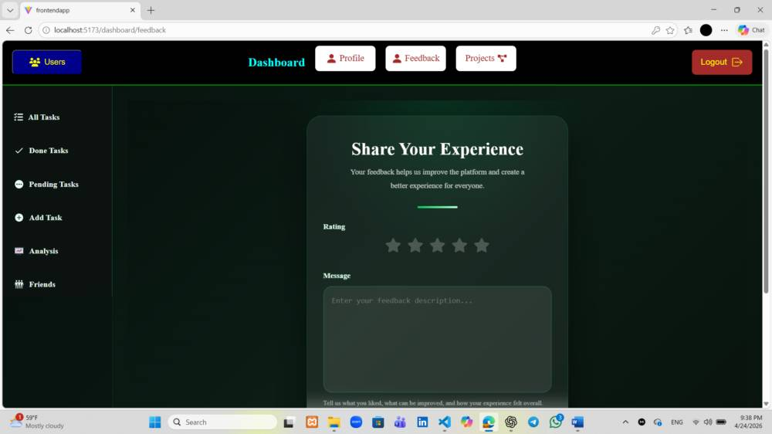

Project Dashboard
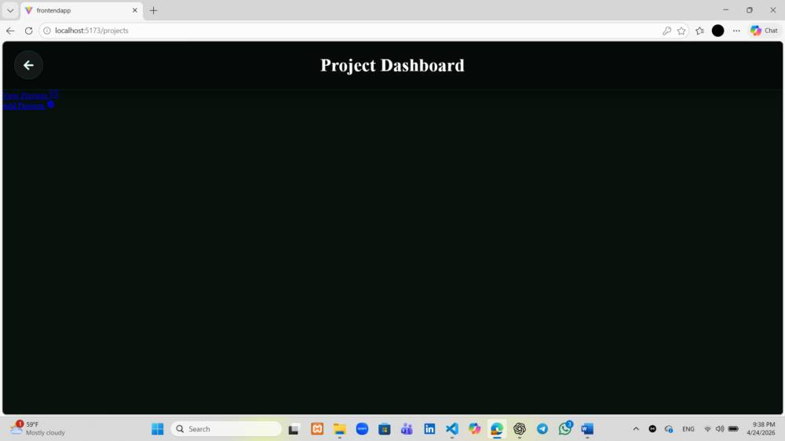

Done Tasks Page
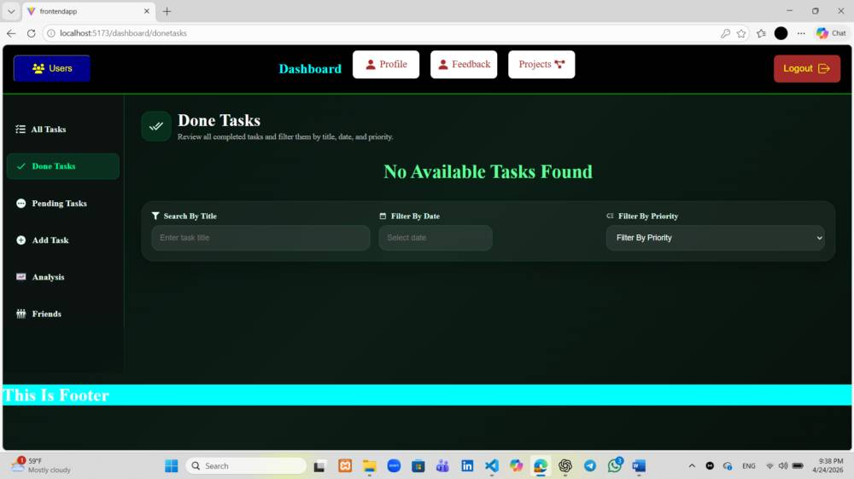

Pending Tasks Page
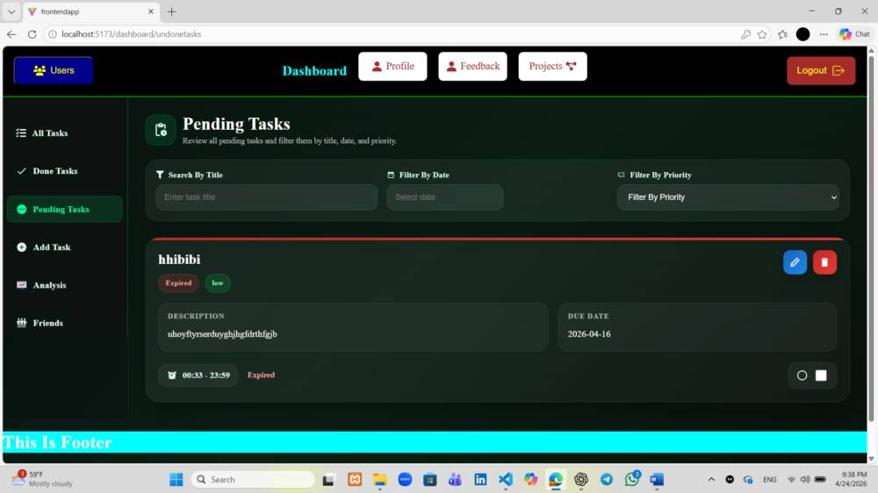

Add Task Page
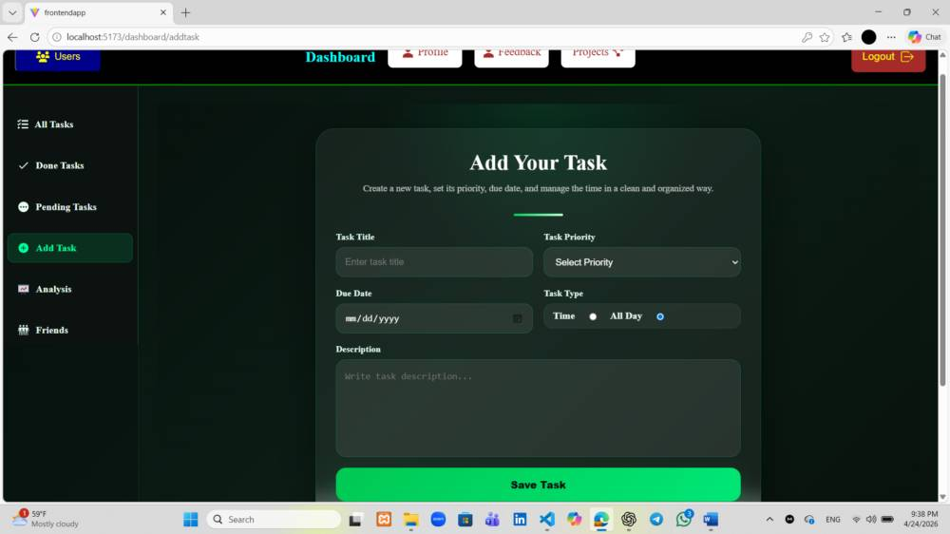

Analysis Dashboard
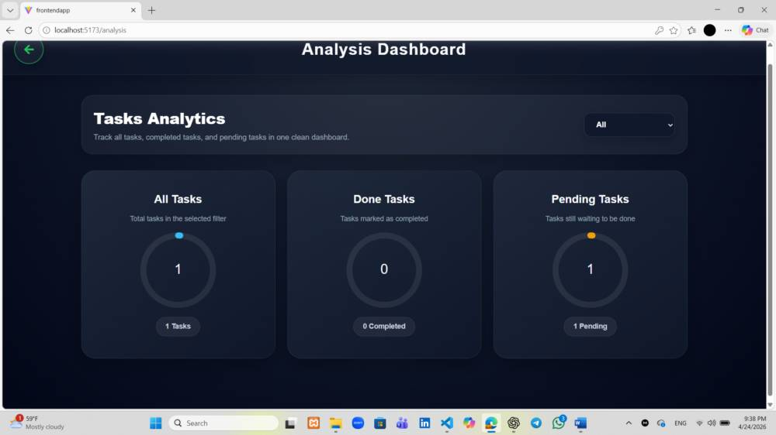

Friends Dashboard
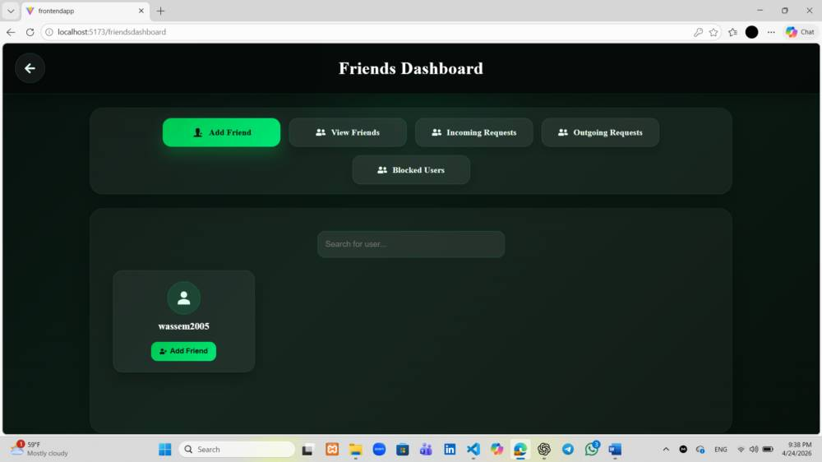

Sign Up Page
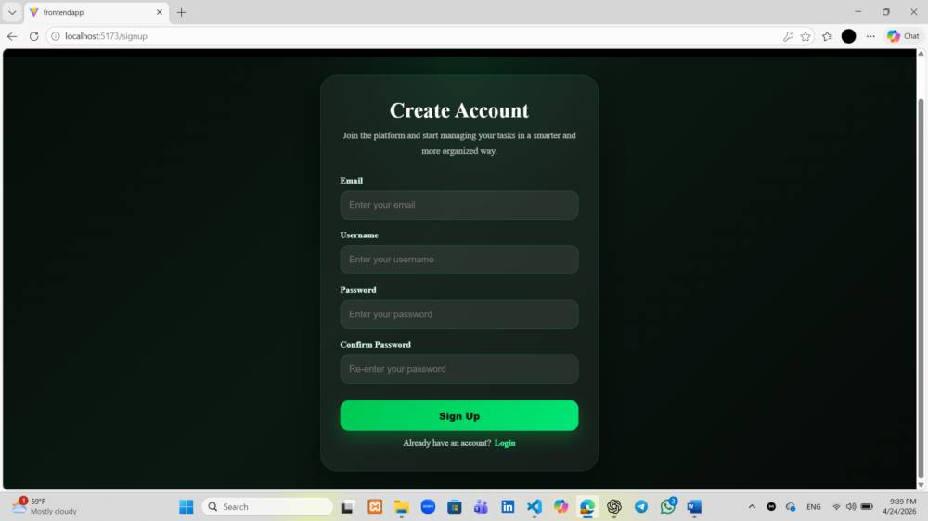

Admin Dashboard
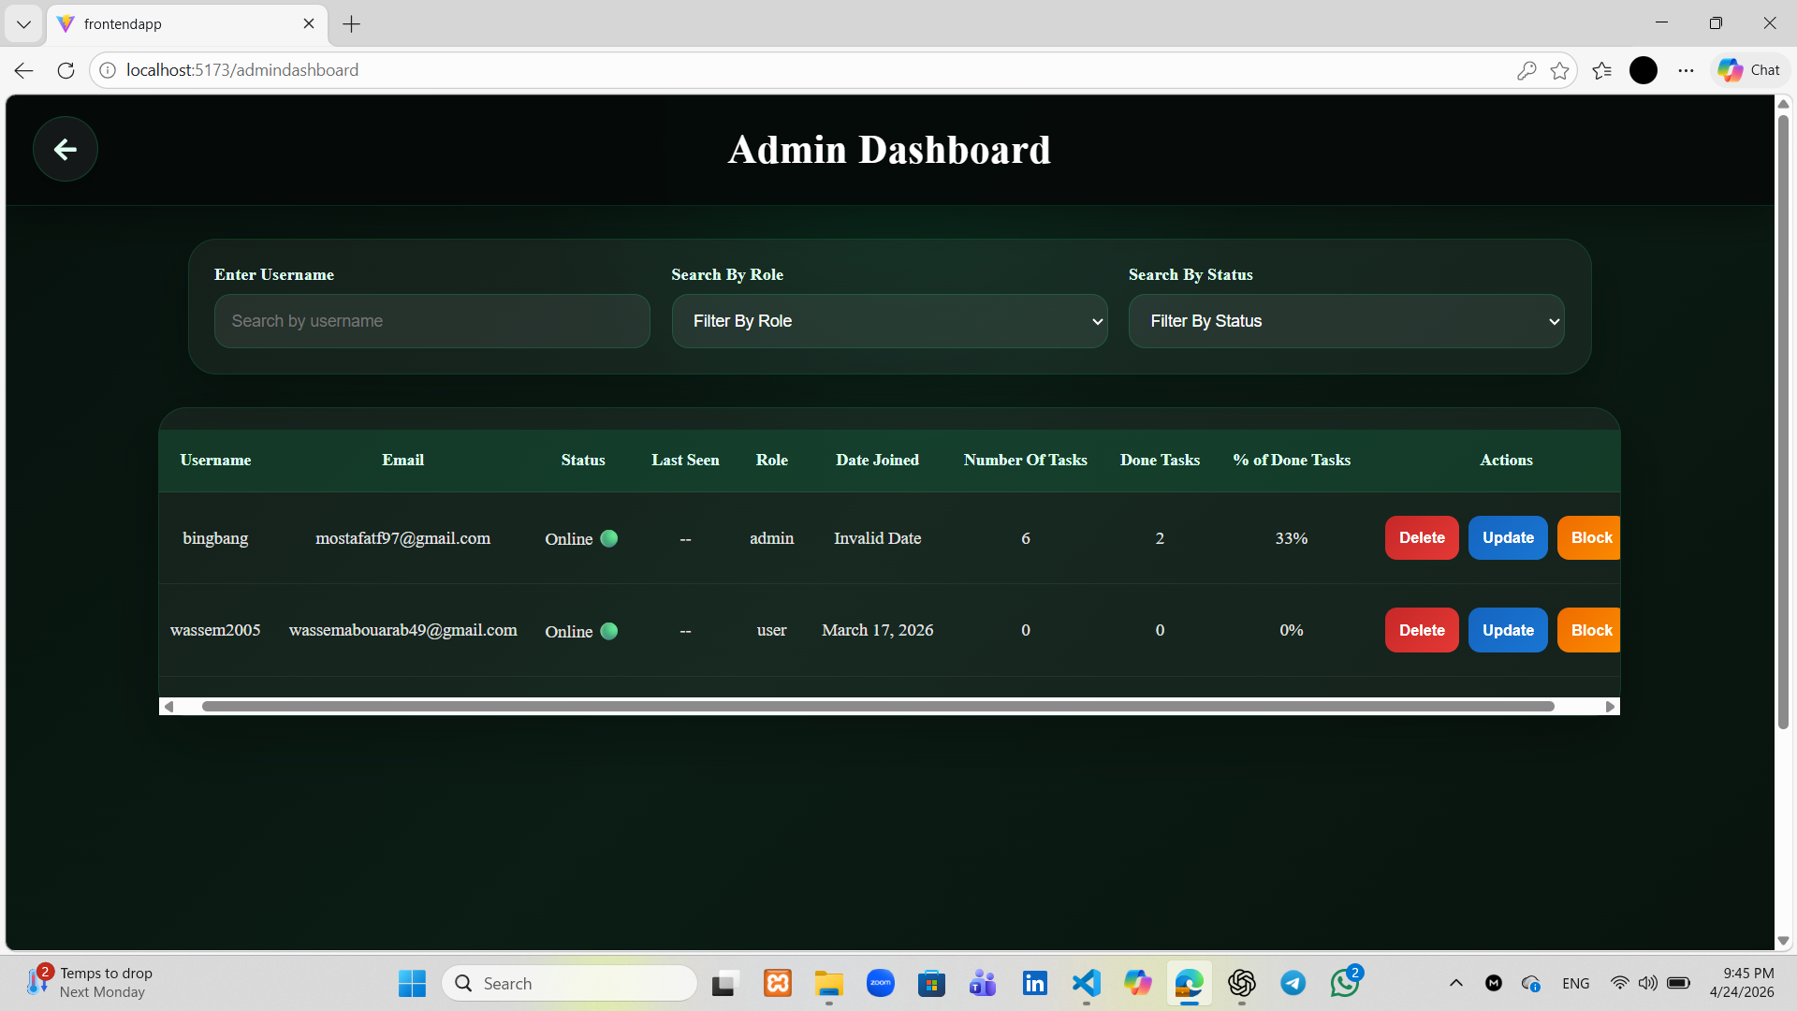

Update User Page
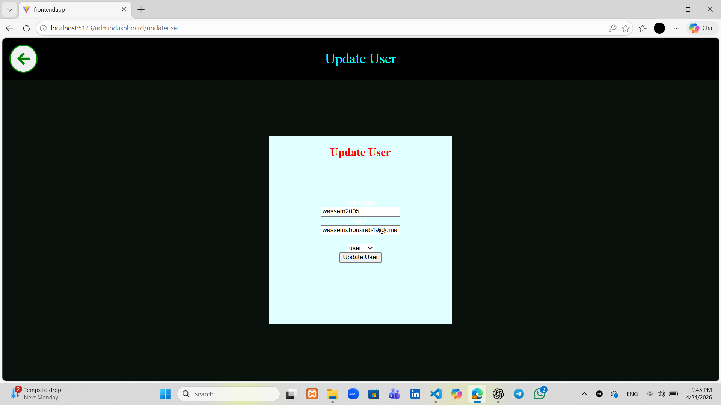

Demo Video

5. Challenges / Blockers
• Technical: Server error handling issues
• Missing Knowledge: Aggregation in Mongoose
• Missing Knowledge: Bi-directional relations and prevention in Mongoose
• Team Coordination: Connection issues related to one team member

6. Plan for Next Week
• Complete mini Jira feature
• Finalize all remaining functionalities
• Deploy the full application (frontend and backend)

7. Deployment Preparation Checklist
• Application runs locally without errors done
• Database is ready done
• Environment variables configured done
• Backend ready for deployment done
• Frontend build ready done
• Basic testing completed done

8 Youtube Video :
https://youtu.be/6c3_4-52180?si=qaWZqKi0LVd0YGFh

