Name: Mostafa waheed Yahia Abd elaty

الاسم: مصطفى وحيد يحيي عبد العاطي

B.N: 941

كود مادة الحاسب:006

Date:25/5/2020

GitHub link: <https://github.com/mostafa-wahed/html-project-repository>

GitHub pages published website: <https://mostafa-wahed.github.io/html-project-repository/curves.html>

Topic: programming languages

Computer programming languages allow us to give instructions in a language which the computer understands to a computer. Just like there are many human-based languages, programmers may use a number of computer programming languages to interact with a computer. The portion of the language a computer can understand is called a “binary.” Translating programming language into binary is known as “compiling.” Each language, from C Language to Python, has its own distinct features, although programming languages often have commonalities.

Such languages allow computers to process broad and complex swaths of information quickly and efficiently. For instance, if a person receives a list of randomized numbers ranging from one to ten thousand and is asked to place them in ascending order, it is likely to take a considerable amount of time and include some errors.

**python**

Python is an advanced language of programming that is interpreted, object-oriented, and built on versatile and robust semantics.

**Applications of python:**

* Python developers, software engineers, back end developers, Python programmers
* Used by IT, engineering, professional services and design employers

Java

java is a high-level, object-oriented, general-purpose programming language with several features making it ideal for web-based development.

Applications of java

* Java developers, Software engineers
* Employers are used in communications, education, finance, healthcare, hospitality, retail and utilities.
* Internet of Things (IoT), Enterprise Architecture, Cloud Computing

**Screenshots**

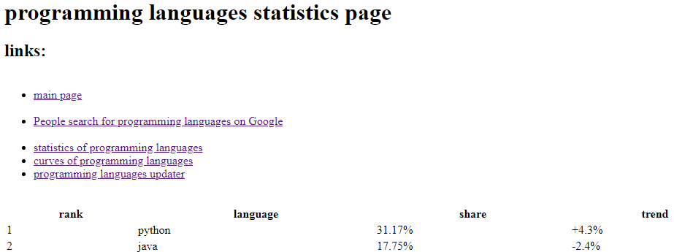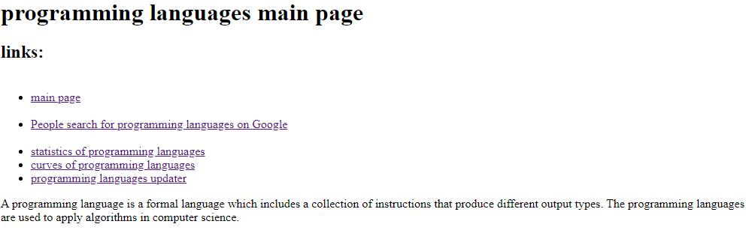

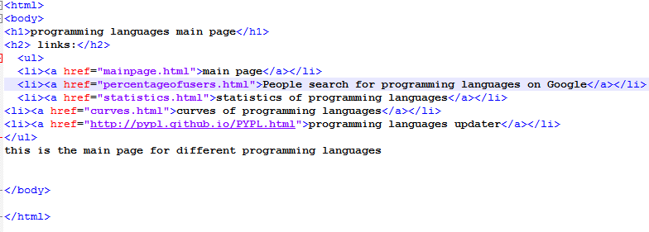**Source code**

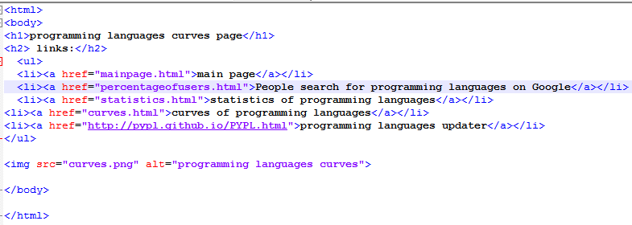

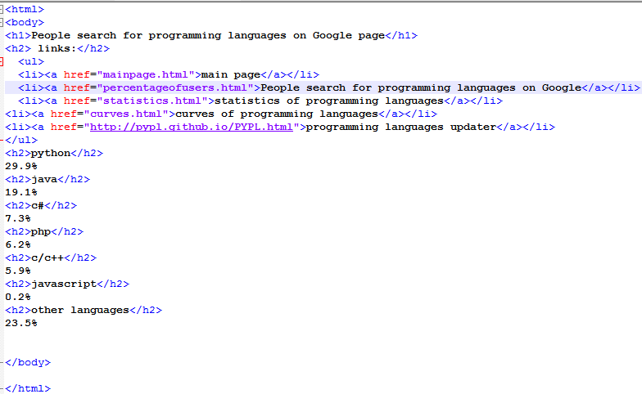

* 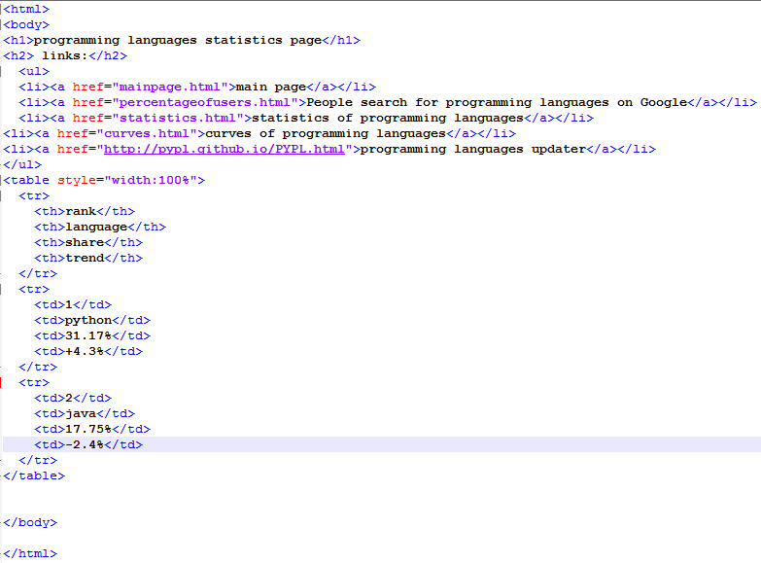

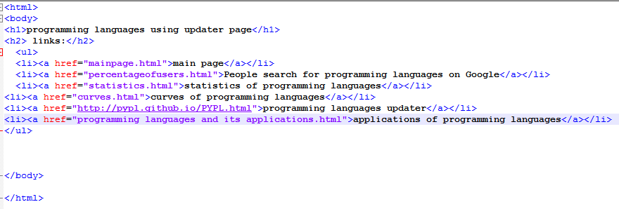

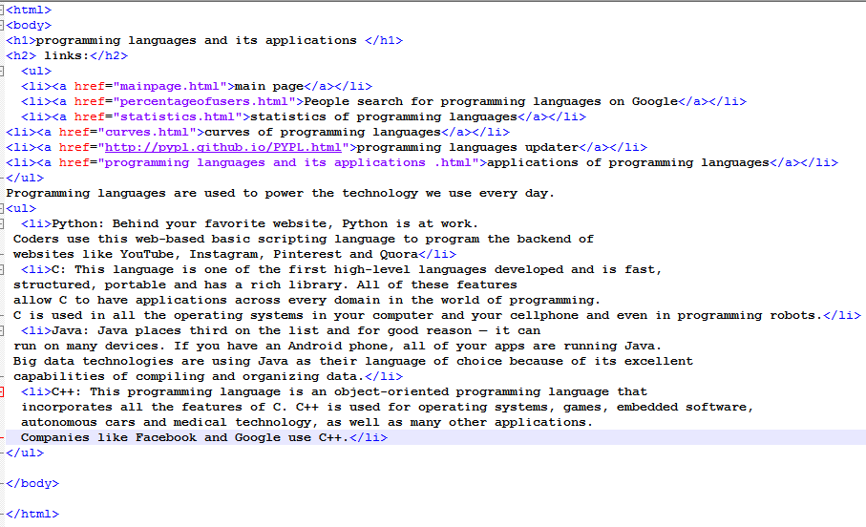

References

computer programming language | Types & Examples. (2020). Retrieved 30 May 2020, from <https://www.britannica.com/technology/computer-programming-language>

Writers, S. (2020). Guide to Programming Languages | ComputerScience.org. Retrieved 30 May 2020, from <https://www.computerscience.org/resources/computer-programming-languages/>

Blonde, T. (2020). 10 Programming Languages and Their Uses | Coding Blonde. Retrieved 30 May 2020, from <https://codingblonde.com/10-programming-languages-and-their-uses/>