Chapter 7: Tables & Chains

7.1 Hooks
The hooks are events that are triggered by every packet that arrives at the Linux box or is generated by the Linux box which should traverse through hooks in order to be easily differentiated and categorized. Also, a function named NF_HOOK() is called to handle different packets based on their hook's name. The handler of each hook call many rules that are inserted into the chains of different tables to process each packet. There are five hooks available in the Linux kernel which are shown in Figure 7-1 and they are described in Table 7-1.

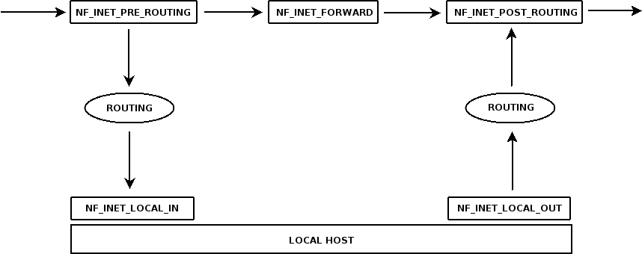

Figure 7-1. Packet traversal in the hooks (The picture, change it!!!)

Hook | Function
NF_INET[6]_PRE_ROUTING | The packets arrived at the Linux box are passed to this hook from the communication device (eth0, ppp0, ...).
NF_INET[6]_LOCAL_IN | The packets destined at the Linux box is passed to this hook after some routing process performed on them.
NF_INET[6]_FORWARD | The packets that are neither destined to the Linux box nor is locally generated are passed to this hook for forwarding.
NF_INET[6]_LOCAL_OUT | The packets that are locally generated are passed to this hook and after some routing process, they go out.
NF_INET[6]_POST_ROUTING | The packets that are going to leave this box are passed to this hook.
Table 7-1. Different hooks in the Linux kernel

The [6] notation in the table means that the hooks of the IPv6 are different from those of IPv4.

7.2 Tables
In order for every function of the iptables to be categorized, there are four tables: filter, nat, mangle and raw. Each of these tables has access to a set or all of the hooks that are discussed in the Section 7.1. The names of the tables are self-explanatory but what....?????

7.3 Chains
As you have seen, each table binds itself with a set of hook that are called chains in the context of iptables. Each chain contains a set set of rules and a specific policy that decides what to do with the packet if it does not match the criteria of the rules contained in that chain. Each table and its corresponding chains (and hooks) are shown in Table 7-2.

Table | Chains (Hooks) | Function
filter | INPUT (NF_INET_LOCAL_IN) | Filters packets that are destined to this box.
filter | FORWARD (NF_INET_FORWARD) | Filters packets that are going to be forwarded by this box.
filter | FORWARD (NF_INET_FORWARD) | Filters packets that are generated locally.
filter | OUTPUT (NF_INET_LOCAL_OUT) | Filters packets that are generated locally.
nat | PREROUTING (NF_INET_PRE-ROUTING) | Translates source addresses and ports to perform SNAT and Masquerade.
nat | POSTROUTING (NF_INET_POST-ROUTING) | Translates destination addresses and ports to perform DNAT and Redirect.
nat | OUTPUT (NF_INET_LOCAL_OUT) | Translates locally generated packets.
mangle | PREROUTING (NF_INET_PRE-ROUTING) | Alters packets that are received by the box and are not routed yet.
mangle | INPUT (NF_INET_LOCAL_IN) | Alters packets that are destined to this box.
mangle | FORWARD (NF_INET_FORWARD) | Alters packets that are going to be forwarded.
mangle | OUTPUT (NF_INET_LOCAL_OUT) | Alters packets that are locally generated.
mangle | POSTROUTING (NF_INET_POST-ROUTING) | Alters packet that are routed and are going to go out on the wire.
raw | PREROUTING (NF_INET_PRE-ROUTING) | Processes packets that came from any network interface. (NOTRACK status)
raw | OUTPUT (NF_INET_LOCAL_OUT) | Processed packets that are locally generated. (NOTRACK status)
Table 7-2. The IP tables

Two types of chains exist, the built-in chains that are shown in Table 7-2 and the user-defined chains which are created by the user and are used as the target of the rules (for more information about targets refer to Chapter 8). Note that there are also Ipv6 hooks which their names start with NF_INET6_* , but they are the same except that they work on IPv6 stack.

7.4 Commands
Here you are going to learn the actual iptables' commands and the arguments that are passed by the shell to the iptables' executables to run our specified piece of code. The commands that are shown here are just related to the tables and chains. For the complete commands' reference of the iptables refer to Appendix A.

7.4.1 Choosing the Table
In order to choose the table (function) you want to incorporate, you should use the iptables tool with the -t argument followed by four parameters; these are filter (it is the default value and need not be specified), nat, mangle and raw. The actual syntax is iptables [-t table]. Also note that the Ipv6 equivalent tool, ip6tables, is used on the filter, mangle and raw tables and the syntax is ip6tables [-t table]. The options are shown in Table 7-3.

Command | Description
ip[6]tables [-t filter] | Used to choose the filtering (firewall) function of the iptables; it does not alter packets, it just filters them.
iptables -t nat | Used to choose the NAT function of the iptables; it does alter packets and can be used in conjunction with filter table to filter packets.
ip[6]tables -t mangle | Used to alter packet headers like MSS, TOS, TTL, ... .
ip[6]tables -t raw | Used to bypass the connection tracking when the connection tracking is in the NOTRACK status.
Table 7-3. Choosing the table

The arguments that are passed to these commands are the same. It means that both iptables [-t table] and ip6tables [-t table] will operate on different tables. As mentioned in Chapter 5 (network address translation), there is no need of NAT in the IPv6, because it does not need any further extension for available public addresses.

7.4.2 Chains
There are many ways to manipulate chains, from adding rules to the chains to creating new user-defined chains. Each argument and its parameters are shown in Table 7-4. The syntax is ip[6]tables [-t table] -argument chain [rule-number] [rule-spec].

Command | Description
-A chain rule-spec | Appends one or more rules to the end of the specified chain.
-D chain rule-spec  -D chain rule-number | Deletes rules from the chains either by number (starting from 1) or by matching rule(s).
-I chain [rule-number] rule-spec | Inserts one or more rules to the head of the specified chain.
-R chain rule-number rule-spec | Replaces a rule by the number specified and by matching the rule specifications.
-L [chain] | List the entire chain rules. If no chain is specified then the chains of the filter table are shown.
-S [chain] | Like the -L argument, it list the chain rules but in the manner of iptables-save.
-F [chain] | Flushes [deletes] entire chain rules.
-Z [chain] | Resets the packet- and byte-counters in all chains.
-N chain | Creates a new user-defined chain.
-X [chain] | Deletes the user-defined chains that are empty (there should be no rules or references when you want to delete the chain).
-P chain target | Sets a policy on the specified chain (For more information refer to Chapter 9).
-E old-chain-name new-chain-name | Renames the user-defined chain
Table 7-4. Chains arguments and parameters

Look at the examples shown in Figure 7-2 to better understand the function of each argument and its corresponding parameters. Also consider that running another Linux box in a virtual machine emulator like Qemu to test these rules will save you many times and a lot of headaches by mis-configuring your actual firewall. Test it, it won't hurt.

# iptables -A INPUT -p icmp -j DROP
// it drops all the icmp packets destined to this machine

# iptables -t mangle -L OUTPUT / -S OUTPUT
// it lists all the rules of the OUTPUT chain in the mangle table

# iptables -N my-wall
// it creates a new user-defined chain named my-wall.

# iptables -t nat -Z OUTPUT
// it reset all the counters of the OUTPUT chain in the nat table

# iptables -t filter -P OUTPUT DROP
// it drops all the packets that are generated locally if no rule is defined in the OUTPUT chain of the filter table (it sets the whole policy of the chain)
Figure 7-2. Examples of tables and chains arguments and parameters
7.5 Summary:
As the name of the iptables imply, it consists of many tables, each serving different functions. The traversal of the packet through Netfilter/Iptables infrastructure can be easily summarized into three categories; packets that are destined to the box, packets that are going to be forwarded and packets that are generated locally. There are also some routing process which takes place and then derives two other hooks, one before that actual process of routing and one after completing the routing process.

The commands in this chapter are for learning purpose only and the actual scenarios that you can use to make use of these commands will be introduced in Chapter 15 – Real World Examples. The reference of all the commands that are shown throughout the book is in Appendix A.

Good luck.

