August 16, 2026



ATLASLOGIX PLATFORM
SYSTEM ARCHITECTURE

MOSTAFA EL-SHERBINIY
Sr. Frontend Engineer
mostafa.elsherbini@alrajhitakaful.com
Table of Contents
Executive Summary 2
Architectural Core Pillars 2
1. High-Level System Architecture 3
2. Core Architecture Principles & Folder Structure 4
3. Authentication, Session & Multi-Tenant Architecture 5
3.1. Authentication & Tenant Switch Sequence Diagram 5
3.2. Role-Based Access Control (RBAC) Architecture 6
3.2.1. RBAC Permission Matrix 6
3.2.2. RBAC Directive & Guard Evaluation Flow 7
4. Overview Dashboard Module Architecture 7
5. Shipments & Shipment Details Dialog Architecture 7
5.1. Shipment Details Dialog & Sub-Tabs Architecture 7
6. HTTP 204 No Content Handling Sequence for Sensor Readings 8
7. Live Sensors & SSE Telemetry Streaming Architecture (Bonus Feature) 9
7.1. SSE Telemetry Streaming Flow Diagram 9
8. Administration & Tenant User Management Architecture 10
8.1. User Role Update Flow Diagram 10

Executive Summary
AtlasLogix is a high-throughput, enterprise-grade multi-tenant logistics tracking and cold-chain compliance platform. Built specifically for mission-critical operations where tracking integrity is non-negotiable, the system provides shipping managers, compliance auditors, and quality control officers with real-time visibility into global shipment routes, environmental sensor metrics (temperature, humidity, vibration, battery level), audit trails, and automated excursion detection.

Architectural Core Pillars
The solution is engineered around five fundamental enterprise pillars:
- Multi-Tenant Data Isolation: Complete client-side and API request context boundary isolation supporting seamless runtime switching between assigned organizational tenants (TENANT-MOSTAFA-ELSHERBINIY and TENANT-MOSTAFA-ELSHERBINIY-MENA).
- Granular Permission-Based Security (RBAC): Fine-grained access control enforced via a reactive PermissionsService, structural element directives (*atlasHasPermission), route guards (permissionGuard), and dynamic navigation tree stripping.
- Resilient HTTP Communication: Strict error-handling contracts for HTTP 204 No Content sensor states, 403 Forbidden unauthorized attempts, and 409 RECORD_LOCKED compliance constraints without throwing unhandled exceptions or JSON parsing errors.
- Real-Time IoT Telemetry Streaming: Low-latency, event-driven telemetry stream reader built over Server-Sent Events (SSE) using short-lived ticket authorization and stream decoding.
- Decoupled Layered Architecture: Clean separation between Presentation Components, Business Facades, State Containers (NgRx SignalStore), and Data Access Layers.
This technical document provides an exhaustive architectural overview of the system implementation, state management design patterns, security frameworks, and component relationships, supplemented with comprehensive Mermaid diagrams.

High-Level System Architecture
The application adopts a Decoupled Layered Architecture with strict unidirectional data flow. By separating presentation components from business logic and HTTP orchestration via a Facade Pattern, the UI remains lean, testable, and completely decoupled from backend REST API contracts.

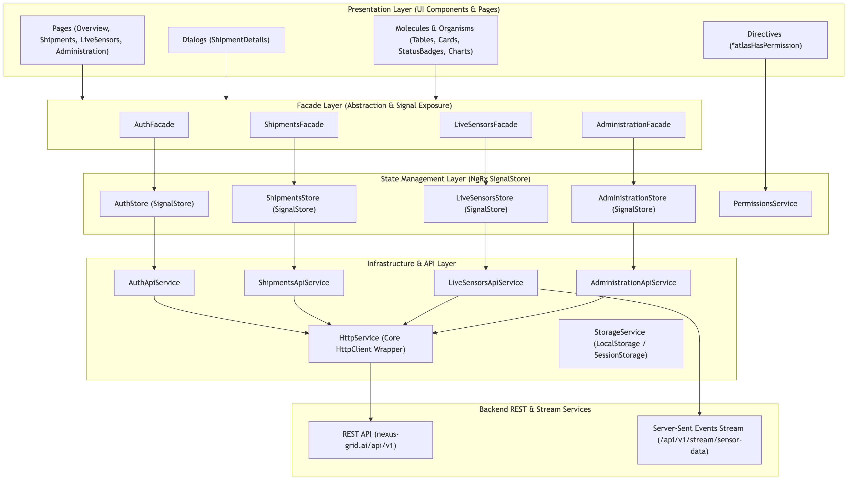

Core Architecture Principles & Folder Structure
The codebase follows a modular feature-based structure:
src/
├── app/
│ ├── core/ # Global singletons, base classes, guards,
│ │ ├── bases/ # AppBase, DialogBase
│ │ ├── guards/ # authGuard, nonAuthGuard, permissionGuard
│ │ ├── interceptors/ # authTokenInterceptor, httpErrorInterceptor
│ │ ├── permissions/ # PermissionsService, EPermission
│ │ └── services/ # HttpService, StorageService
│ ├── layouts/ # DashboardLayout, AuthLayout
│ ├── modules/ # Feature modules
│ │ ├── auth/ # Login page, AuthStore, AuthFacade
│ │ └── dashboard/ # Main compliance workspace
│ │ ├── administration/ # Tenant & user management
│ │ ├── live-sensors/ # Real-time SSE telemetry streaming
│ │ ├── overview/ # Operational metrics & compliance chart
│ │ └── shipments/ # Shipments table, details dialog & tabs
│ ├── shared/ # Atomic design UI components & directives
│ │ └── ui/
│ │ ├── atoms/ # Button, Badge, Label, DashboardHeader
│ │ ├── directives/ # HasPermission directive
│ │ ├── molecules/ # Card, TenantListItem
│ │ └── organisms/ # Sidebar, Profile, Tenants Dropdown
│ └── utilities/ # Routes dictionary, APIS config, helpers

Authentication, Session & Multi-Tenant Architecture
Authentication manages token storage, session hydration on page refresh, and dynamic switching between authorized tenants (TENANT-MOSTAFA-ELSHERBINIY and TENANT-MOSTAFA-ELSHERBINIY-MENA).

Authentication & Tenant Switch Sequence Diagram
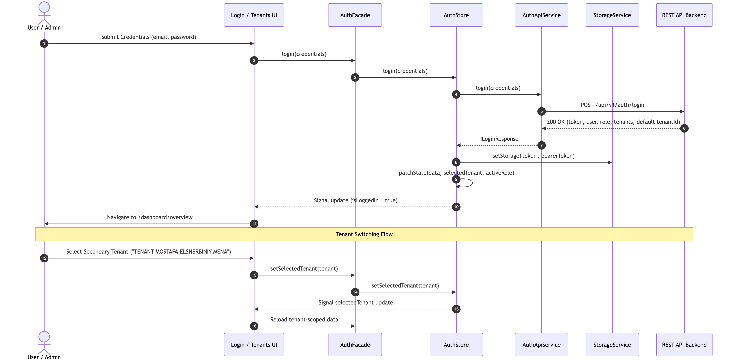

Role-Based Access Control (RBAC) Architecture
Security is enforced using a centralized Permissions Matrix that maps user roles to fine-grained feature permission keys. Access is checked reactively across route guards, sidebar items, dialog tabs, and action buttons.

RBAC Permission Matrix
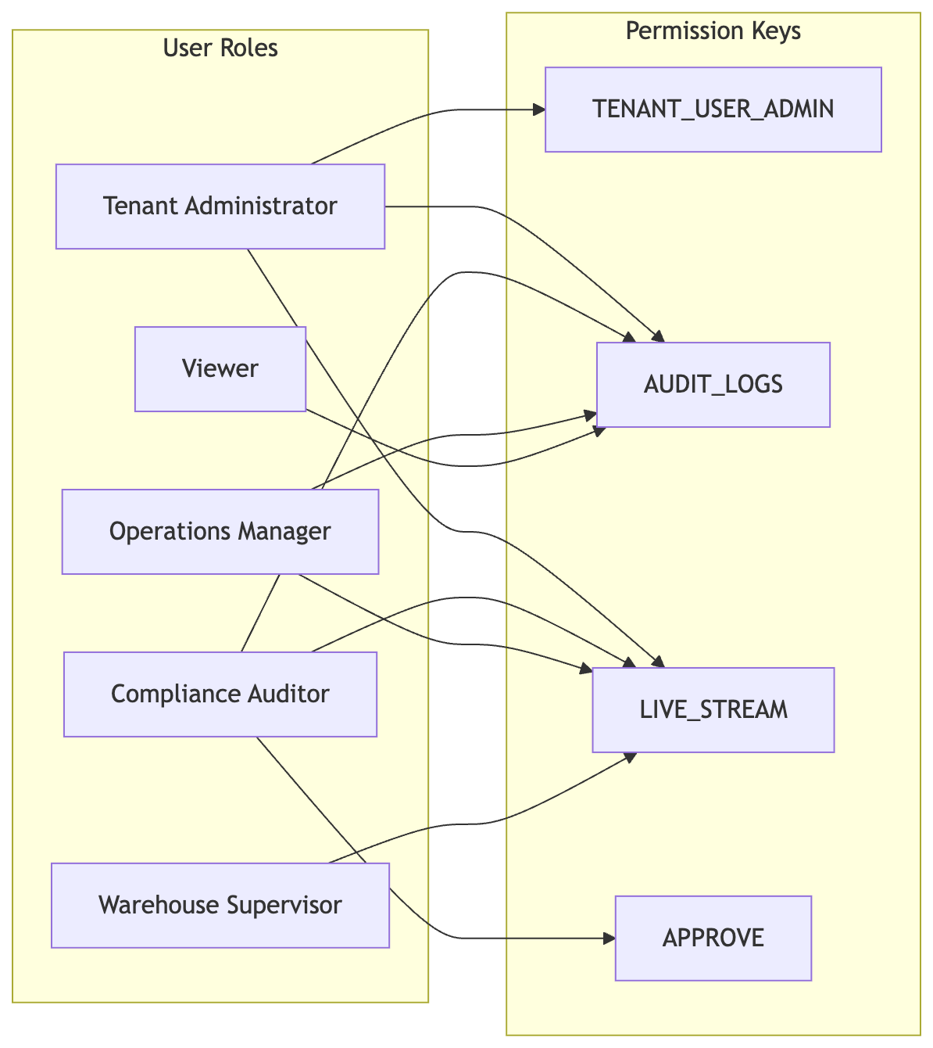

RBAC Directive & Guard Evaluation Flow
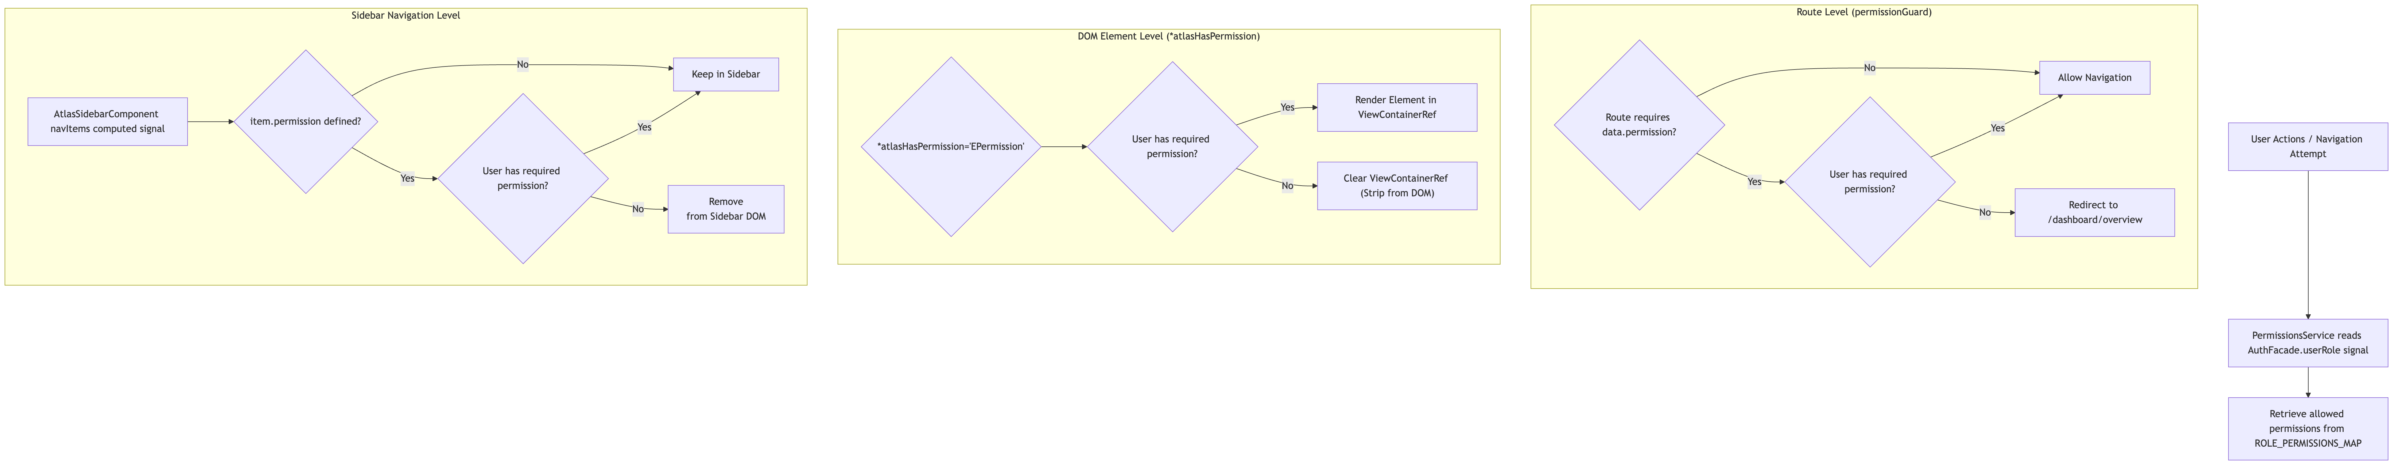

Overview Dashboard Module Architecture
The Overview Dashboard aggregate tenant-wide metrics (total shipments, in transit, approved compliance, needs attention) and renders a live Compliance Distribution Chart powered by ApexCharts.
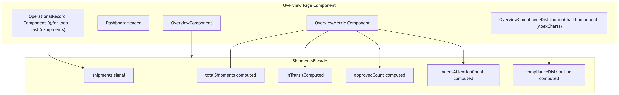

Shipments & Shipment Details Dialog Architecture
The Shipments Module features a data table with client-side/server-side sorting and filtering, coupled with a multi-tab Shipment Details Dialog.

Shipment Details Dialog & Sub-Tabs Architecture
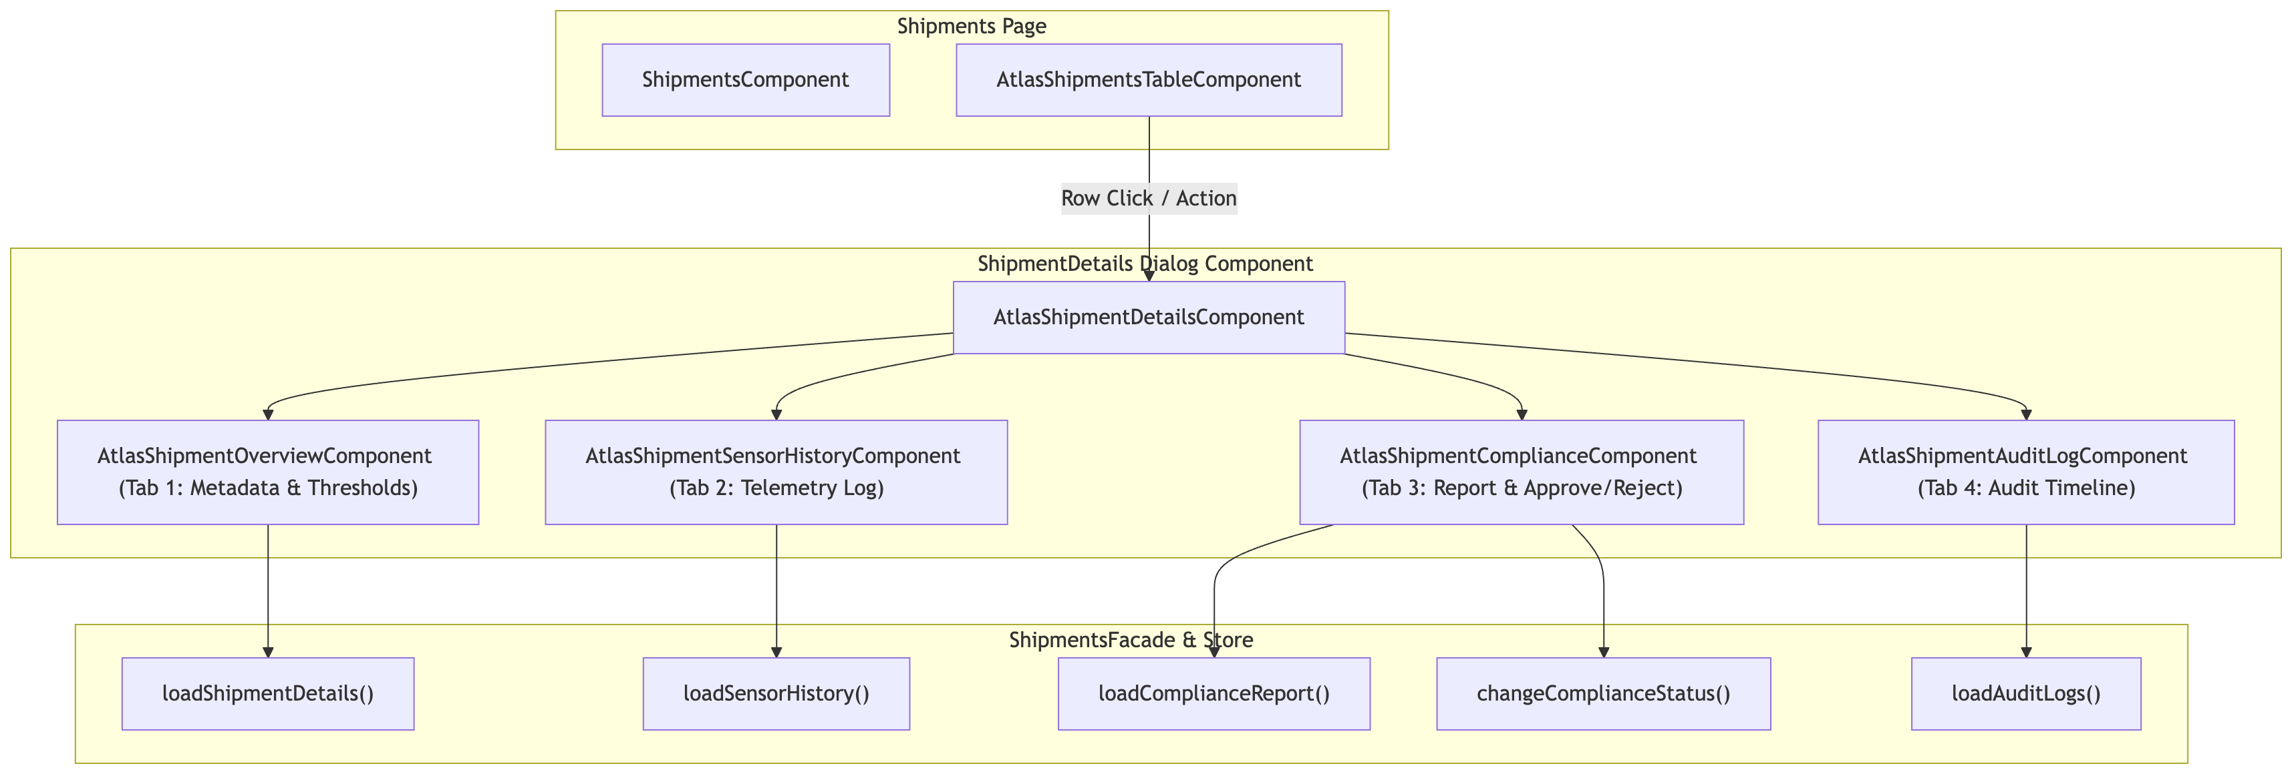

HTTP 204 No Content Handling Sequence for Sensor Readings
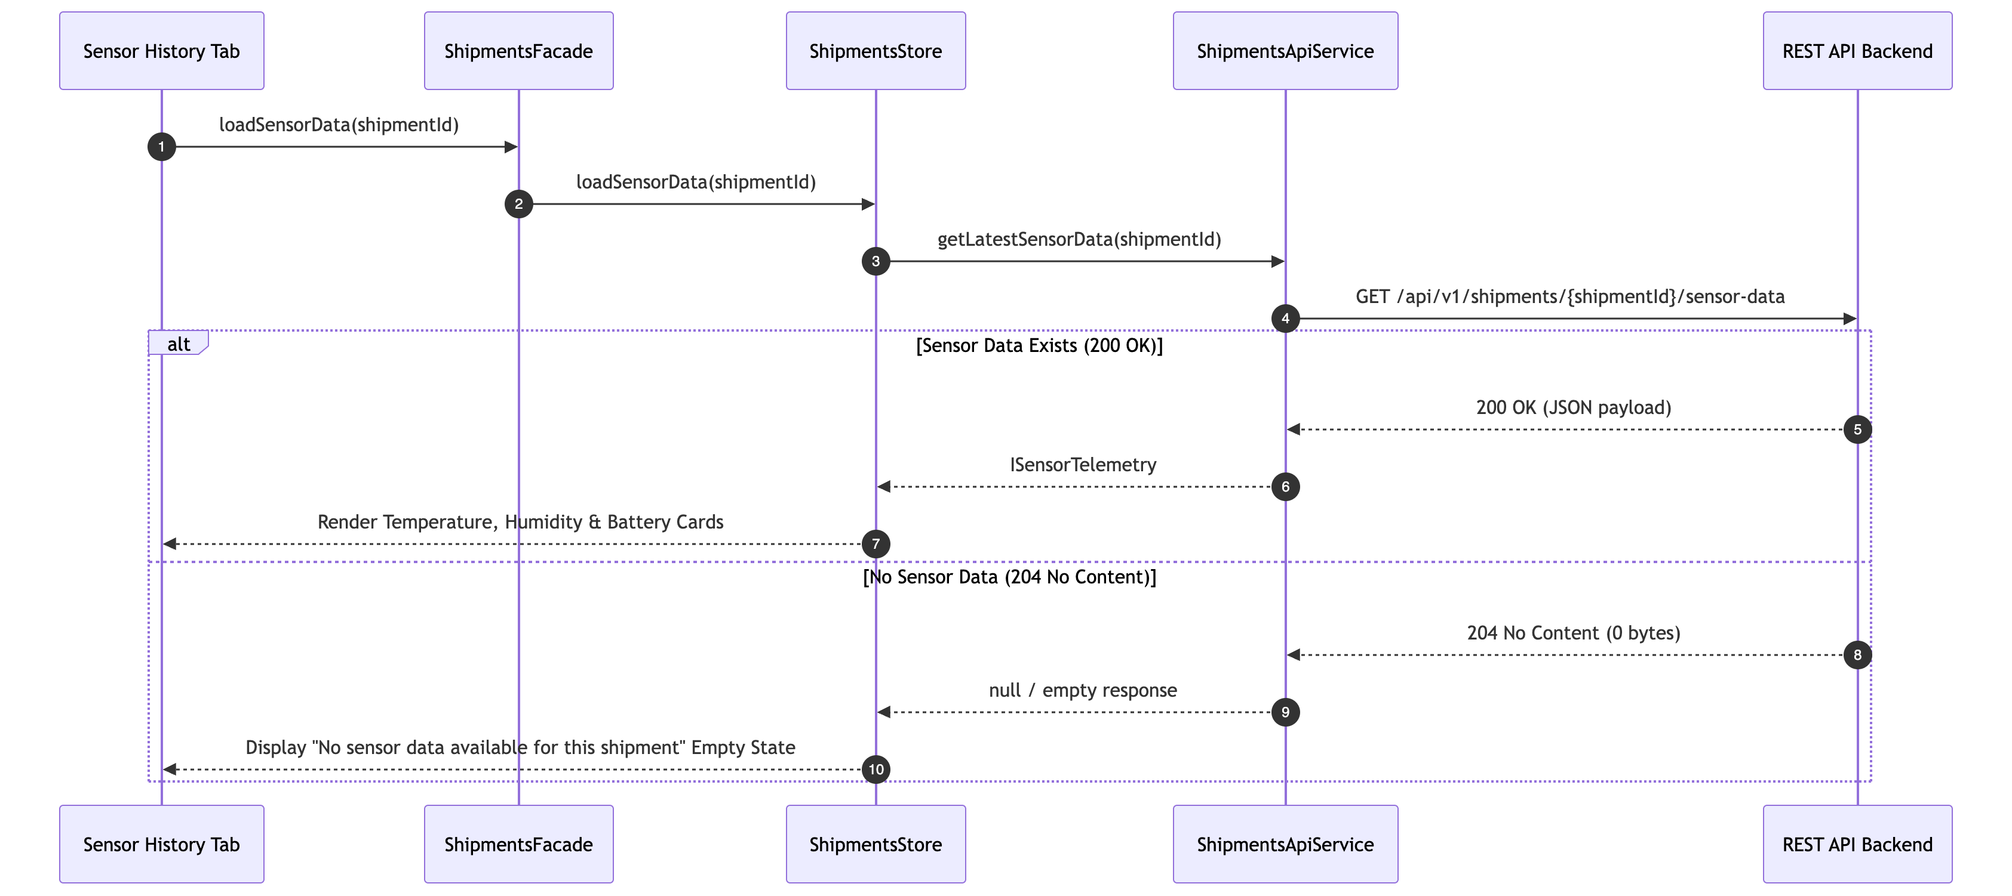

Live Sensors & SSE Telemetry Streaming Architecture (Bonus Feature)
The Live Sensors Module provides real-time IoT stream consumption via Server-Sent Events (SSE). It requests a short-lived ticket and establishes an active HTTP stream using a robust ReadableStream reader.

SSE Telemetry Streaming Flow Diagram
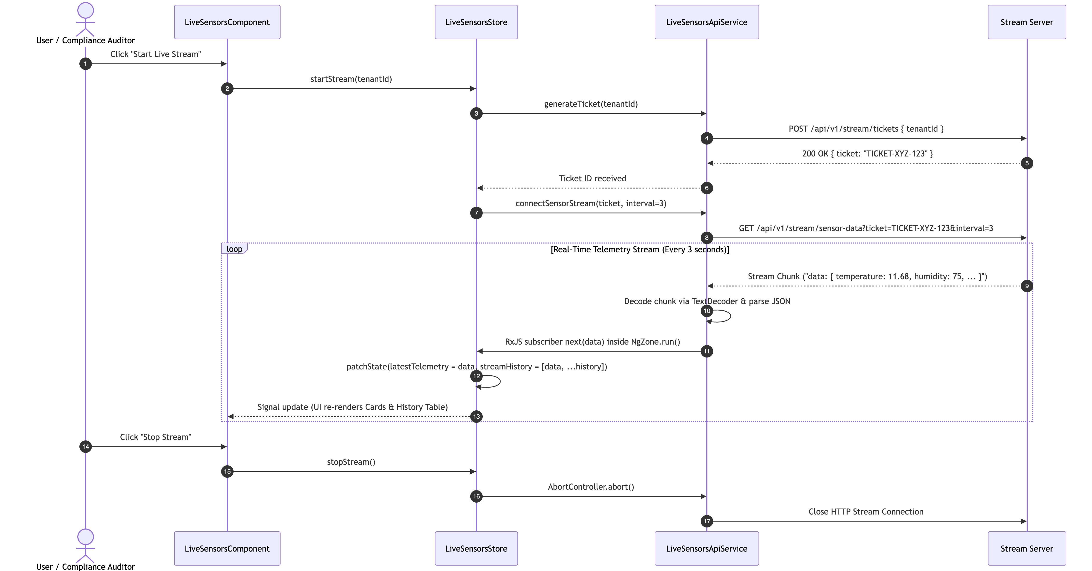

Administration & Tenant User Management Architecture
The Administration Module enables Tenant Administrators to manage organization users and update role assignments via API patch operations.

User Role Update Flow Diagram
